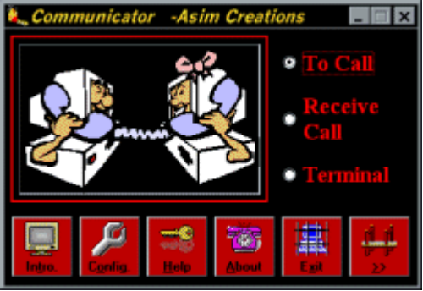
Fig: Main window that appears when the programme runs.

Communicator

SALIENT FEATURES:-

The software has the following unique features

Dialer

- Dialer with LED simulated acoustic click numeric keypad.
- Address Book (AB) with Name, Phone and Notes field.
- Search Engine and erasing of unwanted data are the qualities of AB.
- Capable of shifting data from AB to Dialer.
- Animated display of the workings and instrustions of connecton procedure.
- Reception of incoming Calls
- Easy to connect.
- Users can perform their work after activating it. It is smart enough to generate RING loops through the speaker in order to simulate the actual phone call.
- It can display messages and error in phone call reception.
- Since it can produce sound on call arrival so Users do not need to worry about the incoming call and can comfortably stick to their work.

Chat

- Complete Chating.
- LED simuated screen.
- Save Chating.
- Voice/Data Communication
- Using the Chat Screen User can perform Voice/Data Communication.
- Chat Window is capable of passing commands to attached Modem.
- Chat window is also capable of displaying the O/P of the executed command from Chat Window.
- Users have to concern their Modem Reference Guide for V/D Commands.

Configuration

Using the Configuration window User can have control on following quantities

- Data Bits
- Parity
- Baud Rates
- Communication Ports
- Stop Bits
- Handshaking
- RThreshold
- SThreshold
- Input Buffer size
- Output Buffer size
- Tone Dialing
- Pulse Dialing

Interface

- Attractive.
- Self-explanatory
- Windows Oriented
- User Friendly

-.-

