Creating XML Document
- Select a DTD file. (This step may be omitted should there is no applicable DTD file). For instance, try ‘XML_Dtd\DB.dtd’
- Right click and select ‘Add Root Node’, provide a name for it. e.g ‘Database’ (There can only be one root-node for each XML document!)
- Right click on the root-node and select ‘Add Child’. Provide a name for the child node. e.g ‘New Node’
- Single-left-click to change its name. e.g”table’
- Right-click on any node and select ‘Attribute Maintenance’, provide the attribute name_value pair for current node. For instance, if you want to add the following attribute to a node.
- ID=’Emp001
- Name=’Brandon’
- Gender=’Male’

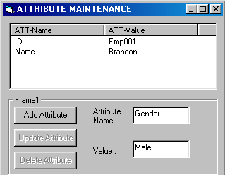
- Right click on any node except the root-node and select ‘Text Maintenance’. Provide the text for it.
- Once everything done, click ‘Generate XML’. A window will be launched showing generated XML codes.
- Click ‘Save file’. MSXML4 will check for syntax error and provide the feedback.
- The file will be subsequently saved when there is no syntax and schematic error.
- One may delete any node at any point.

Edit XML Document

- Open an XML document.
- Edit the document using the treeview, just as creating a new document.
- This time, text is regarded as a node rather than a side-entity ( as in Creating document module). Thus, one must chooses between adding text as child or as next node with respect to one node.
- Regenerate XML file and save it.
- MSXML4 will check for syntax error and provide the feedback.

