Data Flow Diagram

Connection Request

Login Name
1

Add CON header, IP address to data
Packet
Server
User #1

Packet
3

Post a JOIN notification to all users
2

Check if user is registered, if so, add user to list.
Users
Database

Message

1

Add MSG header to message
Server
Message
Packet
User #1

3
2

Find destination IP address from user list

Remove MSG header, retrieve message and sender
Packet
Message
User #2

Data Flow Diagram

Registration

Registration Info

Server
User
1

Add REG header to registration info
Packet

Database
2
3
2
Registration Info

Register User
in database

Remove header from packet

4

Notify user
User

Input-Processing-Output Chart

Client

Input | Processing | Output
Login Name & Password | Attach CON header and IP Address to packet | Send packet to server
Message | Add MSG header, source and destination to message | Send packet to server
Registration info | Add REG header, IP Address to info | Send packet to server
MSG packet | Extract source, destination and message | Display message in window
JOIN packet | Extract username from packet | Add username to list
PART packet | Extract username from packet | Remove username from list
PIC packet | Parse packet and write picture data into temporary file | Display picture in chat window
CRC packet | Extract CRC from packet and compare to existing picture’s CRC | Request picture upload from server if no match

Server

Input | Processing | Output
Connection Request | Log in user to system and assign a system ID | Send “join” notification to all clients
Message | Extract source, destination and message  Find IP address of destination | Send message to destination IP Address
List Request | Create list of online users | Send list to requester
Disconnect notice | Remove user from list | Send “part” notification to all clients
Registration request | Check if user has already registered.  If not, add user to database | Notify user of status of registration
CRC request | Extract username from packet, check if user has picture on system, create CRC from picture | Send CRC packet to client
PIC request | Check if requested user’s picture is on system | Send picture in several packets

Database Structure

Table RegUsers

Field | Data Type | Size/Width | Index
UserID | Number | Long Integer | Yes
UserType | Number | Byte | No
Email | Text | 30 | No
FullName | Text | 30 | No
Other | Text | 100 | No
Password | Text | 20 | No
UserName | Text | 50 | No
UserNo | Text | 15 | No

Table FriendsList

Field | Data Type | Size/Width | Index
UserID | Number | Long Integer | No
FriendID | Number | Long iInteger | No

Data Usage Analysis

Field | RegUsers | FriendsList
Email | *
FriendID |  | *
FullName | *
Other | *
Password | *
UserID | * | *
UserName | *
UserNo | *
UserType | *

Narrative of the Study

On first use, the client must be configured to connect to the correct IP address where the server application is installed. When this is accomplished, the user must then register his login name through his account number. The server keeps a record of all accounts and only one login name can exist for each account number. Once registered, a user cannot change his/her login name, but can change his/her personal information, including real name, password, e-mail, and picture. During the registration the user can optionally upload a picture that other people will see when they chat with the user.

One the registration is complete, the user can log onto the system using his/her chosen login name and password. A list of online users and friends will be downloaded and listed on the main menu. The client will query the server for any offline messages for the user. If there are any messages, they will be sent to the user for viewing. Clicking on a message in the offline messages window will mark the message as read. The user can initiate a chat session my double clicking on a name and typing in the corresponding chat window. Users can also receive chat sessions when another user sends a message. The user can disconnect at any time.

During chat sessions, the client requests for the picture of the user at the other end of the chat session, and will download a copy of the picture for faster access during subsequent chat sessions. If a copy of the other user’s picture already exists on the client, the client will first ask for a CRC of the picture to see if it has been changed, and if so, it can request a retransmission of the picture. If not, it will continue to use the existing copy, thus saving download time and bandwidth.

File transfers may be initiated during chat sessions. The user will select a file and request permission of the other user to send. If the other user accepts, a direct TCP connection will start for the file transfer. The server can also send the same file(s) to all or selected users, for automated multiple sending.

Input Forms

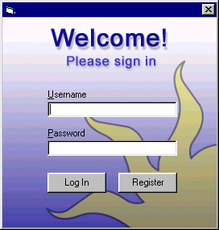

1-1. Login form

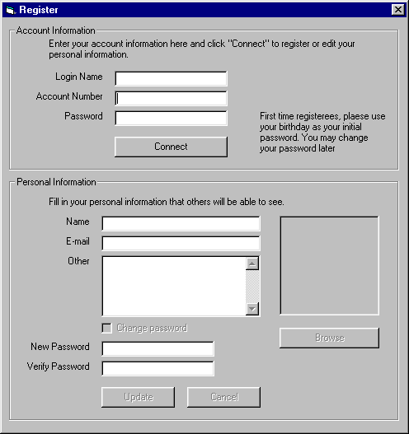

1-2. Registration form

Input Forms

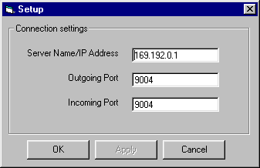

1-3. Setup form

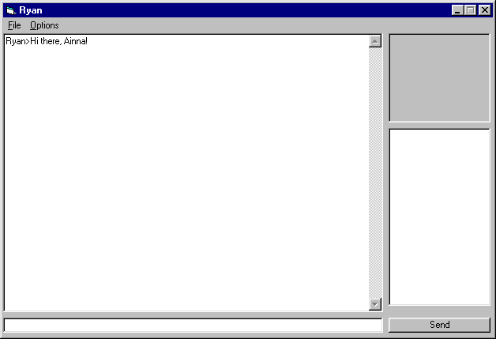

1-4. Chat form

