Using the Interface Scan Automatic HTML Help file generator

How to use the program:

HTML help files, as discussed in the previous article, are both useful and difficult to set up. In response to this, I wrote a program designed to obtain the classes, subroutines, functions, properties, enumerators and events from COM objects and prepare HTML help files.

The program in question requires that each public function, sub and property, each event and the project and classes have UNIQUE help context ID’s. Without this, the results will NOT work properly. It is also strongly recommended that the help strings be filled in with meaningful descriptions. They will appear in the HTML help files produced.

Given this information being correct, when you run the program, you will be faced with a screen like this:

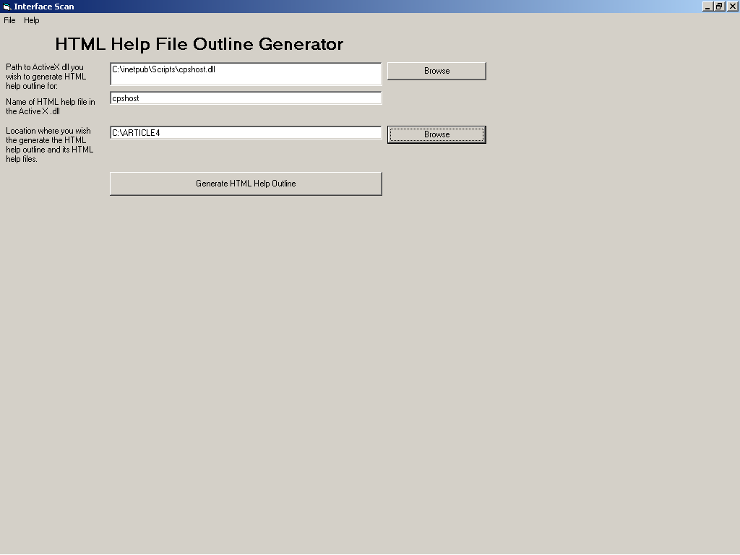

The two browse buttons will allow you to select the name of the dll you wish to scan. The program will suggest a name for the HTML help file based on the name of the program. This name must match the name of the HTML help file name in your program as defined in the property box shown below:

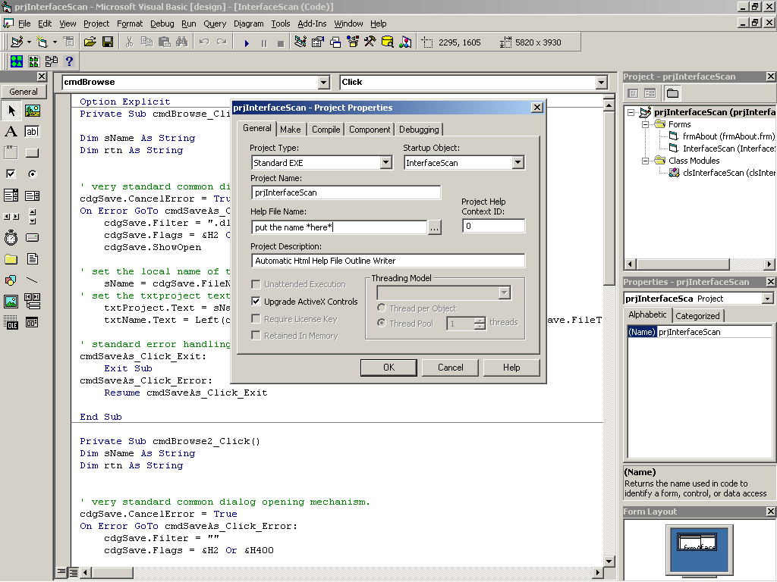

when you generate the HTML help file, you can then go to the directory you decided to put the HTML help components in and open the file as seen in the screen shot (the .hhp file).

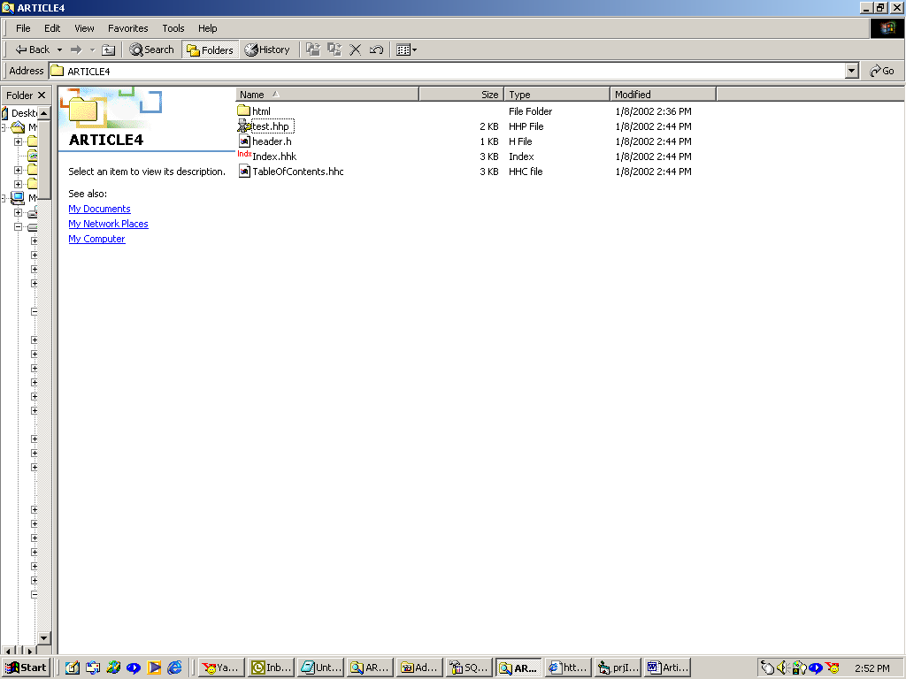

If you have installed the HTML help workshop ( found at http://msdn.microsoft.com/library/default.asp?url=/library/en-us/htmlhelp/html/hwMicrosoftHTMLHelpDownloads.asp?frame=true
) then you will face a screen like this:

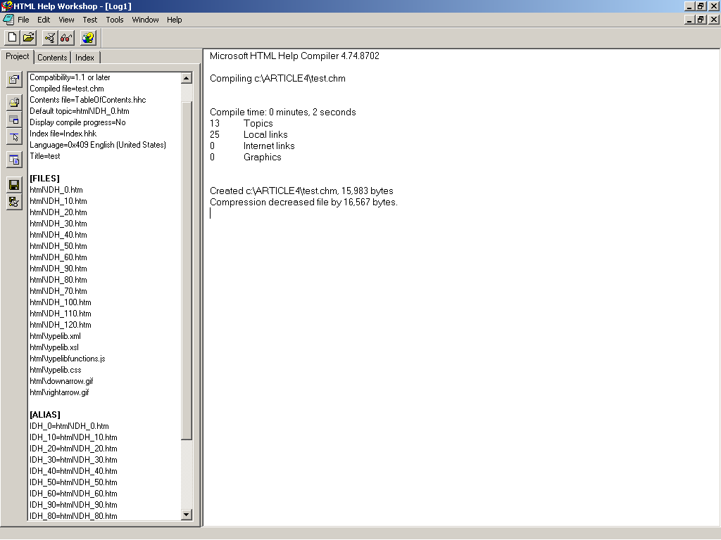

go to file|compile and you should get a result like you see on the right hand side of the above screen shot. Congratulations, you’ve compiled a basic HTML help outline. If you open the .chm file indicated on the compile screen, you can see what it looks like.

What the program does:

The third article will describe how the program generates an XML outline based on the COM interfaces of your DLL. The fourth article will discuss the interactions between XML and XSL to produce the code outlines you see in the HTML help file.

© 2002, Donald Derrick

