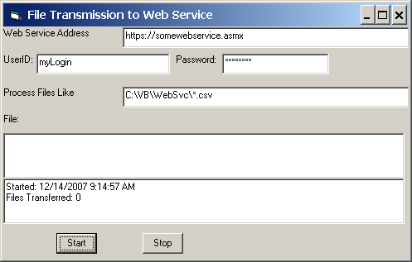

Here’s what WebSvc looks like (Above)

It processes all files matching the path/file mask, then waits for more, ad nauseum

It saves it’s set up data in a file called WebSvc.Set in the app folder (Data looks like):

https://somewebservice.asmx <-the web service
mylogin <-logon
mypassword <-password
C:\vb\WebSvc\*.csv <-fodler and file mask to process

WebSvc displays the current file being processed after the File: Label

It continually adds to a WebSvc.Log file

Processed files get renamed when sent, like example below where original part of file name is in Blue and prefixed/suffixed parts of file are in Red:

Done-11-Dec-07-13-26-03-PBM-01-Oct-07-10-01-01.DUN

Once WebSvc is configured, click start button to start, and stop button to stop

If you can’t connect to the web service or drop a connection to the web service, WebSvc will stop at that point with a message in the log file. Once the web service is available again, you can start it, and it will transmit all files that have been created while it was not running.

