DM Console + Make Tool

- What is this project?
- How to make console apps
- How to use the make tool
- Console Functions Ref

What is this project?

With this project you can make your own real console apps with VB6 like in VB.NET that run in the command prompt on windows. This means it does not popup into it’s own windows as it would when your making an API console.

How to make console apps?

Making a new console app is fairly easy if you use the project I have included see:

Console Template\ Console.vbp

Once you have the project open. Open the bas file WinMain in the project explorer

You will then see the default start up sub as shown below:
This sub is used to house all your console code

Dim Console As New ClsConsole

Public Sub Main()
If Console.cInit = 0 Then
MsgBox "Unable to start console session.", vbExclamation, "error"
Exit Sub
End If

‘ Note thaw lines above are used to init the console object you need this each time
End Sub

You can find more information on the console functions latter on in this file. Or you can also take a look at the example file included.

How to use the Make tool?

The make tool included with this project allows you to convert your app after it’s been compiled to a console app or a GUI app.

To use this tool simple make a new console app or own the example included into VB now compile your console app as you normal do.

Now open the make propject Make\ Make.vbp and press F5

And you see the main opening screen below:

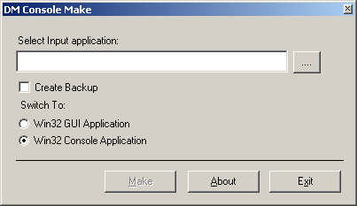

Next select your compiled console app as the input application
If you want to create a backup of the program check the create Backup box

Now for the switch options select Win32 Console Application
You can also switch if back to GUI by selection the option above.

Once you make your choice click the Make Button

You can now run the console application by double clicking on it. Or though the DOS prompt.

Fig below is a screen dump of the sample app included with this file

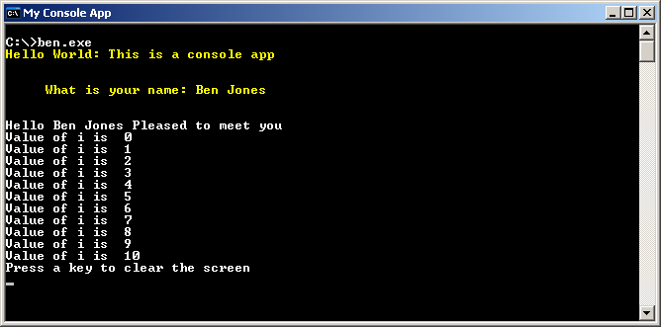

Consoles functions Ref

Below is a short list of the functions included and their purpose:

Console.cBeep Turns on the PC speaker on the mouther board by sending the BELL char to the console
usage Console.cBeep

Console.Title = "Sets a new title for the console"
usage Console.Tilte = “string”

Console.TextAttribute allows you to change the text foreground and background colors or the console
usage Console.TextAttribute = FOREGROUND_RED + FOREGROUND_GREEN + FOREGROUND_INTENSITY 'Yellow

Console.cSetCursorPosition x, y Allows you to position of the cursor on the screen with the values of x and y remember classic LOCATE in Qbasic
usage Console.CsetCursorPosition(10,10)

Console.cWrite Write a new line of text to the console
usage Console.cWrite(“hello”)

Console.cWriteLine Same as above but also appends a new line Vbcrlf
usage Console.cWriteLine(“hello”)

ReadLine Allows you to read the input from the console.
usage varname = ReadLine

Console.cCls Clears the screen
usage Console.cCls

Console.cPuase Waits for input from user once input
usage Console.cPause

Console.cFree Closes the console
usage Console.cFree

Well I hope this project serves as some use to some of you.
As always if you like to use this in your own projects please do so.

Big thank you goes to all other people at pscode for submitting there own console projects to give me an idea for this one.

Any problems getting the code working please email and I try to help you out.

