Intro to Visual Basic

Chapter 1

Let's start out with some of the basic elements of the visual basic IDE "IDE Stands for Integrated Development Environment." The IDE is the visual basic window. This is where you put in all the code and place controls onto the form. The following pictures show what the different elements of the visual basic IDE are and what they do:

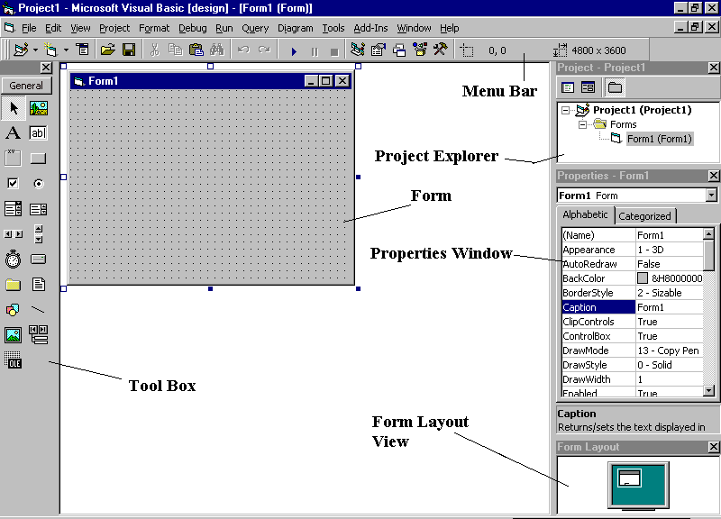
Fig. 1: Visual Basic IDE

Description of the elements of the IDE:

Menu Bar: This is just like the normal menus in any other application. I will go into more detail as time goes on.

Project Explorer: This shows all the Forms, Modules, and Class Modules that are currently in your project.

Form: This is the actual program window. This is where you will place the controls “A control is located in the toolbox. Controls are things like buttons and labels.”

Properties Window: This window displays the different properties that you can set for the control that you currently have selected. Properties range from the back color, font, font color, size, caption, name and many other elements of the control. With this window you can set these properties to what you like.

Form Layout View: This shows you how big your program’s window will be compared to the entire screen. You can position your window on the screen. I will go into more detail later.

Well, we have just gone over some of the basic elements in the Visual Basic IDE. Now let’s write our first very simple program.

Start off by creating a new Standard EXE. In the toolbox, click once on the Label control. Move your mouse cursor onto the form. Click and drag to place a label onto your form. As you can see once you let go of the mouse button, you have a new label on your form. This label’s caption is Label1. In your properties window you should see Caption and it should be highlighted with a blue background, next to it it should say Label1. You can highlight the text Label1 and then type in Hello. Then press enter.

Now go up to Run in the menu bar and click on Start. As you can see a new window pops up with a label in it that says Hello.

Congratulations!!! You have just created your first Visual Basic program!!!

In the next chapter I will teach you how to use the properties window to make your project do some neat things.

Chapter 2

In the last chapter you learned some basic features of Visual Basic and created a simple program. In this chapter you will do some more cool things with visual basic. First off, let’s explain the differences between a Text Box Control and a Label Control. A Label is used just as it sounds like it is used, to label something. It could be used to give the user information about the program they are using or to tell the user what to do with something. A Text Box is used to get information from the user. Now that you know the difference between these two objects you will know how to use them in your programs.

Let’s make a simple program to get you more used to the different properties of controls.

Start Visual Basic and create a new project. Place 5 command buttons onto the form. Name them cmdBigger, cmdSmaller, cmdColor, cmdShow and cmdHide. Now double click on cmdBigger to show the code window. Type in the following code.

Form1.Height = Form1.Height + 30
Form1.Width = Form1.Width + 30

Now double click on cmdSmaller and add the following code to it’s code window:

Form1.Height = Form1.Height - 30
Form1.Width = Form1.Width - 30

Open the code window for cmdColor and add the following code.

If Form1.BackColor = vbRed then
Form1.BackColor = vbGreen
Else
Form1.BackColor = vbRed
End If

Add the following code to the code window of cmdShow.

CmdHide.Visible = True
CmdShow.Visible = False

And finally add the following code to the code window of cmdHide.

CmdHide.Visible = False
CmdShow.Visible = True

Now run the program and click on the buttons.

As you can see, when you click on cmdBigger the form window got bigger. When you clicked on cmdSmaller it got smaller. By clicking on cmdColor the window changed from Red to Green and so fourth. When you clicked on cmdShow cmdHide became visible and cmdShow disappeared. When you clicked on cmdHide cmdShow became visible and cmdHide disappeared.

This simple program just showed you a few of the things you can do with Properties in visual basic. I’m sure that you don’t quite understand what the if statement does yet, so I’ll explain that now. You use the if statement when you have two different conditions that can happen and two different things to do depending on which condition is met. Like in the example project you just did, the two conditions were weather the form’s background color was red or green. Now, the if statement works like this:

If the background color of the form is red Then
Make the background color green
Else “If it is not red”
Make the background color red
End If “Tell the program that this is the end of the if statement”

Hopefully you understand how the If statement works now.

Chapter 3

Let’s make a Useful Program

In the last two chapters we made a few programs that really had no practical use other than to teach you about properties and the different things the controls do. In this chapter we will make a program that actually has a use, VB Note Pad. This program will show you how to add more controls to your Tool Box and how to use some of the other controls that are already in there.

Ok, let’s start out by starting visual basic and creating a new project. Add 1 text box to the form and make it pretty big. Set the following properties for the text box control: Text = Nothing, MultiLine = True, ScrollBars = 2 – Vertical. Now for a description of what each of the properties you just set do. The Text = Nothing means to make it so there is no text in the text box. MultiLine is so that when the user presses the Enter key or the text reaches the end of the line it will go to the next line. ScrollBars = 2 – Vertical. This makes it so that there are vertical “Up and Down” scroll bars on the text box. If there is more text in the text box than can be viewed in it at one time, then you can scroll up and down.

Now add 4 command buttons to the form. Name them cmdNew, cmdOpen, cmdSave and cmdQuit. Open the code window for cmdNew and add the following code:

Text1.Text = “”

This will make it so that there is no text in the text box. Open the code window for cmdQuit and add the following code.

End

This tells visual basic that when the user clicks on this that it is to quit or end.

Now press Ctrl + T. This will open up a new window that has a lot more controls in it. It should look something like the picture below:

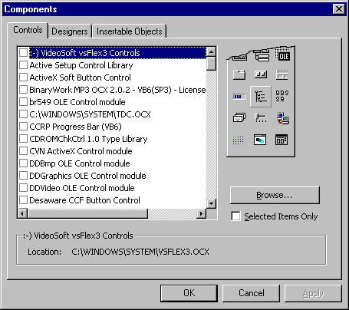

Scroll down to Microsoft Common Dialog Control 6.0 (SP3) and put a check mark in the box beside it. Now click on Apply and then click on Close. If you look in your toolbox now you will see that there is a new control at the end. This is called the Common Dialog Box. The Common Dialog Box is a control that has the common Open, Save, Printer, Font, Color and Help boxes. These are like the boxes that you see when you are in Paint or some other program and you click on Save or Open. You will see more of what these do later in this program.

Now, click and drag the Common Dialog Box control onto your form. Rename it to Dialog. Now open the code window for cmdOpen and add the following code.

Dialog.Filter = “Text Files|*.txt”
Dialog.ShowOpen

Fnum = FreeFile

Open Dialog.FileName for Input as #1
Txt = Input(LOF(Fnum), #Fnum)
Close #1

Text1.Text = txt

Ok, that was a lot of new code for you. Now I’ll explain what all of it does. Dialog.Filter = “Text Files|*.txt” makes it so that when you click on open the Open Dialog Box will filter out all files that are not text files. Dialog.ShowOpen shows the open dialog box. Fnum = FreeFile makes it so that you can open lots of different files. Open Dialog.FileName for Input as #1. This opens the file that you selected so that visual basic can work with it. Txt = Input(LOF(Fnum), #fnum) This just makes the value of Txt equal to the text in the document you opened with the dialog box. Close #1 just tells visual basic that you are done with the file and that it can close it. Text1.Text = txt puts the text in the file you opened into Text1.

Now open the code window for cmdSave and add the following code.

Dialog.Filter = “Text Files|*.txt”
Dialog.ShowSave

Fnum = FreeFile

Open Dialog.FileName for Output as #1
Print #1,Text1.Text
Close #1

This is basically the same as the code for opening a file except for a few differences. There is no txt = Input(LOF(Fnum), #Fnum). Instead there is Print #1, Text1.Text. This simply says that visual basic is to save the text in Text1 to the opened file or #1.

Now save your program and then run it. You have a fully featured text editor program now that you can use to type out your stuff or what ever you want.

Chapter 4

Adding on to VB Note Pad

In the last chapter we made a program called VB Note Pad. This is a basic text editing program that can be used to open, edit and save text files. In this chapter we are going to add some more useful features to our note pad program. We are going to add the ability to print and also some basic error handling to our program.

Ok, first off open up VB Note Pad which you should have saved from the last chapter. Add 1 more command button to the form and name it cmdPrint. Make it’s caption Print. Now open cmdPrint’s code window and add the following code.

Printer.Print
Printer.Print Text1.Text
Printer.EndDoc

Ok, this introduced some new code, Printer. Printer allows you to use the printer in your program to print pictures or words. In this instance, the first Printer.Print prints a blank line. The second Printer.Print Text1.Text prints all the text that is in Text1. The third Printer.EndDoc tells visual basic that that is all we want to print and that it is to print it now.

Now for the error handling. If you have run your program already and pressed cancel on either the Open or Close Dialog Boxes you have noticed that it gave you an error. This is because out basic note pad program has no way to handle the errors. So open up the code window for cmdOpen and add the following code before Dialog.Filter = “Text Files|*.txt”.

On Error Resume Next

Now do the same thing for the code window in cmdSave. This is very basic error handling code. It simply says that if there is an error that it is to go to the next step. In a later chapter we will go on to more advanced error handling. Now save VB Note Pad and go ahead and run it.

Chapter 5

Menu’s Baby!!

As you can see our VB Note Pad program is shaping up to be a pretty useful text editing program. We have simple error handling, Save, Open and Print functions. But all those buttons are making the form window look pretty cluttered up. We are going to fix this by adding menu’s. The following picture shows you what a menu is so you know what you are going to be making.

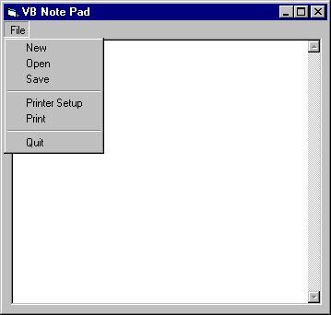

As you can see from the picture, the menu cleaned up the form and put all of those command buttons out of the way. Now if you want to quit, print, open or save all you have to do is click on File and they are all there.

So, how exactly do you add a menu to your program? Well, that’s what I’ll show you now. In Visual Basic click on Tools and drag down to Menu Editor. A window that looks a lot like the following will show up.

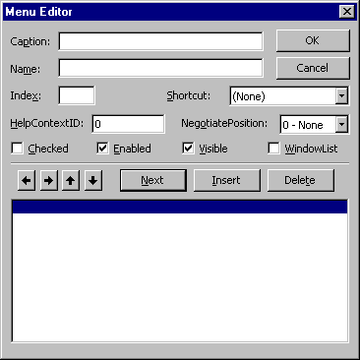

To add a menu you put in a Caption “This would be like File in the picture above”, and then the name of the menu. When you click on file in visual basic you will see a list of different options inside of it. These are called menu options. To add a menu option follow these simple steps:

- Put in the Caption and name of the Menu.
- You should see 4 buttons with arrows on them. The arrows point Left, Right, Up and Down. Clicking on the Right button will place 3 periods “…” in front of the caption of the menu item you are creating. This means that that is a Menu Option to the menu above. When you are done click on Next to put in a new menu item or click on Ok if you are completely done. See the figure below to see a visual representation of what I just explained.

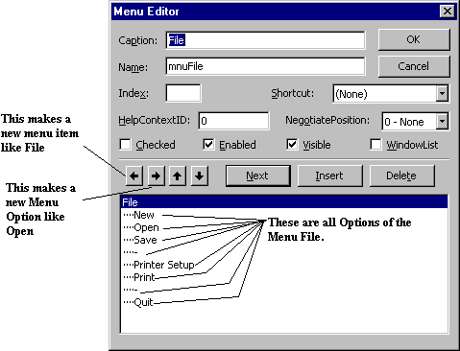

Now we will add the menu to VB Note Pad and get rid of the command buttons. Follow the following steps to add the menu:

- Click on Tools and drag down to Menu Editor
- Type File as the Caption and mnuFile as the Name
- Press Enter
- Now type in New as the Caption and mnuFileNew as the Name
- Press on the Right arrow button
- Press Enter
- Now type in Open as the Caption and mnuFileOpen as the Name
- Press Enter
- Type in Save as the Caption and mnuFileSave as the Name
- Press Enter
- Press the – key for the caption and then mnuFileDiv1 as the Name
- Press Enter
- Type in Print as the Caption and mnuFilePrint as the Name
- Press Enter
- Press the – key for the caption and then mnuFileDiv2 as the Name
- Press Enter
- Finally type in Quit for the Caption and mnuFileQuit for the Name
- Press Ok and you now have a menu on your program.

Now open the code window for cmdNew and cut Text1.Text = “” out. Delete Private Sub cmdNew_Click() and also End Sub. Now go back to the form and click on the File menu at the top of the form and drag down to New. Let go of the mouse button with New highlighted and visual basic opens up the code window for mnuFileNew. Past the code you cut into this window. Now repeat this for the other command buttons on the form. After you complete this you can delete the command buttons and save the program. When you run it you can click on the menu options and they should do the same thing that the command buttons did.

Chapter 6

To Browse or not to Browse

In the last few chapters we learned how to make a simple text editor. In a later chapter we will add on to that but for now we are going to start a new project, an internet browser. I am sure that all of you have either Netscape or Internet Explorer. This chapter will show you how to make your own browser with many of the functions of those two browsers.

Ok, let’s start out by creating a new project. Press Ctrl + T to display the Components box. This is the window that you used to add the Common Dialog Box to VB Note Pad. Scroll down to Microsoft Internet Controls and check it. Press apply and then close that window. Now click on the globe that came up in your Tool Box. Drag it out onto your form window. This is the actual browser control where the internet page will be displayed. Change it’s name to Browser. Now add 5 command buttons to the form. Name them cmdBack, cmdFoward, cmdStop, cmdRefresh and cmdHome. Set the captions to Back, Forward, Stop, Refresh and Home. Now add a text box and name it txtAddress.

Now that you have the components added to the form it’s time to add some code. Open the code window for cmdBack and add the following line of code:

Browser.GoBack

Simple, isn’t it. This simple line of code will take the user to the page they were at before the one they are currently at. Now open the code window for cmdFoward and add the following code:

Browser.GoFoward

This does the same thing as the back button except instead of going back to the previous page it goes forward to the page they were at before they hit back.

Open the code window for cmdStop and add the following code:

Browser.Stop

This will stop the page that is currently loading from loading any more. Open the code window for cmdRefresh and add the following code:

Browser.Refresh

This will refresh the current page. And now add the following code to the code window for cmdHome:

Browser.GoHome

This code will take the browser to the home page that you have set for your other default browser.

Now that we have the code for the command buttons done there is only one thing that we have left to do. Put the code into the text box. Now, to put the code into the text box we are going to have to do something that we haven’t had to do before. When you double click on the text box it will bring up the code window for it. This code window is for one of the text boxes events. An event is something that the user can do. Some of the events of a text box are Key Pressed, Change, Key Down and Key Up. These are different things that the user can do while they are working with the text box. The event tells visual basic what to do when the user does one of those things. The picture below shows you what you would click on to change to a different event.

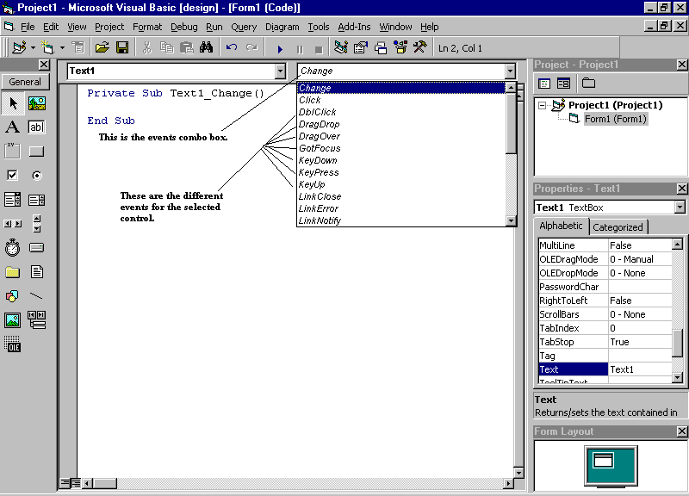

To change to a different event just scroll down to it so that it is highlighted with a blue background and the let off the mouse. More code will appear in the code window and all you have to do is type in the code you want to go with that event.

Ok, Now that you know what an event is, double click on your text box and then go to the Key Pressed event. Add the following code to the Key Pressed event of the text box:

If KeyAscii = 13 then
Browser.Navigate txtAddress.Text
End If

Now. This introduces something new, KeyAscii. Every key on the keyboard has a number that distinguishes it from the other keys on the keyboard. Those numbers are called Ascii characters. What this code does is every time a character is put into the text box visual basic checks to see what the Ascii character for that key is. If the Ascii number is 13, either of the Enter keys on your keyboard, then the web browser is supposed to go the the address that is in the text box. Otherwise it doesn’t do anything.

Now, save your project and run it. As you can see, pressing any of the command buttons will do what it is supposed to do. When you type an internet address into the text box and press Enter, the browser goes to that page. Pretty cool huh?

