What is DLL

Dynamic Link Library is a library of executable functions or data that can be used by a Windows application.

Creating DLL

Run Microsoft Visual Basic and open Standard EXE.

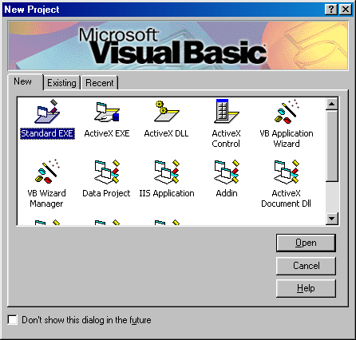

Let’s deal with the Form (Form1 under Project1) later. Meanwhile, under the File Menu, click on Add Project... and open ActiveX DLL

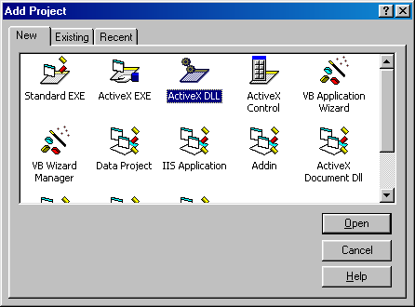

On the Class Module (Class1 under Project2), type this sample code.

Option Explicit

Public Function ShowStr() As String
ShowStr = "Enrico X"
End Function

Now let’s set our focus to Form1 under Project1.

Let’s link the Class Module (Class1 under Project2) into the Form (Form1 under Project1). To do that, under the Project Menu, Click on References... and check Project2 then OK.

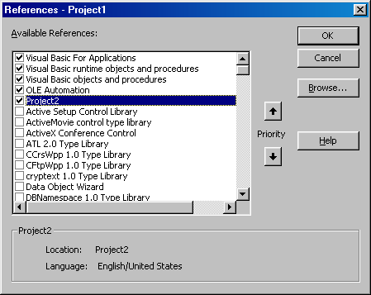

When done, Put a CommandButton in Form1 and type this code.

Option Explicit

Private Str As New Class1

Private Sub Command1_Click()
MsgBox Str.ShowStr
End Sub

Actual Program

The project should look like this at run time.

