INTELLIGENCE GENERATOR / DETECTOR - Version 4

Gary S. Gaulin, 2008

COMPUTER MODEL

This computer model demonstrates self-organizing, self-learning intelligence. On startup this guess/memory intelligence is like a newborn. It does not know up from down or left from right or what it’s seeing, experiencing. But from trial and error quickly learns how to coordinate motors with sensory information to get where it wants to go.

It has a simple ring circuit that adds a sense of awareness of what’s around itself. It is not necessary to include this for it to be intelligent, but the circuit adds a great deal of awareness.

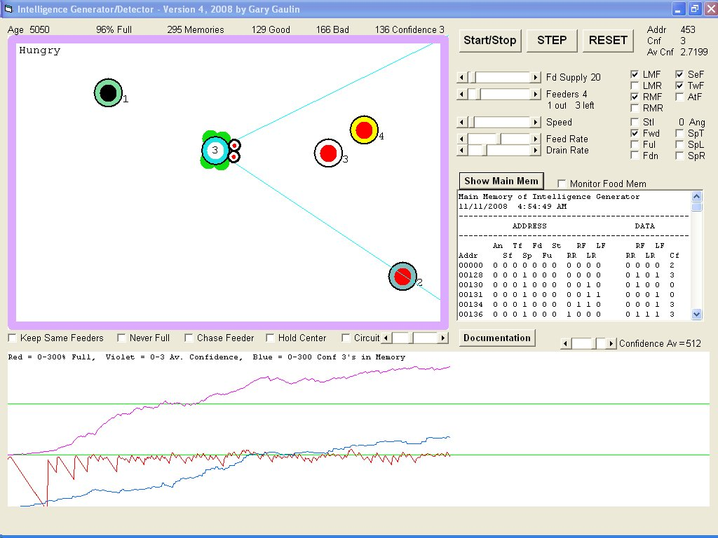

MECHANISM

The mechanism that produces this intelligence is best described by the following simplified program loop. We will here give the intelligence control of tank-like 2 motor drive system. Motor Forward and Motor Reverse is controlled with two bits where motor is off when 00 or 11 while motor is moving one way or the other when 01 or 10 with it not mattering which order the two control bits are connected to memory. It inherently self-organizes all inputs and outputs.

Conf(Addr) is a one bit memory array location that stores Confidence level from 0 to 3 at address specified by the "Addr" variable. Due to the way electronic counters operate (but not synapse) the program assumes that Conf(Addr) will not go below zero or above limit, in this case three. The RunMotors subroutine would here change -1 to 0, and 4 to 3 so it stays in range.

In the first line of program code we have what the intelligence is to control, in this case motors. With molecules this could be the Krebs Cycle. The "Call" instruction causes top to bottom program flow to jump to where another routine generates a virtual environment containing the robot then jumps back when finished. Where real motors are used for an actual robot the four motor control bits would be sent to motor controller circuit, then returns.
The second line adjusts a Confidence level in response to the condition of the "Stall" environmental input sensor that is 1 (true) when wheels stop turning as it would when wall stops it. Other sensors such as eye pixel, battery low sensor and another for having found charger is added with another If..Then.. statement.

The third line uses binary powers of two so that there is a unique memory Address location for each possible input sensor combination. Networks of neurons already connect in a way that forms unique branching pathways so do not require a numerical address like this, but a computer memory here simulating them does. Other inputs can be included in this addressing with the next power of two such as adding "+(EyePixel*32)" to include photosensor to see light from a battery charger. Memory size doubles for each bit added which is at first not a problem but can become unnecessarily complex. Not all sensory information need be included in addressing, just what is needed to make an efficient addressing system to sort visual experiences into unique locations in the memory. When there are a large number of inputs they are first summed in different layers of detail.

The fourth line takes a guess when confidence in an action is below one (zero) by randomly setting the four motor control bits then confidence level to one to indicate low certainty. This part of the mechanism is also intuitive when one tries to imagine what would happen where we could not take a "guess" when necessary. We would forever get stuck right there, maybe repeating the same unsuccessful action like bumping into barrier over and over again until dropping from exhaustion. Flies sometimes do this for a while against a pane of glass to reach a light source on the other side. At some point it has to realize that it is not having any success then try something else.

LoopStart:
Call RunMotors
If Stall=0 then Conf(Addr)=Conf(Addr)+1 Else Conf(Addr)=Conf(Addr)-1
Addr = LMF + (LMR*2) + (RMF*4) + (RMR*8) + (Stall*16)
If Conf(Addr)<1 Then Call RandomGuess: Conf(Addr)=1
Goto LoopStart

This model is also analogous to finger muscle control that through training become coordinated in a way that they have the keyboard layout stored as motions to reach each key. In both cases intelligence successfully learns to navigate a 3D space without requiring a physical map. We are therefore able to type without consciously thinking about the level of intelligence that does the actual typing

Electronically, the memory system it can be though of a RAM memory chip with wires each with a bit of input sensory information (eyes, ear, bumpers, etc.) are connected anywhere to the RAM Address Input bus. This gives each unique environmental situation a unique Memory location where a response can be stored.

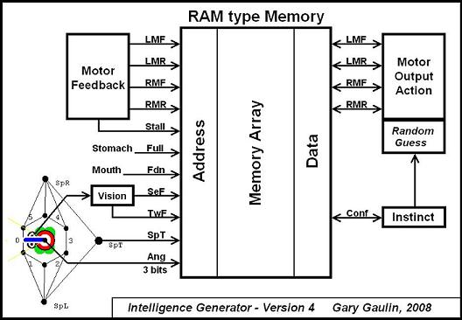

CONFIDENCE

When you encounter a new problem you never saw before, you know when you have no solution in memory. Your confidence in having the correct response is 0, because you have no response at all for that yet. The best you can do is guess. If that didn’t work then you guess again. While growing up we had to try holding cups upside down and other angles to figure out that unless it stays “upright” the contents spill all over the floor. And coordinating muscle movement to walk then run involves a lot of falling down.

In the computer model all locations in memory likewise start off with Confidence = 0. Confidence is incremented up to a maximum of 3.

When a guess leads to what it instinctually wants, it’s stored with Confidence = 1. If it works again, then it’s incremented to 2. Then finally to 3.

The confidence range of 0-3 is all that’s needed. Going beyond that range is not necessary.

How confidence is incremented leads to various behaviors. All at once going from 0 to the max of 3 leads to overconfidence. If its confidence is easily brought back to 0 then it will have little confidence in any of its responses but that can lead to trying new things.

You can experiment with how the confidence is increased or decreased to obtain new personalities. In fact, there are so many ways to define behavior, there is no one right to structure the If…Then… instincts.

INSTINCTS

Instincts are greatly influenced by how the intelligence is wired together.

In biology, a single egg cell divides into many. Some differentiate to form colonies of neurons. Cells that grow connections to others in the colony to form a brain that sends connections into the arms, legs, fins, whatever there is they can connect to.

Neurons start off with more connections than are needed. Then they fight it out. Use it or lose it. Connections that didn’t help you see or crawl, dissolved. In this way, the brain starts off in a condition where it can wire itself into the organism its inside.

Whatever is there for a photoreceptor, will work just fine. Even an eye-spot made of a centriole crystal is better than nothing. On up from there are telephoto eyes of birds of prey. Whatever there is developing for an eye gets wired into.

There is no one right way to form a brain. With all the different sponges and insects and worms and other designs, there are millions of ways to do it. Each results in a different set of instincts.

What an organism does when it hits a wall is instinctual. In this model instincts tell it bashing into a wall is not a good thing, by the Stall condition connecting to the random guess (in higher order is educated guess) circuit that forces it to try something else. We would bump our head, it hurts, the pain condition forcing us to try something different so that doesn’t happen again.

The human brain is much more complex than the one in the computer model. But the overall interaction is much the same. We have a memory that responds to what is being sensed, with action signals sent to muscles, where feedback circuits wire back success or failure and includes pain receptors to add a more automatic “don’t do that” reflex that more suddenly puts what muscles are doing into reverse.

To an organism that must attach to a surface, bumping into one is a good thing. It will instinctually want to stay there. Its body design (phenotype) will be made for attaching to a surface, presenting another challenge for neurons to coordinate.

How the neurons connect, is not ahead of time mapped out in DNA code (genotype) that only makes the neurons who instinctually form colonies of cells that instinctually like to communicate with each other. How that circuit ends up looking like, in part depends on what the neurons have to grow into. Out of their self-organizing conversation comes our human intelligence, or that of a snail.

Instincts are easily added using simple "If...Then..." statements that adjust Confidence level. The following is how the Intelligence Generator computer model accomplishes this:

'INSTINCTS are described by the following If..Then.. statements.
Conf = -1 'Decrement memory confidence unless set otherwise.
If Ful = 0 Then 'If Ful=0 then it's hungry, invoking feeding behavior.
If SpT = 1 Then Conf = 3 'Spinning Towards food it can't see increases confidence.
If SeF(WantsF) = 1 And TwF(WantsF) = 1 Then Conf = 3 'As does moving closer to visible food.
If SeF(WantsF) = 1 And Fwd = 1 And FwdWas = 1 Then Conf = 3
End If
If Fdn = 1 Then Conf = 1 'If now feeding then confidence in last action increases.
If Stl = 1 Then Conf = -3 'Hit the wall, is stalled out, no confidence at all remains.

Seeing food and hungry while motor direction is moving it closer, is here a successful response. But if it is hungry and what it's doing is not getting it any closer, it’s failing, so the intelligence must take a guess. Random motor settings are tried. If settings work then they remain in memory, else it takes another guess what to do.

RING MEMORY

Since the amount of memory required (size of RAM chip if electronic) doubles for every bit of sensory input added, its size can increase very rapidly. But memories such as these do not require details. It’s not necessary to connect every single pixel of eye information directly to memory. Like in human vision many photoreceptor pixels are combined into a single signal before being sent to the brain via optic nerves. The visual information is not all at once processed, it is processed in “layers” of simple circuits.

In this model is a second memory adds an awareness of what’s around it. This way it can sense what is out of its field of vision.

When you click the "Circuit" checkbox you see what is in essence a ring of six neurons, numbered from 0 to 5. The state of what it sees ahead at Angle 0 shifts from neuron to neuron around the ring. The reference angle for body position could come from the sun, magnetic field, nearby landmark, balance circuit, or other source of rotational feedback.

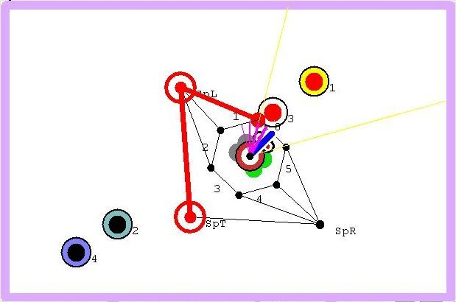

Direction of food is shown as blue pointer. In this example the food angle just switched from being to the left out of field of view, to being straight ahead. The right motor is running forward (green) while the left is stopped (gray). So it's here Spinning Left (SpL) and Spinning Towards (SpT) what it "sees" to the left of it.

Sensing direction like this adds another level of intuition. Will now learn how to turn in the right direction to follow what when out of its field of vision. Like when something goes fast in front of you, turning the right direction is automatic. You don't look left then right back and forth until you by chance see it again.
It's possible to grab the last feeder with your mouse so it has to chase after it. Will notice that it learns to turn in the right direction towards it.

What this adds is shown below, where the chart with Angle and SpT bit added to the Address is shown above the graph of the same age without it. The Food Supply slider control was set to 1 (lowest amount) so it has to work hard to keep itself fed.

In the graph you can also see how well it keeps itself fed, the red line No intelligence at all would have the graph showing a battery level that flat-lines at 0, which in essence, is dead. But notice the red line here. See how it very quickly learns to find food so it doesn't go to zero full, starved, like it would be if stuck in a circle never bumping into food.

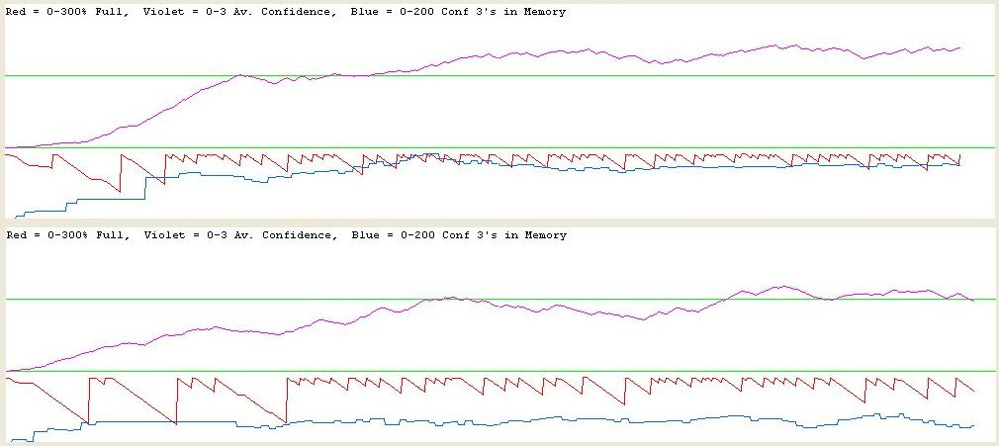

We can see from the lower red line of second graph that it had more trouble staying fed. Confidence is also noticeably lower due to it being a slower learner.

Shown below, is the graph when its ability to see food is entirely taken away.

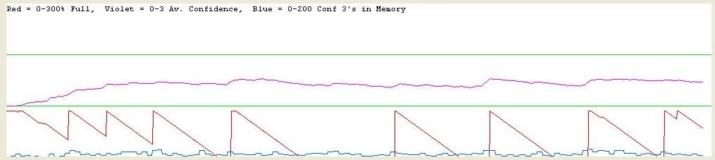

In the above three examples, the only thing that has changed is the amount of environmental sensory information. And this intelligence is not at all fussy. Adding any kind of sensor, that does almost anything, can greatly increase its awareness.

MAIN MEMORY
To show what this intelligence looks like, the contents of its main memory can be displayed by clicking the "Show Main Mem” button. All nonzero memory locations will then be listed as shown below:

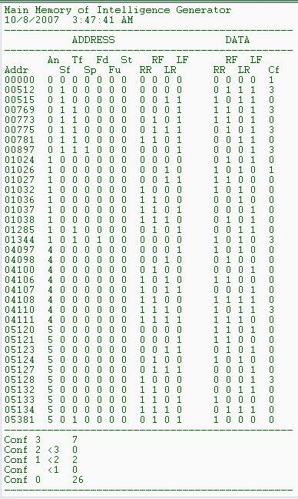
Motor controls Right Motor Forward (RF) and Right Motor Reverse (RR) are in both Address and Data. The address is sensory feedback information, back from the motor circuit that lets it know it’s moving. It could be stuck against a wall, stalled, not turning.

There is no motor On/Off register. Motors are off whenever both RF and RR are 0 or 1, or both LF and LR are the same value.

The “Addr" is the unique address. All other memory locations are unused.

“An” is the angle relative to itself and food.
“Sf” indicates that is sees food in front of it.
“Tf” indicates if it moving Towards food.
“Sp” indicates it’s Spinning towards food (SpT).
“Fd” indicates it’s Feeding, or in other words found food and hungry.
“Fu” indicates it’s Full.
“St” indicates it is Stalled, against wall

