Collision Detection by
Gex

*Before you start reading you should have opened my test project located in folder “Test”

What is collision detection?
- Collision detection is used in games mostly to prevent player to move through objects(walls, crates, water…).

Why is your collision detection different from standard methods?
- Standard methods are slower than this method and require a lot of calculations for object position.

What are standard methods?
- Standard methods take you object sides and check if they are contained within other objects sides by creating imaginary rectangles around your object.
If yourobject.x > otherobject.x and yourobject.y < otherobject.y then collision = true
and stuff like that(code doest really look like that). This may be good if you have only few objects to colide with, but what if there are many? Say 1579? Then its:

For x = 1 to 1579
If yourobject.x > otherobject.x and yourobject.y < otherobject.y then collision = true
Next

Do you know how much it takes visual basic to calculate this stuff 1579 or even more times? Don’t even ask…
P.S. By the way, the code I wrote is much longer than just if and & then. Its more than 4 lines of code.

Did you come up with this idea for your collision detection?
- Actually the idea came from this address but the code is 100% mine and I use pixel precision collision detection. This just inspired me.

How does your collision detection work???
- Good question. Just keep reading, you’ll figure it out…

Lets say you and your friend are playing a SinkSub game. He goes to make a telephone call and leaves his paper on the desk. Because jou just love to cheat you take his paper and draw positions of his subs on a separate paper. The position of his subs looks like this:

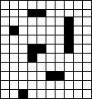

Now I ask you: How do you draw it on a paper without drawing the grid(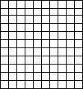)???
Not sure? How about binary system( 1 & 0 )? But how would that look like? Look at this:
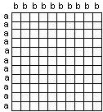 Lets imagine there are a’s on the left and b’s on top(this you will need later).

Here:
b b b b b b b b b b

a 0 0 0 0 0 0 0 0 0 0
a 0 0 0 1 1 0 0 0 0 0
a 0 0 0 0 0 0 0 1 0 0
a 0 1 0 0 0 0 0 1 0 0
a 0 0 0 0 0 0 0 1 0 0
a 0 0 0 1 1 0 0 1 0 0
a 0 0 0 1 0 0 0 0 0 0
a 0 0 0 0 0 0 0 0 0 0
a 0 0 0 0 0 1 1 0 0 0
a 0 0 0 0 0 0 0 0 0 0
a 0 0 1 0 0 0 0 0 0 0

Take a look on the first picture of SinkSub. Does this reminds you of it? It’s the same thing, but 0 represents empty places and 1’s represent position of your friends subs.

How da f*** this helps me???
- You see, this can be applied to games to work as collision detection. How? Well we use an array…

Do you know what is an array?
An array is a variable of any type but can store more than 1 information. For example ordinary string variable:

Code:
VariableString = “suck balls”

This variable will always have the same value and that is “suck balls”. Now an array:
(array must be in module to be declared as public)

Module:
Public VariableString(2) as String

Code:
VariableString(1) = “suck”
VariableString(2) = “balls”

What da f***???
I declared an array string variable with 2 spaces for data(this case string data).
Array can hold more than 1 data unlike the normal string variable.
I call out the data by array name folowing the “(number)” after it.
If I now call VariableString(1) I will get response “suck” and if I call VariableString(2) I will get response “balls”.

So?
Back to this:

b b b b b b b b b b

a 0 0 0 0 0 0 0 0 0 0
a 0 0 0 1 1 0 0 0 0 0
a 0 0 0 0 0 0 0 1 0 0
a 0 1 0 0 0 0 0 1 0 0
a 0 0 0 0 0 0 0 1 0 0
a 0 0 0 1 1 0 0 1 0 0
a 0 0 0 1 0 0 0 0 0 0
a 0 0 0 0 0 0 0 0 0 0
a 0 0 0 0 0 1 1 0 0 0
a 0 0 0 0 0 0 0 0 0 0
a 0 0 1 0 0 0 0 0 0 0

I will declare an array that has 10 spaces for data to hold each row of b’s as strings. You may have wonder now: Why 10? There are 11 a’s! You see an array starts form 0 not from 1, so that’s 0,1,2,3,4,5,6,7,8,9,10 ( 11 totally ) and it means that you can use VariableString(0) too!

CollisionArray(0) = 0 0 0 0 0 0 0 0 0 0
CollisionArray(1) = 0 0 0 1 1 0 0 0 0 0
CollisionArray(2) = 0 0 0 0 0 0 0 1 0 0
CollisionArray(3) = 0 1 0 0 0 0 0 1 0 0
CollisionArray(4) = 0 0 0 0 0 0 0 1 0 0
CollisionArray(5) = 0 0 0 1 1 0 0 1 0 0
CollisionArray(6) = 0 0 0 1 0 0 0 0 0 0
CollisionArray(7) = 0 0 0 0 0 0 0 0 0 0
CollisionArray(8) = 0 0 0 0 0 1 1 0 0 0
CollisionArray(9) = 0 0 0 0 0 0 0 0 0 0
CollisionArray(10) = 0 0 1 0 0 0 0 0 0 0

How can this be implemented to a game?
- Lets say tha 0’s are passable areas and 1’s are not. Your character is a rectangle that has width of 10 and its right above your firs array:

0 0 0 0 0 0 0 0 0 0
0 0 0 1 1 0 0 0 0 0
0 0 0 0 0 0 0 1 0 0
0 1 0 0 0 0 0 1 0 0
0 0 0 0 0 0 0 1 0 0
0 0 0 1 1 0 0 1 0 0
0 0 0 1 0 0 0 0 0 0
0 0 0 0 0 0 0 0 0 0
0 0 0 0 0 1 1 0 0 0
0 0 0 0 0 0 0 0 0 0
0 0 1 0 0 0 0 0 0 0

The Mighty Rectangle wants to move down! Check CollisionArray(0) if there is a “1” in it? No? Move on The Mighty Rectangle!

0 0 0 1 1 0 0 0 0 0
0 0 0 0 0 0 0 1 0 0
0 1 0 0 0 0 0 1 0 0
0 0 0 0 0 0 0 1 0 0
0 0 0 1 1 0 0 1 0 0
0 0 0 1 0 0 0 0 0 0
0 0 0 0 0 0 0 0 0 0
0 0 0 0 0 1 1 0 0 0
0 0 0 0 0 0 0 0 0 0
0 0 1 0 0 0 0 0 0 0

The Mighty Rectangle wants to move down! Check CollisionArray(1) if there is a “1” in it? Huh? Found two 1’s! Guess here ends the journey of The Mighty Rectangle because we don’t allow anyone go pass the 1’s. Basically he could go down if he moved to the right a little:

0 0 0 1 1 0 0 0 0 0
0 0 0 0 0 0 0 1 0 0
0 1 0 0 0 0 0 1 0 0
0 0 0 0 0 0 0 1 0 0
0 0 0 1 1 0 0 1 0 0
0 0 0 1 0 0 0 0 0 0
0 0 0 0 0 0 0 0 0 0
0 0 0 0 0 1 1 0 0 0
0 0 0 0 0 0 0 0 0 0
0 0 1 0 0 0 0 0 0 0

He could move down but only by one pixel because he would come across the 1’s again.

This is how this collision works.

How does this works in Visual Basic?
- Well you could just write the array it self but that’s to hard if your game is like 1024x768
pixels big. That would mean you would have to write an array that has 768 places for string and each string would be 1024 chars long and that would just be silly. I have made a Sub to generate the array, but we will leave that for later. Now let me show you how collision function works. Open up my project and run it. I have made a function to check the array for 0’s and 1’s. Its called CheckCollision(parameters).

The parameters?
Yes. It requires Side, ObjectLeft, ObjectTop, ObjectHeight and ObjectWidth and it will return a boolean value if there is a collision(true or false).

- Side – If you want to move up you would choose Up. Same goes for other directions. You may wonder how did I write (Side as Side,….). Its because I enumed the thing. Check it in the module. It says:

Public Enum Side
Up = 0
Down = 1
Left = 2
Right = 3
End Enum

How does this works? Try writing in the code CheckCollision and hit ‘space’. This will happen:
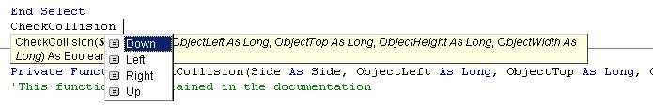
This is just to make things easier.

As for other things you will have to imagine there is a rectangle around the thing you want to check collision for:
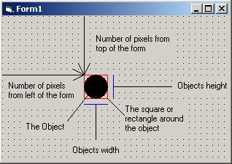
- ObjectLeft – Number of pixels from the leftmost of the form to the top-left point of the rectangle
- ObjectTop - Number of pixels from the topmost of the form to the top-left point of the rectangle
- ObjectHeight – Object height in pixels
- ObjectWidth – Object width in pixels

Important note: Scale mode of the form must be set to “3 – Pixel” if you want your object to return values in pixels!

Once the parameters are passed the function checks the first parameter ‘Side’ and then based on that it does some checking.

0 0 0 1 1 0 0 0 0 0
0 0 0 0 1 0 0 1 0 0
0 0 1 0 0 0 0 1 0 0
0 0 0 0 0 0 0 1 0 0
0 0 0 1 1 0 0 1 0 0
0 0 0 1 0 0 0 0 0 0
0 0 0 0 0 0 0 0 0 0
0 0 0 0 0 1 1 0 0 0
0 0 0 0 0 0 0 0 0 0
0 0 1 0 0 0 0 0 0 0

If you tried to move anywhere now you couldn’t. If you press Up the function would check the second row to find 1’s but only above the rectangle. Because there is one 1, function will return True. Same stuff goes for Down but it takes second row + your object height( lets say your object has 6 in height: 2 + 6 = 8 – it will check row 8 for 1’s ).

How to find 1’s in a row?
Using the InStr(parameters). How does it work? You have to give it 3 parameters: Starting letter( a number), String to be searched and string to find.

InStr(1, “This tutorial suck”, “k”) – It will return a number, in this case 18. 18 is the position of letter “k” in string “This tutorial suck”.

InStr(1, “This tutorial suck”, “y”) – This will return 0 because there is no “y” in the first string.

Also you need to know how Mid(parameters) works:

Mid(String, Start, Lenght)
Mid(“Example text”,5,3) = “ple” – it reads given string starting from letter 5 reading 3 letters to the right.

And now how to check row for 1’s:

If InStr(1, Mid(CollisionArray(ObjectTop - 1), ObjectLeft + 1, ObjectWidth), "1") <> 0 Then CheckCollision = True

The check looks like this:

0 0 0 0 1 0 0 1 0 0

If InStr(1, “0100”, "1") <> 0 Then CheckCollision = True - and it is different than 0 ( its 2 ) so there is collision.

How is it diferrent fo left and right?
- Because you have to check more than 1 array’s value. See here:
CollisionArray(0) = 0
CollisionArray(1) = 0
CollisionArray(2) = 1
CollisionArray(3) = 0
CollisionArray(4) = 0
CollisionArray(5) = 0
CollisionArray(6) = 0
CollisionArray(7) = 0
CollisionArray(8) = 0
CollisionArray(9) = 1
Now you have to check 5 or more arrays. Now we use just Mid and a small loop.

For ArrayPosition = ObjectTop To ObjectTop + ObjectHeight - 1
If Mid(CollisionArray(ArrayPosition), ObjectLeft + ObjectWidth + 1, 1) = 1 Then
CheckCollision = True
GoTo FoundCollision
End If
Next
It will check only one letter of each array being checked and when and if it finds a 1 it will exit the loop and return that there is collision.

How make the array it self?
- It can be done various ways. In my test project I used black pixels as 1’s and all other as 0’s. In my example project I used magenta color as unpassable.

How to get pixel colours?
- Easy. Using FormName.Point or GetPixel API. If you are a begginer it easier to use point, but GetPixel serves its purpose too.

Simple loop that will get pixels from our form:

For a = 0 To Form1.ScaleHeight - 1
For b = 0 To Form1.ScaleWidth - 1

If Form1.Point(b, a) = 0
CollisionArray(a) = CollisionArray(a) & 1
Else
CollisionArray(a) = CollisionArray(a) & 0
End If

Next
Next

This takes a = 0 and b = (1,2,3,4,5,6… ScaleWidth)
Then a = 1 and b = (1,2,3,4,5,6… ScaleWidth)
Then a = 2 and b = (1,2,3,4,5,6… ScaleWidth)
And so on…

Why ScaleHeight – 1?
- Because if your forms height is 100 then, because starting pixel is 0, the last pixel is 99. Same goes for ScaleWidth. Note: Even if your form ScaleMode is “3 – Pixel” if you call form.height you will get twips. You must call form1.ScaleHeight.

This is all so weird. I don’t get a thing!
- Read this tutorial to the end and you just might get it. If not, read it one more time and again, and again untill you get it. Lots of people need to see something to understand (visual impresion is the strongest) so here is the last picture… THE PICTURE OF THE ARRAY!!! MWAHAHAHAHAHA…..

Are you asking your self: “Picture of array? THIS GUY IS NUTS!”
- No my friend. Look. How about after generating the array, you print it to the debug window. How? Ther is a commented line to be uncomented by you:
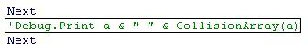

Go ahead, uncoment it. The run the project. If you don’t see the “Immediate” window click view, Immediate window. Now resize the window to be as big as possible. Click on the label to generate collision. And watch the Immediate window fill up with numbers. It looks like this:
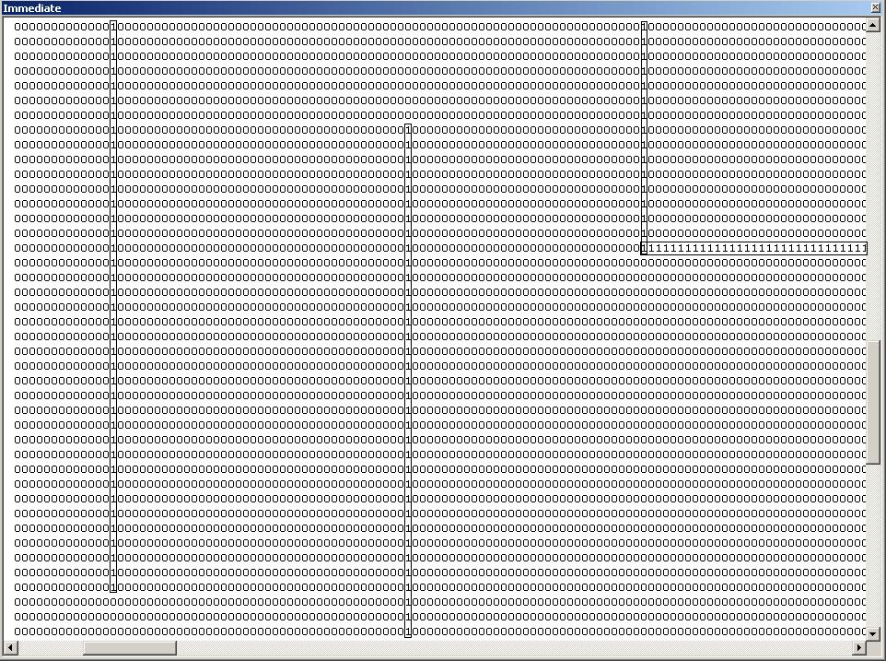

I placed rectangles around 1’s for you to better see them. Now you ask me what is this?
It’s the marked location:
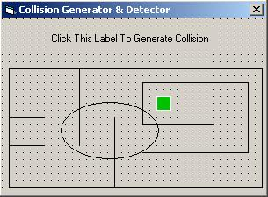 Simple isnt it?

If you draw this on the form:
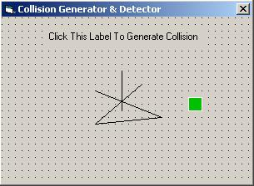 And click generate collision you would get:

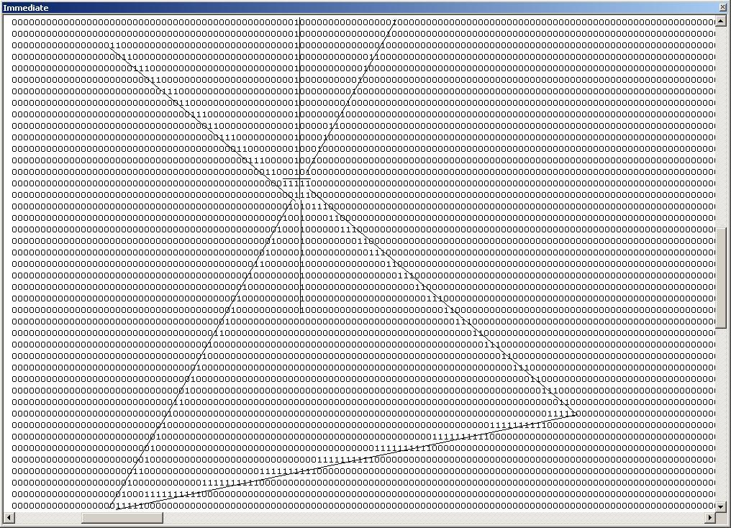

Now you get it? Easy as spelling delimitation backwards.

This tutorial is near at end. One more thing: I have made and example project to show you basic use of my collision detection. Its located in the folder “Example” and the difference from my test project is that main form has a graphics from a game ( Chrono Trigger ), magenta collor is treated as unpassable and there is a loop that hides the lines after collision has been generated.

For and against of my collision:
- Against: I don’t know how much ArrayVariable takes memory. Fix: Use different type of variable( read some of the optimization tutorilas on planet-source-code.com)

- Against: If the graphics is very big (height 5000 pixels, you would need VariableString(5000) which will take much memory. Fix: Also see previous fix and you could change that 1 value doesn’t represent 1 row of pixels. It could be 2,3 or 4 pixels per row, so your variable would be 2,3 or 4 times smaller.

- Against: I cant use anything that doesn’t have thing.Left and thing.Top and thing.Width and thing.Height(This goes for BitBlt-ed sprites)!!! Fix: As for width and height they should be always constant, unless your object is goint to ‘grow’ in the game, and if so just pass the new width and height to the CollisionDetector. As for the Left and Top positions… You could create invisible control, like imagebox, and use it to follow you sprite. When the imagebox collides that means that the sprite collided too, so don’t let him move anymore. There is also some API for creating invisible rectangle so you could use this rectangle to follow your sprite just like the image box. Im sorry I cant tell you more about this, but there is always planet-source-code.com.

- Against: It takes time to generate collisions.
Fix 1.: You could make an editor for your game that would generate collision into a text file. Later in the game, you just ‘feed’ the array from text file.
Fix 2.: If you want to generate ‘collision on the fly’ while the game is running you should make a good use of loading screen ☺. It wont kill anybody to wait a second or two to game to load.

*I would prefer fix method 1 because you don’t have to draw lines on your game and hide them each level. Also encrypt the text file so the user cant mess with it ☺.

- For: Very fast, always require no more than few comparing functions. Very flexible, can be
applied easily and changed to suit your needs.

- For: Collision can be changed fast while the game is running to make some unpassable terrains passable and it works the other way too!

If I used your code in my game do I need to pay you, give you credit or what man?
No, no, nothing like that. You just have to leave a comment on the planet-source-code.com website on the page you downloaded this code from and say “Hey man, I used you code in my game: “ & VariableGameName & “ . Thanks a bunch” or something like that. And one other thing. If you make a game( even a shareware ), I get one registered copy of it ☺. Also don’t forget to vote.

This is the end of my tutorial. I hope you find it helpful. Best regards

Geci Dejan

