Tired of the same old Visual Basic splash screen every time you start up? Wish you could change it, to something better looking? Don’t know how? Now YOU can learn how to create your own visual basic splash screen!

Before we begin, please read the following important disclaimer:

MODIFYING SOFTWARE IS BOTH DANGEROUS AND ILLEGAL. IF YOU DO NOT HAVE PERMISSION FROM THE ORIGINAL OWNER, THEN IT’S A BREACH OF COPYRIGHT. THIS TUTORIAL SHOWS YOU HOW TO CHANGE YOUR EXECUTABLE FOR EDUCATION PURPOSE ONLY. SELLING OF THIS SOFTWARE IS ILLEGAL, AND SHOULD NOT BE DONE. THE WRITER OF THIS TUTORIAL (GRAYDA) WILL TAKE NO RESPONSIBILITY FOR ANY DAMAGE CAUSED TO YOUR COMPUTER, IT’S SOFTWARE OR PERIPHERALS

With that out of the way, you need to get your slimy hands on some “Resource Editing” tools. In this example, we are going to use the following bits of software:

ResHacker: http://rpi.net.au/~ajohnson/resourcehacker
The GIMP-Win32 (Image editor): http://www.gimp.org/
Visual Basic 6.0 Enterprise edition: http://www.microsoft.com

If you don’t want / have The GIMP, Photoshop will be fine, or if you are really desperate, Windows PaintBrush can be used.

STEP ONE: OPENING VB

Once you have downloaded and installed ResHacker, open it. It should look something like this:

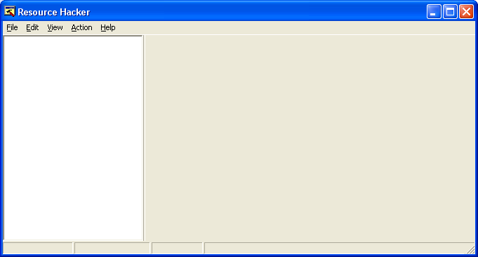

To the left is the list of resources in the program you have open (Resources are things like String Tables in VB, Program / DLL Icons, Cursors, Forms and other stuff like that). To the right is where resources are displayed for looking and editing.

Let’s open Visual Basic. Go to file, Open and browse your way to the visual basic folder (most likely c:\program files\Microsoft Visual Studio\VB98). Your first guess is to open VB6.exe… WRONG! ☺

You need to open Visual Basic’s accompanying DLL file, VB6IDE.dll. Click it and click OK. The ResHack window will change:

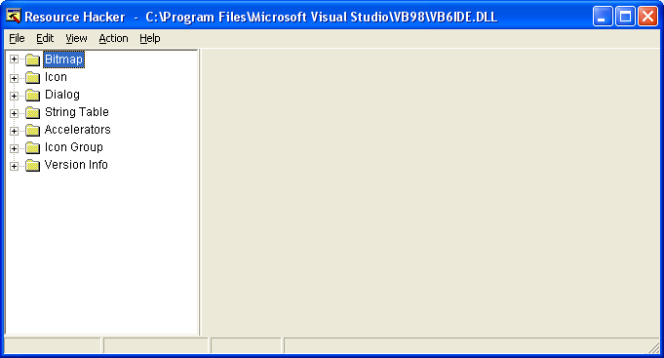
You can check out the other resources later, but for now we are looking for: BITMAP (The top one). Expand it [+]. You should see a whole bunch of numbers:

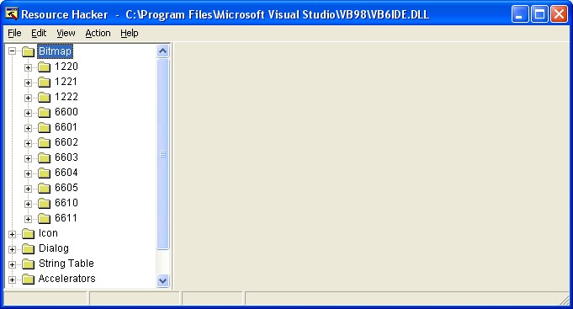

Now comes the tricky part: Working out what resource you need to change. Here is a starter’s guide:

NUMBER: | DESCRIPTION:
1220 | Picture shown when adding custom controls
1221 | Picture shown when adding designers
1222 | Picture shown when adding insertable objects
6600 | 16 Colour Bitmap for VB6.0 Standard Edition
6601 | 16 Colour Bitmap for VB6.0 Professional Edition
6602 | 16 Colour Bitmap for VB6.0 Enterprise Edition
6603 | 256 Colour Bitmap for VB6.0 Standard Edition
6604 | 256 Colour Bitmap for VB6.0 Professional Edition
6605 | 256 Colour Bitmap for VB6.0 Enterprise Edition
6610 | 256 Colour Bitmap shown in About Box
6611 | 16 Colour Bitmap shown in About Box

The 16 Colour bitmap is for when your computer is in Safe Mode, or is in 16 Bit mode. The 256 Colour Bitmap is for use on 32bit colour depth and higher. To ensure you new splash screen shows irregardless of colour depth, make sure you edit both files.

To save your existing splash screen, right click on the resource number (When expanded, and click: Save [ Bitmap xxxx : xxxx ] Where XXXX is your resource folder number and resource. Save it somewhere safe. It’ll be good for nostalgia…

Now comes the fun part! Making your picture!

STEP TWO: PURDY PICTURES

Oh yeah! Let your creative juices flow. Or just scribble some crap. When making your picture, keep the following in mind:

- Your picture size MUST be 431x331, or else VB might crash, the picture might get chopped off, or look ugly. I don’t know, but it will be bad. Apparently the bitmap filter in Paint Shop Pro is messed up, and may re-size 1 or 2 pixels in the opposite direction. You just need to do some PaintBrush tweaking to get it pixel perfect

- Your picture MUST be in 256 colour mode, OR 16 bit colour mode for it to work. 16 bit for Resources 6600 to 6602 and 6611 and 256 bit colour depth for the rest.

- VB Just loves to draw crap all over your pictures, so here is the guide on where not to draw stuff:

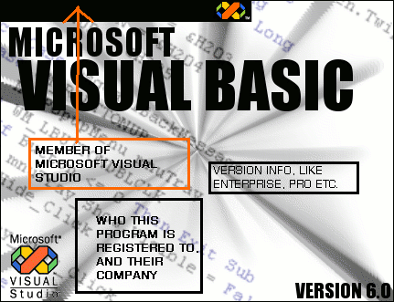

Anything with a box around it, Don’t write any text there, coz VB will type over it with some information stuff.

Also, black is a bad background colour, unless you wish to suppress the text. The Microsoft Visual Studio logo doesn’t appear by it’s self, you have to add it in manually

- When you are ready to save, convert your picture to INDEXED colours. In the GIMP it’s done like this:

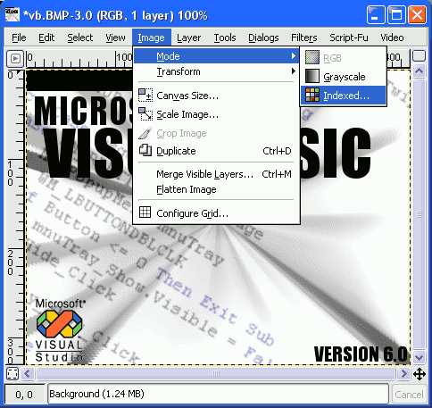

If you are using PaintBrush, go to file, save, then under “Save as type”, set it to 256 Colour Bitmap (*.bmp; *.dib). (or 16 colour bitmap if you are making a low-colour version)

Because I don’t own PaintShop Pro, or PhotoShop, I can’t tell you how to save these files. So scour the help file for “Saving Indexed Images”. If you come across anything that will let you reduce the number of colours to 256, then try that.

If you can’t get your picture to look right, then try the template that comes with this tutorial. It’s called “Splash Template.jpg”, and is in baseline JPEG format. You just need to draw your picture in, then save

Fun’s over folk. Next step, replacing the existing resource with your modified one.

STEP THREE: REPLACING

Switch back to ResHack, and right-click on the resource you want to replace and click “Replace Resource…”:

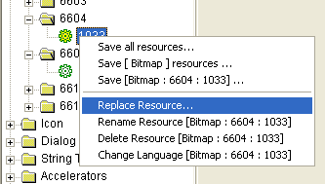

You will now see the following dialog box:

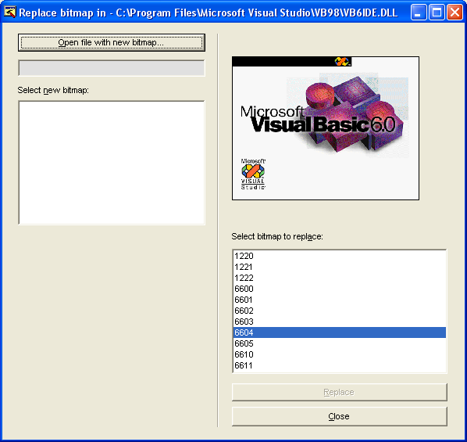

Click the button: Open file with new bitmap and select your new bitmap. Click OK, then click “Replace” at the bottom of the form. Your new bitmap is there, waiting to be saved.

Even though ResHacker has a backup system, make your own backup just in case. I strongly recommend it!!

Click File, Save and then your ready to go! Enjoy your new splash screen, and your new-look VB!

If your feeling adventurous, then why not fiddle with the other resources in the various VB files. Just remember to backup before you save! Have fun!!

If you want to ask questions, e-mail firestorm_visual@hotmail.com or visit the web-site at: www.solidinc.tk

