CONTENTS

Opening/Converting an INI File to XML
Saving the XML File
Viewing the XML File
Deleting a Section
Deleting a Key
Finding the Value of a Key
Creating a New Key/Value pair
Creating a New Section
INI Files Don’t Have Descriptions!!!
Opening/Converting an INI File to XML

Converting an INI file to the XML format used with the XMLConifg class object is as simple as opening any other file used with any application. Click the File menu item, then click on Open and select the INI file in the Open dialog box as shown below.

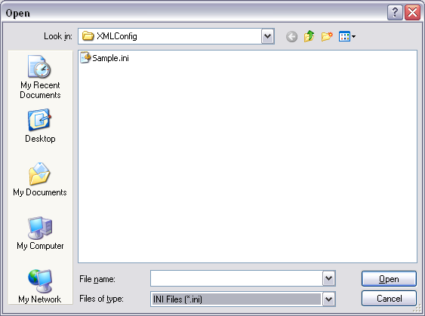

When you select the file and click the Open button, the file will automatically be converted to the correct XML format. The new file will have the same filename as the old INI file but with a .xml extension. For example, sample.ini becomes sample.ini.xml. Notice that the .ini remains in the filename, this is done so that you are able to distinguish that the file was originally an INI type file. You can change this however by using the Save As feature of this utility.

To create a new INI style XML file that follows the format required by XMLConfig class object you can simply use the text boxes on the right hand side of the form to start entering section names, descriptions, keys, and values. The first time you try to write a value to a file, you will be prompted to supply a filename with a Save As dialog box.
Saving the XML File

Saving the XML file is simple and for the most part is transparent to the user/developer. You simply open an INI or XML file and start writing values or deleting keys and sections. The updates to the file occur immediately.

You can use this utility to create new INI style XML files by simply opening the application and entering values as desired. The first time you attempt to write a value you will be prompted for the Filename with a Save As dialog box.
Viewing the XML file

Viewing the XML file is simple; you can either use the File/View XML menu option or click the View XML button on the right hand side of the form.

The result of doing this is to open the XML file in the default web browser that you as the user have defined for your computer. An example is shown below.

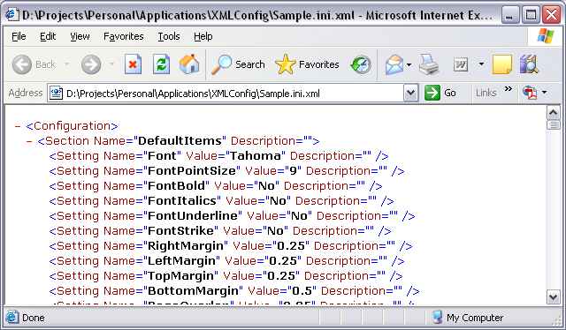

You can also choose to open the XML file in any text editor, such as Notepad. But be forewarned that the result is less than desirable since it is not formatted in any way, and the result appears similar to what is shown below.

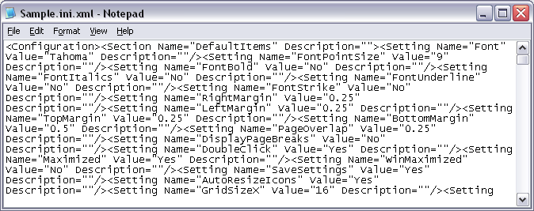

You can choose to place carriage returns and tabs as appropriate, but there is no difference to the XMLConfig class object.
Deleting a Section

Deleting a section is simple. You simply select a Key or Section in the Tree View control and click the Delete Section button. You will be prompted to make sure the Delete action is what you really wish to do. When you select Yes from the Message box, the entire Section and its contents will be deleted from the XML file.

Note; this is a destructive delete and there is no way to perform an Undo.
Deleting a Key

Deleting a Key is simple. You simply select the Key you wish to delete in the Tree View control and click the Delete Key button. You will be prompted to make sure the Delete action is what you really want to do. When you select Yes from the Message box the Key and its Attributes will be deleted from the XML file.

Note: this is a destructive delete and there is no way to perform an Undo.
Finding the Value of a Key

To find the value of a specific Key you simply select the Key in the Tree View control. The Text boxes on the right side of the form will be populated with the contents that are contained in the XML file and will look something similar to the following.

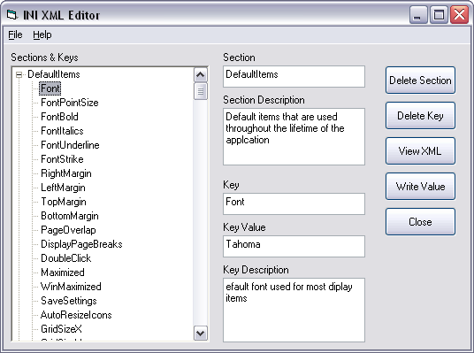

Creating a New Key/Value pair

Creating a new Key/Value pair is very simple. Select the Section or a Key within the section that you want to add a Key/Value pair to and then use the text boxes on the right side of the form to enter the new Key and its Value and any description that you may wish to provide. When you are satisfied with your new entry, click the Write Value button. The new Key and its value will be created for you automatically.
Creating a New Section

Creating a new Section is as simple as creating a new Key/Value pair within a Section. Simply use the text boxes on the right to supply a new Section name and description as you wish, you must then provide a Key/Value pair for at least one Key within the Section. You would then click the Write Value button and the Section and Key will be created for you automatically.
INI Files Don’t Have Descriptions!!!

While it’s true that INI files don’t have descriptions, you can place comments within an INI file to document what a Section and/or Key are used for within an application. The Description field provided by the XMLConfig class object provides the same purpose,

While it’s true that a comment can be added to an XML file for documentation purposes, the Description attribute of a Section or Key should be used for this purpose.

If a comment is added to the XML file manually or programmatically, the XMLConfig class will simply ignore it when performing various tasks. The INI XML Editor utility assumes that the Description attribute is used for commenting what a Section/Key is used for. For these reasons you should use the Description attribute for its intended purpose.

