Table Of Contents
- – Introduction
- – Starting Off
  - – Why Visual Basic?
  - – You Should Know…
2.3 – Ready, Set, Go!
- – Making your first app
  - – User Interface
  - – Good Code
  - – Start Your App
- – Error Handling
  - – About Error Handling
  - – An Error Handling App
- – Tips and Tricks
  - – Modules
  - – Loops
  - – Timers
  - – More Tips and Tricks
- – Finishing Notes
6.1 – Data Types

THINGS TO LOOK FOR

- – Introduction

Programming can be very difficult, especially when you’re a beginner. That’s why I created this tutorial. It is meant to help you to program great applications with the best code, best user interface, and most reliability, in the shortest time.

••••••••••••••••••••••••••••••••••••••••••••••••••••••••••••••••••

- – Starting Off

Before you start, you should know about some things… here they are.

2.1– Why Visual Basic?

Why should you use Visual Basic to develop your applications? Well, for one, it’s easy. Visual Basic is a good starting language for new programmers. It’s fairly simple to understand (much more easy than languages like C/C++), but also powerful, fast (in most cases), and file size of your application is usually smaller than with some other languages. But that’s just a few reasons why to use Visual Basic. Many programmers who could do C/C++ prefer Visual Basic, for a number of reasons. Each different language has it’s own pros and cons.

2.2-You Should Know

If you’re going to use Visual Basic, there are some things you should know first. First of all, Visual Basic isn’t a very good language to develop 3D games like Quake or 4x4 Evolution in because it simply isn’t fast enough. However, 3D games CAN BE DONE, except it is extremely difficult. For some examples, visit VBGames.co.uk and truevision3dsdk.com. Also, you should remember not to get frustrated. There is always help somewhere, it’s just a matter of finding it. Some great sites you should visit are Planet Source Code and VBWeb. As a third note, you should know that sometimes, the hardest part of programming is finding an idea.

2.3-Ready, Set, Go!

Now that you’re ready, let’s get started on your first application!

••••••••••••••••••••••••••••••••••••••••••••••••••••••••••••••••••

3.0-Making Your First App

We’ll now start work on your first Visual Basic application. Just follow the directions, and have fun!

3.1-User Interface
A big part of creating applications is user interface. It should look fairly nice, and should be easy to understand. Here’s an example of what NOT to do.

Figure 1 – A poorly designed UI
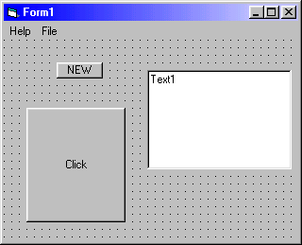

Now, let’s look at what’s wrong with this. There are some obvious problems, and some more concealed ones. First of all, one button is MUCH too big. It takes up way more space than it requires and it look ugly. Second of all, another one is too small. Buttons should be a good size between 1095 X 375 and 1215 X 495 in Twip scale mode. Second off all, the form is poorly designed overall. It should be in a more organized fashion, with the buttons in once place and the text box in another. A third problem on this form is that in the menu, Help comes before File. If you look at any windows app, you’ll notice that Help usually comes last, and NEVER before File, which is usually first. A good user interface would look something like this.

Figure 2 – A well designed UI
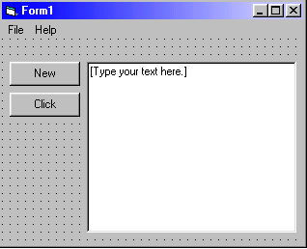

The difference is pretty obvious. The form is organized, the buttons are a nice size, and File comes first. Which program would you rather use?

3.2 – Good Code

Code should be well designed, too. There are good and bad ways to do things, and using different ones can make your program run better or worse. But, one thing that code should be is organized, like forms. This makes it easier to read. Here is an example of some good code.

Figure 3 – Organized Code
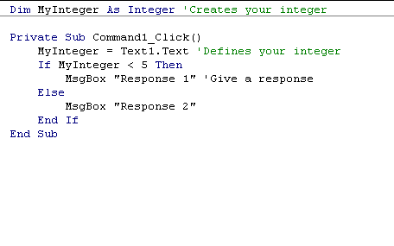

Another good thing to put in code are comments. Comments can be used to remind you of what your code does, or to show copyrights if you are distributing open-source apps. The red, circled area in figure 4 is a comment.

Figure 4 – Commented Code
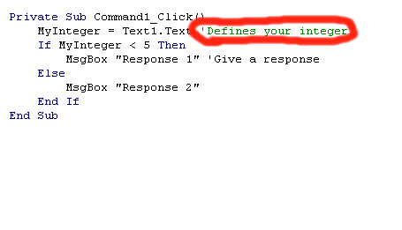
To insert a comment, just press ‘ before you type and everything that follows the ‘ on that line is a comment, and will appear in green. Now, I’ll get started teaching you how to make your first app before you stop reading.

3.3 – Start Your App

To start off, we’re going to make a simple app with a list where items can be removed and added to the list. To start the app, we need to design the interface. It will need two (2) command buttons, cmdAdd and cmdRemove, a ListBox, lstItems, and a TextBox, txtAdd. It should look something like this:

Figure 5 – The Interface for your first app
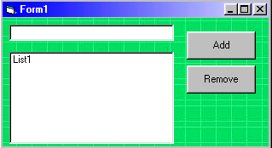

NOTE-
I’ve used a background picture for this app. As you can see, using a background picture can make your app look more attractive. To set a background picture for your app, click on the form, then find “Picture” in the properties window.

Now, we need the code. Copy and paste this code, and then try the program.

Private Sub cmdAdd_Click()
If txtAdd.Text = "" Then
MsgBox "Please type the item to add in the textbox!"
Else
With lstItems
.AddItem txtAdd.Text
End With
End If
End Sub

Private Sub cmdRemove_Click()
If lstItems.ListIndex = -1 Then
MsgBox "Please select an item from the list!"
Else
lstItems.RemoveItem lstItems.ListIndex
End If
End Sub

The program should now work if the code was copied correctly and all components are named correctly. Now, let’s analyze the code. Lines 1 through 9 tell the program what to do if a user clicks the Add button. You’ll notice we use the if statement. Using the if statement allows us to determine between two possibilities and allow a different outcome for each one.. In this case, if the user didn’t enter anything in the text box, the program generates an error message because there is nothing in the textbox. We don’t want a list item with no value, so instead of putting that item in, we stop and tell the user to enter something in the textbox. If there is something in the textbox, it is added to the list. The with statement is used here. Using the with statement, you can change a components properties without having to put it’s name a hundred times. Here’s an example. If I don’t use the with statement, I’d have to write my code like this…

Private Sub cmdButton_Click()
cmdButton.Caption = “Hello”
cmdButton.Width = 1332
cmdButton.Height = 355
End Sub

However, if I use the with statement, my code could be like this…

Private Sub cmdButton_Click()
With cmdButton
.Caption = “Hello”
.Width = 1332
.Height = 355
End With
End Sub

See the difference?

Now, back to our app. In lines 11 through 17, we tell the program what to do if the Remove button is clicked. We use if again here. This time we use it to make sure that an item to be removed from the list is selected. If there is no item selected, then the program will generate an error. That is why we have the if statement to make sure an item is selected. Otherwise, we tell the user to select an item. This is called error handling, which we will learn about in the next ‘ chapter’. Error handling is important, because without it, the program will crash!

••••••••••••••••••••••••••••••••••••••••••••••••••••••••••••••••••

- - Error Handling

As I said in the last chapter, error handling is extremely important, because without it, applications often crash. In this chapter we will learn how to use error handling.

4.1 – About Error Handling

There are two methods of error handling… one way is to figure out the problem and make sure it CAN’T happen. The other is to make sure that the application doesn’t crash if there is a problem. If you know what causes the problem, you can do something like putting an if statement to make sure the user fills out a textbox, like in the last chapter. If you don’t know what the problem is or can’t stop it from happening, you can use the statement On Error Resume Next. This way you can either make the program cancel the operation so that the error doesn’t occur.

Private Sub cmdDo_Click()
On Error GoTo Uhoh
MsgBox “Done”
Uhoh:
MsgBox “There was an error”
End Sub

That way, if there is an error, it generates a message box that says “There was an error”. Otherwise, it generates a message box reading “Done”. And that’s what error handling is all about! This way, the app won’t crash when there is an error!

4.2 – An Error Handling App

Now we’ll make our first error handling application. First, start a new Visual Basic project. Add a DriveListBox called Drive1 and a DirListBox called Dir1. It should look something like this.

Figure 6 – The Error Handling App Interface
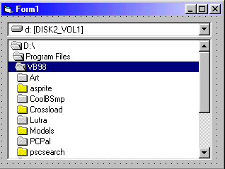

First we’re going to see what happens WITHOUT error handling. Add this code to your app.

Private Sub Drive1_Change()
Dir1.Path = Drive1.Drive
End Sub

Now test the app. Press [F5] to run, then make sure there is NO disk in your A drive, then select A: from the DriveListBox. Now, you should get an error. There is no disk in A: so the program cannot complete its function. The DirListBox can’t read from A: because it doesn’t exist to the DirListBox. Now, let’s try the app with error handling. Erase your current code and try this.

Private Sub Drive1_Change()
On Error Resume Next
Dir1.Path = Drive1.Drive
End Sub

Now, instead of generating an error, the program just doesn’t go to that drive instead! However, this isn’t the best way to do error handling. The user thinks that something is screwed up, because the program is not responding to them. So, you should NOT use that method of error handling. Here’s a better method.

Private Sub Drive1_Change()
On Error GoTo Error
Dir1.Path = Drive1.Drive
Exit Sub
Error:
MsgBox “That drive is not available.”
End Sub

Using that code, the program will show a message box which says “That drive is not available.” Instead of just doing nothing. So, this method of error handling works much better!

••••••••••••••••••••••••••••••••••••••••••••••••••••••••••••••••••

- – Tips and Tricks

Now that you’re familiar with the basics of creating a good app, I’m going to finish off by teaching you some good tips and tricks to develop your app.

5.1 – Modules

Modules are extremely useful while developing. They can be used so that you can organize your code better, and they are also a great place for Public subs. Public subs are extremely useful, because they allow you to save space and time. If I wanted to make an app that saved files, I would have to write the code over and over again if things could be saved on different forms, unless I used a public sub. This is how it would be used. I’d put this code in my module.

Sub SaveIt()
Open “C:\Test.txt” For Output As #1
Print #1, Text1.Text
Close #1
End Sub

Then, to save on my forms, I would just go like this…

Private Sub cmdSave_Click()
SaveIt
End Sub

Not only is it useful, but it’s extremely simple!

5.2 – Loops

Loops have many good uses. They tell the program to repeat an action until a specified event. For example, say I had a class module which allowed me to get the total number of tracks on a CD, but I wanted to list the numbers 1 to the total number of tracks in a listbox. To do this, I could use a loop. It might look something like this.

Dim Snd As CDAudio ‘The module is called CDAudio

Private Sub Form_Load()
Set Snd As New CDAudio
Dim CurTrak As Integer
CurTrak = 1
Do Until CurTrak = Snd.GetNumTracks ‘This is the loop
List1.AddItem CurTrack
Loop
End Sub

Now the list box will list 1 to the total number of tracks! This function may be useful if you’re ever making a CD player. However, if you try to use this code now, it won’t work for you, because you don’t have the CDAudio module.

NOTE-
To use a loop, you must use the Do statement. A loop must look something like…

Do Until End
MsgBox “Stuff”
Loop

Or

Do While Not End
MsgBox “Stuff”
Loop

5.3 – Timers

Timers are useful for repeating something over and over after a certain amount of time. Using a timer, you could make a message box appear every 5 seconds if the timer’s interval was set to 5000, like this:

Private Sub Timer1_Timer()
MsgBox “It’s been 5 seconds!”
End Sub

A timer is like a loop, except a loop is done at the speed at which a computer can calculate, which is about .00000000000000000001 of a second (I don’t actually know, but it’s something like that). With a timer, it is done not as often.

5.4 – More Tips and Tricks

A few last tips and tricks. First, I’ll teach you about the left and top values. The left value is how far from the left side of the form a component is. The top value is how far down from the top it is. It’s illustrated in the diagram below.

Figure 7 – The Left And Top Values
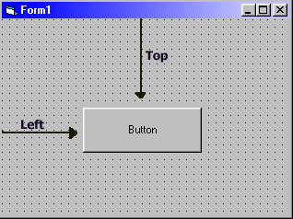

You can move an object using the left and top values. For example, try this code:

cmdButton.Top = cmdButton.Top – 50

The command button will move 50 towards the top. The “50” can be a big or small distance, depending on your scale mode.

The next tip I’d like to show you is saving a file. It’s extremely simple if you know how. Just use the Open function, and the Print function. Use it like this:

Open “C:\test.txt” For Output As #1
Print #1, “Hello”
Close #1

That opens C:\test.txt and makes it say hello. You can also use the Write function. Using Open For Output overwrites the whole file, but if you just want to add to the file, you can Open For Append like this…

Open “C:\test.txt” For Append As #1
Print #1, “Hello”
Close #1

Using those tricks should help you!

••••••••••••••••••••••••••••••••••••••••••••••••••••••••••••••••••

- – Finishing Notes

I’ve just got one thing left that I’d like to explain…

6.1 – Data Types

If you know the different data types, it can be very useful for you. I’m going to explain some of them here. These are just the ones you’ll likely be using most often.

Boolean

To use a Boolean, you would use this syntax.

Dim NameGoesHere As Boolean

That creates a Boolean, called NameGoesHere (Replace NameGoesHere with your own boolean name.) A Boolean can only be true or false. One way to use a Boolean would be in a loop, like this.

NameGoesHere = True

Private Sub Command1_Click()
Do Until NameGoesHere = False
MsgBox “BLAH”
Loop

This makes a loop that continues until the Boolean NameGoesHere is set to false.

Integer

An integer is a 2 byte data type that stores a number from -32,768 to 32,767. However, integer can’t handle decimals, so if you wrote code like this…

Private Sub Command1_Click()
Dim Temp As Integer
Temp = 143.272
MsgBox Temp
End Sub

Your message box would say 143.

Long

A Long (Long Integer) is basically the same as an integer, except it has a bigger range of what it’s able to hold. A Long can store from –2,147,483,648 to –2,147,483,647. The syntax of a long looks like this.

Dim l1 As Long

That gives you a long, then you set it’s value just like an integer.

L1 = 3336921

Double

A double (double precision floating point) can store decimals. I’m not exactly sure how much it can data it can store, but it’s a lot. There is also a Single data type, but I think double is used more often. A double’s syntax is basically the same as a longs or an integers.

Dim D1 As Double

And, to define it…

D1 = 1.23

String

A string is designed to store ASCII text. For example, a string would be used to store something like “Hello!”. A strings syntax is like this…

Dim S1 As String

Defining a string is a bit different. It looks like this.

S1 = “Hi.”

Notice the difference? It’s the “ and ” - a string must have open and close quotations, unlike a double, long, or integer. By the way, a string can store from 1 to approximately 65,400 characters.

••••••••••••••••••••••••••••••••••••••••••••••••••••••••••••••••••

That’s all for this tutorial!

••••••••••••••••••••••••••••••••••••••••••••••••••••••••••••••••••

Written by wipeout
E-Mail wipeoutgc@hotmail.com
Copyright © 2001

••••••••••••••••••••••••••••••••••••••••••••••••••••••••••••••••••

