Student Information and Evaluation System (HX SIES)
(School’s Management Information System)
SERVER Manual

Preface

Student Information and Evaluation System (SIES) is a basic School’s MIS. The application deals with student personal information, college records, such as their subjects and their grades, summary reports for enrollees, curricula, course and management of the said records. This application is based on schools basic Student Information and Record Keeping and tracking (Cagayan State University at Sanchez Mira). The SIES being developed will not aim to totally automate the whole system, but with the aim to automate as it progresses in its development.

The developers makes use of staggered development in implementing the system to easily track down bugs, faults and to easily incorporate needed modules to make the system holistic.

The developers do not intend to make this system be a common basis for MIS application but aims to serve as a proto type for building an MIS starting on this application.

The SIES consists of 5 different modules: Student Personal Information (SPI), Student College Record (SCR), Curricula, Student Evaluation System (SE) and Reports Module. The SPI deals with Students Personal Data (e.g. Personal Data Sheet). It keeps track on student information to be kept and will be easily retrieved when needed. Curricula also, keep the curriculum information for a certain school year. SE, is a basic enrollment procedure for every school. Students are first evaluated for their subjects before they can enroll. The role of this SE is to reduce the time for Evaluation by easily comparing Student’s college record to the curriculum where they belong. This will facilitate a better and more efficient Enrollment procedure. Lastly, the Reports module deals with summary reports (based on reports of Cagayan State University at Sanchez) on enrollees for the whole department, for each course and year level.

With this, the following topics will guide users in using the SEIS.

Thank you for using HX SEIS version 1.0

Developers

Introduction

Record keeping and management is one of the critical operations of every company. Records being kept and manage affects decisions performed, analysis, solution extraction and proper implementations of new rules and guidelines. Record keeping and managing, especially when dealing with large data, is not an easy task. It would require well-versed personnel to do the required work and optimize its performance. Good example of a company, which deals with large data, is a school. School manages student records from their entrance until they exit the school, and of course, maintains them through out. They handle different curricula, subjects, faculty and staff and personnel records and manage them all to form a fully organized and working system.

A manual school system is a laborious task. It requires more time for processing and the mere fact that it is slow, affecting work efficiency; another drawback would be its accuracy in processing. The introduction of Information and Communication Technology (ITC) in business made a significant improvement in handling this type of problems. In this case, it will eliminate some or most of the difficult task, minimizing them in to smaller manageable problems to solve. ITC has greatly improved work efficiency, accuracy and management of operations. The fast phase of this technology has lead in to a better (lazy people) performance of all business operations.

But handling these tasks is not an easy work. One way to deal with this problem is to break them into pieces and work for individual function, and then integrate them as one fully functional system. In this manner, we can easily track down or even optimize and eliminate all business constraint affecting the manual system operation.

In this case we take Cagayan State University at Sanchez Mira College of Arts and Sciences (CAS) department to start this operation. CAS Department handles 3 different courses, the BSIT, AB English and BS Math courses. Each has their own curricula to maintain. The following context will explain and will try to provide solution to speed up and increase efficiency in student record management in the said department.

Objectives

- Speed up transactions on the Department (CAS).
- Eliminate to a minimum value all the problems encountered.
- Provide a better record management
- Better record retrieval
- Provide efficient evaluation of student
- Create reports for the department

Scope and Limitations

The said project is not as ambitious as it is. It will only try to eliminate some difficulties of the existing system. Basically it will not touch faculty records, schedules. It will mainly focus on Student Personal Information, Student Collegiate Record Maintenance, Evaluation, Curricula storage and management and Departmental Reports.

The application is a client server application. This means that it needs a Server to work. The server is where the database is stored. Clients are use to connect to this server.

But the developers will tend to integrate scopes upon request. But for now, it would be limited within this scope of operation.

System Requirements

The SEIS requires the following:

Hardware:
(Client)
Monitor with screen resolution of 1024x728
Compatible Mouse and keyboard
Any Processor with a speed of 1.5Ghz or higher recommended
128mb of RAM
Video card with memory of 32mb or higher recommended
Network Interface card
Uninterrupted Power Supply

(Server)
Monitor with screen resolution of 1024x728
Compatible Mouse and keyboard
Any Processor with a speed of 1.5Ghz or higher recommended (Dual Processor Recommended)
128mb of RAM (512 recommended)
Video card with memory of 32mb or higher recommended
Network Interface card
Uninterrupted Power Supply

Peripherals:
Network Cables
Switch/Hub
RAID Devices
CD-ROM

Software:
(Client)
Any Windows Operating System (Win 2000,XP Professional Recommended)
SQL Server Version 7.0 (Standard Edition)
Internet Explorer 5.1 or higher (Any web browser)
Microsoft Windows Common Controls must be installed
Microsoft Office (Any)

(Server and Back Unit)
Any Microsoft Windows Server Operating System (Advanced Server 2000 recommended)
SQL Server Version 7.0 (Standard Edition) or higher
Internet Explorer 5.1 or higher (Any web browser)
Microsoft Windows Common Controls must be installed
Microsoft Office (Any)
Microsoft Visual Studio 6.0 (Enterprise Recommended)
Network Utility Program
Back up utility program

System Overview

Due to some circumstances, the developers of this system choose incremental development model. This software engineering model enables them to integrate modifications, check and implement bugs in the system. This will also allow them to easily monitor user requests for full system performance.

In concept, the system runs on a network based/managed organization. It requires a server to store the records, a back up server incase the server goes down, and client hosts, who will serve as access end points for the server. The server holds the key for the system access. It makes use of SQL Server authentication/User logins. A client/User can access the system as long as the System Administrator grants access to his account, or has given an account. The server of course, has full access to the entire database. The set up for a network based system allows user to access the system any where as long as the computer is connected in their network group.

Development interface used is Microsoft’s Visual Basic 6.0. The choice is based on VB6s Rapid Application Development Technique and of course, it was the first choice of the developers. Choice is also influenced by the fact that VB6 database flexibility would be a plus factor on its network operation.

The following data describes the table definition of the SEIS:

Tables

Courses
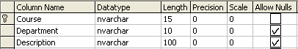

Curriculum
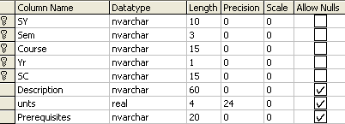

Names
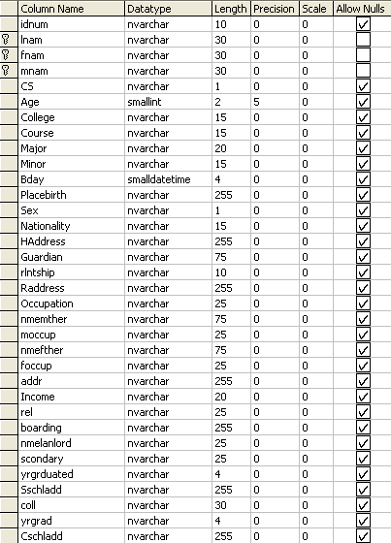

Relationships
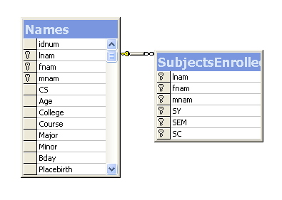
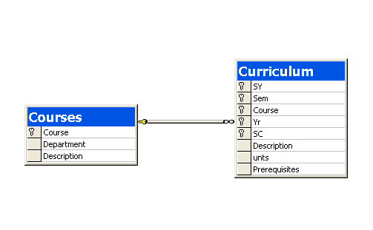

Since the Development model used is Incremental, any modifications in the system are very easy and flexible to handle. Client updates are to be run by the server.

User Interface
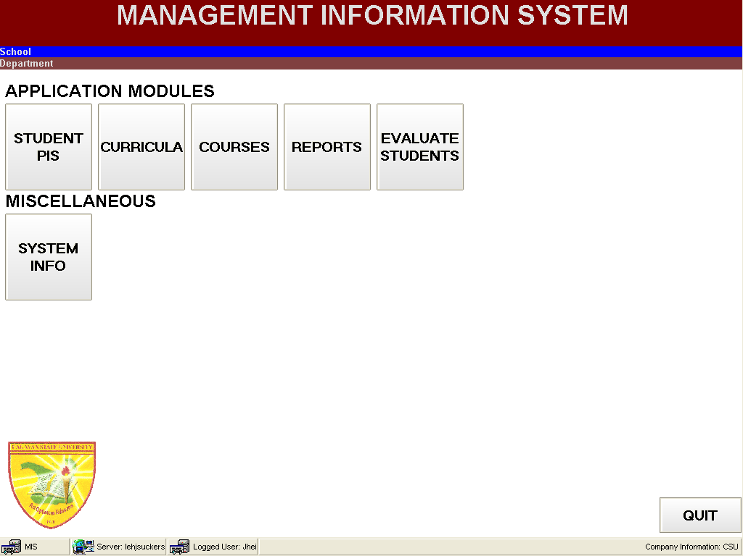
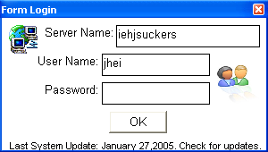
Log in Form. You must supply a server name (The name of your server), a user name and the password assigned to you by your System Administrator.
MAIN FORM. A successful log in will enable you to access the main form.
SPI, SCR, SES Module. This button lets you access the SPI,SES and SCR. When you are logged, you can access this, depending on your rights in the server.
Curricula Module. This button lets you access the Curricula. When you are logged, you can access this, depending on your rights in the server.
Reports Module. This button lets you create reports. When you are logged, you can access this, depending on your rights in the server.
Exit the System

Evaluation Module. This module is moved on the SPIS (implemented)

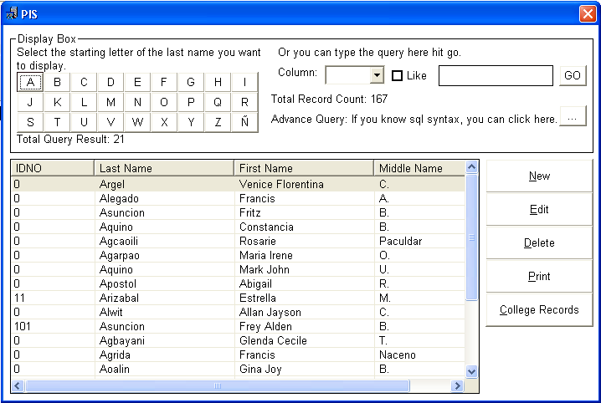
PIS Selection Bar. You can click the starting letter of the last name of the student you want to view.
PIS Selection Bar Advance. Select the field you want to use and write your query and click go to customize your record display.
New Record
Edit Active Record
Delete Active Record
Print Active Record
View College Record of the Active Student

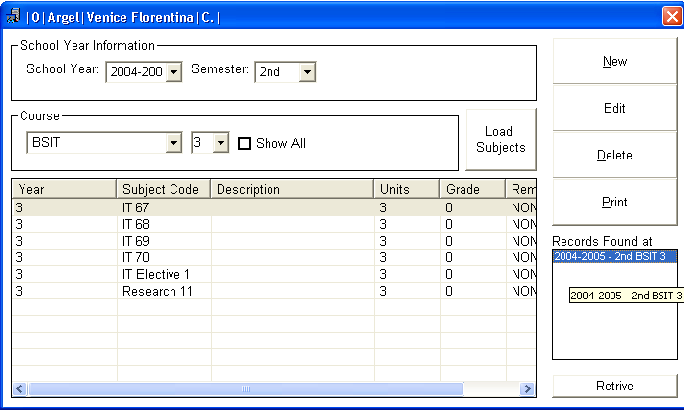
Set SY and Sem

Set Course and year to display and Click here

View all in summary Student Record (Active only)

A more detailed UI is in the client manual, since this is a server manual, we won’t discuss that here.

Assigning of user names and password is done in the SQL SERVER. Administrator must set the Accounts, their rights on the database to use. The system is using a database with a name CSUMIS. Please create this database and then import the tables in the folder dba. These tables are the main tables in used in the system.

Accounts must be assigned on each user, we recommend that the administrator must set rights on selecting, adding, deleting and updating records. The SQL Server will have to take care of the security of data, backing up and of course restoration. The system it self imposes its own security measures but of course, it do depends on the SQL Server settings.

For more detail information, mail us at iehjsucker@yahool.com, iehjhsucker@hotmail.com.

Snail mail me at #124 National Hi-way, Bagumbayan, Lal-lo, Cagayan, Philippines 3509 (I do appreciate snail mails than emails).
HX Tech® Building Outstanding Technology
Iehjsuckers Sucks!
2005

