How to use the VB Resource Feature to store OCX Files for distribution

STEP 1: Go to Add-Ins and Select Add-In Manager
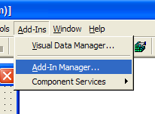

Most VB programmers haven’t realized the POWER of this.
We can STORE STUFF in the EXE Easily!

STEP 2: Turn on the VB 6 Resource Editor

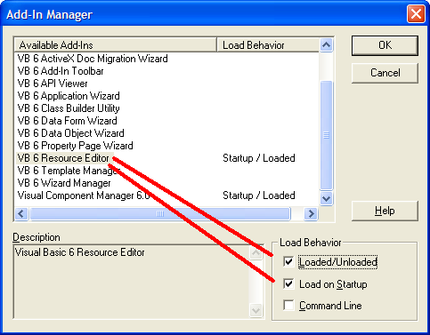

STEP 3: Open the Resource Editor and Add a CUSTOM Resource
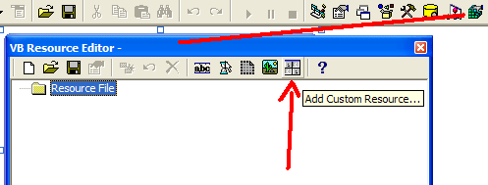
STEP 4 : Add the OCX File for Installation within the “Splash Screen”.

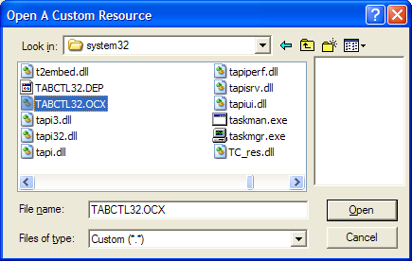

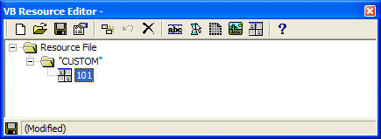

STEP 5: SAVE (Yes, press the “Floppy Disk”)

Suggest you save it in the same place as your project.

STEP 6 : Here’s the SIMPLE CODE to EXTRACT that OCX

Private Sub InstallTabCTL32_OCX()
On Error Resume Next
MKDir “c:\Program Files\”
MKDir “c:\Program Files\MyAppFolder\”
On Error GoTo 0
Dim bytResourceData() As Byte
bytResourceData = LoadResData(101, "CUSTOM")
Open "c:\Program Files\MyApp\TABCTL32.OCX" For Binary Shared As #1
Put #1, 1, bytResourceData
Close
End Sub
STEP 7: Really Simple – Review my SETUP OCX IN SPLASH SCREEN and modify!

This is the easiest and coolest way to avoid setup problems with users executing from within a ZIP file.

And it’s even cooler because it uses that BUILT-IN VB TOOL for Resource Files!

Cheers,
Kevin (Kevin@V8Software.com)

