If you are concerned about keystroke theft when you are entering UserId/Passwords while online to the Internet, then maybe this program is for you. Or you would like to have many different and unusual Ids/Passwords but don’t want the trouble of remembering the many codes, then maybe this program is for you.

The program uses a password protected Access database to store User Id’s and Passwords and a Visual Basic 6.0 program to display the data so that by clicking an entry you will be provided with either the User Id or Password passed to the clipboard. You then can position the cursor where desired and the requested data will be down loaded. No keystrokes are used and the data never appears unless it is dumped to a non-protected field. If the field is protected then the answer is not displayed. You don’t have to remember the various Id’s or Passwords that you have assigned to various sites. Data other than ID’s or Passwords may also be stored in these fields.

When the program is executed a small screen is placed in the upper right hand corner and will remain “On Top” until the program is stopped or another “On Top” program is executed. This screen may be moved as desired to facillate reading under it’s location. No reference to the actual ID’s or Passwords is shown on the screen unless the user so desires. Even the title in the Form line has a non-meaning as to the programs purpose. Any nonchalant user clicking on any of the items will not see any result unless they should “paste” on another screen.

You can test the system by executing the program “ListIt”(either from the source code or an execute program(you can create))and at the same time execute the VB test program “TestOutput”. Then select an entry from the table and place it in the TestOutput Screen.

Sample screen Test Output program
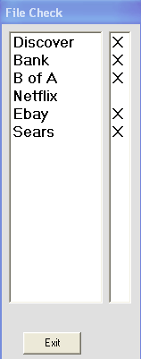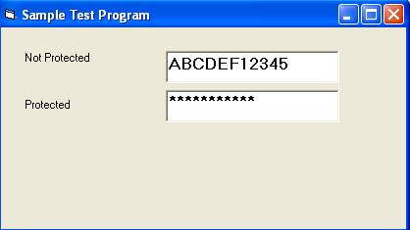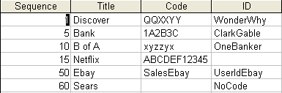
Database Contents
- “Netflix” is selected from the “Sample Screen”. The “Code” “ABCDEF12345” is placed into the Clipboard from the Database for “Netflix”.
- First the Clipboard entry “ABCDEF12345” is placed into “Not Protected” text box in the Text Output Program using Paste (control V).

- The same “ABCDEF12345” in the Clipboard is placed into “Protected” text box in the Text Output Program using Paste (control V). However because this output text box has the Password Character is set to “*” each of the entry is coded with asterisks.

- It is not necessary to place the output Clipboard into several output text boxes but is shown here only for an example of how to use the system.

Other items of interest:
- Password for the sample database is “TestPass”.
- Be sure to include the reference “Microsoft (DAO) 3.6 Object Library”.
- The “X” in the far left column indicates the item has an entry in the ID field.
- If you click on either column and the item has no entry (blank) the program will provide a message indicating that no data is available.
- The coding for “making a form always on top” and “Opening a database” were provided by Microsoft.
- The Program and the Database must be located in the same directory.
- The Database Name and the Database Password are parameters set up in the Form_Load routine.

