G r a d i n g S y s t e m

Design and code by Nader Chehab

I. College Project Requirements

Due date: December 2, 2002
Evaluation: 35%

Scenario

You have been assigned the job of writing an application called Grading System using Visual Basic and Access to help the instructors of the Computer Science Department or LaSalle College determine the student’s course evaluations.

Following are the business rules:

- Each instructor can teach more than one course and each course can be taught by more than one instructor.
- Each instructor has his/her own evaluation chart for a given course; that is, the same course may be evaluated in two different marking schemes.
- Instructors can enter/update/delete student information for the courses they are teaching. For simplicity, student information includes only Student Number (7-digit number), First Name and Last Name.
- By means of the application, each instructor can Mark/Edit students’ absences. The number of absences will be taken into account in calculating the final mark for a given course. (Refer to the Agenda)
- Instructors can list all the courses they are teaching.
- Each instructor can View/Print
- The Final Marks List for a given course he/she has taught.
- The Absence List for a given course he/she is teaching.
- For each course, instructors can Enter/Update/Delete/Search students’ grades information (e.g. assignments, labs, projects, mid-term exams, final exams).
- To use the system, each instructor is required to enter username and password (created by the Administrator) and he/she is allowed to access only his/her courses and change username and password if needed.
- Any student who shows an unacceptable absence rate, according to LaSalle College attendance policy, will be given a maximum mark of 56%.

II. Overview

The Grading System has been designed to help maintain and organize a secure and dynamic database in any educational institution.

The database is managed to hold all student, teacher, course and grade information that are used thought the year.
The system is maintained by two kinds of users:

The Administrator and the Teachers.

Here’s a brief list of the Administrator’s main tasks:

- Create the Database (dynamically, from the application)
- Add, Modify or Delete Teacher records
- Add, Modify or Delete Course records
- Assign Courses to each Teacher.
- Add, Modify or Delete Student records
- Register Students to Courses.

And a list of each Teacher’s task:

- Specify his/her own marking scheme for each course taught.
(i.e. how many tests does every course include, how much is every test worth, what is the maximum absence rate etc.)
- Fill in the students’ grades for every course taught.
- View/Print an Excel spreadsheet of grades for a given course.

We notice that the teachers’ tasks are limited to the strict minimum.
Most of the work is done by the administrator, to enhance the security and stability of the system.

II. Using the System

Here’s an illustrated explanation on how to use this system.

- Step 1
First, the Administrator must add all the Teachers, Courses and Students to the database. These records can be updated anytime later.
At this point there is not relation between these 3 entities.

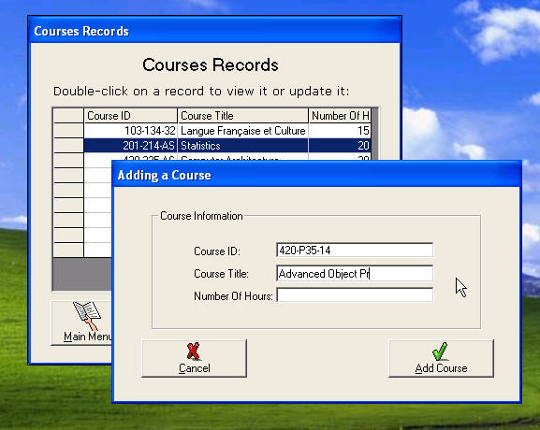
Figure 1: Adding a course

- Step 2
The Administrator must assign one or more course for every teacher.
One course can be taught by many teachers, and one teacher can teach many courses.

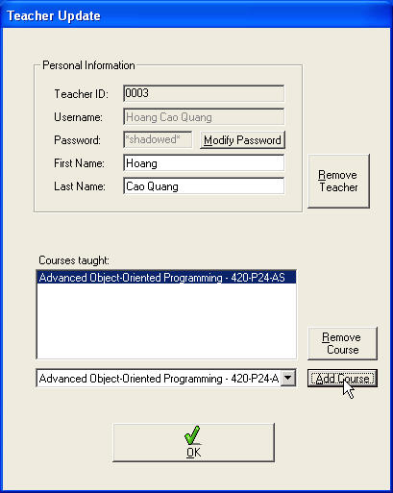
Figure 2: Assigning courses to teachers

- Step 3
The Administrator must register the students to their courses.
Each student can take many courses, each course can be registered by many students.
If a course is taught by more than one teacher, it is necessary to choose a teacher for the student who is registering to this course.

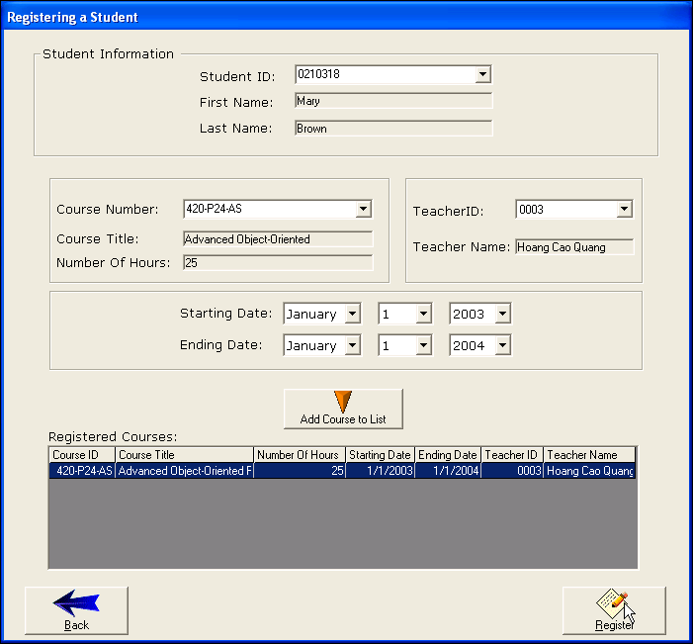
Figure 3: Registering a student

- Step 4
Now the Administrator’s main task is finished.
Every teacher needs to login and specify each of his/her course’s properties
(i.e. how many tests does every course include, how much is every test worth, what is the maximum absence rate etc.)

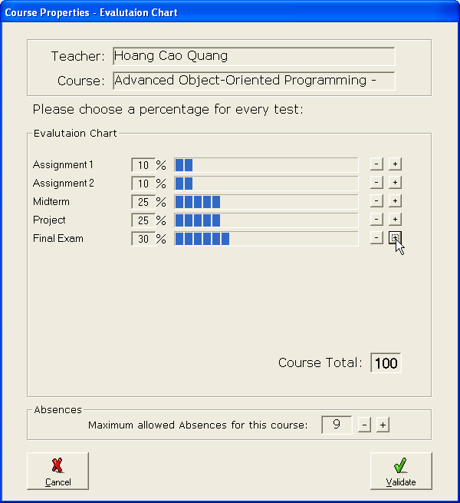

- Step 5
The last thing to do is to fill in the students’ grades and absences.
The final marks and the student’s status (passed/failed) are calculated automatically depending on the tests’ marks and the absence rate.
All student grades can be edited at any time.

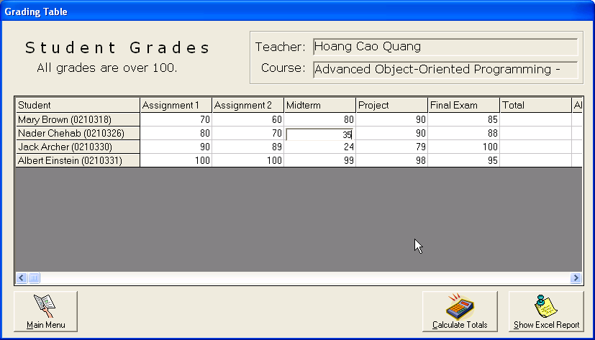

III. How it works

In this section, I will describe briefly how the Grading System has been designed.

- The Database
The Grading System uses Access database (.mdb) to store all information.
The database is made of four major tables that are:
  - The Teachers table
  - The Courses table
  - The Students table
  - The TeacherCourse table

The last table (TeacherCourse) is not necessary,
although it was easier for me to keep it.
However, the database can be designed using only the 3 first tables.
All other tables are created dynamically at run-time,
every time the Administrator assigns a course to a teacher.

For example, let’s say we have a teacher:
Teacher ID: 0002
Username: Shanbedi

And a course:
Course ID: 420-P34-AS
Course Title: C++ Programming
…

When the administrator assigns this course to Shanbedi, a new table called named: ‘Shanbedi420-P34-AS’ will be created in the database. This table will contain 5 fields: StudentID (Primary key), Grades, Absences, StartingDate, EndingDate.
All fields will be empty.

When the Mr. Shanbedi fills in the course’s information, the table will have one additional field for each test that he creates, and a special row with
studentID = ‘0000000’ that will contain the course’s properties.

For instance let’s say Shanbdedi made these 5 tests for his course and a maximum absence rate of 9 hours:
Assignment 1 worth 10 %
Assignment 2 worth 10 %
Midterm Exam worth 25 %
Final Project worth 25 %
Final Exam worth 30 %

The table ‘Shanbedi420-P34-AS’ will look like this:

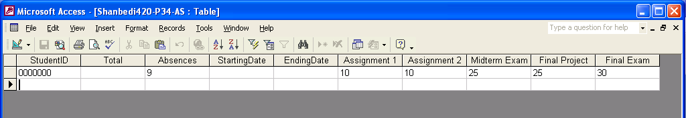

- Security

The database is protected with a password specified by the Administrator. The password is encrypted and stored in win.ini in the [GradingSystem] section.
When an administrator or a teacher logs in, the typed password is encrypted and then compared to the encrypted password stored in the Teachers table, in the database. The function uses XOR encryption.
For example is the password is: “teacher” the it will be stored in the database as: “MVTWYWA”. This makes it harder for someone to break the account.

