hello everyone..

here is the simple Modbus TCP/IP simulation program.. you can test your concept PLC programs on your PC by connecting Modbus TCP..

this is a great example for the GET/set datas on plc.. but with this program you can access as read & write only digital outputs and analogue outputs only.. & you must declare as blank your do & ao adressess on the PLC program..

for example :

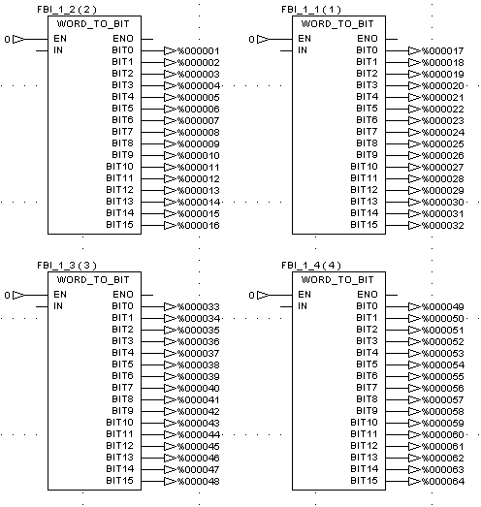

I declared DOs as above Picture on PLC Program.. then on the my program I am reading from plc between 000001 to 000032 DO & 400001 to 400016 adresses and I am writing values to PLC adresses are between 000033 to 000064 and 400017 to 400032 adresses..

I used simple graphical object for animation drawing.. you can use & create objects only :

Lines,
Rectangles,
Circles,
Labels,
Textboxes,
Buttons.

After the finish of both PLC Program & animation drawing you need to write script for animation it..

The script used VBScript codes here..windows sicripts automations.. only for extra a declared objects here.. coding is easy..

For the animation of used button objects you need to know that object’s index number.. you can easily see that index number on the status bar to go by Mouse icon to that object.. then you must code button function like that :

Fonction type & Object Name & index Number & _ and event & ()

Last of that code you must end your function or sub program.

Here is the sample..

Sub Button12_Click()
………
………
End Sub

End of this code.. you can execute this code by using click this button..

For the get data from PLC:

Dim A
A = Object.fromPLC("DDO",33) ‘ this function loads DDO number of 33..
A = Object.fromPLC("ACO",32) ‘ This function loads ACO number of 32

For the set data to PLC

Object.toPLC “DDO”,33,1 ‘ This sets DDO 33 as 1 (000033 address.)
Object.toPLC “ACO”,20,9999 ‘ this sets ACO20 9999 value.. (400020 addrss)

For extra you can change objects datas..

Dim a
a=Object.GetObjectInfo(index,"Left") ‘ Loads Objects Left value to a
“Top”
“Height”
“Width”
“Text”
“MainColor”
“BorderColor”

& of course you can set objects datas..

Object.SetObjectInfo index ,”left”,350
Object.SetObjectInfo index,”MainColor”,RGB(255,34,23)

& there is no detail more.. cos as you all know the vbscript laguage standarts..

I hope this been helpfull..

Best Regards………………………..

ADROGOS

