PHILIPS HB-311, PUVA LAMP

Instructions booklet

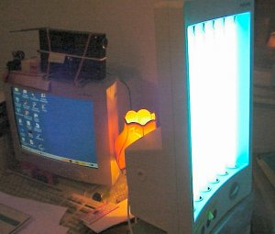

WARNINGS
-Before connecting the appliance to the mains socket, check if the voltage indicated on the rating plate corresponds with the mains voltage in your home.
-Water and electricity are a dangerous combination! Therefore, do not use the table top solarium in wet rurroundings (e.g. in the bathroom or shower, or near a swimming pool).
-If you are just been swimming or have just taken a shower, dry yourself thoroughly before using the appliance.
-Take care that children cannot play with the table top solarium. As a precaution remove the plug from the wall socket after use.
-Let the table top solarium cool down first (about 15 min.) before storing it away.
-Keep the ventilation openings at the back clear of obstruction when using the table top solarium.
-Do not exceed the advised session times or the maximum amount of 'tanning hours'. (See section 'UV sessions: How often? And how long?')
-Do not select a shorter operational distance than the advised 10 cm (approx. 4").
-Do not treat each part of the body more often than once a day. Avoid intensive skin exposure to natural sunlight on the same day as a UV session.
-If you have any symptoms or illness, if you take any medicines and /or apply cosmetics which increase skin sensitivity, you should not have a UV session. Special care is also necessary in cases of pronounced individual sensitivity to ultraviolet. When in doubt, please consult your doctor.
-A table top solarium is not to be used by people who get sunburnt without tanning when exposed to the sun, by persons suffering from sunburn, by children, or by persons who suffer (or have previously suffered) from skin cancer or who are predisposed to skin cancer.
-Consult your doctor if ulcers, moles or persistent lumps develop on the skin.
-Always wear thw protective eye goggles while tanning to protect your eyes against excessive doses of ultraviolet, visible light and infrared. (Also refer to section 'UV and your health')
-Remove creams, lipstick and other cosmetics well in advance of a UV session.
-Do not use sunscreen lotions or creams.
-Do not use suntan lotions or creams.
-If your skin should feel taut after the sun tanning session, you may apply a moisturizing cream.
-Never use the table top solarium if the timer has become faulty.
-Colours may fade under the influence of the sun. The same effect may occur when using the table top solarium.
-Do not expect the table top solarium to yield better results than the natural sun.

The Sun
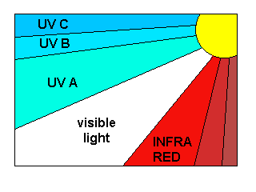
The sun is the source of energy on which all life on earth depends.
There are various kinds of solar energy: the sunlight enables us to see, we feel the warmth of the sunshine on our skin, and under the influence of the sun our skin is tanned.
These three effects are due to three spscific components of the sun radiance spectrum, each of the components having their own wave lengths

The sun radiates electro-magnetic vibrations with widely different wave lengths. The wave lengths of heat rays or ‘infrared’ (IR) are longer than the wave lengths of visible light. And the wave lengths of ‘ultraviolet’ (UV), which tans our skin, are shorter than these.
Science has managed to reproduce these three kinds of solar radiation: heat (e.g. infraphil), light (lamps) and UV (solariums, sun couches etc.)

UV-A, UV-B and UV-C
Ultraviolet (UV) is subdivided into UV-A (longer wave lengths), UV-B and UV-C (shorter wave lengths).
UV-C seldom reaches the earth as it is filtered out by the atmosphere.
UV-A and UV-B cause the tanning effect of the skin.

In fact there are two processes which produce tanning, and they are simultaneously effective:

- ‘indirect tanning’. Primarily UV-B stimulates the production of a substance called ‘melanin’, which is necessary for tanning. The effect does not show until a couple of days after the sunbath.
- ‘direct tanning’. The UV-A and also part of the visible light cause quicker browning without reddening or ‘getting sunburnt’.

The table top solarium
This Table top solarium emits predominantly UV-A, and also a very small amount of UV-B.

UV and your health
After an excessive exposure to ultraviolet (from the natural sun or from your table top solarium), the skin may develop sunburn.
Beside numerous other factors, such as excessive exposure to the natural sun, improper and excessive use of your table top solarium will increase the risk of skin and eye disease.
The nature, intensity and duration of the radiation on one hand, and the sensitivity of the individual on the other, are decisive on the degree in which these effects can occur.
As skin and eyes are more exposed to UV, the more risk increases of diseases such as inflammationof the cornea and/or conjunctiva, damaging of the retina, cataract, premature aging of the skin and skin tumours.
Certain medicines and cosmetics increase the sensitivity to UV.

UV sessions: how often? And how long?

You may have one UV session per day, over a period of five to ten days. Allow at least 48 hours between the first two sessions.

After such a course, you may rest the skin for a while.
Approximatively one month after a course your skin will have lost much of the tan. Yow might then decide to start a new course.

On the other hand, it is also possible to have one or two UV sessions per week after a course has elapsed in order to keep up the tan.

Whatever you may prefer, make sure that you do not exceed the maximum amount of tanning hours.
For this table top solarium the maximum is 30 hours (= 1800 minutes) per year.

Duration of the UV session (for each separately treated part of the body) in minutes | 1st  ses- sion | Rest of  min. 48 hours | 2nd  ses- sion | 3rd  ses- sion | 4th  ses- sion | 5th  ses- sion | 6th  ses- sion | 7th  ses- sion | 8th  ses- sion | 9th  ses- sion | 10th  ses- sion
For persons with very sensitive skin | 10 | Rest of  min. 48 hours | 10-15 | 10-15 | 10-15 | 10-15 | 10-15 | 10-15 | 10-15 | 10-15 | 10-15
For persons with normal sensitive skin | 10 | Rest of  min. 48 hours | 20-25 | 20-25 | 20-25 | 20-25 | 20-25 | 20-25 | 20-25 | 20-25 | 20-25
For person with less sensitive skin | 10 | Rest of  min. 48 hours | 30-40 | 30-40 | 30-40 | 30-40 | 30-40 | 30-40 | 30-40 | 30-40 | 30-40

Example:

Imagine that you take a 10 day UV course, with a 10 minute session on the first day and a 25 minutes session on the following nine days.

The entire course then includes (1x10 minutes)+(9x25 minutes)=235 minutes.
Over a year you may have 7 of these courses (as 7x235 minutes=1645 minutes).

From the table it will be seen that the first session of a course should have a duration of 10 minutes.
This is not dependent upon individual skin sensitivity.

Note:
If you think that the session are too long for you (e.g. if the skin gets taut and tender after the session), we advise you to reduce the session by e.g. 5 minutes.

Therefore, it is of great importance
- that you follow the instructions in sections ‘Warnings’ and ‘UV sessions: how often? And how long?’;
- that you select the advised operational distance of 10 cm (approx. 4”);
- that you do not exceede the maximum amount of tanning hours per year (i.e. 26 hours or 1560 minutes);
- that you always wear the provided goggles while tanning.

General Description:

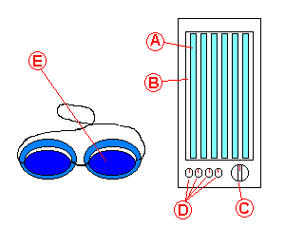
Figure 1

A - Tube lamps (type Philips Cleo 20 W) with starters (type Philips S2)
B – Reflectors
C – Timer 60 minutes
D – Memo Knobs for four persons
E – Protective goggles, 2 pairs, (type n°. HB 071 / service n°. 4822 690 80123 – illustrated – or type n°. HB 072 / service n°. 4822 690 80147 – not illustrated)

Maintenance:
Have the tubes lamps and starters replaced only by authorized service personel: only these have the required skill and dispose of the original replacement parts.

