Back-face removal/culling in world space using the dot product (3D programming)

This tutorial focuses on the use of the Dot Product of two vectors for back-face culling/removal in world space. This tutorial is only of use to people interested in 3D programming. It is written with Direct3D 8 as the API and Visual Basic 5/6 as the IDE, so it's wise to use these API/IDEs with this tutorial, although it can easily be modified to work with other 3D APIs/programming IDEs. You will need a good understanding of basic/intermediate maths (although, I am currently only studying GCSE level) and obviously some knowledge of working with 3D programming. This tutorial does not contain a big sample project, because my next submission to PSC (D3DWorld Version 3) should have back-face culling/removal implemented fully. I have provided many code snippets in this tutorial, which you should be able to incorporate into any 3D scene or world based program, with relative ease. It is nearly always used in 3D games like Quake and Half-Life etc. because without it, the frame rate would be significantly lower (maybe even as much as half).

What is back-face removal?

In any 3D scene or world there are always many polygons, which are not facing the viewer, and thus simply waste CPU power by drawing them. Back-face removal is the process of testing every polygon before it is drawn in a scene as to whether or not it is facing the viewer or not. If it isn't, then it is not drawn, if it is, well then it is drawn. We are going to do this by using the dot product of two vectors, which will be explained later. There are other methods of doing this, one involving the cross product and screen space, but the one I am about to show is much better.

What is the dot product?

The dot product is simply a function which when performed on two vectors returns a scalar value, which is the cosine of the angle between the two vectors, scaled by the length of these vectors.

Therefore:
cosofangle = DotProduct(v1, v2) / v1length * v2length

If you are using normalized or unit vectors (vectors with a length of 1, e.g. (1, 0, 0), (-1, 0, 0), (0, 1, 0) or (-0.707, -0.006, 0.707)) then you can obviously omit the scaling, because the length of both will be 1:
cosofangle = DotProduct(v1, v2)

You may not understand how to get a vector's length or how to normalize one. It is much easier to work with normalized vectors in my opinion, so below are two possible methods on how to do these two important functions. For the rest of this tutorial, we will be working solely with normalized vectors, for simplicity, so make sure that you normalize all of your vectors involved in the back-face removal upon creation. (Or just before they are used for back-face removal).

Function GetVectorLength(vector As D3DVECTOR) As Single
GetVectorLength = Sqr((vector.x * vector.x) + (vector.y * vector.y) + (vector.z * vector.z))
End Function

Function NormalizeVector(vector As D3DVECTOR) As D3DVECTOR
Dim vLength As Single
Dim vector_ret As D3DVECTOR

vLength = GetVectorLength(vector)

vector_ret.x = vector.x / vLength
vector_ret.y = vector.y / vLength
vector_ret.z = vector.z / vLength

NormalizeVector = vector_ret
End Function

By now you maybe asking how to do the dot product. Well below is a function for doing just that:

Function GetDotProduct(vector1 As D3DVECTOR, vector2 As D3DVECTOR) As Single
GetDotProduct = (vector1.x * vector2.x) + (vector1.y * vector2.y) + (vector1.z * vector2.z)
End Function

Now I can go on to tell you how to utilise this function for back-face removal.

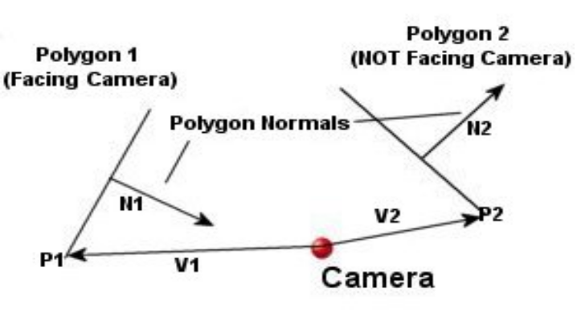

The above diagram illustrates two polygons (1 & 2) and also their respective normals, which describe the way that they face. It is best to calculate these before runtime and store them in an array if possible. The function for calculating a polygon normal is below, along with the ‘cross product’ function, which is used to get the polygon normal. Notice that the polygon normal is itself normalized, although I don’t think that it is necessary. The ‘GetPolygonNormal’ function takes three consecutive vertices (in a clockwise direction, I think) of the polygon as arguments. These are then converted to two vectors, describing two edges of the polygon and the cross product function then returns the polygon normal.

Function GetPolygonNormal(vecPolygon1 As D3DVECTOR, vecPolygon2 As D3DVECTOR, vecPolygon3 As D3DVECTOR) As D3DVECTOR
Dim vec1 As D3DVECTOR
Dim vec2 As D3DVECTOR
Dim vtemp As D3DVECTOR

vec1.x = (vecPolygon2.x - vecPolygon1.x)
vec1.y = (vecPolygon2.y - vecPolygon1.y)
vec1.z = (vecPolygon2.z - vecPolygon1.z)

vec2.x = (vecPolygon3.x - vecPolygon1.x)
vec2.y = (vecPolygon3.y - vecPolygon1.y)
vec2.z = (vecPolygon3.z - vecPolygon1.z)

vtemp = CrossProduct(vec1, vec2)

vtemp = NormalizeVector(vtemp)

GetPolygonNormal = vtemp
End Function

Function CrossProduct(vecPolygon1 As D3DVECTOR, vecPolygon2 As D3DVECTOR) As D3DVECTOR
Dim vtemp As D3DVECTOR

vtemp.x = (vecPolygon1.y * vecPolygon2.z) - (vecPolygon1.z * vecPolygon2.y)
vtemp.y = (vecPolygon1.z * vecPolygon2.x) - (vecPolygon1.x * vecPolygon2.z)
vtemp.z = (vecPolygon1.x * vecPolygon2.y) - (vecPolygon1.y * vecPolygon2.x)

CrossProduct = vtemp
End Function

Below is the actual function for checking if a polygon back-faces.

‘vecPolygonPoint is any point on the polygon (P1 or P2 in diagram), vecPolygonNormal (N1 or N2 in diagram) is the pre-calcuated polygon normal, ‘vecCameraPosition is the position of the camera
Function IsBackFace(vecPolygonPoint As D3DVECTOR, vecPolygonNormal As D3DVECTOR, vecCameraPosition As D3DVECTOR) As Boolean
Dim v1 As D3DVECTOR
Dim sngResult As Single

' calculate the vector from the camera position (V1 or V2 in diagram) to the supplied point on the polygon
v1.x = vecPolygonPoint.x - vecCameraPosition.x
v1.y = vecPolygonPoint.y - vecCameraPosition.y
v1.z = vecPolygonPoint.z - vecCameraPosition.z

' normalize that vector
v1 = NormalizeVector(v1)

' now we can dot product v1 (the vector from the camera position to the supplied polygon’s point) with the polygon normal
sngResult = DotProduct(v1, vecPolygonNormal)

‘if the result of the dot product (remember this is the cosine of the angle between the polygon normal and the vector from the camera position) is ‘greater than zero, then the angle between them (which is the inverse or arc cosine of what the dot product returns) must be smaller than 90. If the ‘result of the dot product is smaller than 0, then the angle between them is obviously greater than 90. This is because, for example, the cosine of ‘90 is 0 and of 91 is –0.017. Therefore it is obvious that a cosine less than 0 gives an angle greater than 90 and vice-versa. If the angle is ‘greater than 90 then we want to keep that face as it is facing the camera. If the angle is smaller than 90, then it’s not facing the camera, so we ‘don’t want it. There is a diagram below, which will hopefully clarify this. (You will probably need to compare the diagram below with the one above ‘to understand these concepts.)
If sngResult > 0 Then
IsBackFace = True ' yep, this is a back-face, we want to lose it
Else
IsBackFace = False ' this polygon is facing the viewer, so we don't want to get rid of it
End If
End Function

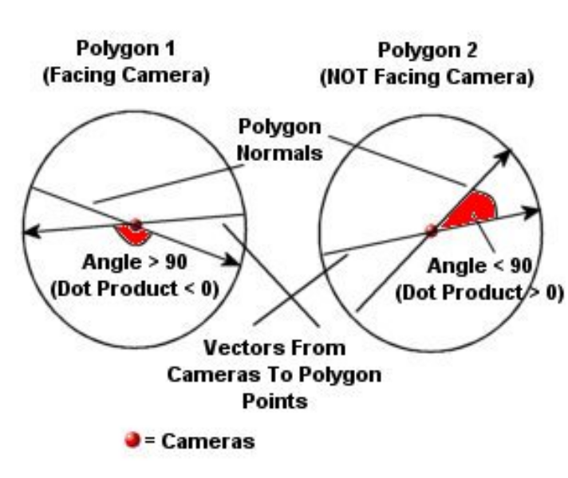

I suppose that it’s quite hard to believe that this little function can help you lose many polygons quite early on in the transformation process and can significantly increase your frame rate. Another point to remember is that the argument, ‘vecPolygonPoint’ can be ANY point on the polygon, because they all lie on the same infinite plane, usually you would just send the first vertex.

Hopefully you have understood this tutorial, it is pretty complicated, so I would read it over a few times. If you have any comments/queries or suggestions then please leave feedback. If you find this useful, then please do vote for me. Look out for my D3DWorld version 3 on PSC, which should use back-face removal fully, and provide a sample project for you where it is actually used for real.

Richard Hayden. (r_hayden@breathemail.net)

