Visual Installer can be downloaded for free from;

http://msdn.microsoft.com/vbasic/downloads/VisualBasic6.asp

This document supplies a brier overview for using Microsoft Visual Studio Installer v1.0 or later.

Preface

Microsoft Visual Studio Installer is a packaging and deployment wizard for Visual Studio projects like Visual Basic. The package created using this tool uses Windows Installer, so that the setups appear compatible with other Microsoft Office Applications. The next steps will guide you on how to use this tool for creating effective packages for your projects.

Step #1 You must have installed a complete licensed version of Microsoft Visual Studio 6.0.

Visual Studio Installer requires Microsoft Visual Interdev for creating setup and deployment packages. Additionally, you must have installed latest service packs too. Currently, Visual Studio Installer comes in two versions v1.0 and v1.1 available for download. You must install both versions in order to use it. Although v1.0 can still work, it is recommended to have latest version to avoid any setup problems for your package.

Step #2 Compile latest version of your Visual Basic project first.

Prepare and compile a latest executable for your Visual Basic project before attempting to create setup and deployment for your package.

Step #3 Create an installer project for your Visual Basic Project.

Visual Studio Installer supports notion of project even for creating setup and deployment for your product. Open Microsoft Visual Interdev, and make the following selections. Pay

particular attention to highlighted areas in blue.
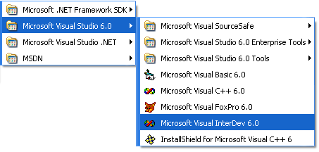
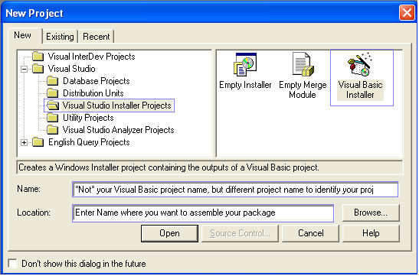
Step #4 Point wizard to you Visual Basic Project that you want to deploy.
After creating a new Visual Studio Installer Project, the wizard will now prompt you to enter the location of you Visual Basic Project. The wizard uses this Visual Basic Project (*.vbp) file to determine which dynamic link libraries, active-x controls your project uses.

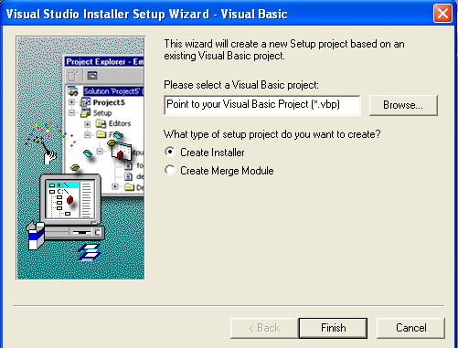

Step #5 Check your Project Explorer Window first.
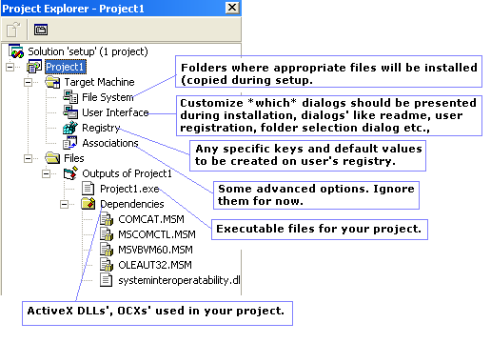
After the Visual Studio Installer has analyzed and created a project for your Visual Basic Files, have a look at the Project Explorer Pane. It should appear similar the one shown here.

Step #6 Double-click each setting above and select appropriate options for setup.

You will need to double-click each node and select appropriate options customized for your setup. The selections and options provided are much simple to customize. Most of work involved is in this step only.

Step #7 Build your project.

The final step to create your setup is to first save your project and then build it. After you are
satisfied with your setup settings, you now want to build your setup. To do so, select Build from Build menu. The status bar will indicate the activity and will update you when it has finished. After a build has been formed, save your Visual Studio Installer Project once again, and exit Visual Interdev.

Step #8 Where is my setup?

The default folder where your setup will be assembled is “your Visual Studio Installer Project Path\Output\DISK_1\”. You need to check this folder for an “. msi” (Microsoft Installation) file. This is the file you require. You need to distribute this setup file to your users. The screenshot shows a sample setup created using Microsoft Visual Studio Installer v1.1.

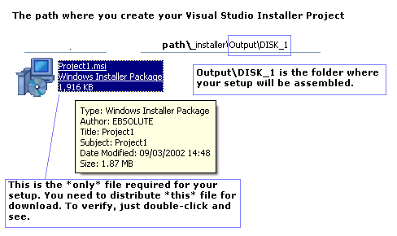

These are required steps to create a package using Microsoft Visual Studio Installer. Although there are some more options than can be customized for your setup needs, a basic understanding on initial steps is of advantage.

