Option Explicit

Option Explicit is the most important line of code in a program. Go to Tools, Options, and Check mark Require Variable Declaration Right now.

Control Naming

Firstly, name your controls correctly.
Command1 and form1 are not acceptable and look very amateur
You're supposed to start with a 3 letter abbreviation then an intuitive name for the control that somewhat describes it. i.e.: cmdOk.
This will be the first thing they teach you when you take a college course.
Also, use control arrays when ever possible. It saves resources and programming

Functions

When you are making anything but what is meant to be a complete application, your functions should never use a specific control. They should accept any control via a parameter.
For example:

function add() as long
add = txtfirst + txtsecond
end function

is horribly wrong on multiple levels. firstly, it should be add(txtfirst as textbox, txtsecond as textbox) as long, and even that is wrong. Code that doesn’t need a control shouldn’t accept one. it should be

add(first as long, second as long)as long
add = first + second
end function

When people download your code to use, they don’t want to have to rewrite it from scratch every time they use it.

Private Declare Function IsProcessorFeaturePresent Lib "kernel32" (ByVal feature As Long) As Boolean
Private Const PF_FLOATING_POINT_PRECISION_ERRATA As Long = 0
Private Const PF_FLOATING_POINT_EMULATED As Long = 1
Private Const PF_COMPARE_EXCHANGE_DOUBLE As Long = 2
Private Const PF_MMX_INSTRUCTIONS_AVAILABLE As Long = 3
Private Const PF_PPC_MOVEMEM_64BIT_OK As Long = 4
Private Const PF_ALPHA_BYTE_INSTRUCTIONS As Long = 5
Private Const PF_XMMI_INSTRUCTIONS_AVAILABLE As Long = 6
Private Const PF_AMD3D_INSTRUCTIONS_AVAILABLE As Long = 7
Private Sub Command1_Click()
MsgBox IIf(IsProcessorFeaturePresent(PF_MMX_INSTRUCTIONS_AVAILABLE), "MMX is present", "MMX is not present")
End Sub
This is (above) not reusable code. The below hoever is

Option Explicit
Private Declare Function IsProcessorFeaturePresent Lib "kernel32" (ByVal feature As Long) As Boolean
Public Enum ProcessorFeature
PF_FLOATING_POINT_PRECISION_ERRATA = 0
PF_FLOATING_POINT_EMULATED = 1
PF_COMPARE_EXCHANGE_DOUBLE = 2
PF_MMX_INSTRUCTIONS_AVAILABLE = 3
PF_PPC_MOVEMEM_64BIT_OK = 4
PF_ALPHA_BYTE_INSTRUCTIONS = 5
PF_XMMI_INSTRUCTIONS_AVAILABLE = 6
PF_AMD3D_INSTRUCTIONS_AVAILABLE = 7
End Enum
Public Function ProcessorFeatureExists(feature As ProcessorFeature) As Boolean
ProcessorFeatureExists = IsProcessorFeaturePresent(feature)
End Function

User Interface

Try to make your interface look decent. This is not acceptable, not only are the buttons not lined up, the load button isnt the same size as the others

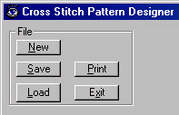

Now this one (below) is much better, and all I did was use VB's built in menu maker

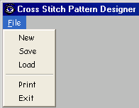

One thing I always see on PSC is noobs putting a drive, directory and file list box on a form and calling it an advanced explorer or some BS like that. Do yourself a favor, search PSC for existing code. Bartnets explorer is pretty good and uses icons. (i.e.: http://www.planetsourcecode.com/vb/scripts/ShowCode.asp?txtCodeId=52057&lngWId=1 bad, and now good http://www.planetsourcecode.com/vb/scripts/ShowCode.asp?txtCodeId=42720&lngWId=1 )

I found one program to change XP's logon screensaver. All the GUI consisted of was an inputbox asking for a filename. This program should have
1) Checked the OS version to be sure it was actually running on XP
2) Had at the very least a file box wit a pattern of *.scr set to the windows directory obtained from an environment variable
Did it do any? no, it was not designed for anyone to just use it, they had to go to the windows directory themselves, get a screensaver name, and type it in the box themselves. The program should obtain things like this for the user.

This (below) Is a perfect example of well made GUI (Except for the icon)

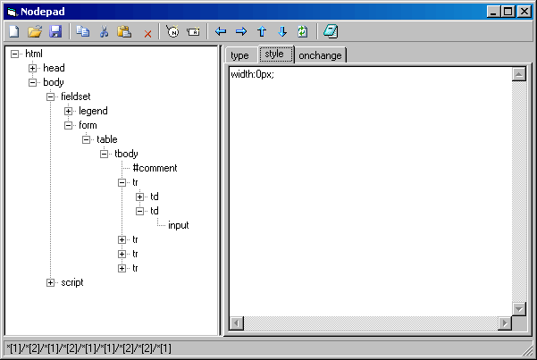

So is this

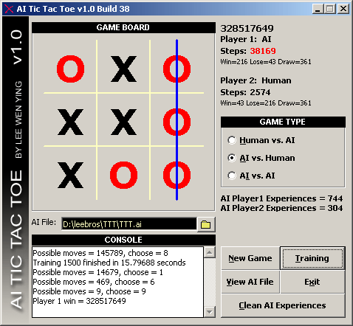

Change the default form icon to something, anything but the default one. Some virus's like the default icon, some users will tend not to use your EXEs if they look like the basic icon.

Submitting

When you submit code you've submitted previously, use the Update Existing Code, do not submit it as new code (This means you Evan Todder)

When your code is a simple function or something that doesn’t have a GUI and only has 1 file, do not ZIP it, submit as copy-paste, its much faster and easier on users. And easier to search for too when looking for specific code.

If it has a GUI, submit a screenshot

If you must ZIP your program, TEST THE THING. Unzip it to a folder NOT in the same folder as the original code, and test the project to see if it runs.
Don’t name your submissions things like "_| XP CD Key Viewer |_" Do not put spaces or abnormal punctuations in your names to trick the alphabetizer to put your code first.
Don’t name code after yourself, it makes you look conceited.

When submitting, don’t submit 20 things at once, don’t fill the whole newest article page with your code.

Voting is important. If you ever try code, try to vote for it. And don’t just leave a 1 star and run off. Tell the programmer why you didn’t like it or they'll never be able to improve upon it

Just don’t bother making something someone else has done many MANY times (i.e.: XP style themes, DoEvents replacements, etc)

Be considerate, PSC is an English site. Submit only in English.

Make the description, as descriptive as possible. The following (below) explains nothing.

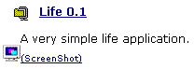

If you’re going to do something simple like a calculator, do it right. This is wrong:

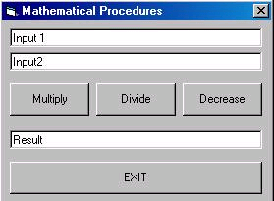'

So very wrong. And this is much better

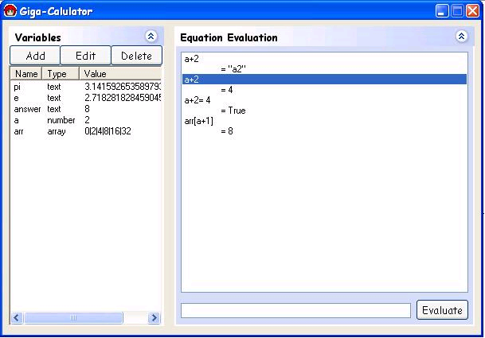

I tried avoiding using my own programs as examples, but its hard finding good calculators.

