1 TO MANY FORM
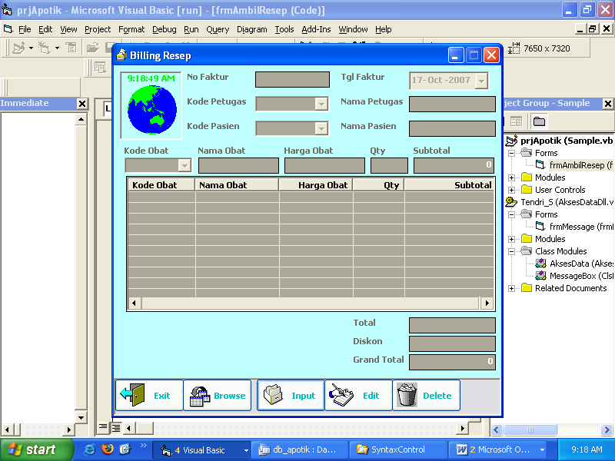
MODULE
Public AksesDB As New Tendri_S.AksesData
Public NewMB As New Tendri_S.MessageBox 'New MsgBox(replace vb’s msgbox)
Sub openDB()
Dim konek As String

konek = "DSN=APOTIK"
'konek = "Provider=Microsoft.Jet.OLEDB.4.0;Data Source=" & App.Path & "\db_apotik.mdb"

AksesDB.KonekStr = konek

AksesDB.TipeKoneksi = OnDemand
End Sub

FORM
Dim rs As New Recordset
Dim xx As String
Dim RecArray()
Sub RecordArray()
ReDim RecArray(0 To 6)

RecArray(0) = Me.tNoFak
RecArray(1) = Me.DTPicker1
RecArray(2) = Me.cbKdPtugas
RecArray(3) = Me.cbKdPasien
RecArray(4) = Me.tDiskon
RecArray(5) = Me.tTtl
End Sub
Private Sub Form_Load()
openDB ← load DataBase
kosong Me
aktif Me, False

Call AksesDB.FillListCombo("kdptugas", "petugas", cbKdPtugas)
Call AksesDB.FillListCombo("kdpasien", "pasien", cbKdPasien)
Call AksesDB.FillListCombo("kdobat", "obat", cbKdObt)
End Sub
Private Sub cmSave_Click()
Call RecordArray

If AksesDB.CekData("ambilreseph", "nofak", tNoFak) = True Then
mb.TendriMsg "Duplication Data..!", vbExclamation, "Message"
Exit Sub
End If

xx = "select * from ambilreseph where nofak=''"
Call AksesDB.InsertData(xx, RecArray)

For I = 1 To LV.ListItems.Count
ReDim RecArray(0 To 3)
RecArray(0) = Me.tNoFak
RecArray(1) = LV.ListItems.Item(I).Text
RecArray(2) = LV.ListItems.Item(I).SubItems(2)
RecArray(3) = LV.ListItems.Item(I).SubItems(3)
xx = "select * from ambilresepd where nofak=''"
Call AksesDB.InsertData(xx, RecArray)

ReDim RecArray(0 To LV.ListItems.Count - 1)
RecArray(0) = LV.ListItems.Item(I).SubItems(2)
yy = "select hrgobat from obat where kdobat='" & LV.ListItems.Item(I).Text & "'"
Call AksesDB.UpdateData(yy, RecArray)
Next

NewMB.TendriMsg "Data has been saved..", vbInformation, "Tendri Data Access"

kosong Me
aktif Me, False
LV.ListItems.Clear

cmNew.Visible = True
cmEdit.Visible = True
cmDel.Visible = True
cmCancel.Visible = False
End Sub
Private Sub cbKdObt_Click()
tNmObt = AksesDB.GetData("obat", "nmobat", "kdobat", cbKdObt)
tHrg = AksesDB.GetData("obat", "hrgobat", "kdobat", cbKdObt)
Text1.SetFocus
End Sub
Private Sub cbKdPasien_Click()
tNmPasien = AksesDB.GetData("Pasien", "nmpasien", "kdpasien",bKdPasien)
End Sub
Private Sub cbKdPtugas_Click()
tNm = AksesDB.GetData("Petugas", "nmptugas", "kdptugas", cbKdPtugas)
End Sub
Private Sub cmDel_Click()
psn = NewMB.TendriMsg("Delete Data?", vbYesNo + vbQuestion, "Confirm")
If psn = vbNo Then Exit Sub

Call AksesDB.DeleteData("ambilreseph", "nofak", tNoFak)
Do While Not LV.ListItems.Count <> 0
Call AksesDB.DeleteData("ambilresepd", "kdobat", LV.SelectedItem.Text)
Loop

NewMB.TendriMsg "Data is completely removed..", vbInformation, "Message"

kosong Me
aktif Me, False
LV.ListItems.Clear
End Sub
Private Sub cmBrowse_Click()
dt = InputBox("Masukkan No Faktur, Tgl Faktur, Kode Petugas yang dicari :", "Input")
xx = "select * from ambilreseph where "
xx = xx & "left(nofak, " & Len(dt) & ")='" & dt & "' "
xx = xx & " or day(tgl)=" & Val(dt) & " or "
xx = xx & " left(kdptugas," & Len(dt) & ")='" & dt & "'"
xx = xx & " order by nofak"
Set rs = AksesDB.SearchData(xx)

LVB.ListItems.Clear

If rs.State = 0 Then Set rs = AksesDB.SearchData(xx)

If rs.State <> 0 Then
Do Until rs.EOF
Set lst = LVB.ListItems.Add(, , rs(0))
lst.SubItems(1) = rs(1)
lst.SubItems(2) = rs(2)
lst.SubItems(3) = rs(3)

rs.MoveNext
Loop
End If
LVB.Visible = True
End Sub
Private Sub LVB_DblClick()
If LVB.ListItems.Count = 0 Then LVB.Visible = False: Exit Sub

Me.tNoFak = LVB.SelectedItem.Text
Me.DTPicker1 = LVB.SelectedItem.SubItems(1)
Me.cbKdPtugas = LVB.SelectedItem.SubItems(2)
Me.cbKdPasien = LVB.SelectedItem.SubItems(3)
tNm = AksesDB.GetData("petugas", "nmptugas", "kdptugas", LVB.SelectedItem.SubItems(2))
tNmPasien = AksesDB.GetData("pasien", "nmpasien", "kdpasien", LVB.SelectedItem.SubItems(3))

cari = "select * from ambilresepd where nofak='" & tNoFak & "'"
Set rs = AksesDB.SearchData(cari)

LV.ListItems.Clear
If rs.State = 0 Then Set rs = AksesDB.SearchData(cari)

If rs.State <> 0 Then
Do Until rs.EOF
Set lst = LV.ListItems.Add(, , IIf(IsNull(rs(1)), "", rs(1)))
lst.SubItems(1) = AksesDB.GetData("obat", "nmobat", "kdobat", rs(1))
lst.SubItems(2) = AksesDB.GetData("obat", "hrgobat", "kdobat",rs(1))
lst.SubItems(3) = IIf(IsNull(rs(3)), "", rs(3))
lst.SubItems(4) = rs(3) * rs(2)

rs.MoveNext
Loop
End If

LVB.Visible = False
Totalkan

xx = "select diskon,total from ambilreseph where nofak='" & tNoFak & '"
Set rs = AksesDB.SearchData(xx)

If rs.State = 0 Then Set rs = AksesDB.SearchData(xx)

If rs.State <> 0 Then
tDiskon = rs(0)
tGrandTtl = rs(1)
End If
End Sub
Private Sub Form_Unload(Cancel As Integer)
Set AksesDB = Nothing
End Sub

