Delauney Triangulation

Abstract
A discussion of a method that has been used with success in terrain modelling to estimate the height at any point on the land surface from irregularly distributed samples. The special requirements of terrain modelling are discussed as well as a detailed description of the algorithm and an example of its application.
Introduction
There are a number of possible techniques that can be used for surface interpolation, that is, estimating the height at a point given nearby sample heights. Some of the more common methods are natural neighbour interpolation, surface patches, quadratic surfaces, polynomial interpolation, spline interpolation, and Delauney Triangulation, an implementation of which is described here. Some such interpolation is often required in the display of empirical data, for example, terrain modelling where elevation samples are obtained from surveys, meteorology where data is collected from weather stations, regional planning using data collection stations, and mesh generation for finite element analysis.
This paper discusses a technique suitable for terrain modelling but also for other applications which have the following characteristics
- There are regions of high and low sample density. For example, in terrain modelling there will generally be a low sample density inside bodies of water and a high sample density in the areas of particular interest.
- There may be discontinuities in the surface resulting in samples very close to each other on the sample plane but of wildly differing height values. These may be natural structures as cliffs and river banks or man-made discontinuities like retaining walls. Most smoothing methods do not handle these cases very well especially those based on polygonal functions where surface overshoot, oscillation and general instability occurs.
- The samples often lie along contours. These may be derived from existing contour maps or from the paths taken by a survey team. This is another aspect of differing sample densities. Along the sampling curves there is a high sampling density but perpendicular to the path there are no samples until the next path is reached.
- A large number of samples will often need to be handled. The time needs to increase modestly as the number of samples increases for a technique to be suitable. Typical sample numbers may be from 100 to 100,000. Such large numbers of samples are particularly common when automated sampling methods are employed.
- Samples are often obtained in an incremental procedure. An initial sample may be collected and analyzed, the areas of interest can then be sampled at a higher density. It is advantageous to be able to add the new points to the surface obtained so far thus refining the current surface definition as opposed to recomputing the surface from scratch from the combined set of data points.
- The algorithm should be such that it can be run on desktop computers where large amounts of memory, disk space or fast processors can not be assumed.
The technique to be discussed has been used for terrain modelling with success, it copes with the above aspects of many terrain data sets, and it readily lends itself to grid and contour generation as well as 3D rendering.
Triangulation
Triangulation involves creating from the sample points a set of non-overlapping triangularly bounded facets, the vertices of the triangles are the input sample points. There are a number of triangulation algorithms that may be advocated, the more popular algorithms are the radial sweep method and the Watson algorithm which implement Delaunay triangulation.
The Delauney triangulation is closely related geometrically to the Direchlet tesselation also known as the Voronoi or Theissen tesselations. These tesselations split the plane into a number of polygonal regions called tiles. Each tile has one sample point in its interior called a generating point. All other points inside the polygonal tile are closer to the generating point than to any other. The Delauney triangulation is created by connecting all generating points which share a common tile edge. Thus formed, the triangle edges are perpendicular bisectors of the tile edges.
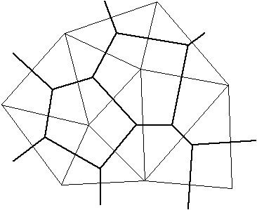

Figure 1. Delauney triangles (thin lines) and associated Direchlet Tesselations (thick lines) for nine generating points. Triangle edges are perpendicular bisectors of the tile edges. Points within a tile are closer to the tile's generating point than to any other generating point.
Such a triangulation has many desirable features. It can be shown that a convex equilateral formed by two adjacent triangles has a greater minimum internal angle than if the equilateral was formed another way. In this sense the triangles are as equilateral as possible, thin wedge shaped triangles are avoided.
The triangulation is unique (independent of the order in which the sample points are ordered) for all but trivial cases. One such case is if four points lie on the corners of a rectangle, they may be triangulated in one of two ways. These situation occur rarely in real data but if uniqueness is important then a straightforward solution is to slightly perturb one or more of the vertices on the offending rectangle.
One particular situation where many other techniques perform poorly is when there is a mixture of regions of high and low density sampling. Triangulation based methods honor this situation by giving a large number of triangles and hence more detail to the highly sampled regions and large triangles, less detail, to the regions with a few samples.
Discontinuities are handled quite naturally. The surface can have a discontinuity as narrow as the sampling process permits, it simply results in near vertical triangular facets. Note however that unless special action is taken there can not be two samples at precisely the same point on the sample plane but with different heights. This can occur with discrete digitizers when digitizing near discontinuities. A perturbation of the sample point in the correct direction is usually a satisfactory solution to this problem.
An algorithm to implement triangulation can be quite efficient and thus suitable for areas with a large number of samples. Furthermore, if further samples are obtained at a later date they can be added to the already existing triangulation without having to triangulate all the samples plus the extra samples. This makes it possible to efficiently perform a successive refinement on those areas where more detailed information is required.
The planar surfaces formed may be used directly as facets making up the surface or they may be used to produce samples on a regular grid. Given a list of triangular bounded facets it is simply a matter of finding the facet whose projection onto the sample plane encloses the point to be estimated. The intersection of the facet plane at the grid point is the estimate of the height. Another method of estimating the points on a grid is to use the Direchlet tesselations instead of the triangular facets. This avoids the cone shaped peaks about local minima and maxima which the first method tends to generate. It is intuitively more appealing because the tesselations correspond to an area of influence about the sample points. Contour maps can be generated directly from the triangular facets or from the samples distributed on a rectangular grid. Generating smooth surfaces if that is required is also generally easier if gridded data is available.
Algorithm
At any stage of the triangulation process one has an existing triangular mesh and a sample point to be added to that mesh. The process is initiated by generating a supertriangle, an artificial triangle which encompasses all the points. At the end of the triangulation process any triangles which share sides with the supertriangle are deleted from the triangle set.
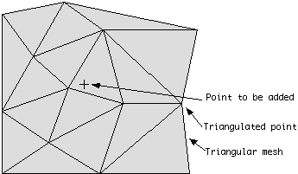

Figure 2a. New sample point to be added to existing triangular mesh
All the triangles whose circumcircle encloses the point to be added are identified, the outside edges of those triangles form an enclosing polygon. (The circumcircle of a triangle is the circle which has the three vertices of the triangle lying on its circumference).
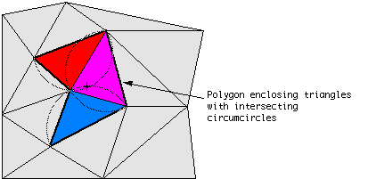

Figure 2b. Triangles whose circumcircle include the new point form an enclosing polygon.
The triangles in the enclosing polygon are deleted and new triangles are formed between the point to be added and each outside edge of the enclosing polygon.
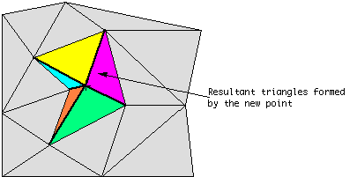

Figure 2c. New triangular polygons formed from new point to the outside edges of the enclosing polygon.
After each point is added there is a nett gain of two triangles. Thus the total number of triangles is twice the number of sample points. (This includes the supertriangle, when the triangles sharing edges with the supertriangle are deleted at the end the exact number of triangles will be less than twice the number of vertices, the exact number depends on the sample point distribution)
The triangulation algorithm may be described in pseudo-code as follows.

subroutine triangulate

input : vertex set
output : triangle set

initialize the triangle set
determine the supertriangle
add supertriangle vertices to the vertex set
add the supertriangle to the triangle set
for each sample point in the vertex set
initialize the edge buffer
for each triangle currently in the triangle set
calculate the triangle circumcircle center and radius
if the sample point lies in the triangle circumcircle then
add the three triangle edges to the edge buffer
remove the triangle from the triangle set
endif
endfor
delete all doubly specified edges from the edge buffer
//this leaves the edges of the enclosing polygon only
add to the triangle set all triangles formed between the sample point
and the edges of the enclosing polygon
endfor
remove any triangles from the triangle set that use the supertriangle
vertices
remove the supertriangle vertices from the vertex set
end
The above can be refined in a number of ways to make it more efficient. The most significant improvement is to presort the sample points by one coordinate, the coordinate used should be the one with the greatest range of samples. If the x axis is used for presorting then as soon as the x component of the distance from the current point to the circumcircle center is greater than the circumcircle radius then that triangle need never be considered for later points, as further points will never again be on the interior of that triangle’s circumcircle.
The time taken is relatively independent of the input sample distribution, a maximum of 25% variation in execution times has been noticed for a wide range of naturally occurring distributions as well as special cases such as normal, uniform, contour and grid distributions.
Execution time t is a function of the number of sample points n and since the number of generated triangles at any stage during the triangulation process is almost linearily correlated to (double) the number of points already processed, the time may be estimated for unsorted sample points as
t = (n² + n) φ

where φ is a factor depending solely on the speed of hardware used. Tests on an AMD 1800 MHz Athlon processor have shown that an object-oriented software approach can triangulate 500 samples in less than two seconds and 1,000 samples took about eight seconds; φ therefore is approximately 16 µsecs.

Presorting the sample points by their x-component will shorten the execution time dramatically; the time was .5 secs for 500 samples, 1.3 secs for 1000 samples and 8.3 secs for 3000 samples.

