MLM Software Developed by Vikrant Thakker

Project Overview
In the Pyramid MLM Network a customer can sponsor three new customers.The shape of the network
will look like a Pyramid. The business scheme may vary depending on the company's policy.The company defines the scope of profit sharing in each level starting from level -1 to N - levels.

In the Pyramid MLM Network a customer can sponsor three new customers. The shape of the network will look like a Pyramid. The business scheme may vary depending on the company’s policy. Here the company defines the scope of profit sharing in each level starting from level 1 to level 4.

Now let us understand the logic in detail…

Total Amt. Company Charges from a new member = Rs. 300

Minimum commission (profit share) that goes into Company’s Account = Rs. 100
(This means that when a new member registers, company gets minimum Rs. 100, while the other amount is distributed to the members in other level)

Below shown is the distribution of Rs. 300 received from a new Member…
Note :- Rs. 100 goes into Company’s account, so only Rs. 200 are left for distribution to other members.

Bussiness logic

Sno | Levels | Number Of Customer | Per Sponsor Amount | Total profit of the particular level
1. | I | 3 | Rs.100 | Rs.3x1000 = 3000
2. | II | 9 | Rs.50 | Rs 9x750 = 6750
3 | III | 81 | Rs.25 | Rs.81x500 = 40500
4 | IV | 6561 | Rs.25 | Rs.6561x25 = 164025
-- | -- | -- | -- | -- -- --
N | N | ₃ N | N | N

GenealogyView

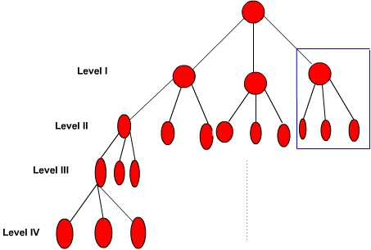

Title : Multi-Level-Marketing (MLM) Software

Developer : Vikrant Thakker Email : vikrant_thakker@yahoo.com

Description : This is an end-to-end solution software for companies in DIRECT MARKETING AREANA - MLM (Multi Level Marketing)

This caters to the requirement of profitability analysis. Customer Registration, incentive calculation and updation etc.

I would like to highlight the points, which are very specific to this software.

I basically have divided the entire operation into six modules

I. Customer registration.
II. Network formation
III. Franchise sales and inventory tracking.
IV. Incentive calculation
V. Payment module
VI. Analytical Reports Generation

The code is simple and readable, easy to modify for your own use...

This software came from Planet-Source-Code.com...the home of millions of lines of source code

