End-to-End Technical Report
Dynamic Retail Scraping & Product-Matching Classification Pipeline
Prepared by Pranav

Executive Summary
This project builds an automated pipeline that ingests paired product URLs from Walmart, Target, and Amazon, defeats each retailer's anti-bot defenses, extracts and normalizes product data, and classifies each pair into one of four relationship categories: Exact Match, Size Different, Color Different, or No Match.
Against a 319-row human-labeled ground-truth set, the pipeline's classifications agreed with human labels at a 99.7% rate. The two hardest engineering problems were bypassing two structurally different anti-bot systems (PerimeterX's behavioral CAPTCHA on Walmart vs. Akamai's silent JSON-stripping on Target) and making perceptual image matching robust to differing product-photography backgrounds across retailers.

1. Problem Statement
The objective was to build a resilient data pipeline for dynamic product comparison across major e-commerce retailers. The system needed to:
- Ingest pairs of product URLs and defeat enterprise-grade anti-bot systems (PerimeterX, Akamai).
- Extract deeply nested JSON schemas to recover specifications and images.
- Perform AI-assisted background removal followed by classical perceptual image hashing to compare product photos independent of background noise.
- Classify each product pair into one of four categories: Exact Match, Size Different, Color Different, No Match.
- Benchmark automated classifications against a human-labeled ground-truth dataset (sample_data.csv) to measure precision and accuracy.

2. System Architecture
The pipeline runs as four sequential stages, orchestrated asynchronously so that scraping, extraction, matching, and classification can overlap across product pairs:
- Step 0 — Ingestion & Anti-Bot: routes each URL through a retailer-specific bypass strategy.
- Step 1 — Extraction & Normalization: recursively parses nested JSON payloads and normalizes units/keys; runs AI background removal ahead of image hashing.
- Step 2 — Matching: fuzzy-aligns specification keys and computes perceptual image similarity.
- Step 3 — Classification & Evaluation: applies a rule-based elimination tree to assign a category, then scores against ground truth.
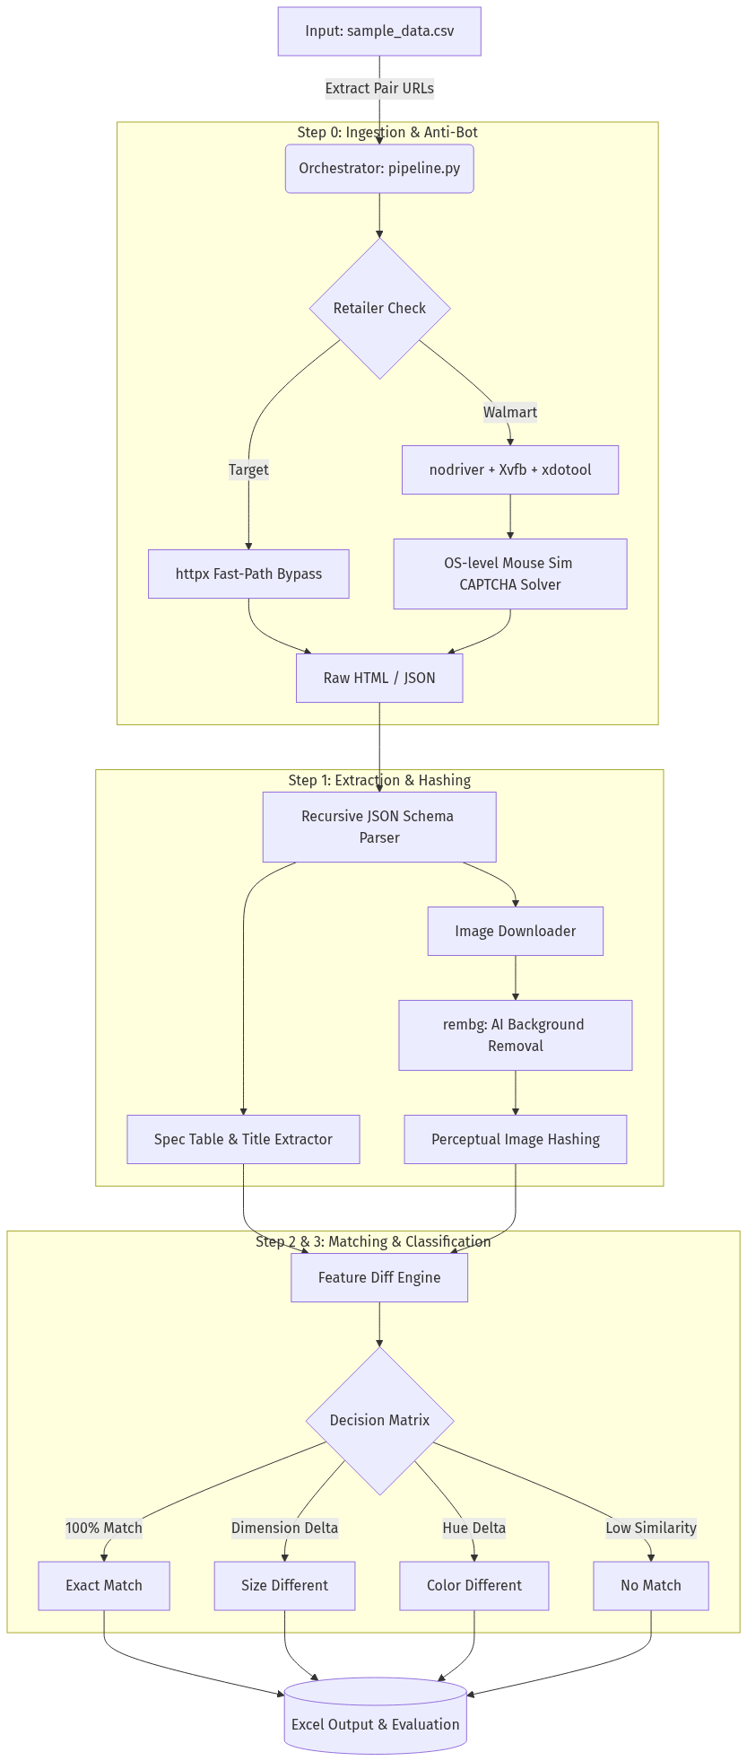
Figure 1. Pipeline architecture flowchart.

3. Implementation Detail

3.1 Step 0: Ingestion & Anti-Bot (src/step0_scraper.py)
The pipeline runs as an asynchronous orchestrator that distributes URLs to workers via a queue. Each retailer requires a different bypass strategy because their anti-bot systems detect scrapers differently:
- Target (Akamai): Target's defense doesn't challenge the client — it silently strips the __NEXT_DATA__ JSON payload from the HTML when it detects a headless client, returning a blank page instead of a CAPTCHA. Since this check is JavaScript-driven, an request that never executes JS never triggers it, and the raw payload is returned directly.
- Walmart (PerimeterX): Walmart serves an aggressive behavioral "press-and-hold" CAPTCHA. Standard headless browsers (Selenium, Puppeteer) are flagged via canvas fingerprinting and WebDriver signals. The pipeline instead launches inside a virtual display (Xvfb) and uses to issue OS-level mouse events, which PerimeterX's behavioral telemetry cannot distinguish from real hardware input.

3.2 Step 1: Extraction & Normalization (src/step1_extractor.py)
- Key/value cleanup: drops UI noise (e.g. shipping_fee, media-player metadata) from spec tables, aliases equivalent keys across retailers (e.g. clothing_neck_style → neck_style), and converts units (oz → g, volume → ml) so values are numerically comparable.
- Background removal: product images are passed through the U-2-Net model () and composited onto a uniform white background before hashing, removing retailer-specific photography backgrounds as a confound.

3.3 Step 2: Matching (src/step2_matcher.py)
- Fuzzy key alignment: uses at an 80% threshold to link differently-named keys across retailers (e.g. "Sleeve Type" ↔ "Garment Sleeve Style").
- Semantic value matching: domain-specific equivalence rules (e.g. neck_style values "crew" and "round" are treated as equivalent).
- Perceptual image similarity: computes Hamming distance on the phash generated in Step 1 and converts it to a 0–100% similarity score. Note: phash itself is a classical DCT-based hash, not a learned model — the AI component in this pipeline is the upstream background-removal step, not the hashing itself.

3.4 Step 3: Classification & Evaluation (src/step3_classifier.py)
- Elimination tree: normalizes brand names (stripping suffixes like "inc"/"llc"), checks title similarity, and evaluates aligned_mismatches. If only size-related keys mismatch → CASE_B_SIZE_DIFF; if only color keys mismatch → CASE_C_COLOR_DIFF; otherwise → NO_MATCH.
- Evaluation harness: maps AI verdicts against sample_data.csv. True negatives are handled correctly — e.g. an AI "Size Different" verdict against a human "Incorrect Match" label is scored as a correct alignment, not a mismatch.
- Reporting: exports results to an workbook with conditional color coding by output class (green/amber/red).

3.5 Core Utilities (src/utils.py)
- Exponential backoff: synchronous and async retry decorators that double delay on failure, preventing IP bans.
- O(1) row-skip caching: jsonl_index_composite indexes already-scraped rows into Python tuple sets, cutting re-check latency from a ~5s browser scrape to ~0.003s.
- Cross-row memoization: url_to_raw caches responses by URL so duplicate URLs across rows are never fetched twice.

4. Results
Total ground-truth rows evaluated: 319
Overall agreement with human labels: 99.7%
The pipeline correctly identified structural discrepancies (missing specs, divergent image hashes, mismatched titles) and classified them as "No Match," consistent with human "Incorrect Match" labels.
Open item: overall accuracy alone is a weak metric for a 4-class problem, especially if the ground-truth classes are imbalanced. A per-class precision/recall breakdown or confusion matrix — and the class distribution of the 319 rows — would make this result more defensible under scrutiny.

5. Technical Challenges & Engineering Solutions

5.1 The Anti-Bot Paradox: Walmart vs. Target
Walmart (PerimeterX) — behavioral block
Challenge: standard headless browsers are detected via canvas fingerprinting and WebDriver flags, making the CAPTCHA unsolvable through conventional automation.
Solution: nodriver masks WebDriver signals; combined with Xvfb and xdotool, the system issues OS-level mouse events that behavioral telemetry cannot distinguish from a physical user.
Target (Akamai) — telemetry block
Challenge: Target doesn't challenge the client directly — it detects the headless browser and silently strips __NEXT_DATA__ from the response, returning a blank page.
Solution: since the check is JS-driven, an httpx request that never executes JavaScript never triggers it, and Target returns the full JSON payload directly.

5.2 Evolving JSON Schemas
Challenge: mid-project, Target restructured its frontend, moving product data into a dynamically generated data_source_modules array and breaking the hardcoded parsing paths.
Solution: replaced fixed-path parsing with a recursive tree search that locates the product footprint anywhere in the DOM/JSON structure, making the parser resilient to future schema changes.

5.3 Visual Noise in Image Matching
Challenge: retailers photograph products against different backgrounds (e.g. Walmart's plain white vs. Amazon's lifestyle shots), which degrades hash-based similarity even for identical products.
Solution: rembg (U-2-Net) strips the background from every product image before hashing, so perceptual similarity reflects the product rather than the photo backdrop.

6. Conclusion & Key Learnings
This project underscored that modern web scraping is effectively an adversarial security problem — TLS fingerprinting, JS telemetry, and headless-browser detection all had to be reasoned about explicitly rather than treated as an afterthought. The core engineering judgment call was recognizing which class of defense each retailer used, and matching the tool to the threat: OS-level input simulation for a behavioral block (Walmart), versus a minimal, JS-free HTTP request for a telemetry block (Target). Applying the heavier tool where the lighter one would suffice would have been unnecessary complexity and added fragility.

