To-do’s feature

These features are just proof of concept and do not cover all to-do features like notification etc.

Below api are tested

1. Get method by any web browser
2. Post method by Postman client

**How to start Express server**

1. Open nodejs server
2. Run “npm install” in the console.
3. Run “nodemon start” in the console, to start the express server.

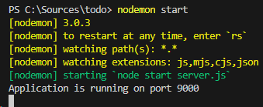

1. Now you can call api by web browser or any httpClient tool.

**APIs below are available.**

1. Get list all of To-do’s by <http://localhost:9000/todo-list>

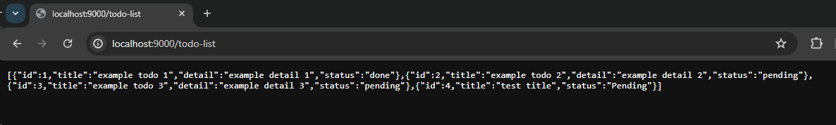

1. Get single Todo by <http://localhost:9000/todo?id=1>

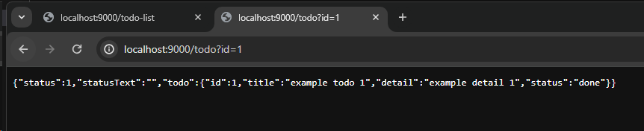

1. Add new To-do by Use httpClient post to <http://localhost:9000/todo>

Below are parameters needed

1.”title” is an to-do title

2. “detail” is an to-do detail

3. Param id is not needed for this request.

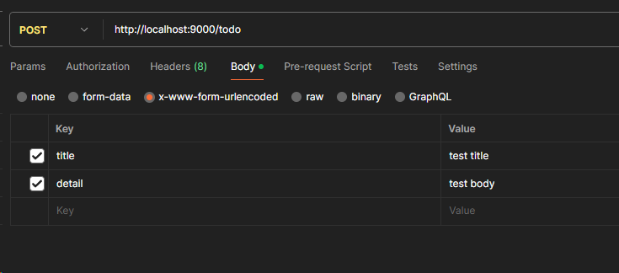

New record return as below.

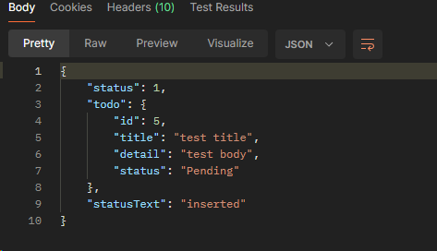

1. To update existing to-do post data to Api http://localhost:9000/todo

With parameters below

1. Param “title” for todo title
2. Param “detail” for todo detail
3. Param “id” for specific id to be update
4. Param “status” for update new to-do status.

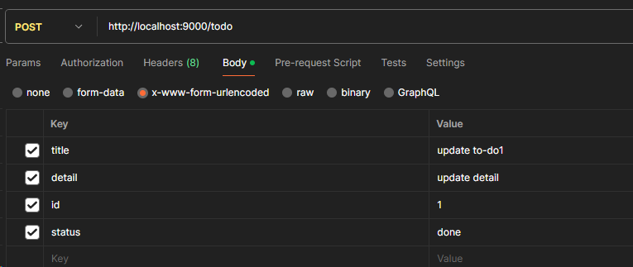

The output should look like below.

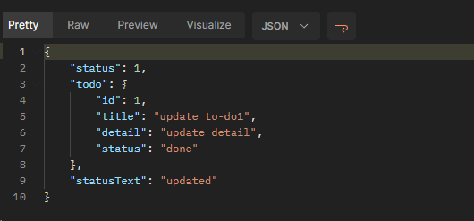

1. To delete specific to-do post data tol api <http://localhost:9000/delete>

With below parameter needed

1. Param “id” is a to-do id to be deleted.

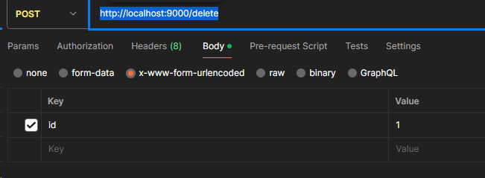

The output should look like below.

