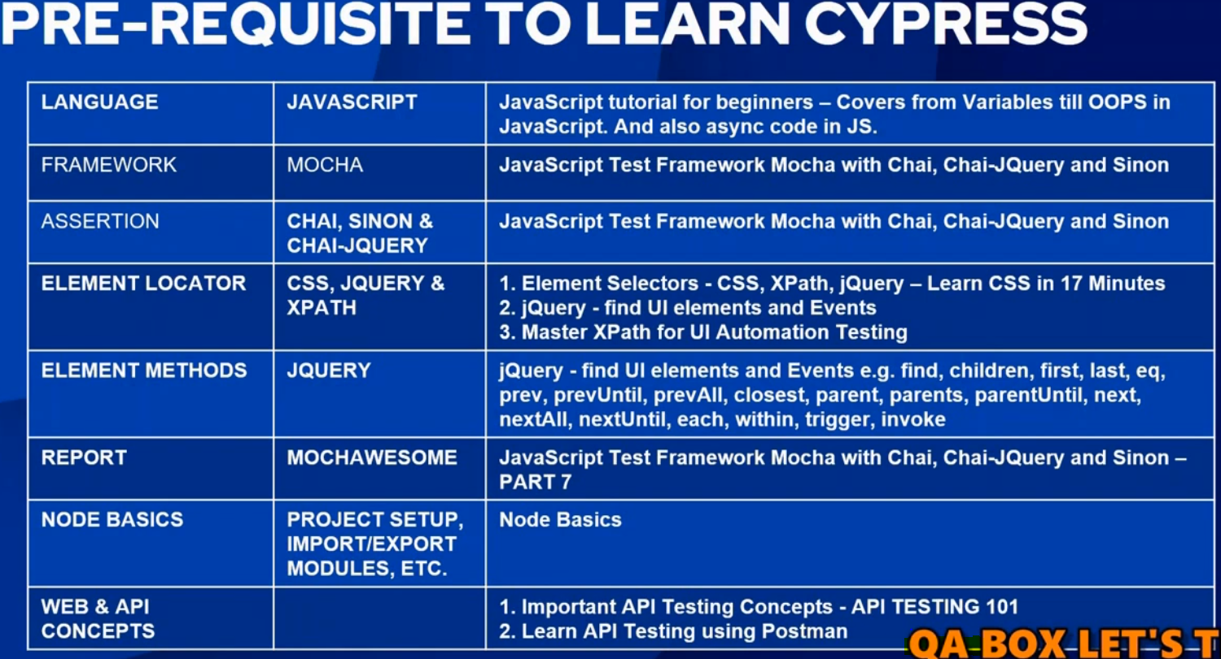

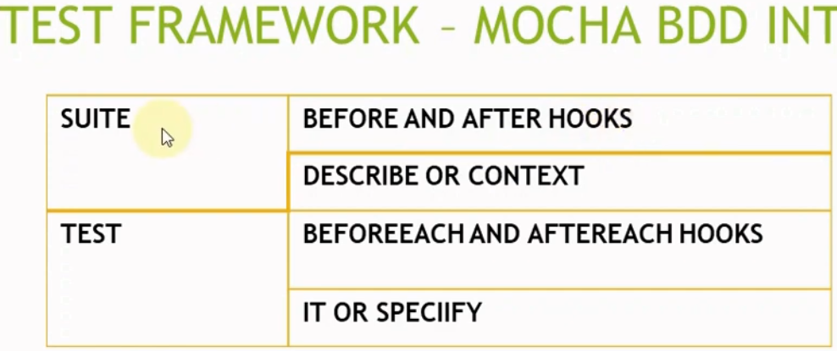

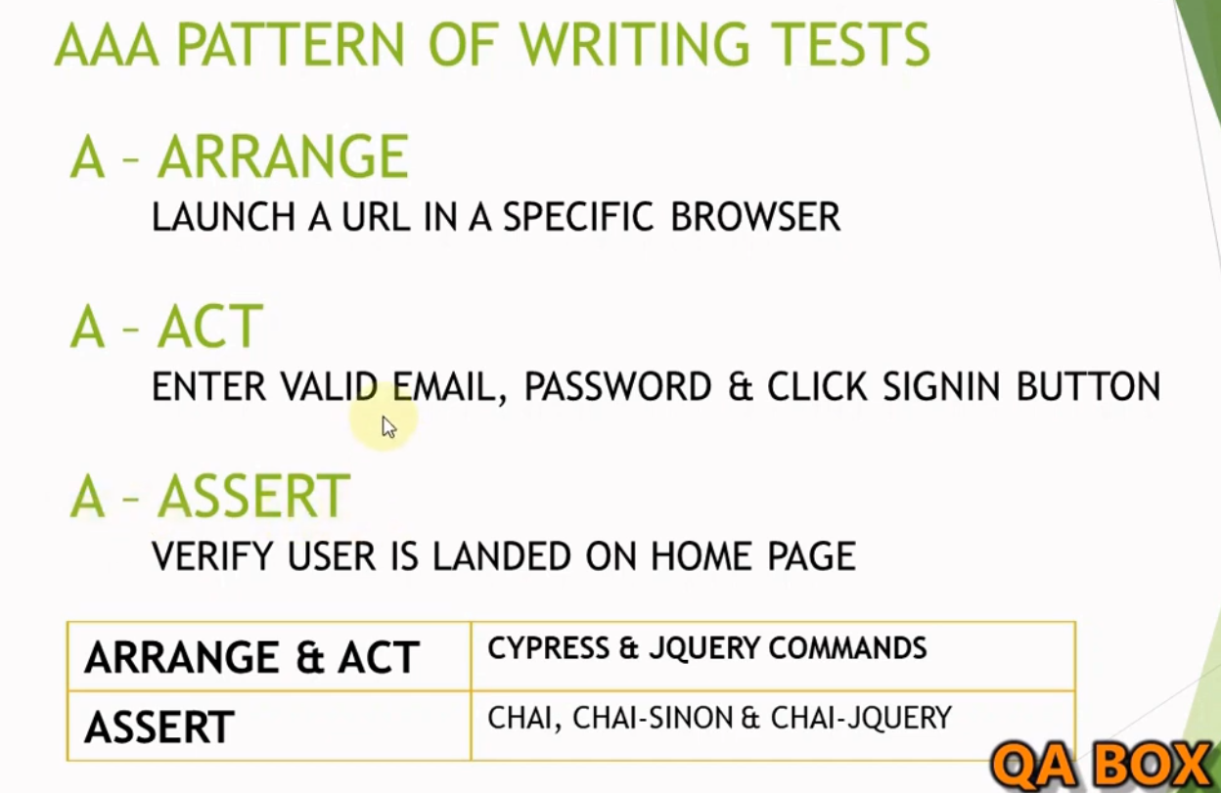

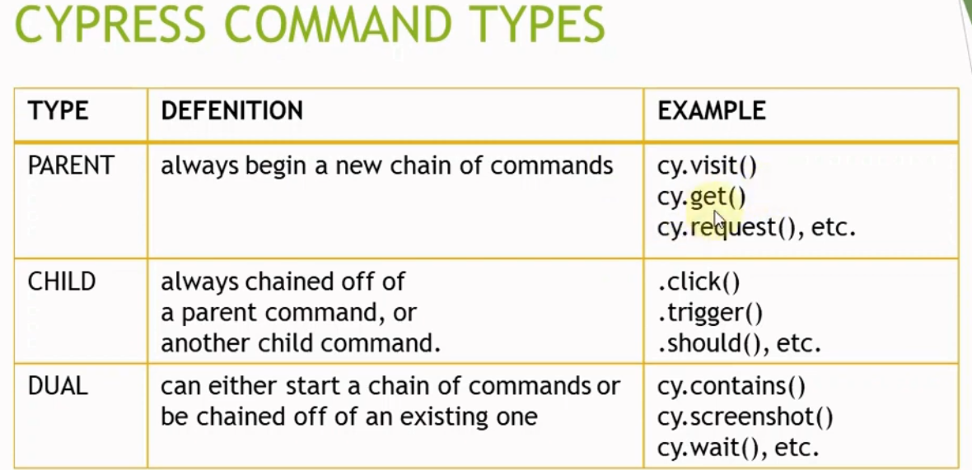

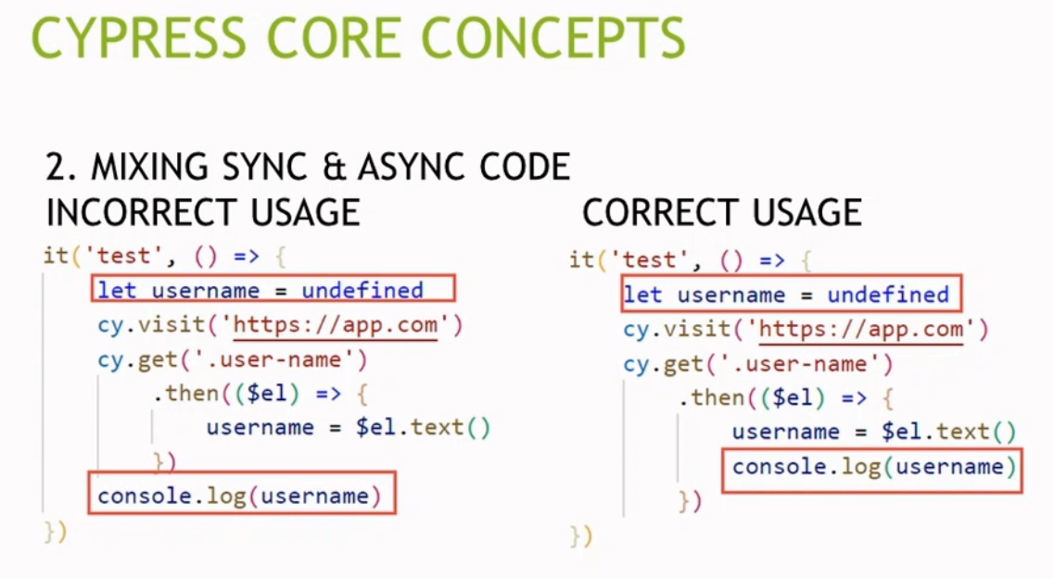

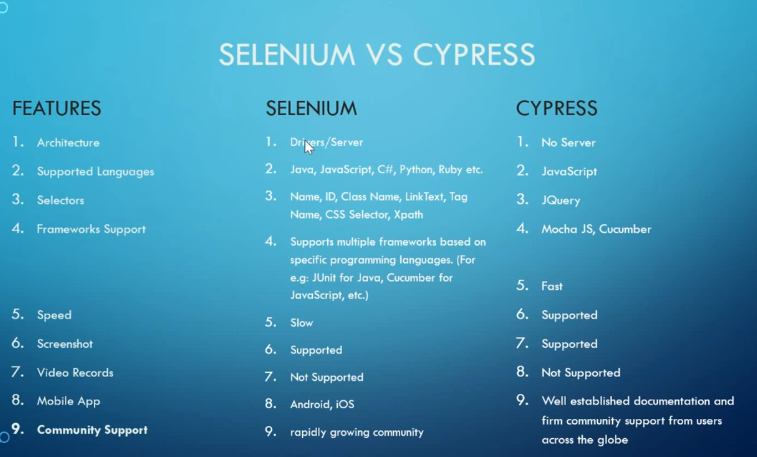

|  |  |  |  |
| --- | --- | --- | --- |
| Cheat sheet of Selectors | | | |
| 1 | **CSS Selector** | **Example** | **What gets selected** |
| 2 | **.class** | .body | **All elements with class="body"** |
| 3 | **#id** | #table | **Element with id="table"** |
| 4 | **\*** | * | **All elements** |
| 5 | **element** | section | **All <section> elements** |
| 6 | **element, element** | section, a | **All <section> elements and all <a> elements** |
| 7 | **element element** | section a | **All <a> elements inside <section> elements** |
| 8 | **element > element** | section > a | **All <a> elements where the parent is a <section> element** |
| 9 | **element + element** | section + a | **All <a> elements that are placed immediately after <section> elements** |
| 10 | **elementOne - elementTwo** | a ~ li | **Every <li> element that is before an <a> element** |
| 11 | **[attribute]** | [target] | **Elements which have a 'target' attribute.** |
| 12 | **[attribute=value]** | [target=_blank] | **Elements with target="_blank"** |
| 13 | **[attribute ~= value]** | [title~=table] | **Elements with a title attribute containing the word "table"** |
| 14 | **[attribute |= value]** | [lang|=lt] | **Elements which have an attribute "lang" set to "lt"** |
| 15 | **[attribute ^= value]** | link[href^="www"] | **Every <link> element containing 'href' attribute which starts with "www" is selected** |
| 16 | **[attribute $= value]** | link[href$=".exe"] | **Every <link> element containing 'href' attribute which ends with "www" is selected** |
| 17 | **[attribute *= value]** | link[href*="css"] | **Every <link> element whose href attribute value contains the substring "css"** |
| 18 | **:active** | link:active | **Active link** |
| 19 | **::after** | section::after | **Insert something after the content of each <section> element** |
| 20 | **::before** | section::before | **Insert something before the content of each <section> element** |
| 21 | **:checked** | input:checked | **Every checked <input> element** |
| 22 | **:disabled** | form:disabled | **Every disabled <form> element** |
| 23 | **:empty** | a:empty | **Every <a> element that has no children (including text nodes)** |
| 24 | **:enabled** | form:enabled | **Every enabled <form> element** |
| 25 | **:first-child** | section:first-child | **Every <section> element that is the first child of its parent** |
| 26 | **::first-letter** | section::first-letter | **First letter of every <section> element** |
| 27 | **::first-line** | section::first-line | **First line of every <section> element** |
| 28 | **:first-of-type** | section:first-of-type | **Every <section> element that is the first <section> element of its parent** |
| 29 | **:focus** | form:focus | **The <form> element which has focus** |
| 30 | **:hover** | link:hover | **Links on mouse over** |
| 31 | **:in-range** | input:in-range | **Input elements with a value within a specified range** |
| 32 | **:invalid** | input:invalid | **All input elements with an invalid value** |
| 33 | **:lang(language)** | track:lang(en) | **Every <track> element with a lang attribute equal to "en"** |
| 34 | **:last-child** | a:last-child | **Every <a> element that is the last child of its parent** |
| 35 | **:last-of-type** | a:last-of-type | **Every <a> element that is the last <a> element of its parent** |
| 36 | **:link** | a:link | **All unvisited links** |
| 37 | **:not(selector)** | :not(a) | **Every element that is not an <a> element** |
| 38 | **:nth-child(n)** | section:nth-child(2) | **Every <section> element which has a parent and is the second child of it** |
| 39 | **:nth-last-child(n)** | section:nth-last-child(2) | **Every <section> element that is the second child of its parent, counting from the last child** |
| 40 | **:nth-last-of-type(n)** | section:nth-last-of-type(2) | **Every <section> element that is the second <section> element of its parent, counting from the last child** |
| 41 | **:nth-of-type(n)** | section:nth-of-type(2) | **Every <section> element that is the second <section> element of its parent** |
| 42 | **:only-of-type** | section:only-of-type | **Every <section> element that is the only <section> element of its parent** |
| 43 | **:only-child** | section:only-child | **Every <section> element that is the only child of its parent** |
| 44 | **:optional** | input:optional | **Input elements with no "required" attribute** |
| 45 | **:out-of-range** | input:out-of-range | **Input elements with a value outside a specified range** |
| 46 | **:read-only** | input:read-only | **Input elements that have an attribute "read-only"** |
| 47 | **:read-write** | input:read-write | **Input elements with the "read-only" attribute NOT specified** |
| 48 | **:required** | input:required | **Input elements with the "required" attribute specified** |
| 49 | **:root** | :root | **Root element of the document** |
| 50 | **::selection** | ::selection | **Portion of an element that is selected by a user** |
| 51 | **:target** | #page:target | **Current active #page element** |
| 52 | **:valid** | input:valid | **All input elements with a valid value** |
| 53 | **:visited** | a:visited | **All visited links** |