Desktop Application improvements

Our application until now was completely separated the front end and back end.
The GUI part was a dummy without functionalities, and the logic was already a console application.
This two weeks I have developed the back end more as you can see from the UML. And also started to implement the Controllers that do the connection between the model that was already the console Application we used for getting data and test our algorithm and the GUI also I have done some small changes on GUI.

UML Diagram of Backend
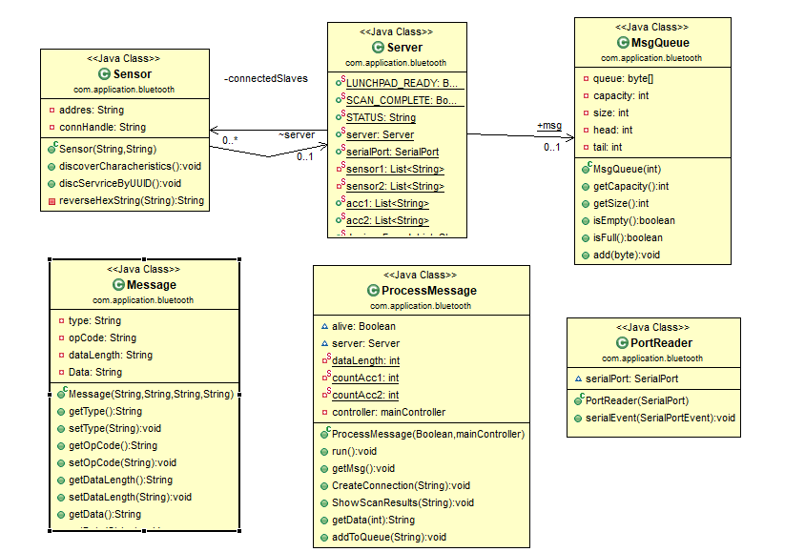

I have also made progress on defining the right bit mask for the services to help on communication
between our application and lunchpad and his slaves.
As can be seen in the UML I have created a new Class now called sensor and I create a new instance of that class whenever I establish a new connection between server(central device lunchpad) and a slave in this case Sensor. That helps because now after I discover Services and Characteristics, I can save them into that instance. After that I can create every kind of those that I call commands but that are hexadecimal strings send to the lunchpad by the serial port, since every instance will have its Characteristics and connection handle every detail about the slave. The class called Server that contains a collection of the connected slaves and can do whatever it want with those.
The problems that I am facing now are the buzzer service and the button service because I have to find the right hex values for them and to create the bit mask for the lunchpad.

GIU Updates

On top of the buttons, a ListBox was added to allow the user to select
the desired Sensortags to be connected. While this works as intended most
of the time, some problems arise when there are multiple devices around the
launchpad that have Bluetooth open. While they do not get recognized by
the application, and thus are not allowed to connect, the scanning function
finds only 8 devices at a time and currently these devices are not only the
Sensortags. It happens that either one or both Sensortags are not in the list
of scanned devices. This issue is currently a high priority that will be fixed
before the final report.
