Elis Haruni
Effort: 11h + 20h

This is the report for 4 week since I could not report the previous time.

First a recap of what I was doing I am working all the time with establishing BLE connection and creating a network to read the required data from the sensors.
I started directly with multi_role project that was suggested to me I could connect tow Slaves to the lunchpad (Master) but to discover Characteristics and read/write I could not do. That happened because the Write/read function of multi role project was not implemented. Considering to implement that function and solve the problem I decided not to do it because of my restricted knowledge on C and C++ from this decision starts the work of this 4 weeks.

Effort: 11h
First 2 weeks using host_test application with lunchpad again as a master I created a network for 1 sensor as a slave reading data and saving them in queue to print on console after that just to see the messages.
The implementation was done by the help of Java library to read and write to a serial COM port called jssc.jar.

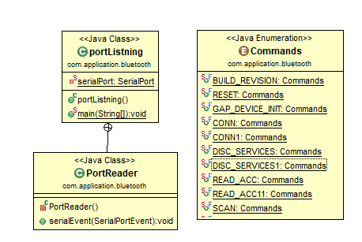
UML diagram for the first prototype of Network system in JAVA

First I needed only this three classes portListning PortReader that is a private inner class of port listning and an Enumeration for some commands that I need to send to lunchpad.
In the port listning Class the main method search for available COM ports and print them after that it ask you what port want to connect and open. After that activating a SerialPortEvent to the opened port will notify this thread every time that an event is happening to the port write/read.
On the PortReader Class that implements SerialPortEvent Interface implementing the required method serialEvent I only catch read events so when the lunchpad is sendig me data and I just print the hexadecimal Sring in console to check the data.
The time consuming part was Creating the so called Commands I started to build commands using TI BLE Vendor Specific HCI Reference Guide BLE5 Version 1.0.0.
Creating commands like that was taking a lot of time and I figured out another method sniffing the port with a port sniffer application while I used BLE device monitor for getting data.
Then o got all the writing commands with the help HCI Reference Guide I could translate all messages so I Go only the commands that I need to read from Accelerator. Here I was trying to get data only from Accelerator then later will think for Gyroscope.
A the end I could get data for my Application but I need to translate those data and to parse in the way I get a use of them.

Effort: 20h

This 2 week I continue on building the NS (Network System) part of SSNS.
New current Application UML diagram.

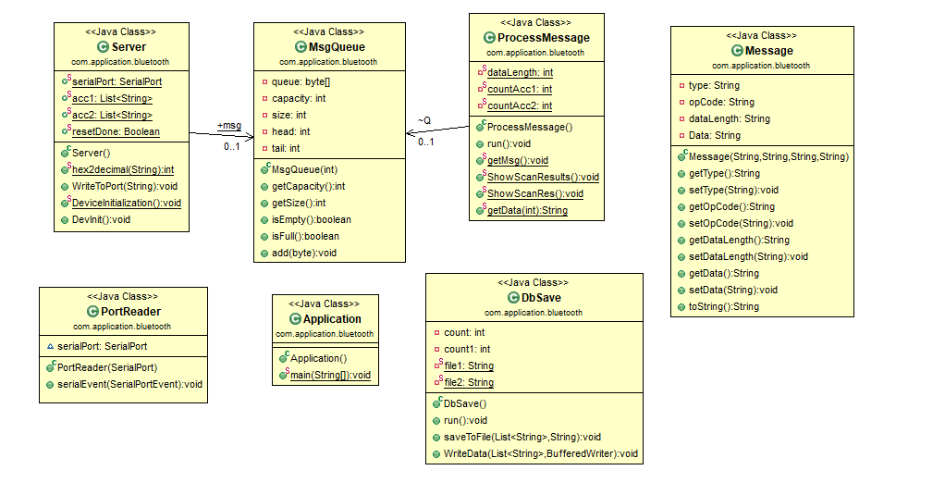
This is the auto generated UML diagram from an Eclipse plugin that's why there are some relations missing without a detailed explanation this UML is not understandable because of missing elements.
Also here the Commands Enumeration is missing because is very big for the figure.
Here we have now 7 classes this is developed from the first Application in previous weeks with 3 classes PortReader is the same but instead of a private inner class now I use Aggregation and Inheritance to implement the same thing. “portListning” was not named good for Java convention by mistake and with the new ideas I got a new name for it that is Server and the main() method now is in a new class Called Application that is somehow the user interface for now(Consloe view).
Now I don’t print the message on the Console when I get an event but insert the byte array to a Byte Queue I implemented and to process the Messages and to parse and translate the messages I use a new thread that gets the data from Queue so I get lower chances to interrupt or to put the main Thread in a lot of work and risk losing data.
I have defined a structure of the every message with the help of TI BLE Vendor Specific HCI Reference Guide BLE5 Version 1.0.0.
DbSave class is just a class to save Accelerator data in 2 different files for different sensors.
So with this Structure I can connect 2 sensortags and get data from them in the same time.
Apart for the successful work I was working on developing a python script to read the data from sensor and also with android code from TI but I then gave another try to this before finding a solution on one of those 2.

Rerfernces :

1.TI BLE Vendor Specific HCI Reference Guide BLE5 Version 1.0.0.
2.CC26x0 SimpleLink™ Bluetooth® low energy Software Stack 2.2.x Developer's Guide
3. http://dev.ti.com/tirex/content/simplelink_cc2640r2_sdk_1_40_00_45/docs/blestack/ble_user_guide/html/ble-stack-3.x/gatt.html#

