Report 4: Raul Bertone
Effort: 12

Sensortag
During testing of the Sensortag, a bug was encountered: every few seconds the data stream coming from the Sensortag would freeze, only to resume after approximately one second. Additionally, after the first pause, the values measured by the accelerometer would be off by a factor of 2. This behavior was present both while the Sensortag was connected to a smartphone as well as to the Launchpad. This pointed to the problem being in the modification that we performed in the Sensortag’s code.

After talking with Group 2, which made similar modifications but didn’t use the “EXCLUDE” directives for the pre-processor, we were mislead into thinking that the directives themselves were at fault. This made us loose some time chasing a red herring. Debugging revealed however that the “bug” was actually a feature we inadvertently turned on, namely Wake-On-Motion. This interrupts the sending of sensor data when there is no movement for more then a few seconds. Turning the feature back off, neatly solved the problem.

Fall Notification Service (FNS)
We developed the last main missing feature, the service that handles the notifications triggered by the detection of a fall. Its code interacts with each and every other part of the desktop application and ties them all together.
On start the FNS idles while waiting for a trigger. When the fall detection algorithm thinks the user has fallen, it alerts the FNS which turns on the buzzer in the Sensortag and raises the “Fall Detected” flag in the GUI and then waits for a preset amount of time (default 10 seconds) for feedback from the user in the form of a button press on the Sensortag. If no such feedback comes, help is requested (an email is sent to the helper’s address) and the “Help Requested” flag is raised in the GUI. Instead, in case a button is pressed before the preset time has elapsed, the buzzer is turned off and the “Fall Detected” flag lowered, after which the cycle repeats itself.
Below you see a state machine diagram illustrating the service’s operation:

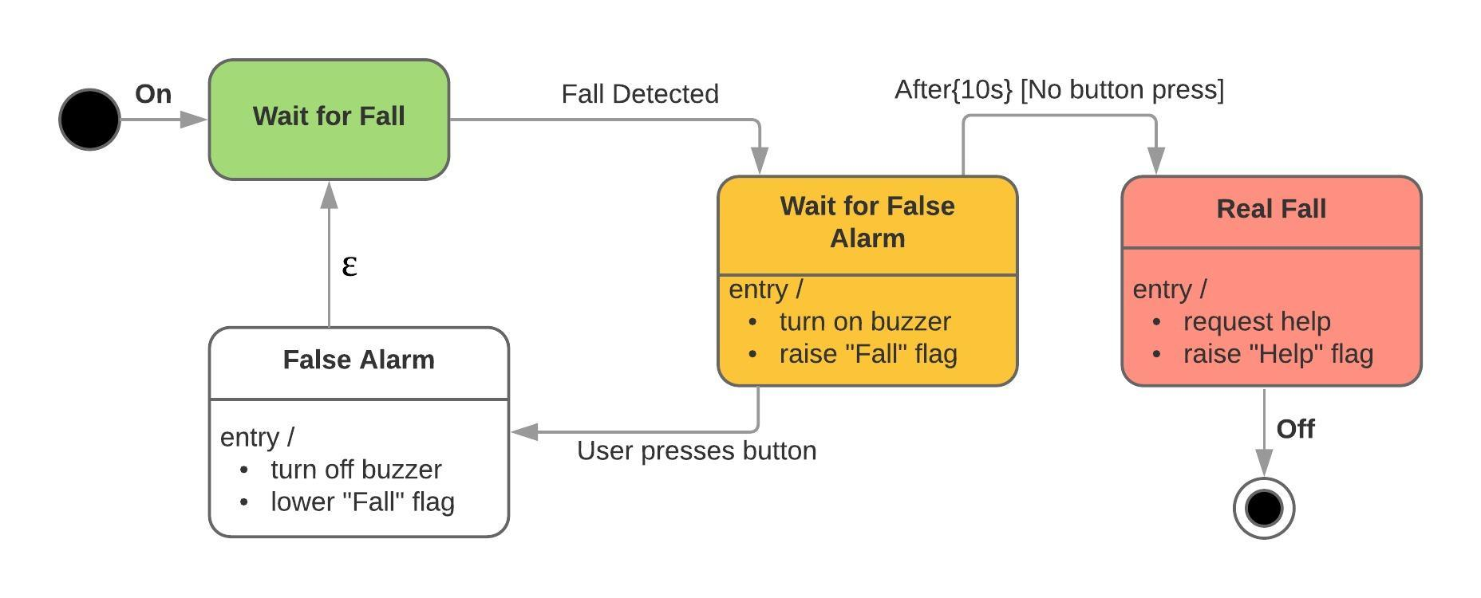

[for Johnny: at the following link you find the original image that you can use for the report]
https://raw.github.com/raulbertone/SSNS/development/documentation/State_Diagram.jpeg

As part of the development of this feature, we also collaborated to link it to the GUI. In particular Raul explained in detail the Fall Notification Service to Muyassar, so that she could modify it to interact with the GUI for turning the necessary flags on and off.

