# Analysis of Callus Development in Maize via Genetic Mapping and Transcriptional Profiling

# Abstract

Plant transformation is generally required for most genome engineering platforms. However, the transformation efficiency is highly dependent on species, individual genotypes, and tissue types. In maize, calli induced from immature embryos are regularly used for transformation. The callus development has been found to be associated with plant regeneration, thereby influencing the transformation efficiency. Of the segregation progeny of a transformation-amenable inbred line A188 and a transformation-recalcitrant inbred line B73, the callus forms into two major types: type I and type II, in which the type II callus grows faster and is the favorable type for regeneration. Here, type I and II calli from the B73xA188 F2 population were analyzed by Genotyping-By-Sequencing (GBS), which identified the quantitative trait loci (QTLs) controlling the callus type at chromosomes 2, 5, 6, 8, and 9. This result was largely supported by the bulk segregant RNA-Seq (BSR-Seq) analysis. Both analyses indicated that only the A188 allele at the chromosome 6 locus positively contributed to the formation of the type II callus. With BSR-Seq, differentially expressed genes (DEGs) between the type II and I F2 calli were identified. In addition, the fast-growth and slow-growth sectors developed from the same A188 immature embryos were separately dissected for the transcriptomic comparison. Both sets of DEGs from the two RNA-Seq comparisons are enriched in the process of cell wall organization, indicating the important role of the cell wall related pathway in callus morphological development. Combination of the five QTLs with the transcriptome analysis identified 39 DEGs located in the broad QTLs interval, providing the candidate genes for plant transformation improvement.

## Introduction

Plant transformation is an important process for genome engineering. For both crop improvement and biological research, an efficient transformation in diverse genetic backgrounds is highly beneficial [(Que *et al.* 2014; Altpeter *et al.* 2016)](https://paperpile.com/c/2Ehiwv/hmVwf+4HDkB). However, for many plant species, the transformation efficiency remains low and highly depends on cultivars selected. In maize, even though the transformation frequency has been improved through breeding [(Armstrong *et al.* 1991)](https://paperpile.com/c/2Ehiwv/FtzDT), medium optimization [(Duncan *et al.* 1985; Kotchoni *et al.* 2012; Cho *et al.* 2014, 2015)](https://paperpile.com/c/2Ehiwv/CN0J9+gwYNN+cj95U+SSly5), and embryogenesis genes manipulation [(Lowe *et al.* 2016)](https://paperpile.com/c/2Ehiwv/QbVRO), the transformation efficiency across cultivars, or genotypes, varies dramatically, and the underlying genetic basis remains unclear [(Que *et al.* 2014; Altpeter *et al.* 2016)](https://paperpile.com/c/2Ehiwv/4HDkB+hmVwf).

In maize, the embryogenic callus produced by the immature embryo is widely utilized for gene transformation. The callus formation and the regeneration are the major factors influencing the transformation efficiency [(Duncan *et al.* 1985; Tomes and Smith 1985; Hodges *et al.* 1986)](https://paperpile.com/c/2Ehiwv/CN0J9+0B2nN+Zb4vb). Of 25 maize inbred lines surveyed in the Hogdes’ study [(Hodges *et al.* 1986)](https://paperpile.com/c/2Ehiwv/Zb4vb), the calli induced from immature embryos of A188, A634, W117, MS71, and H99 were highly regenerable, while the regeneration frequencies of the calli of B73, H84, and N28 were less than 20%. When the highly regenerable line A188 was crossed to the other 24 inbred lines, the regeneration of the progeny of most of the inbred lines, such as B73, Mo17, H95, Oh43, and VA26, were markedly improved, which suggested the callus embryogenesis is under the genetic control and A188 contains at least some dominant alleles contributing to the regeneration capacity. The genetic elements of the callus embryogenesis were analyzed by QTL mapping [(Armstrong *et al.* 1992; Krakowsky *et al.* 2006)](https://paperpile.com/c/2Ehiwv/e185S+eIi7w) and GWAS [(Ma *et al.* 2018)](https://paperpile.com/c/2Ehiwv/QQyi9).

Two distinct types of embryogenic callus, type I and type II, can be initiated from the maize immature embryos. Type I callus was translucent, slow growing, and compact structure mixed with differentiated tissue, while type II callus was highly embryogenic, white or pale yellow, fast growing and friable [(Tomes and Smith 1985; D’Halluin *et al.* 1992; Welter *et al.* 1995; Frame *et al.* 2000)](https://paperpile.com/c/2Ehiwv/lFjjq+0B2nN+HJLZf+3yMgc). Plants are generally regenerated from the type I callus through either the meristem or the somatic embryo, or from the type II callus developed from the somatic embryo [(Welter *et al.* 1995)](https://paperpile.com/c/2Ehiwv/lFjjq). Even though type I and II calli from different genotypes had been used to produce transgenic plants [(D’Halluin *et al.* 1992; Ishida *et al.* 1996)](https://paperpile.com/c/2Ehiwv/3yMgc+WvRHP), type II callus was favorable for gene transformation due to the features of fast growth and high regenerability over years [(McCain *et al.* 1988; Frame *et al.* 2000)](https://paperpile.com/c/2Ehiwv/HJLZf+x5v03).

Hi-II is a popular line used for maize transformation [(Ishida *et al.* 1996; Songstad *et al.* 1996; Que *et al.* 2014)](https://paperpile.com/c/2Ehiwv/WvRHP+TJRcM+4HDkB), and was generated by the cross of two partial inbred lines, Hi-II A and B, each of which had almost 100% type II callus initiation of immature embryos [(Armstrong *et al.* 1991; Ishida *et al.* 1996; Songstad *et al.* 1996)](https://paperpile.com/c/2Ehiwv/FtzDT+WvRHP+TJRcM). Hi-II A and B were developed from maize inbred lines B73 and A188. The Inbred B73 is an elite line but transformation recalcitrant, while A188 is a highly regenerable line with a poor agronomic performance [(Hodges *et al.* 1986)](https://paperpile.com/c/2Ehiwv/Zb4vb). The type II calli can be initiated from both A188 and B73 genotypes but the frequency of type II callus of B73 is much lower [(McCain *et al.* 1988)](https://paperpile.com/c/2Ehiwv/x5v03). The excellent type II callus initiation of the Hi-II A and B supported the possibility of regeneration improvement through genetic selection.

Plant regeneration can be also improved through molecular manipulation. Two transcription factors BBM and WUS2have been shown to dramatically improve the embryogenesis in maize and other monocot crops [(Lowe *et al.* 2016)](https://paperpile.com/c/2Ehiwv/QbVRO), indicating the importance of gene regulators for plant regeneration. More studies explored transcriptional regulation during the callus formation [(Shen *et al.* 2012; Salvo *et al.* 2014; Zhang *et al.* 2019; Du *et al.* 2019)](https://paperpile.com/c/2Ehiwv/54NvI+vJfbi+HBta5+oqhsJ). Analysis of the callus induction from the maize immature embryo at the early stage revealed that the genes involved in the callus development were enriched in the processes of nutrition uptake, cell wall organization, hormone pathway, stress response, lipid metabolism, signal transduction, oxidation-reduction process, heme binding, and iron ion binding [(Shen *et al.* 2012; Salvo *et al.* 2014; Zhang *et al.* 2019; Du *et al.* 2019)](https://paperpile.com/c/2Ehiwv/54NvI+vJfbi+HBta5+oqhsJ). In our study, the genetic mapping and transcriptomic profiling were performed to analyze the callus development using both F2 progeny of B73xA188, as well as transcriptomic analysis with fast- and slow-growth callus tissues identified from A188 calli. Our results provide fundamental knowledge for further studies of callus embryogenesis in plants.

## Materials and Methods

**B73xA188 F2 callus tissues for mapping and RNA-Seq**

B73xA188 F1s were grown and self-pollinated to produce F2 ears in the nursery. Immature embryos with length 1.0-1.2 mm were dissected from 13 F2 ears at 11 days after pollination (DAP) and cultured for 3 weeks on N6 medium supplemented with 1.5 mg/L 2,4- dichlorophenoxyacetic acid (2,4-D) at 28˚C in the dark. To map QTLs associated with maize callus type I and II, we separately selected 100 eXtremely type I (XT-I) and II (XT-II) calli from 2,194 F2 calli (13 F2 ears). Each selected callus was cut into two pieces, one was for individual Genotype-By-Sequencing (GBS), and the other one was for bulked segregant RNA-sequencing (BSR-Seq). For BSR-Seq, fifty calli were pooled as one bulk sample, and 4 bulk samples in total were used for RNA-Seq.

**A188 callus tissues for RNA-Seq**

A188 immature embryos (N=330) were dissected from 4 ears at 11 DAP and cultured on N6 medium for 30 days followed by 5 days sub-culture. Sixty of A188 type II calli with fast and slow growing sections were sampled. Specifically, on each callus, the fast and slow growing parts were identified and sampled separately. Sections from 20 fast or slow growing calli were separately pooled. In total, 3 fast growing callus bulks and 3 slow growing callus bulks were collected for RNA-Seq.

**DNA isolation and GBS sequencing**

DNAs of calli was isolated using the DNeasy Plant Mini Kit (Qiagen, USA). In brief, callus samples were disrupted under liquid nitrogen, and then dissolved in buffer AP1 following the manufacturer's instructions. Finally, The DNA was eluted with distilled water and normalized to 15 ng/ul for GBS library preparation.

Hi-II A and B seeds were grown in the greenhouse at 27˚C in the day and 23°C at night with a 16-hour photoperiod. Ten-day-old seedlings were harvested for DNA extraction using the DNeasy Plant Mini Kit (Qiagen, USA). The DNA was dissolved in water and normalized to 15 ng/ul for GBS library preparation.

The GBS protocol was described in chapter 2. In brief, 150 ng DNA of each individual sample was digested with restriction enzymes Bsp1286I (New England Biolabs, USA) at 37˚C for 2 hours followed by the ligation oligos as barcodes using T4 ligase (New England Biolabs, USA) at 16˚C for 1.5 hours. The enzymes in the previous reactions were inactivated at 65˚C for 20 minutes. After that, digestion-ligation products of multiple samples were equally pooled and purified with Qiaquick PCR purification kit (Qiagen, USA) and AMPure XP beads (Beckman Coulter Life Sciences, USA). The purified DNA was input as the template for PCR amplification with the Q5 high fidelity DNA polymerase (New England Biolabs, USA) and the primers matching to Illumina adaptors. The PCR product was purified by using AMPure XP beads (Beckman Coulter Life Sciences, USA), resulting in a GBS library. The GBS library sequenced on an Illumina HiseqX 10 platform at Novogene.

**RNA extraction and sequencing**

XT-I, XT-II, A188 fast and slow growing tissue samples were grounded with mortar and pestle under liquid nitrogen. RNA isolation used the RNeasy Plant Mini Kit (Qiagen, USA) following the manufacturer's instruction. Library preparation and RNA sequencing were performed at Novogene. About 20 million pair reads were generated for each RNA sample on a HiseqX 10 platform.

**Genotypes of GBS segment markers**

Illumina 150-bp paired raw reads were trimmed using Trimmomatic (version 0.38) [(Bolger *et al.* 2014)](https://paperpile.com/c/2Ehiwv/W5wRX), followed by decoding and fine trimming procedures with custom scripts to assign reads to each individual sample. To increase genotype calling accuracy in the following steps, high-depth (>30x) whole genome sequencing (WGS) data of A188 and B73 were used to call genotypes of the two parental lines (NCBI SRA accession: SRX8420667, SRX8420668, SAMN05578024, SAMN05578025).

After trimming, reads were aligned to the B73 reference genome version 4 (B73Ref4) [(Jiao *et al.* 2017)](https://paperpile.com/c/2Ehiwv/DdtE7) using the BWA aligner [(Li and Durbin 2010)](https://paperpile.com/c/2Ehiwv/5wS1E). Aligned reads were filtered if they did not match the following criteria: insert size of 50-800 bp, mapping score greater than 40, the match region greater than 50, the mismatch percentage less than 6%, and the percentage of the unmatched overhang, or the tail, of the read length less than 5. The GATK haplotypecaller [(Li and Durbin 2010; McKenna *et al.* 2010; Poplin *et al.* 2018)](https://paperpile.com/c/2Ehiwv/5wS1E+gezQE+6lFNI) was used to discover SNPs. SNPs were further filtered and converted to segment (bin) markers by using the R package of Genomap (<https://github.com/liu3zhenlab/genomap>).

**QTL mapping using R/qtl**

Genetic position of each segment marker was estimated using a B73XA188 DH genetic map. The R/qtl [(Broman *et al.* 2003)](https://paperpile.com/c/2Ehiwv/KL38C) function scanone was used to map the QTLs with the standard interval mapping method and the binary model. Two LOD thresholds were used: the LOD value at the 5% significance level from 1000 permutations and the LOD value of 3 [(Broman 2001)](https://paperpile.com/c/2Ehiwv/eI2HW). R/qtl functions plotPXG and fitqtl were used to plot and estimate the QTL effect, respectively.

**Genetic mapping using logistic regression**

With GBS segment genotyping data of individual XT-I and XT-II, the logistic regression was employed to test the hypothesis that there was no genotype frequency difference between XT-I and XT-II groups. Two approaches were employed to determine significance thresholds. Multiple tests were accounted for with the false discovery rate (FDR) of 1% [(Benjamini and Hochberg 1995)](https://paperpile.com/c/2Ehiwv/6YLHj). A permutation test similar to a standard QTL permutation test was conducted 1000 times to determine the distribution of p-values under the null hypothesis and the significance level of 5% were selected as the p-value cutoff.

**BSR-Seq analysis**

RNA-Seq raw reads were trimmed using Trimmomatic (version 0.38) [(Bolger *et al.* 2014)](https://paperpile.com/c/2Ehiwv/W5wRX), and then aligned to B73Ref4 with STAR (version 2.7.3a) [(Dobin *et al.* 2013)](https://paperpile.com/c/2Ehiwv/7Jbl0). SNPs were discovered using GATK unifiedgenotyper [(Li and Durbin 2010; McKenna *et al.* 2010; Poplin *et al.* 2018)](https://paperpile.com/c/2Ehiwv/5wS1E+gezQE+6lFNI). Bi-allelic SNPs were selected using GATK with the criteria "AF >= 0.2 && QUAL >= 30.0 && DP >= 100 && DP < 10000". Potential error SNPs based on polymorphic data between B73 and A188 were discarded. The generalized linear model assuming the binomial distribution of two alleles were employed to detect the association between the SNP site and callus types.

**Differential expression analysis**

Reads trimming and alignment were described in the BSR-Seq method. With read counts per gene resulting from STAR analysis, the statistical test with DESeq2 was performed to identify differentially expressed genes [(Love *et al.* 2014)](https://paperpile.com/c/2Ehiwv/YDww9). Multiple tests were accounted for with the false discovery rates (FDR) for the XT-II versus XT-I comparison and the fast- versus slow-growth A188 callus comparison [(Benjamini and Hochberg 1995)](https://paperpile.com/c/2Ehiwv/6YLHj).

**Gene ontology (GO) enrichment analysis**

Differentially expressed genes (DEGs) with the FDR of 10% were used to determine if DEGs are enriched in certain GO terms. The resampling method in GOSeq [(Young *et al.* 2010)](https://paperpile.com/c/2Ehiwv/jJR4J) was employed. The p value cutoff is 0.05.

**Identification of candidate genes**

Three sets of genes were selected to explore the genes of interest using Venn Diagram in R (<https://www.r-graph-gallery.com/14-venn-diagramm.html>). The three gene sets include the genes in the QTL intervals and two DEG sets. Genes in the LOD support QTL intervals were identified using Bedtools [(Quinlan and Hall 2010)](https://paperpile.com/c/2Ehiwv/p12G7). Significant DEGs between type II and I, and DEGs between A188 fast- and slow-growth comparison were selected with absolute fold changes greater than 2 and the FDR of 5%.

**Plotting**

Genotypes of markers were plotted using the function plotPXG in R/qtl. All other plots, including genetic mapping of the QTLs, segments genotypes of HI-II, XT-I and II samples, were plotted with custom R scripts.

## Results

### Genetic mapping of the callus type

Immature embryos dissected from 13 B73xA188 F2 ears were cultured on N6 callus induction media. After three weeks of culture, compact type I and friable type II calli (**Figure 3.1a**) were observed, and 100 most typical type I (referenced to as extremely type I, or XT-I) and 100 most typical type II (referenced to as extreme type II, or XT-II) calli were sampled. Individual calli were subjected to Genotype-By-Sequencing (GBS) and XT-1 and XT-2 calli were separately pooled, 50 calli per bulk, resulting in two bulks of XT-1 and two bulks of XT-II for bulked segregant RNA sequencing (BSR-Seq).

Out of the 200 calli, GBS data of 153 individuals were produced, and 96,703 SNPs were identified. SNP genotypes of each F2 individual were used to infer chromosomal segments harboring multiple SNP markers with the same genotypes. The number of segments indicated the number of discernible recombination events per F2 individual. After filtering F2 individuals with recombination events higher than expected [(Ren *et al.* 2020)](https://paperpile.com/c/2Ehiwv/4Zqgh), 60 XT-I and 58 XT-II individuals were retained. With the segment genotypes, 6,369 GBS segment markers were generated for genetic mapping of the callus type (**Figure 3.1b, 3.1d; Figure C.1-C.10; Table 3.1**). A standard interval QTL mapping approach and a method of logistic regression were employed for the QTL mapping. The two approaches identified highly concordant QTL peaks at chromosome 2, 5, 6, 8 and 9, which were designated as CtAB.2.01, CtAB.5.01, CtAB.6.01, CtAB.8.01, and CtAB.9.01, respectively. The LOD supported QTL intervals were estimated (**Table 3.1**). In total, these five QTLs explained 50.9% of the phenotypic variance.

From BSR-Seq of the bulked XT-I and XT-II samples, 68,147 SNPs were identified. Assuming read counts of two alleles of a SNP site had a binomial distribution, the statistical test found 284 associated SNP sites with a divergent allele distribution between the XT-I and XT-II. Most associated SNPs were located on chromosomes 2, 3, 5, 6, 8, and 9, supporting the GBS mapping result with an additional peak on chromosome 3 (**Figure 3.1c; Figure D.3; Table 3.1**).

Among these five QTLs, CtAB.5.01 was the QTL with the strongest signal (**Figure 3.1b-d, 3.2; Table 1**). The homozygous B73 genotype of CtAB.5.01 was highly enriched in XT-II individuals, while the homozygous A188 genotype was enriched in XT-I individuals (**Figure 3.2d,c**). The phenotypic means of the three genotypes indicated that two alleles of QTL CtAB.5.01 functioned additively, and the B73 allele was favorable for the type II callus. In addition to CtAB.5.01, the B73 alleles were favorable alleles for type II callus phenotype at the QTLs CtAB.2.01, CtAB.8.01, and CtAB.9.01 (**Figure 3.3, 3.4; Table 3.1**), whereas the A188 genotype only positively contributed to type II callus at CtAB.6.01 (**Figure 3.3,3.4; Table 3.1**).

### The type II callus favorable alleles of three QTLs selected in Hi-II A and B

Hi-II A and B were genotyped by the GBS method and genotypes of chromosomal segments were inferred, which showed that most chromosome regions are in a homozygous status (**Figure 3.5**). Based on genotypes of segments, 22 breakpoints and 54 recombination breakpoints were found in Hi-II A and B, respectively (**Figure 3.5; Table C.1**). The genotype data also showed that the type II callus favorable alleles of three QTLs, CtAB.2.01, CtAB.6.01, and CtAB.8.01, were selected in both Hi-II A and B. However, the type II callus favorable alleles at the major QTL, CtAB.5.01, and one minor QTL, CtAB.9.01 were not selected.

### Differential expression of type II and I F2 calli

BSR-Seq were also used to examine differential expression between XT-I and XT-II calli, identifying 1,193 up-regulated and 1,012 down-regulated differentially expressed genes (DEGs). Gene ontology (GO) term enrichment analysis showed that up-regulated genes were enriched in the pathways related to transmembrane components, lipid metabolism, oxidative response, carbohydrate metabolism, DNA binding, and aspartic-type endopeptidase process, while the down-regulated genes were enriched in the pathways involved in DNA binding, metal ion binding, cell wall organization, and aspartyl esterase process (**Figure 3.6**). Further examination found that 66 down-regulated DEGs were associated with cell wall modification, such as pectinesterase, expansin, xyloglucan endotransglucosylase, and beta-galactosidase.

### Differential expressed genes of A188 fast- and slow-growth calli

In the tissue culture, the growth rate of callus tissues varies. Fast- and slow-growth calli initiated from single immature embryos of A188 were sampled for RNA-Seq analysis (**Figure 3.7**). In total, 1,287 up-regulated DEGs and 1,926 down-regulated DEGs in fast-growth calli were identified from the comparison. GO enrichment analysis (**Figure 3.8**) indicated that up-regulated DEGs were enriched in the process related to transcriptional regulation, transmembrane transportation, fatty acid biosynthesis, and heme binding, and the down-regulated DEGs were enriched in the process of oxidative response, metal ion binding, DNA binding, heme binding, and cell wall formation. Of the 83 down-regulated DEGs associated with the GO term of cell wall, 60 genes were overlapped with the DEGs from the XT-II and XT-I comparison, which further supported that the cell wall composition plays a role in the growth rate of calli.

### Integration of genetic mapping and DEGs

The QTL intervals include 9,273 annotated genes which was about 23.4% of the total annotated genes in B73 version 4 [(Jiao *et al.* 2017)](https://paperpile.com/c/2Ehiwv/DdtE7). From the QTL intervals, we identified 39 DEGs from the two RNA-Seq comparisons with the fold changes in both comparisons greater than 2 and the 5% FDR (**Figure 3.9; Table 3.2**). QTL CtAB.6.01 contains five such genes. All these five genes were down-regulated in the F2 XT-II versus XT-I comparison, and four gene down-regulated and one gene up-regulated in the comparison between A188 fast- and slow-growth calli (**Table 3.2**). The four genes down-regulated in both XT-II and fast-growth calli include *wat1* (walls are thin 1, Zm00001d036123) and *end1* (early nodulin homolog1, Zm00001d036125) that are homologs of genes involved in the nodule development, *si1* (silky1, Zm00001d036425) encoding a DNA binding protein involved in the silk development, and the gene Zm00001d036409 encoding an unknown function protein with C2-C2 zinc finger. All these genes were low expressed in immature embryos 13 days after pollination (DAP) and highly or medium expressed in the endosperm except *wat1*, which was highly expressed in the pericarp and the endosperm adjacent to scutellum [(Doll *et al.* 2020)](https://paperpile.com/c/2Ehiwv/p4Tav). The cell wall related gene *wat1* encoding an EamA-like transporter was further examined (Figure 3.10). Comparison the A188 and B73 allele sequences found seven SNPs and a 3-bp insertion/deletion (INDEL) in exons, and two large INDELs (382-bp in an intron and 277-bp in the 3’ UTR) and a number of SNPs located in other non-coding sequences. However, the allelic expression in XT-II and XT-I maintained a similar ratio based on read counts of each SNP allele in the fifth exon, and no obvious difference was observed in the transcript at the sequence level.

## Discussion

Traits related callus development are not easy to quantify and a few studies have been conducted to map transformation related to genomic loci [(Armstrong *et al.* 1992; Lowe *et al.* 2006; Krakowsky *et al.* 2006; Salvo *et al.* 2018)](https://paperpile.com/c/2Ehiwv/e185S+eIi7w+b7QHN+arIWV). In the two studies using A188 or Hi-II, they were used to cross with other transformation-recalcitrant lines and identified chromosomal segments from transformation-amenable parents or segregation distortion after multiple rounds of selection of the highly transformable progeny [(Armstrong *et al.* 1992; Lowe *et al.* 2006)](https://paperpile.com/c/2Ehiwv/eIi7w+b7QHN). Using this atypical QTL mapping strategy, transformation associated loci were found at chromosomes 1, 2, 3, and 9 using an (A188 x B73) x B73 backcrossed population [(Armstrong *et al.* 1992)](https://paperpile.com/c/2Ehiwv/eIi7w), and mapped to chromosomes 1, 2, 3, 6, and 10 using an FBLL x (FBLL x Hi-II) backcross population [(Lowe *et al.* 2006)](https://paperpile.com/c/2Ehiwv/b7QHN). The chromosome 3 QTL was further examined and mapped to an approximately three megabase region [(Salvo *et al.* 2018)](https://paperpile.com/c/2Ehiwv/arIWV). In our study, we mapped the genomic loci responsible for the callus type to chromosomes 2, 5, 6, 8, and 9. As the previous reports selected highly transformable lines from the backcrossed progeny, the traits under selection are related to callus initiation, callus growth, and regeneration. In our study, the callus type is the trait examined, at least partially explaining the difference in the QTL identification. Type II callus favorable alleles at five QTL we found are found in both A188 and B73 parents, consistent with the finding that their recombinant inbred lines (e.g., Hi-II A and B) developed a higher proportion of type II calli than the parents during tissue culture. Only the QTL on chromosome 6 carries the A188 allele favoriting the type II callus, indicating this QTL is critical for the formation of the type II callus. The QTL on chromosome 6 overlaps with the chromosome 6 QTL detected in Lowe et al. 2006 study, which supports that the chromosome 6 QTL may be correlated with regeneration.

Callus induction is a complex process of cell dedifferentiation. The biological processes involved in early callus induction were revealed through transcriptional analysis [(Shen *et al.* 2012; Salvo *et al.* 2014; Zhang *et al.* 2019; Du *et al.* 2019)](https://paperpile.com/c/2Ehiwv/54NvI+vJfbi+HBta5+oqhsJ). In our study, the transcription analysis was performed on calli after 21 days and 35 days. In the comparisons between fast growing type II and slow growing type I, and between the fast growing and slow growing A188 type II call, genes down-regulated in fast growing calli are enriched in the pathway related to the cell wall organization. The cell wall is crucial for plant growth development [(Marowa *et al.* 2016)](https://paperpile.com/c/2Ehiwv/ReXLs), and the differential expressed genes involved in cell wall organization were also identified in the previous transcriptional analysis of callus induction in maize [(Shen *et al.* 2012)](https://paperpile.com/c/2Ehiwv/54NvI). The down-regulation of genes functioning in cell wall organization could loosen the cell wall and cellular adhesion [(Nishikubo *et al.* 2011; Marowa *et al.* 2016; Wormit and Usadel 2018)](https://paperpile.com/c/2Ehiwv/ReXLs+M8Yrs+lTqwi). The difference in the cell wall component and structure between type I and II may result in different water, ion, oxygen, and nutrient uptake ability, thereby affecting the growing rate, transformation efficiency, and regeneration ability.

The DEGs in different callus types are expected to contribute to the phenotypic variation. We found 39 significant DEGs shared by both RNA-Seq comparisons were located in the QTLs intervals. Of the 39 genes, a gene *wat1* close to our QTL is on chromosome 6. Cell elongation was defected in the *Arabidopsis* *wat1* mutant, which resulted in an abnormal secondary cell wall in the fiber cell and short stem [(Ranocha *et al.* 2010)](https://paperpile.com/c/2Ehiwv/uiP9t). The down-regulated *wat1* gene in our transcription analysis may be involved in the cell wall modification and callus morphology.

## Conclusion

In this study, we employed multiple strategies to understand the genetic basis of the formation of the callus type in A188 x B73. Besides genomic changes in the sequence level, the chromatin state may play important roles in the callus response and regeneration. Epigenetic changes during tissue culture in maize and other species were discussed in the previous chapter and literature [(Lee and Seo 2018; Han *et al.* 2018)](https://paperpile.com/c/2Ehiwv/fEWek+c6NaS). A comprehensive study combining the genetic mapping, transcriptional analysis, and epigenetic analysis are needed to better understand the genetics of callus type trait.

## References

[Altpeter F., N. M. Springer, L. E. Bartley, A. E. Blechl, T. P. Brutnell, et al., 2016 Advancing Crop Transformation in the Era of Genome Editing. Plant Cell 28: 1510–1520.](http://paperpile.com/b/2Ehiwv/hmVwf)

[Armstrong C. L., C. E. Green, and R. L. Phillips, 1991 Development and availability of germplasm with high Type II culture formation response. Maize Genetics Cooperation Newsletter 65: 92–93.](http://paperpile.com/b/2Ehiwv/FtzDT)

[Armstrong C. L., J. Romero-Severson, and T. K. Hodges, 1992 Improved tissue culture response of an elite maize inbred through backcross breeding, and identification of chromosomal regions important for regeneration by RFLP analysis. Theoretical and Applied Genetics 84-84: 755–762.](http://paperpile.com/b/2Ehiwv/eIi7w)

[Benjamini Y., and Y. Hochberg, 1995 Controlling the false discovery rate: A practical and powerful approach to multiple testing. J. R. Stat. Soc. 57: 289–300.](http://paperpile.com/b/2Ehiwv/6YLHj)

[Bolger A. M., M. Lohse, and B. Usadel, 2014 Trimmomatic: a flexible trimmer for Illumina sequence data. Bioinformatics 30: 2114–2120.](http://paperpile.com/b/2Ehiwv/W5wRX)

[Broman K. W., 2001 Review of statistical methods for QTL mapping in experimental crosses. Lab Anim. 30: 44–52.](http://paperpile.com/b/2Ehiwv/eI2HW)

[Broman K. W., H. Wu, S. Sen, and G. A. Churchill, 2003 R/qtl: QTL mapping in experimental crosses. Bioinformatics 19: 889–890.](http://paperpile.com/b/2Ehiwv/KL38C)

[Cho M.-J., E. Wu, J. Kwan, M. Yu, J. Banh, et al., 2014 Agrobacterium-mediated high-frequency transformation of an elite commercial maize (Zea mays L.) inbred line. Plant Cell Rep. 33: 1767–1777.](http://paperpile.com/b/2Ehiwv/cj95U)

[Cho M.-J., J. Banh, M. Yu, J. Kwan, and T. J. Jones, 2015 Improvement of Agrobacterium-mediated transformation frequency in multiple modern elite commercial maize (Zea mays L.) inbreds by media modifications. Plant Cell Tissue Organ Cult. 121: 519–529.](http://paperpile.com/b/2Ehiwv/SSly5)

[D’Halluin K., E. Bonne, M. Bossut, M. De Beuckeleer, and J. Leemans, 1992 Transgenic maize plants by tissue electroporation. Plant Cell 4: 1495–1505.](http://paperpile.com/b/2Ehiwv/3yMgc)

[Dobin A., C. A. Davis, F. Schlesinger, J. Drenkow, C. Zaleski, et al., 2013 STAR: ultrafast universal RNA-seq aligner. Bioinformatics 29: 15–21.](http://paperpile.com/b/2Ehiwv/7Jbl0)

[Doll N. M., J. Just, V. Brunaud, J. Caïus, A. Grimault, et al., 2020 Transcriptomics at Maize Embryo/Endosperm Interfaces Identifies a Transcriptionally Distinct Endosperm Subdomain Adjacent to the Embryo Scutellum. Plant Cell 32: 833–852.](http://paperpile.com/b/2Ehiwv/p4Tav)

[Du X., T. Fang, Y. Liu, L. Huang, M. Zang, et al., 2019 Transcriptome Profiling Predicts New Genes to Promote Maize Callus Formation and Transformation. Front. Plant Sci. 10: 1633.](http://paperpile.com/b/2Ehiwv/oqhsJ)

[Duncan D. R., M. E. Williams, B. E. Zehr, and J. M. Widholm, 1985 The production of callus capable of plant regeneration from immature embryos of numerous Zea mays genotypes. Planta 165: 322–332.](http://paperpile.com/b/2Ehiwv/CN0J9)

[Frame B. R., H. Zhang, S. M. Cocciolone, L. V. Sidorenko, C. R. Dietrich, et al., 2000 Production of transgenic maize from bombarded type II callus: effect of gold particle size and callus morphology on transformation efficiency. In Vitro Cellular & Developmental Biology-Plant 36: 21–29.](http://paperpile.com/b/2Ehiwv/HJLZf)

[Han Z., P. A. Crisp, S. Stelpflug, S. M. Kaeppler, Q. Li, et al., 2018 Heritable Epigenomic Changes to the Maize Methylome Resulting from Tissue Culture. Genetics 209: 983–995.](http://paperpile.com/b/2Ehiwv/fEWek)

[Hodges T. K., K. K. Kamo, C. W. Imbrie, and M. R. Becwar, 1986 Genotype specificity of somatic embryogenesis and regeneration in maize. Nat. Biotechnol. 4: 219–223.](http://paperpile.com/b/2Ehiwv/Zb4vb)

[Ishida Y., H. Saito, S. Ohta, Y. Hiei, T. Komari, et al., 1996 High efficiency transformation of maize (Zea mays L.) mediated by Agrobacterium tumefaciens. Nat. Biotechnol. 14: 745–750.](http://paperpile.com/b/2Ehiwv/WvRHP)

[Jiao Y., P. Peluso, J. Shi, T. Liang, M. C. Stitzer, et al., 2017 Improved maize reference genome with single-molecule technologies. Nature 546: 524–527.](http://paperpile.com/b/2Ehiwv/DdtE7)

[Kotchoni S. O., P. A. Noumavo, A. Adjanohoun, D. P. Russo, J. Dell’Angelo, et al., 2012 A simple and efficient seed-based approach to induce callus production from B73 maize genotype. Am. J. Mol. Biol. 02: 380–385.](http://paperpile.com/b/2Ehiwv/gwYNN)

[Krakowsky M. D., M. Lee, L. Garay, W. Woodman-Clikeman, M. J. Long, et al., 2006 Quantitative trait loci for callus initiation and totipotency in maize (Zea mays L.). Theor. Appl. Genet. 113: 821–830.](http://paperpile.com/b/2Ehiwv/e185S)

[Lee K., and P. J. Seo, 2018 Dynamic Epigenetic Changes during Plant Regeneration. Trends Plant Sci. 23: 235–247.](http://paperpile.com/b/2Ehiwv/c6NaS)

[Li H., and R. Durbin, 2010 Fast and accurate long-read alignment with Burrows-Wheeler transform. Bioinformatics 26: 589–595.](http://paperpile.com/b/2Ehiwv/5wS1E)

[Love M. I., W. Huber, and S. Anders, 2014 Moderated estimation of fold change and dispersion for RNA-seq data with DESeq2. Genome Biol. 15: 550.](http://paperpile.com/b/2Ehiwv/YDww9)

[Lowe B. A., M. M. Way, J. M. Kumpf, J. Rout, D. Warner, et al., 2006 Marker assisted breeding for transformability in maize. Mol. Breed. 18: 229–239.](http://paperpile.com/b/2Ehiwv/b7QHN)

[Lowe K., E. Wu, N. Wang, G. Hoerster, C. Hastings, et al., 2016 Morphogenic Regulators Baby boom and Wuschel Improve Monocot Transformation. Plant Cell 28: 1998–2015.](http://paperpile.com/b/2Ehiwv/QbVRO)

[Ma L., M. Liu, Y. Yan, C. Qing, X. Zhang, et al., 2018 Genetic Dissection of Maize Embryonic Callus Regenerative Capacity Using Multi-Locus Genome-Wide Association Studies. Front. Plant Sci. 9: 561.](http://paperpile.com/b/2Ehiwv/QQyi9)

[Marowa P., A. Ding, and Y. Kong, 2016 Expansins: roles in plant growth and potential applications in crop improvement. Plant Cell Rep. 35: 949–965.](http://paperpile.com/b/2Ehiwv/ReXLs)

[McCain J. W., K. K. Kamo, and T. K. Hodges, 1988 Characterization of Somatic Embryo Development and Plant Regeneration from Friable Maize Callus Cultures. Bot. Gaz. 149: 16–20.](http://paperpile.com/b/2Ehiwv/x5v03)

[McKenna A., M. Hanna, E. Banks, A. Sivachenko, K. Cibulskis, et al., 2010 The Genome Analysis Toolkit: a MapReduce framework for analyzing next-generation DNA sequencing data. Genome Res. 20: 1297–1303.](http://paperpile.com/b/2Ehiwv/gezQE)

[Nishikubo N., J. Takahashi, A. A. Roos, M. Derba-Maceluch, K. Piens, et al., 2011 Xyloglucan endo-transglycosylase-mediated xyloglucan rearrangements in developing wood of hybrid aspen. Plant Physiol. 155: 399–413.](http://paperpile.com/b/2Ehiwv/M8Yrs)

[Poplin R., V. Ruano-Rubio, M. A. DePristo, T. J. Fennell, M. O. Carneiro, et al., 2018 Scaling accurate genetic variant discovery to tens of thousands of samples. Cold Spring Harbor Laboratory 201178.](http://paperpile.com/b/2Ehiwv/6lFNI)

[Que Q., S. Elumalai, X. Li, H. Zhong, S. Nalapalli, et al., 2014 Maize transformation technology development for commercial event generation. Front. Plant Sci. 5: 379.](http://paperpile.com/b/2Ehiwv/4HDkB)

[Quinlan A. R., and I. M. Hall, 2010 BEDTools: a flexible suite of utilities for comparing genomic features. Bioinformatics 26: 841–842.](http://paperpile.com/b/2Ehiwv/p12G7)

[Ranocha P., N. Denancé, R. Vanholme, A. Freydier, Y. Martinez, et al., 2010 Walls are thin 1 (WAT1), an Arabidopsis homolog of Medicago truncatula NODULIN21, is a tonoplast-localized protein required for secondary wall formation in fibers. Plant J. 63: 469–483.](http://paperpile.com/b/2Ehiwv/uiP9t)

[Ren W., X. Gong, K. Li, H. Zhang, F. Chen, et al., 2020 Recombination Pattern Characterization via Simulation Using Different Maize Populations. Int. J. Mol. Sci. 21. https://doi.org/](http://paperpile.com/b/2Ehiwv/4Zqgh)[10.3390/ijms21062222](http://dx.doi.org/10.3390/ijms21062222)

[Salvo S. A. G. D., C. N. Hirsch, C. R. Buell, S. M. Kaeppler, and H. F. Kaeppler, 2014 Whole transcriptome profiling of maize during early somatic embryogenesis reveals altered expression of stress factors and embryogenesis-related genes. PLoS One 9: e111407.](http://paperpile.com/b/2Ehiwv/vJfbi)

[Salvo S., J. Cook, A. R. Carlson, C. N. Hirsch, S. M. Kaeppler, et al., 2018 Genetic fine-mapping of a quantitative trait locus (QTL) associated with embryogenic tissue culture response and plant regeneration ability in maize (Zea mays L.). Plant Genome 11: 170111.](http://paperpile.com/b/2Ehiwv/arIWV)

[Shen Y., Z. Jiang, X. Yao, Z. Zhang, H. Lin, et al., 2012 Genome expression profile analysis of the immature maize embryo during dedifferentiation. PLoS One 7: e32237.](http://paperpile.com/b/2Ehiwv/54NvI)

[Songstad D. D., C. L. Armstrong, W. L. Petersen, B. Hairston, and M. A. W. Hinchee, 1996 Production of transgenic maize plants and progeny by bombardment of hi-II immature embryos. In Vitro Cellular & Developmental Biology - Plant 32: 179–183.](http://paperpile.com/b/2Ehiwv/TJRcM)

[Tomes D. T., and O. S. Smith, 1985 The effect of parental genotype on initiation of embryogenic callus from elite maize (Zea mays L.) germplasm. Theor. Appl. Genet. 70: 505–509.](http://paperpile.com/b/2Ehiwv/0B2nN)

[Welter M. E., D. S. Clayton, M. A. Miller, and J. E Petolino, 1995 Morphotypes of friable embryogenic maize callus. Plant Cell Rep. 14: 725–729.](http://paperpile.com/b/2Ehiwv/lFjjq)

[Wormit A., and B. Usadel, 2018 The Multifaceted Role of Pectin Methylesterase Inhibitors (PMEIs). Int. J. Mol. Sci. 19. https://doi.org/](http://paperpile.com/b/2Ehiwv/lTqwi)[10.3390/ijms19102878](http://dx.doi.org/10.3390/ijms19102878)

[Young M. D., M. J. Wakefield, G. K. Smyth, and A. Oshlack, 2010 Gene ontology analysis for RNA-seq: accounting for selection bias. Genome Biol. 11: R14.](http://paperpile.com/b/2Ehiwv/jJR4J)

[Zhang X., Y. Wang, Y. Yan, H. Peng, Y. Long, et al., 2019 Transcriptome sequencing analysis of maize embryonic callus during early redifferentiation. BMC Genomics 20: 159.](http://paperpile.com/b/2Ehiwv/HBta5)

## Figures

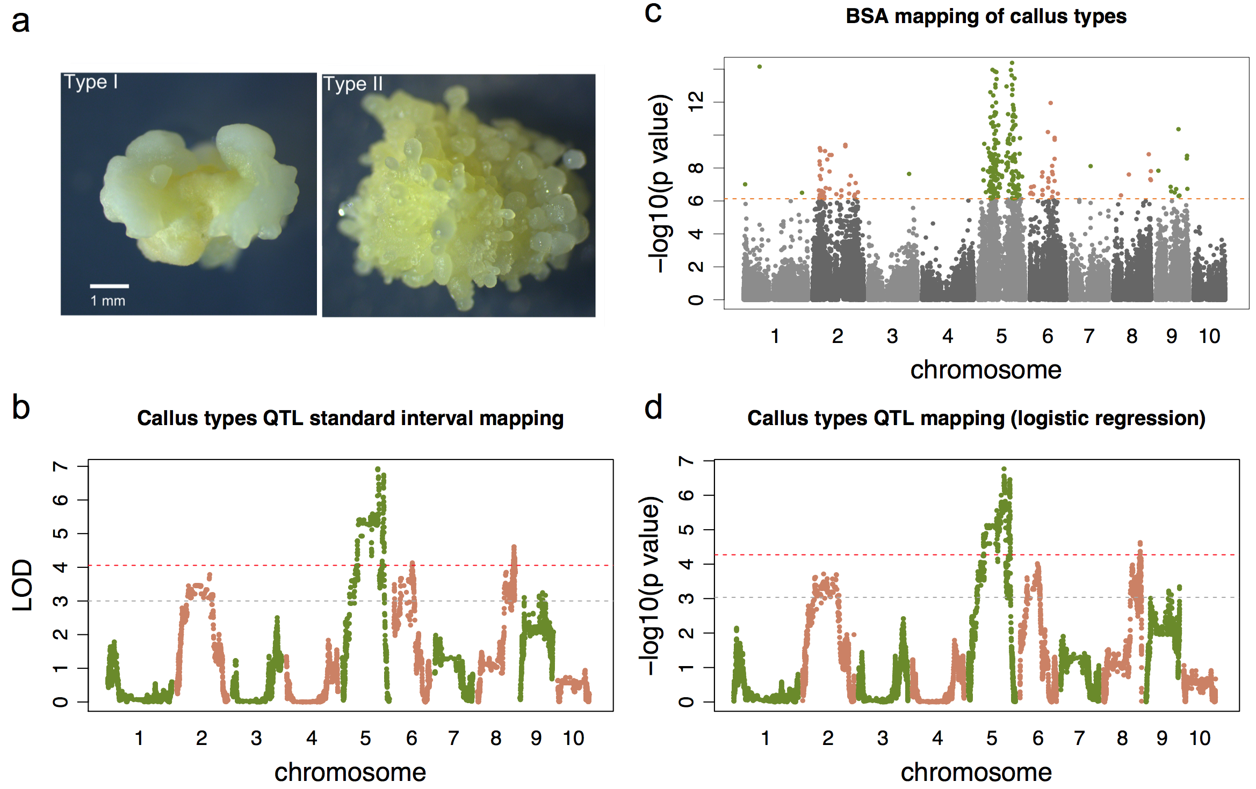

Figure . Genetic mapping of callus type QTLs

(**a**) Type I and type II calli initiated from B73XA188 F2 immature embryos. (**b,d**) Genetic mapping of callus type with GBS seg markers. **(b**) the QTLs were mapped using the standard interval mapping method (R/qtl) with a binary model. The red dash line indicates the significance threshold defined by the 1000 permutation tests at 5% significance level, and the grey dash line indicates the threshold 3. (**d**) the QTLs were mapped with a logistic regression method. The red dash line indicates the significance threshold defined by the 1000 permutation tests at 5% significance level, and the grey dash line indicates the threshold of FDR=0.01. (**c**) Genetic mapping of callus type with SNPs identified from BSR-Seq. The orange dash line indicates the threshold using the Bonferroni correction at the 5% significance level. The significant SNP markers were colored in olive green or light salmon. In all three mapping plots, x-axes designate the accumulated physical positions of markers.

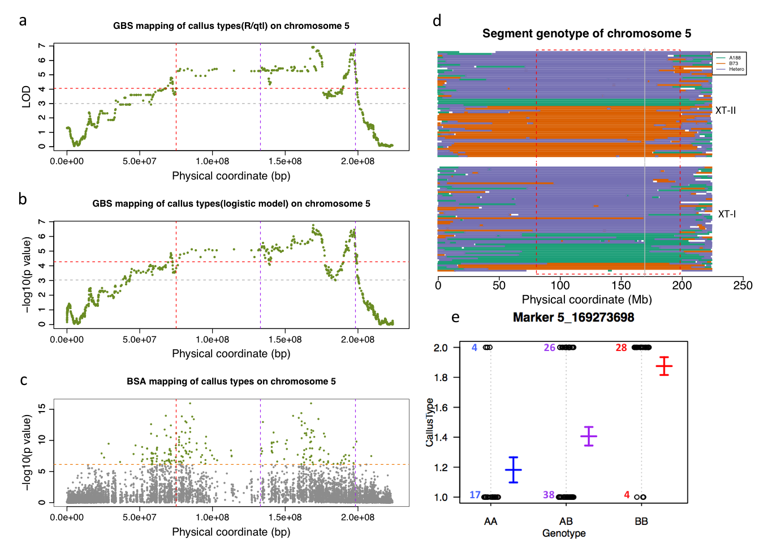

Figure . Detailed characterization of QTL CtAB.5.01

(**a,b**) Genetic mapping of callus type with GBS segment markers on chromosome 5. (**a**) The result on chromosome 5 using the interval QTL mapping. The red dash line indicates the significance threshold defined by permutation tests at the 5% significance level, and the grey dash line indicates the threshold 3 of LOD. (**b**) The QTL result on chromosome 5 using a logistic regression method. The red dash line indicates the significance threshold with permutation tests at 5% significance level, and the grey dash line indicates the threshold of the 1% FDR. (**c**) Genetic mapping of callus type from BSR-seq. The orange dash line indicates the threshold defined by the Bonferroni correction at the 5% significance level. The significance SNP markers are colored in olive green or light salmon. The vertical purple dash lines (in **a-c**) indicates the LOD support QTL interval, and the red vertical dash line indicates the left flanking of the interval adjusted based on the BSR-seq mapping. (**d**) Genotype of the 118 F2 individuals on chromosome 5. The upper panel contains the genotypes of 58 XT-II individuals, and the bottom panel contains the genotypes of 60 XT-I individuals. Each horizontal line represents the genotype of an individual. The green, orange, purple, white lines stand for a chromosome region with homozygous A188 genotype, homozygous B73 genotype, heterozygous genotype, and missing data, respectively. The red rectangle indicates a QTL interval, and the gray vertical line labels the QTL position mapped by the GBS segment markers. The individuals within a phenotype group (XT-I and XT-II) are ordered based on the genotype of the QTL marker. (**e**) The effect of the QTL marker. The y-axis represents the callus type phenotype, and x-axis represents different genotypes. Type I and II phenotype is coded as 1 and 2, respectively. The genotype AA is homozygous A188 genotype, AB is heterozygous genotype, and BB is homozygous B73 genotype. The open circle in the plot indicates an F2 individual, which was genotyped by the GBS method. As only two phenotype categories and three genotype groups, the open circles clustered together in different densities. The number of each genotype in each phenotype group is indicated nearby. The phenotype means of each genotype group were plotted in blue, purple and red with standard deviation.

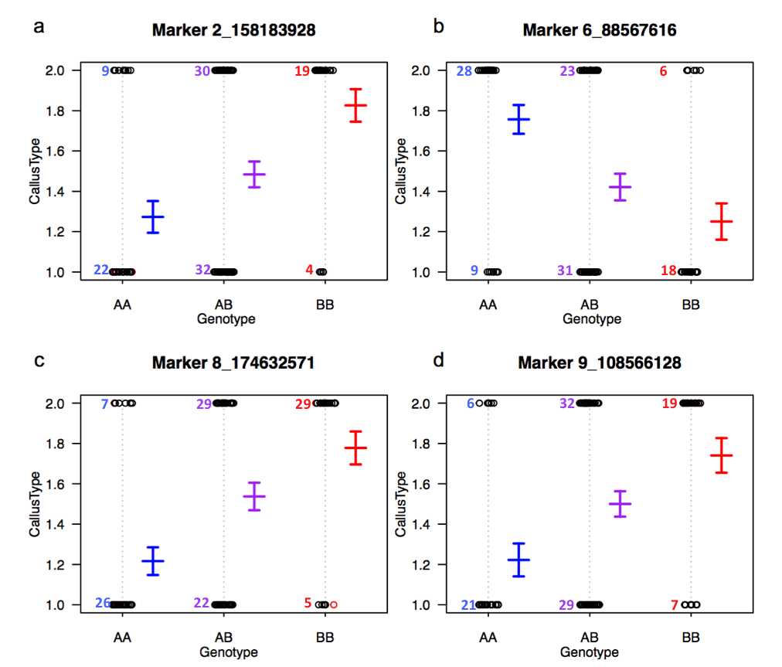

Figure . Effect of QTL markers on chromosomes 2, 6, 8, and 9

(**a**) Marker effect of QTL CtAB.2.01. (**b**) Marker effect of QTL CtAB.6.01. (**c**) Marker effect of QTL CtAB.8.01. (**d**) Marker effect of QTL CtAB.9.01. The y axis represents the phenotype, and the x axis represents different genotypes. Type I phenotype was coded as 1, and type II was coded as number 2. The genotype AA was homozygous A188 genotype, AB was heterozygous genotype and BB was homozygous B73 genotype. The open circle in the plot indicated an F2 individual, which was genotyped by GBS method. As only two phenotype categories and three genotype groups, the open circles clustered together in different densities. Numbers represent counts of individual samples in each group. The phenotype means of each genotype group were plotted in blue, purple and red with standard deviations.

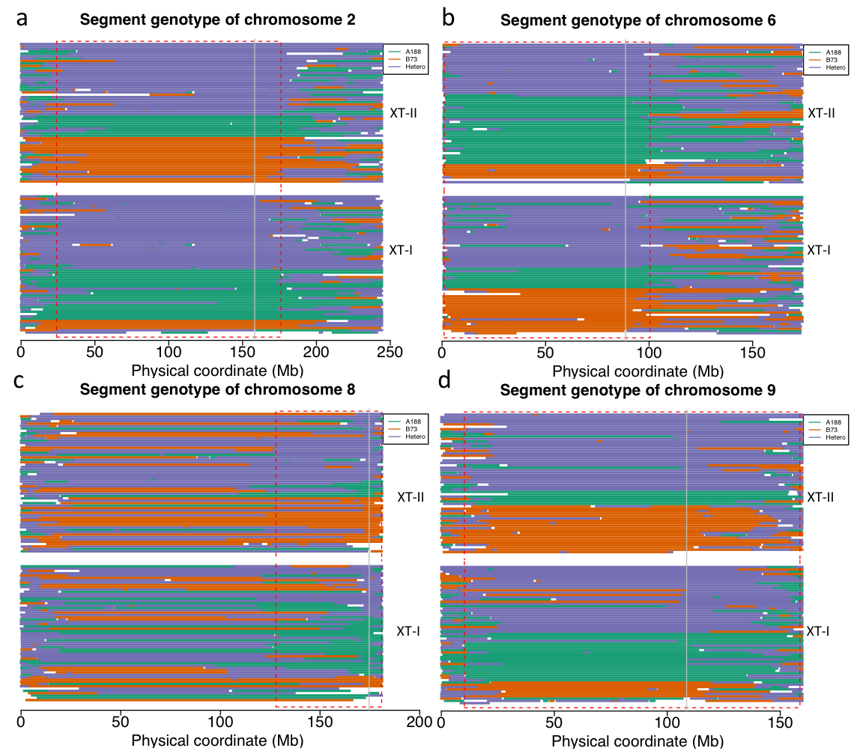

Figure . Genotype of the 118 F2 individuals on chromosomes 2, 6, 8, and 9

(**a**) Genotype of chromosome 2. (**b**) Genotype of chromosome 6. (**c**) Genotype of chromosome 8. (**d**) Genotype of chromosome 9. The upper panel of each plot includes the genotypes of 58 XT-II individuals, and the bottom panel includes the genotypes of 60 XT-I individuals. Each horizontal line represents the genotype of an individual. The green, orange, purple, white lines indicate the chromosome region (segment) with homozygous A188 genotype, homozygous B73 genotype, heterozygous genotype, and missing data, respectively. The red rectangle indicates the QTL interval, and the gray vertical line labeles at the QTL position mapped by the GBS segment markers. The individuals within a phenotype group (XT-I and XT-II) were ordered based on the genotype of the QTL marker.

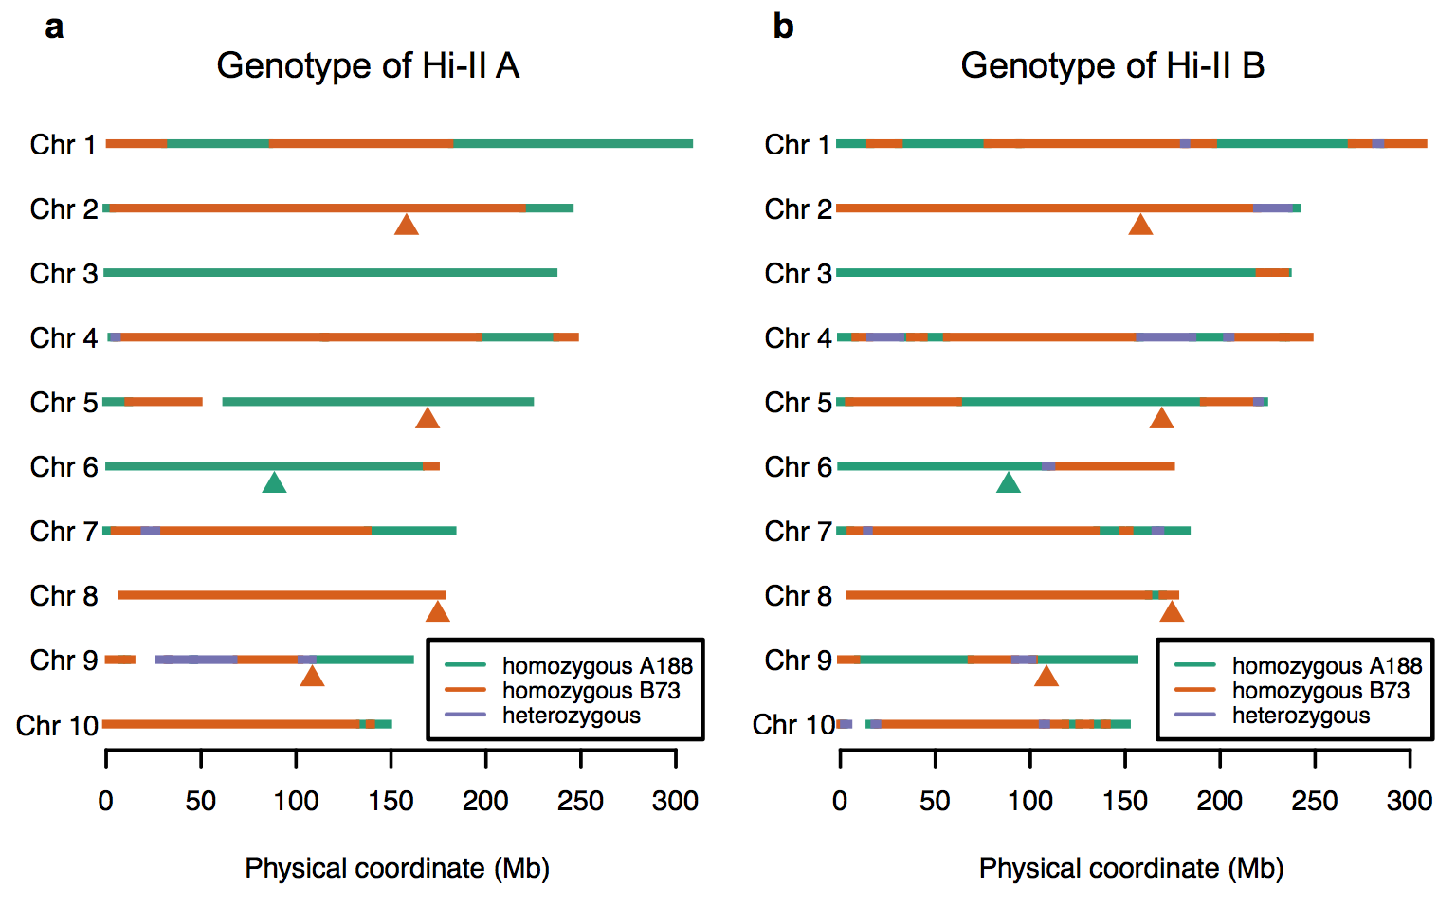

Figure . Genotypes of Hi-II A and B

(**a**) Genotypes of chromosome segments in Hi-II A. (**b**) Genotype of chromosome segments in Hi-II B. The green, orange, purple, white lines indicate chromosome segment with homozygous A188 genotype, homozygous B73 genotype heterozygous genotype, and missing data, respectively. The triangle under chromosomes labels the QTLs mapped by the GBS method, and the color of the triangle indicates the favorable allele. Green indicates the A188 allele and orange indicates the B73 allele. Red rectangles indicates the QTL intervals.

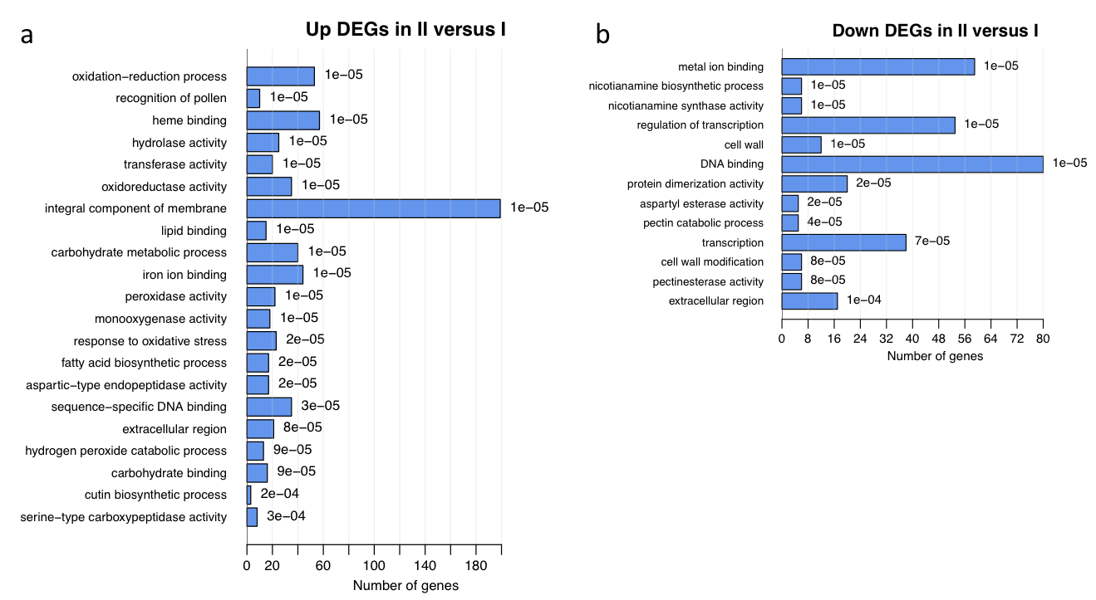

Figure . GO term analysis of type II and I DEGs

**(a**) GO term analysis of up-regulated DEGs. (**b**) GO term analysis of down-regulated DEGs. GO terms with a p-value smaller than 0.05 were presented.

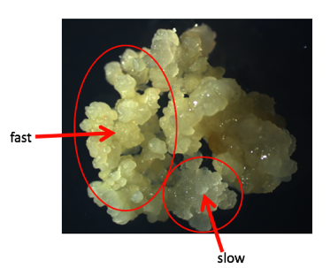

Figure . Fast and slow growing A188 callus

Fast- and slow-growth calli are indicated by ovals and arrows.

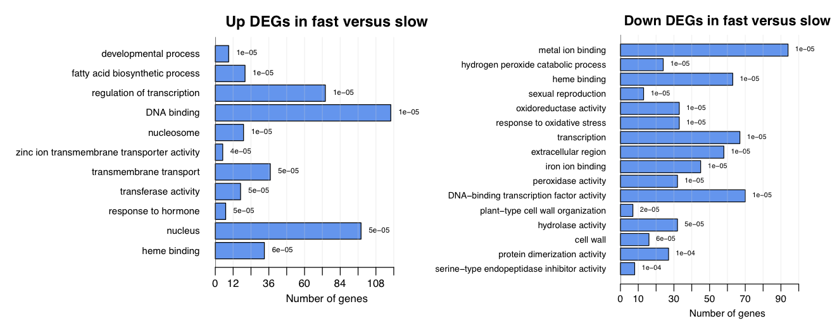

Figure 3.8 GO term analysis of DEGs between fast- and slow-growth A188 calli

(**a**) GO term analysis of up-regulated DEGs. (**b**) GO term analysis of down-regulated DEGs. GO terms with a p-value smaller than 0.05 were presented.

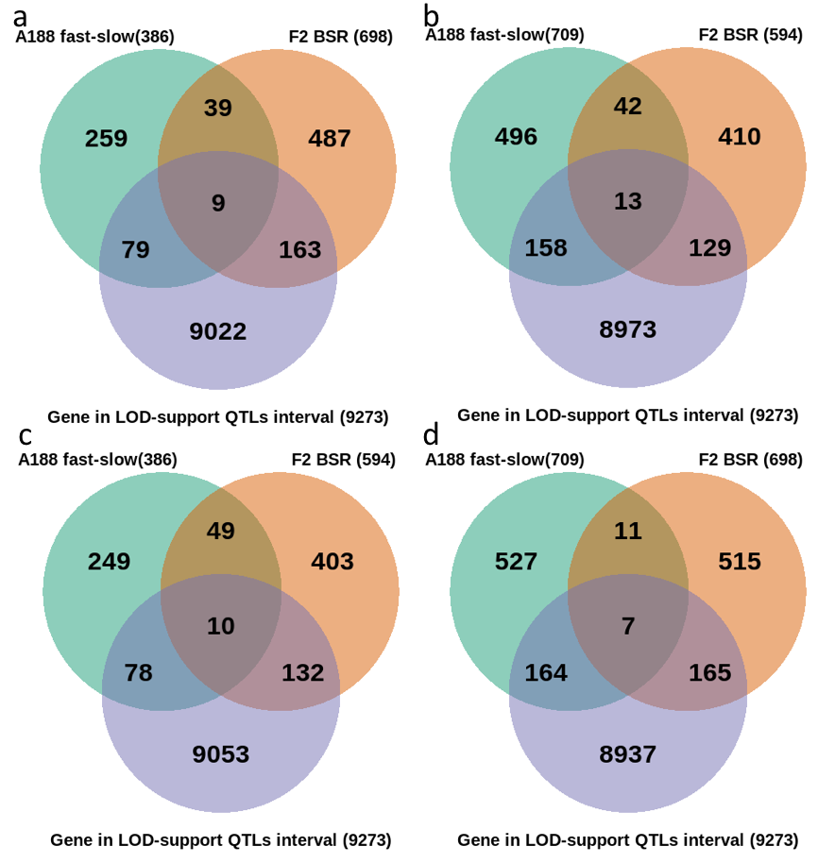

Figure . Venn diagrams of genes in genetic mapping intervals and DEGs

(**a**) Venn diagram of up-regulated DEGs and genes in the QTLs interval. (**b**) Venn diagram of down-regulated DEGs and genes in the QTLs interval (**c**) Venn diagram of up-regulated DEGs in the comparison between fast- and slow-growth A188 calli, down-regulated genes in F2 type II and I calli comparison, and the genes in the QTLs interval. (**d**) Venn diagram of down-regulated DEGs in the comparison between fast- and slow-growth A188 calli, up-regulated genes in F2 type II and I calli comparison, and the genes in the QTLs interval.

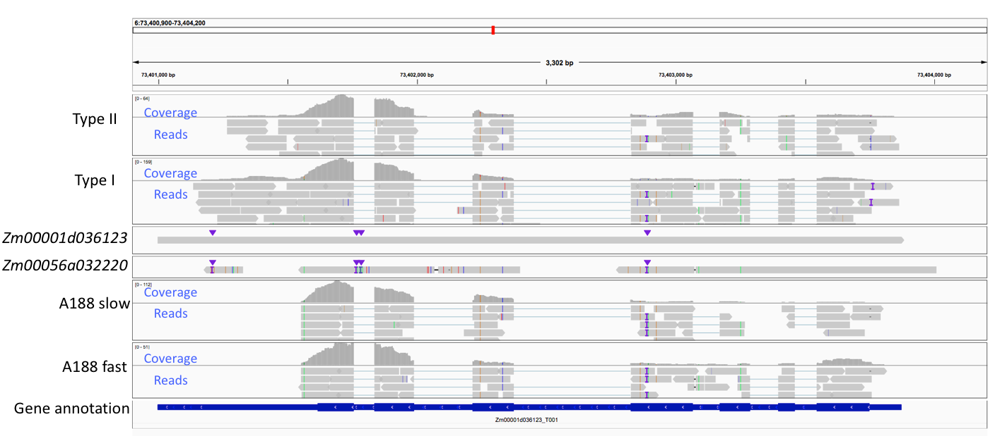

Figure . The expression of gene *wat1*

Snapshot of the alignment of RNA-Seq and the alleles of *wat1*. The sample name, DNA sequence name, or the gene annotation are labeled on the left of the alignment or annotation. The gene annotation of *wat1* in B73 Ref4 is indicated in blue rectangle in the bottom track, higher rectangle represents the exon of the gene, and white arrow indicates the transcription orientation. The tracks over the gene annotation represents different alignment files. Reads and coverage are shown in each alignment. The ticks with blue, green, orange, and red indicate the SNPs or sequencing errors. “I” and triangle indicate INDELs. In the DNA sequence Zm00056a032220, the “three reads” in order were the full-length gene annotated in the A188Ref1, and the gaps were the INDELs between A188 and B73 alleles of *wat1*.

## Tables

Table . The QTLs supported by three mapping methods

|  |  |  |  |  |  |  |  |  |  |  |  |  |  |  |  |  |  |  |  |  |  |  |  |  |  |  |  |  |  |  |  |  |  |  |  |  |  |  |  |  |  |  |  |  |  |  |  |  |  |  |  |  |  |  |  |  |  |  |  |  |  |  |  |  |  |  |  |  |  |  |  |  |  |  |  |  |  |  |  |  |  |  |  |  |  |  |  |  |  |  |  |  |  |
| --- | --- | --- | --- | --- | --- | --- | --- | --- | --- | --- | --- | --- | --- | --- | --- | --- | --- | --- | --- | --- | --- | --- | --- | --- | --- | --- | --- | --- | --- | --- | --- | --- | --- | --- | --- | --- | --- | --- | --- | --- | --- | --- | --- | --- | --- | --- | --- | --- | --- | --- | --- | --- | --- | --- | --- | --- | --- | --- | --- | --- | --- | --- | --- | --- | --- | --- | --- | --- | --- | --- | --- | --- | --- | --- | --- | --- | --- | --- | --- | --- | --- | --- | --- | --- | --- | --- | --- | --- | --- | --- | --- | --- | --- |
| |  |  |  |  |  |  |  |  |  |  |  |  |  | | --- | --- | --- | --- | --- | --- | --- | --- | --- | --- | --- | --- | --- | | QTL | Chr | R/qtl mapping | |  | logistic regression | |  | BSR-seq | |  | QTL interval** | | | QTL  (bp) | LOD |  | QTL  (bp) | p value |  | QTL  (bp) | p value |  | Interval start (bp) | Interval end (bp) | | CtAB.5.01 | 5 | 169273698 | 6.93 |  | 169273698 | 1.71E-07 |  | 84632155 | 0.00E+00 |  | 80458296* | 2E+08 | | CtAB.8.01 | 8 | 174632571 | 4.61 |  | 174479910 | 2.35E-05 |  | 169073812 | 1.46E-09 |  | 127872514 | 1.8E+08 | | CtAB.6.01 | 6 | 88567616 | 4.13 |  | 83296319 | 9.63E-05 |  | 99960681 | 1.12E-12 |  | 1006642 | 1E+08 | | CtAB.2.01 | 2 | 158183928 | 3.79 |  | 99580047 | 1.93E-04 |  | 156883753 | 3.88E-10 |  | 24095104 | 1.8E+08 | | CtAB.9.01 | 9 | 108566128 | 3.25 |  | 159752864 | 4.50E-04 |  | 108540812 | 4.39E-11 |  | 10213832 | 1.6E+08 |   **The QTL interval is the LOD support interval, which was estimated in R/qtl.  * QTL CtAB.5.01 was adjusted to include the BSR-seq QTL. |  |  |  |  |

Table . 39 Significant DEGs in the QTL intervals

|  |  |  |  |
| --- | --- | --- | --- |
|  | |  |  |
| Gene | Chr. | DEG pattern* | Description |
| Zm00001d003379 | 2 | up-up | FAMILY NOT NAMED // MLP-LIKE PROTEIN 423-RELATED |
| Zm00001d003823 | 2 | up-up | E1.14.-.- |
| Zm00001d005071 | 2 | up-up | Protein-serine/threonine phosphatase / Serine/threonine specific protein phosphatase |
| Zm00001d012259 | 8 | up-up | OLIGOPEPTIDE TRANSPORTER-RELATED // SUBFAMILY NOT NAMED |
| Zm00001d012274 | 8 | up-up | Omega-hydroxypalmitate O-feruloyl transferase / O-hydroxycinnamoyltransferase |
| Zm00001d012535 | 8 | up-up | FAMILY NOT NAMED // NON-SPECIFIC LIPID TRANSFER PROTEIN GPI-ANCHORED 2-RELATED |
| Zm00001d016237 | 5 | up-up | AQUAPORIN NIP1-1-RELATED |
| Zm00001d017140 | 5 | up-up | Chlorogenate--glucarate O-hydroxycinnamoyltransferase |
| Zm00001d017251 | 5 | up-up | PROTEIN CER1-LIKE 1-RELATED |
| Zm00001d003614 | 2 | down-down | Non-specific serine/threonine protein kinase / Threonine-specific protein kinase |
| Zm00001d010911 | 8 | down-down | Chitinase / Poly-beta-glucosaminidase |
| Zm00001d011813 | 8 | down-down | ABA/WDS induced protein (ABA_WDS) |
| Zm00001d012080 | 8 | down-down | Probable lipid transfer (LTP_2) |
| Zm00001d015420 | 5 | down-down | EXPRESSED PROTEIN |
| Zm00001d017041 | 5 | down-down | NA |
| Zm00001d017502 | 5 | down-down | Trehalose-phosphatase / Trehalose 6-phosphate phosphatase |
| Zm00001d036123 | 6 | down-down | EamA-like transporter family (EamA) |
| Zm00001d036125 | 6 | down-down | Early nodulin 93 ENOD93 protein (ENOD93) |
| Zm00001d036409 | 6 | down-down | zinc-finger of the FCS-type, C2-C2 (zf-FLZ) |
| Zm00001d036425 | 6 | down-down | MADS BOX PROTEIN // MADS-BOX FAMILY PROTEIN |
| Zm00001d045390 | 9 | down-down | Early nodulin 93 ENOD93 protein (ENOD93) |
| Zm00001d045391 | 9 | down-down | Early nodulin 93 ENOD93 protein (ENOD93) |
| Zm00001d003978 | 2 | up-down | NA |
| Zm00001d003999 | 2 | up-down | Cotton fibre expressed protein (DUF761) |
| Zm00001d011239 | 8 | up-down | C2 CALCIUM/LIPID-BINDING PLANT PHOSPHORIBOSYLTRANSFERASE-LIKE PROTEIN |
| Zm00001d012477 | 8 | up-down | Laccase / Urishiol oxidase |
| Zm00001d016632 | 5 | up-down | SERINE/THREONINE-PROTEIN KINASE RIO // SUBFAMILY NOT NAMED |
| Zm00001d016758 | 5 | up-down | NA |
| Zm00001d036051 | 6 | up-down | Glucan endo-1,3-beta-D-glucosidase / Laminarinase |
| Zm00001d045048 | 9 | up-down | Pectinesterase / Pectin methylesterase |
| Zm00001d045519 | 9 | up-down | ISP4 LIKE PROTEIN // SUBFAMILY NOT NAMED |
| Zm00001d046675 | 9 | up-down | NA |
| Zm00001d002898 | 2 | down-up | Peroxidase / Lactoperoxidase |
| Zm00001d002901 | 2 | down-up | Peroxidase / Lactoperoxidase |
| Zm00001d003432 | 2 | down-up | Aldose 1-epimerase / Mutarotase |
| Zm00001d004075 | 2 | down-up | Phosphodiesterase I / Phosphodiesterase |
| Zm00001d004401 | 2 | down-up | Cupin domain (Cupin_2) |
| Zm00001d004921 | 2 | down-up | O-METHYLTRANSFERASE // SUBFAMILY NOT NAMED |
| Zm00001d016760 | 5 | down-up | ABA/WDS induced protein (ABA_WDS) |
| *up-up: Significant DEG was up-regulated in both A188 fast-slow and type II-I comparisons. down-down: both down-regulated. Up-down: up in A188 comparison, down in type II-I comparison; and vice versa. | | | |

Supplemental data of Chapter 3

Supplemental Figures

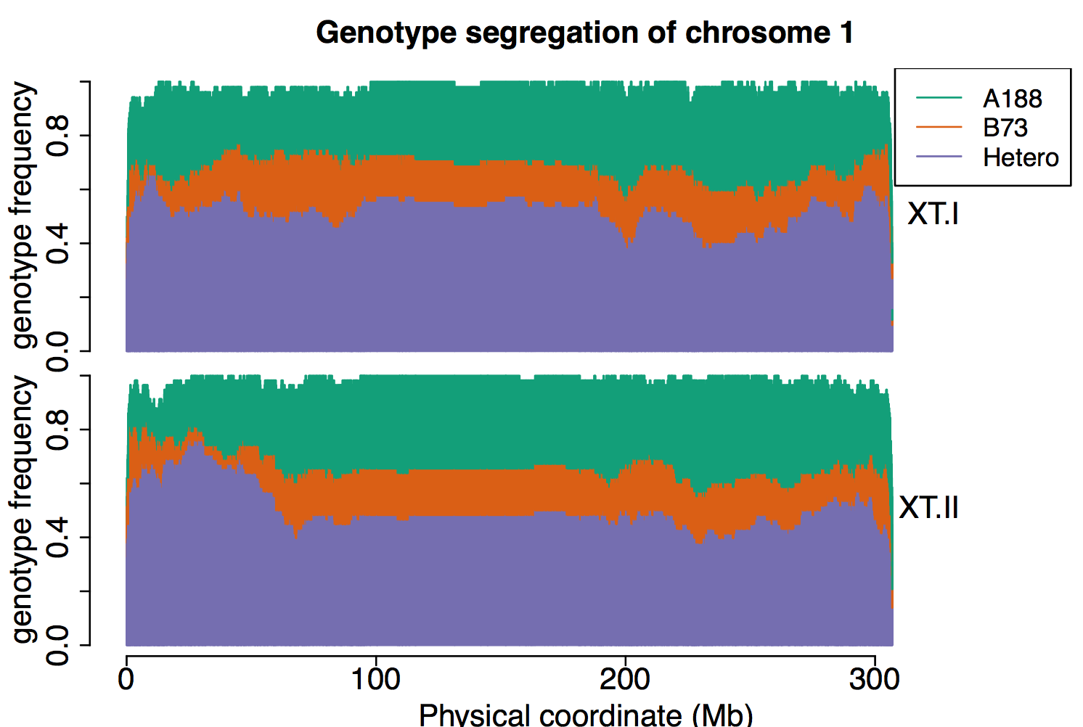

**Figure C.1 Genotype segregation of F2 calli on chromosome 1.** The upper panel showed the genotype frequency of 60 XT-I individuals, and the bottom panel showed the genotype frequency of 58 XT-II individuals. Each panel resulted from the aggregate of hundreds of vertical lines, and a vertical line represented the genotype distribution of a seg marker. The genotype frequency of heterozygotes, homozygous B73, and homozygous A188 of the seg marker were labelled in purple, orange, and green, and the missing rate of seg marker indicated with white.

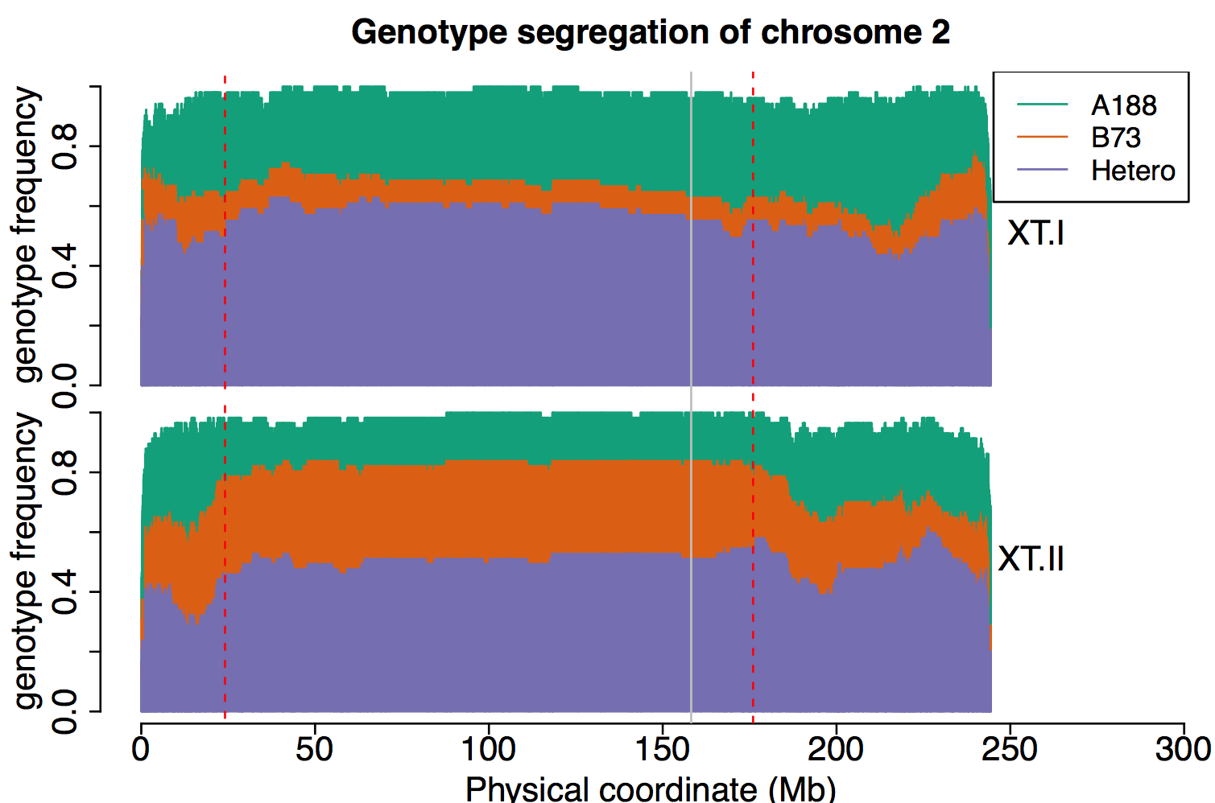

**Figure C.2 Genotype segregation of F2 calli on chromosome 1.** The upper panel showed the genotype frequency of 60 XT-I individuals, and the bottom panel showed the genotype frequency of 58 XT-II individuals. Each panel resulted from the aggregate of hundreds of vertical lines, and a vertical line represented the genotype distribution of a seg marker. The genotype frequency of heterozygotes, homozygous B73, and homozygous A188 of the seg marker were labelled in purple, orange, and green, and the missing rate of seg marker indicated with white.The red dash line indicated the QTL interval, and the gray vertical line labeled at the QTL position mapped by the GBS seg markers.

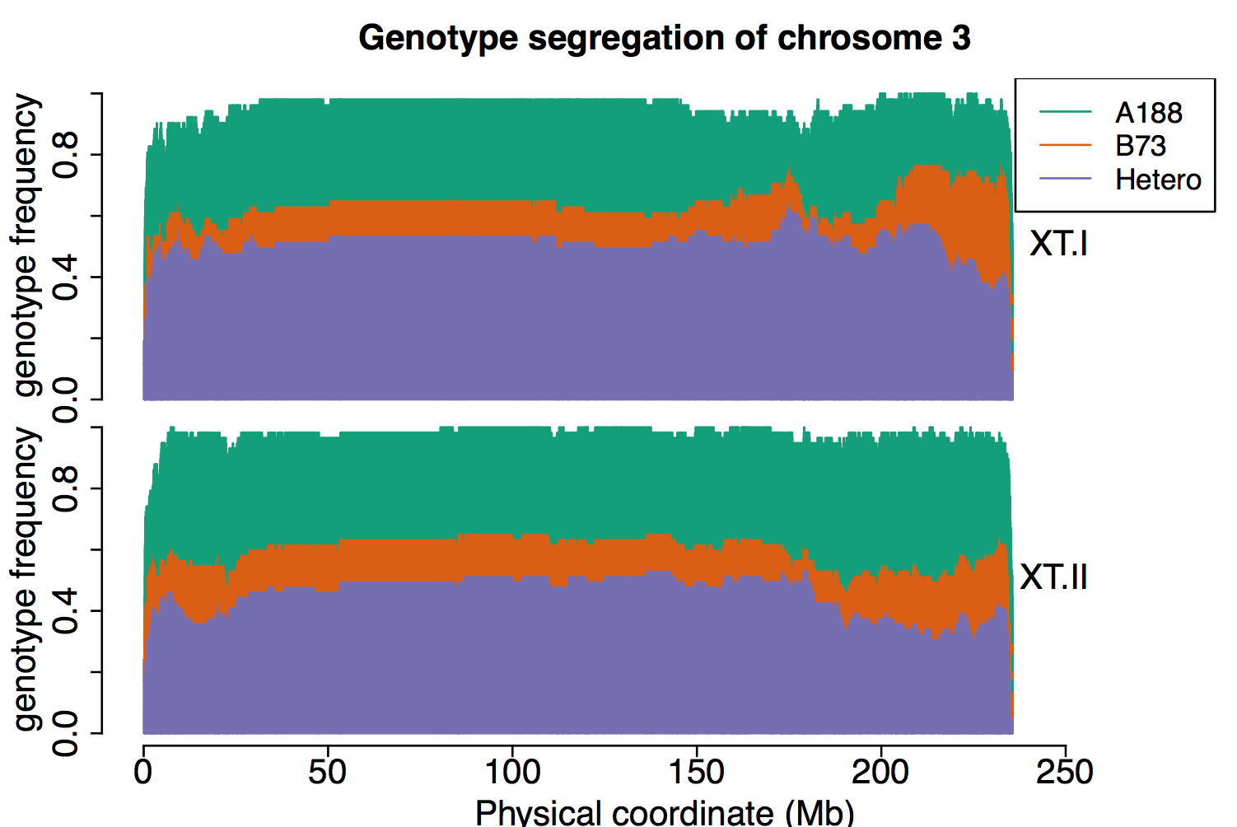

**Figure C.3 Genotype segregation of F2 calli on chromosome 3.** The upper panel showed the genotype frequency of 60 XT-I individuals, and the bottom panel showed the genotype frequency of 58 XT-II individuals. Each panel resulted from the aggregate of hundreds of vertical lines, and a vertical line represented the genotype distribution of a seg marker. The genotype frequency of heterozygotes, homozygous B73, and homozygous A188 of the seg marker were labelled in purple, orange, and green, and the missing rate of seg marker indicated with white.

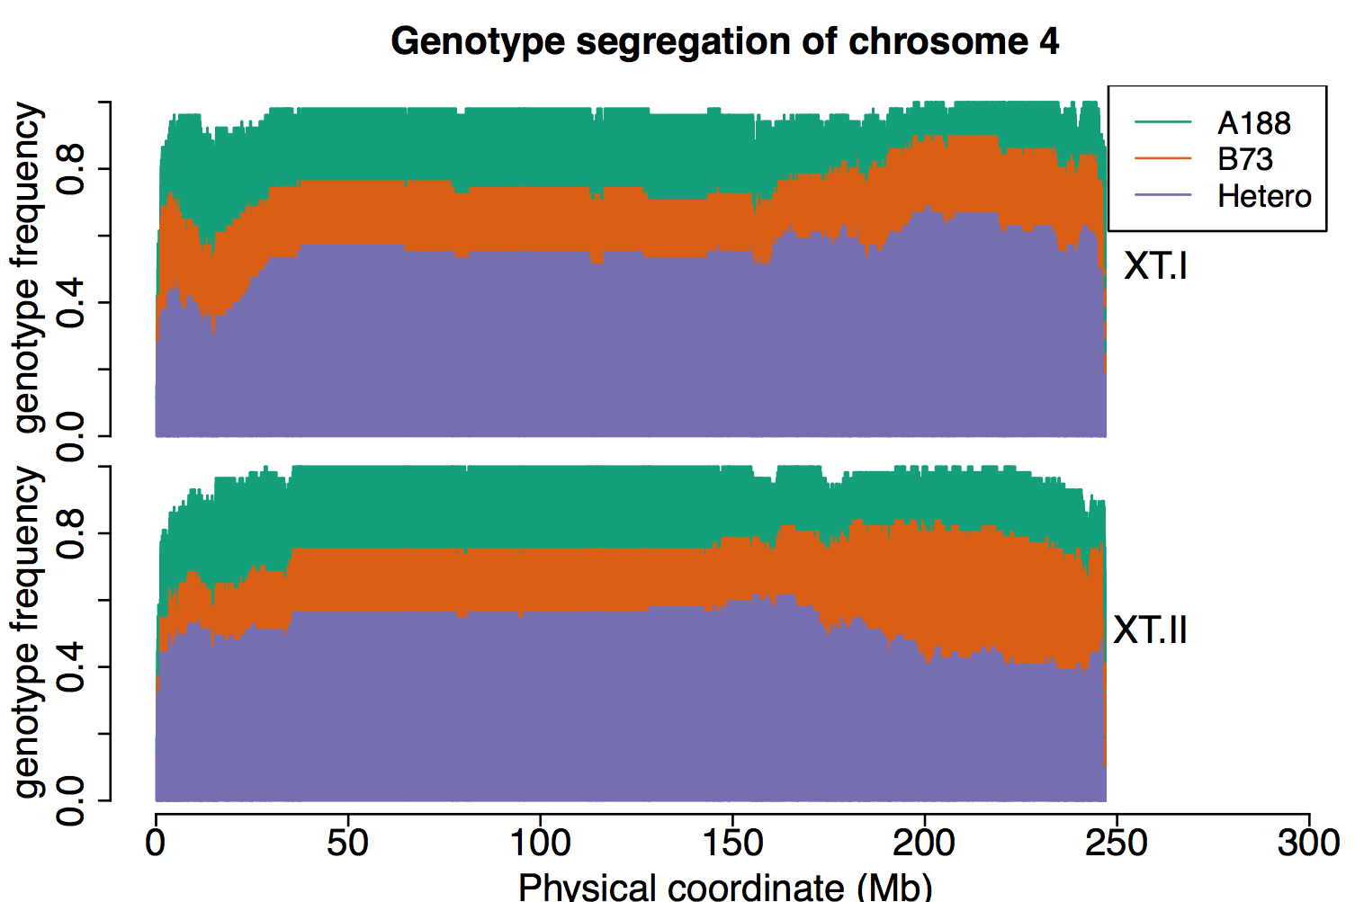

**Figure C.4 Genotype segregation of F2 calli on chromosome 4.** The upper panel showed the genotype frequency of 60 XT-I individuals, and the bottom panel showed the genotype frequency of 58 XT-II individuals. Each panel resulted from the aggregate of hundreds of vertical lines, and a vertical line represented the genotype distribution of a seg marker. The genotype frequency of heterozygotes, homozygous B73, and homozygous A188 of the seg marker were labelled in purple, orange, and green, and the missing rate of seg marker indicated with white.

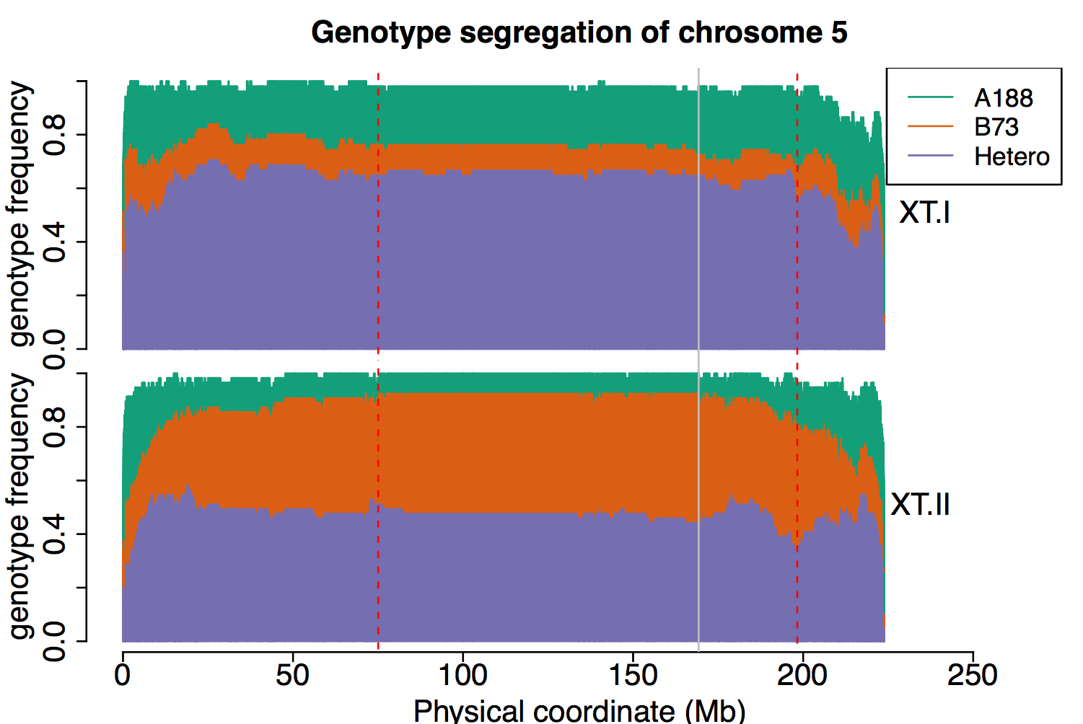

**Figure C.5 Genotype segregation of F2 calli on chromosome 5.** The upper panel showed the genotype frequency of 60 XT-I individuals, and the bottom panel showed the genotype frequency of 58 XT-II individuals. Each panel resulted from the aggregate of hundreds of vertical lines, and a vertical line represented the genotype distribution of a seg marker. The genotype frequency of heterozygotes, homozygous B73, and homozygous A188 of the seg marker were labelled in purple, orange, and green, and the missing rate of seg marker indicated with white.The red dash line indicated the QTL interval, and the gray vertical line labeled at the QTL position mapped by the GBS seg markers.

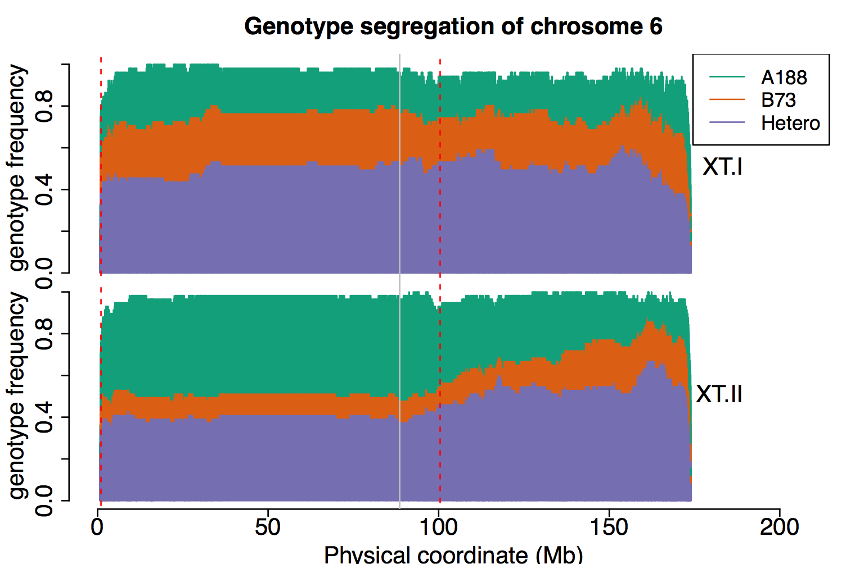

**Figure C.6 Genotype segregation of F2 calli on chromosome 6.** The upper panel showed the genotype frequency of 60 XT-I individuals, and the bottom panel showed the genotype frequency of 58 XT-II individuals. Each panel resulted from the aggregate of hundreds of vertical lines, and a vertical line represented the genotype distribution of a seg marker. The genotype frequency of heterozygotes, homozygous B73, and homozygous A188 of the seg marker were labelled in purple, orange, and green, and the missing rate of seg marker indicated with white.The red dash line indicated the QTL interval, and the gray vertical line labeled at the QTL position mapped by the GBS seg markers.

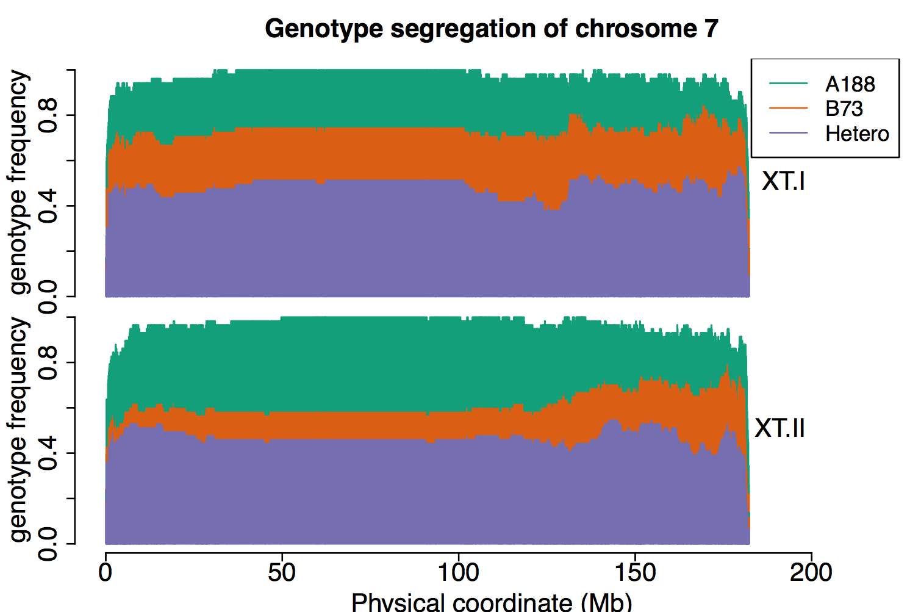

**Figure C.7 Genotype segregation of F2 calli on chromosome 7.** The upper panel showed the genotype frequency of 60 XT-I individuals, and the bottom panel showed the genotype frequency of 58 XT-II individuals. Each panel resulted from the aggregate of hundreds of vertical lines, and a vertical line represented the genotype distribution of a seg marker. The genotype frequency of heterozygotes, homozygous B73, and homozygous A188 of the seg marker were labelled in purple, orange, and green, and the missing rate of seg marker indicated with white.

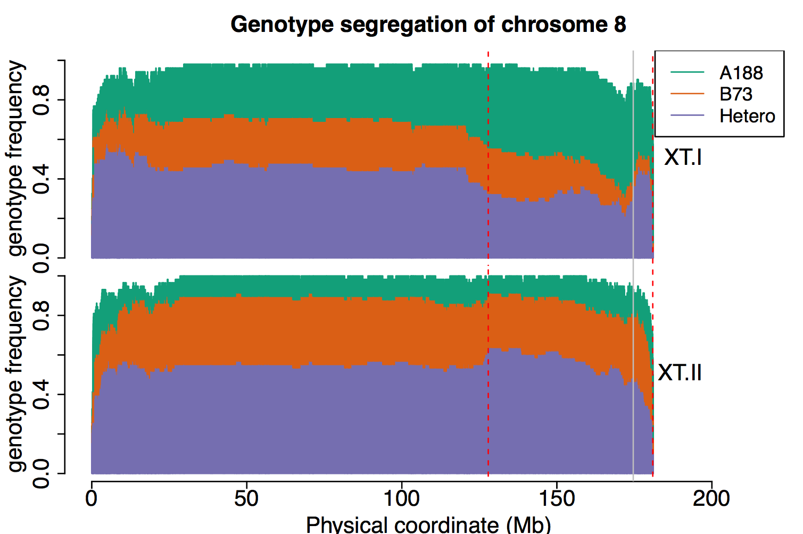

**Figure C.8 Genotype segregation of F2 calli on chromosome 8.** The upper panel showed the genotype frequency of 60 XT-I individuals, and the bottom panel showed the genotype frequency of 58 XT-II individuals. Each panel resulted from the aggregate of hundreds of vertical lines, and a vertical line represented the genotype distribution of a seg marker. The genotype frequency of heterozygotes, homozygous B73, and homozygous A188 of the seg marker were labelled in purple, orange, and green, and the missing rate of seg marker indicated with white.The red dash line indicated the QTL interval, and the gray vertical line labeled at the QTL position mapped by the GBS seg markers.

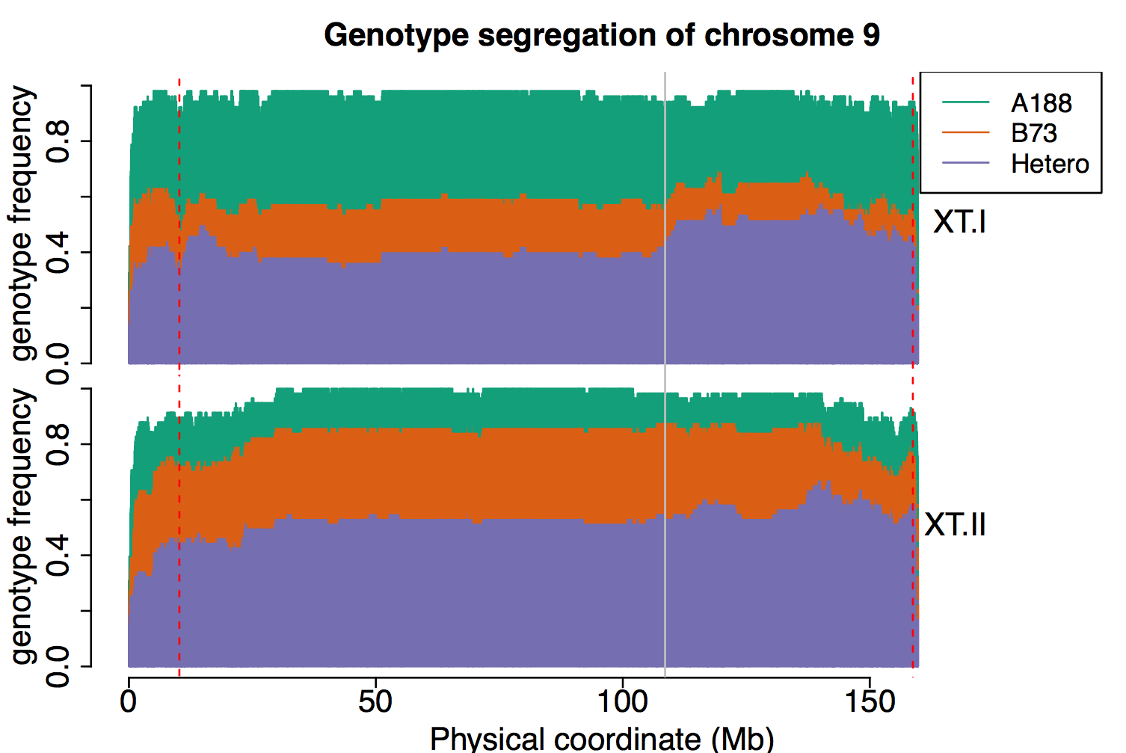

**Figure C.9 Genotype segregation of F2 calli on chromosome 9.** The upper panel showed the genotype frequency of 60 XT-I individuals, and the bottom panel showed the genotype frequency of 58 XT-II individuals. Each panel resulted from the aggregate of hundreds of vertical lines, and a vertical line represented the genotype distribution of a seg marker. The genotype frequency of heterozygotes, homozygous B73, and homozygous A188 of the seg marker were labelled in purple, orange, and green, and the missing rate of seg marker indicated with white.The red dash line indicated the QTL interval, and the gray vertical line labeled at the QTL position mapped by the GBS seg markers.

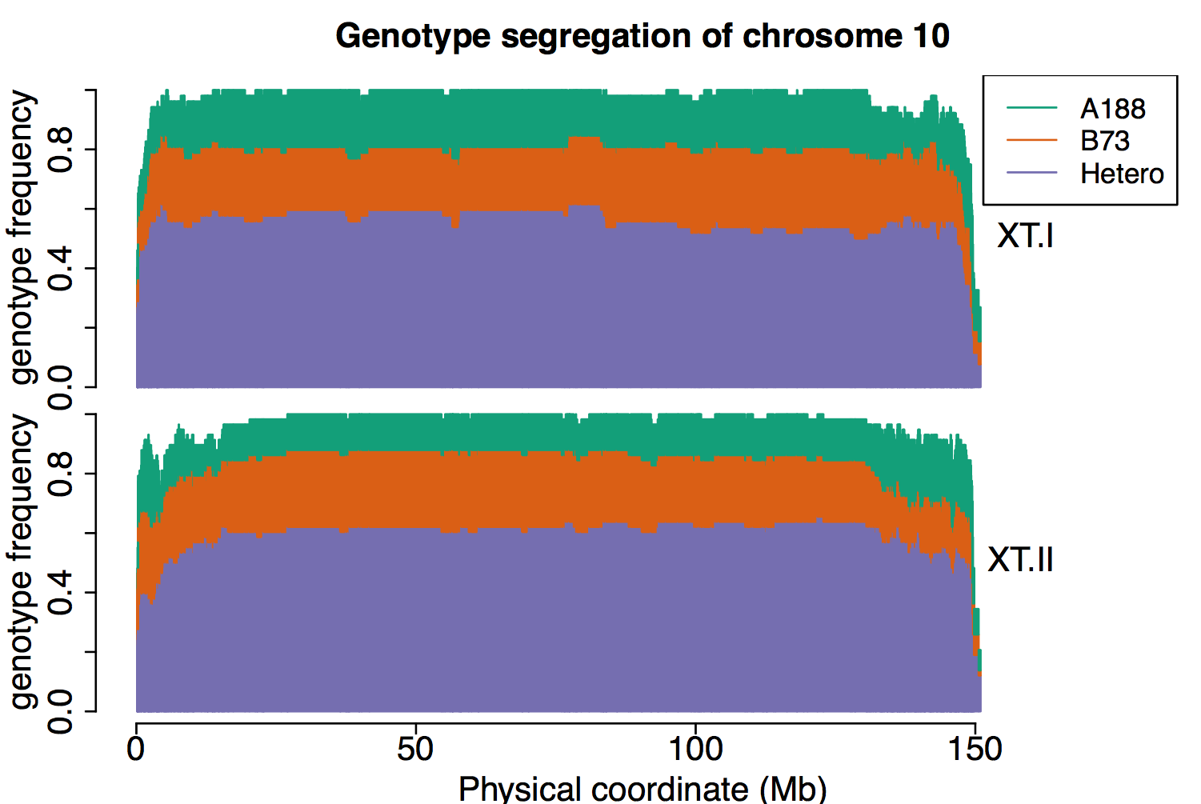

**Figure C.10 Genotype segregation of F2 calli on chromosome 10.** The upper panel showed the genotype frequency of 60 XT-I individuals, and the bottom panel showed the genotype frequency of 58 XT-II individuals. Each panel resulted from the aggregate of hundreds of vertical lines, and a vertical line represented the genotype distribution of a seg marker. The genotype frequency of heterozygotes, homozygous B73, and homozygous A188 of the seg marker were labelled in purple, orange, and green, and the missing rate of seg marker indicated with white.

Supplemental Tables

|  |  |  |  |
| --- | --- | --- | --- |
| **Table C.1 The recombination site of Hi-II A and B** | | | |
| Variety | chromosome | Breakpoint start | Breakpoint end |
| Hi-II A | 1 | 29788826 | 31284852 |
| Hi-II A | 1 | 85619028 | 87989974 |
| Hi-II A | 1 | 180574929 | 182294746 |
| Hi-II A | 2 | 2806972 | 4073950 |
| Hi-II A | 2 | 218688090 | 219601429 |
| Hi-II A | 4 | 195401513 | 197040039 |
| Hi-II A | 4 | 236305116 | 237642838 |
| Hi-II A | 5 | 11830286 | 11934522 |
| Hi-II A | 5 | 48444693 | 50340857 |
| Hi-II A | 5 | 59281022 | 63499717 |
| Hi-II A | 6 | 165411893 | 169000236 |
| Hi-II A | 7 | 2853784 | 4613286 |
| Hi-II A | 7 | 20297583 | 20462620 |
| Hi-II A | 7 | 26177306 | 26703924 |
| Hi-II A | 7 | 137449054 | 137952706 |
| Hi-II A | 9 | 7721967 | 8363362 |
| Hi-II A | 9 | 10778140 | 11243043 |
| Hi-II A | 9 | 13103712 | 27753901 |
| Hi-II A | 9 | 66812179 | 68989174 |
| Hi-II A | 9 | 101592249 | 103077214 |
| Hi-II A | 9 | 108428834 | 109335212 |
| Hi-II A | 10 | 131155582 | 133899951 |
| Hi-II B | 1 | 15588668 | 15967094 |
| Hi-II B | 1 | 30547334 | 30915591 |
| Hi-II B | 1 | 77152697 | 77668738 |
| Hi-II B | 1 | 196037123 | 197952644 |
| Hi-II B | 1 | 269260399 | 269450192 |
| Hi-II B | 1 | 278639483 | 282259154 |
| Hi-II B | 1 | 284082304 | 284325223 |
| Hi-II B | 1 | 285703108 | 286338963 |
| Hi-II B | 2 | 219340501 | 219605738 |
| Hi-II B | 2 | 235846855 | 238068108 |
| Hi-II B | 3 | 220853291 | 220969622 |
| Hi-II B | 3 | 224973587 | 225742788 |
| Hi-II B | 3 | 228922713 | 229396381 |
| Hi-II B | 4 | 7351231 | 8136195 |
| Hi-II B | 4 | 15020272 | 15982239 |
| Hi-II B | 4 | 31376411 | 33181999 |
| Hi-II B | 4 | 36810597 | 36972978 |
| Hi-II B | 4 | 43673512 | 44285903 |
| Hi-II B | 4 | 55492642 | 56277649 |
| Hi-II B | 4 | 154925784 | 157947748 |
| Hi-II B | 4 | 185175375 | 185705739 |
| Hi-II B | 4 | 203460228 | 203811329 |
| Hi-II B | 4 | 205237817 | 205647602 |
| Hi-II B | 4 | 232560730 | 233399493 |
| Hi-II B | 4 | 234468486 | 236643741 |
| Hi-II B | 5 | 4613746 | 4688978 |
| Hi-II B | 5 | 7506467 | 8524135 |
| Hi-II B | 5 | 12589478 | 13379431 |
| Hi-II B | 5 | 61716329 | 63585220 |
| Hi-II B | 5 | 190396392 | 191578686 |
| Hi-II B | 5 | 219604659 | 220998423 |
| Hi-II B | 6 | 108324284 | 111301573 |
| Hi-II B | 7 | 4964090 | 5603840 |
| Hi-II B | 7 | 134262506 | 135482267 |
| Hi-II B | 7 | 147572276 | 149235763 |
| Hi-II B | 7 | 151981548 | 152606466 |
| Hi-II B | 7 | 165738518 | 166119042 |
| Hi-II B | 7 | 168261566 | 168497523 |
| Hi-II B | 8 | 161887370 | 162640397 |
| Hi-II B | 8 | 169610649 | 169917671 |
| Hi-II B | 8 | 176144076 | 176849751 |
| Hi-II B | 9 | 8120960 | 9505572 |
| Hi-II B | 9 | 67874714 | 69278941 |
| Hi-II B | 9 | 91833221 | 92245606 |
| Hi-II B | 9 | 100840645 | 102045282 |
| Hi-II B | 9 | 154666389 | 155603098 |
| Hi-II B | 10 | 15336217 | 15544393 |
| Hi-II B | 10 | 17707977 | 18142986 |
| Hi-II B | 10 | 19216382 | 20024663 |
| Hi-II B | 10 | 105518971 | 106765463 |
| Hi-II B | 10 | 108135667 | 109905042 |
| Hi-II B | 10 | 118196289 | 118820313 |
| Hi-II B | 10 | 125533041 | 126025041 |
| Hi-II B | 10 | 131247507 | 133446876 |