**Project Name**

Wheat Whole-genome Genetic Variation Map 2.0 (VMap 2.0)

**What is the VMap 2.0 project ?**

Wheat Whole-genome Genetic Variation Map 2.0 (VMap 2.0) is one of the great feats of exploration in wheat genome research. The project is an inward voyage of wheat genetics discovery led by Strategic Priority Research Program of the Chinese Academy of Sciences. The project originally was planned in 2018 whose goal was the complete mapping from diploid *Aegilops tauschii* to tetraploid and hexaploid bread wheat, as well as understanding the natural selection and domestication, particularly removal of deleterious mutations.

**Project goals**

1. Capture most genetic variants with frequencies of at least 1% in the different ploidy wheat populations and *Ae.tauschii* studied.

2. Evaluate the dynamic change of deleterious mutations in the wheat genome

3. Dissect the genetic basis conferring wheat adaptive plasticity to improve crop trait biology

**The significance of the VMap 2.0 project**

**1. Functional impacts for researchers and technology creation**

By incorporate additional published genomic data and newly resequencing data, new algorithm and technology will be in-demand to develop and visualize the genome characterization data of multiple layers. Key issues should be asked by researchers to trace the inner genetic basis of wheat global adaption.

**2. Informing biodiversity conservation and yield increase strategies for breeders**

Population comparative analysis found low diversity and an inconsistent burden of putatively deleterious mutations due to the special demographic history of polyploid and domestication bottleneck through human selection. Removal of deleterious by gene editing technology will show the highest potential for crop improvement among these species.

**Project research progress**

* **The VMap 2.0 Phase I: Collection of global resources**

In this project, aiming to provide a comprehensive description of the large amount of common and rare variation in the wheat, we collected 706 accessions with different ploidy level and a broad set of continental backgrounds. The sample contains a total of 437 hexaploid wheat, 230 tetraploid wheat, as well as 39 *Ae.tauschii*, which are distributed in 82, 41 and 8 countries (Armenia, Azerbaijan, Iran, Russia, Soviet Union, Syria, Turkey, United States) relatively.

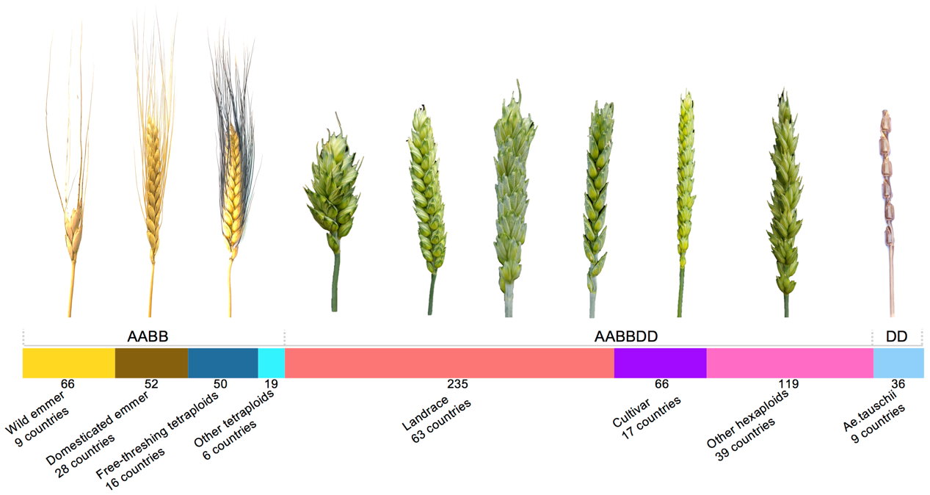

* **The VMap 2.0 Phase II: Developing comprehensive genetic variation map**

The start of the wheat DNA sequence in the autumn of 2018 coincided with the publication of wheat reference genome IWGSC RefSeq v1.0 on *Science*. So we have catch the great opportunity of wheat genome research. Several pipelines were developed to cover the variation of the whole-genome. In summary, VMap 2.0 includes biallelic SNPs, triallelic SNPs as well as Indels (Insertions and Deletions). A total of 242,988,963 SNPs (240,480,666 Bi-SNPs and 2,508,297 Tri-SNPs) and 8,973,260 Indels (2,819,378 Insertions and 6,167,072 Deletions) are included in VMap 2.0. This dataset will be useful for future high level analysis.

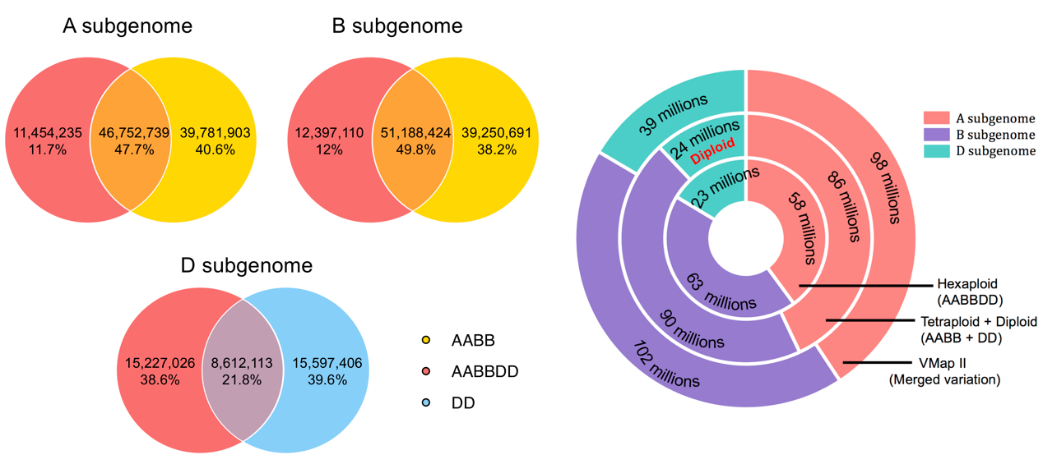

**Personal Introduction**

I began my studies in plant genetics with the ambition to work on deleterious mutations. My interests concentrate mainly on the application of quantitative genetics and computational biology to associate agriculturally important phenotypes. And now I am devoting myself to the study on biological effect of deleterious mutations on wheat genome. As a leader of the VMap 2.0 project, I think it is such an rare opportunity in life that I will cherish it and do my best.

William Cowper from “The Task” (1785) said that variation is the spice of life. That looks good! Surely I will be earnest to new chance! *Sometimes when you innovate, you make mistakes. It is best to admit them quickly, and get on with improving your other innovations.*

**Contact**

[**biaoyue17@genetics.ac.cn**](mailto:biaoyue17@genetics.ac.cn)**;** [**dxxu@genetics.ac.cn**](mailto:dxxu@genetics.ac.cn)