Supplmental reproducible analysis for: Genetically encoded, noise-tolerant, auxin biosensors in yeast facilitate metabolic engineering and directed evolution

Patarasuda Chaisupa[1]

Mahbubur Rahman*[2]

Sherry B. Hildreth[3]

Saede Moseley[4]

Chauncey Gatling[5]

Richard F. Helm[6]

R. Clay Wright[7]

knitr::opts_chunk$set(echo = TRUE, collapse = TRUE,   
 tidy = TRUE, message = FALSE,   
 warning = FALSE)  
library(flowCore)  
library(flowTime)  
library(ggplot2)  
library(stringr)   
library(ggridges)  
library(dplyr)  
library(tidyr)  
library(tidyverse)  
library(drc)  
library(gridExtra)  
library(openCyto)  
library(ggcyto)  
library(flowStats)  
library(flowClust)  
library(wesanderson)  
library(patchwork)  
library(ggthemes)  
library(agricolae)

# Time-course response and ratiometric measurement of the single-fusion biosensors

## Time-course degradation

# Read in flow sets from 20200611 and 20200614  
flowSet <- read.plateSet(path = "~/Google Drive/Shared drives/PlantSynBioLab/Data/Mahbub/FlowSets/",  
 pattern = "202006", phenoData = "annotation.txt")  
flowSet <- flowSet[which(flowSet@phenoData@data$strain %in% c("T1T1", "A2A2"))]  
  
write.flowSet(flowSet, "flowSets/single-time-course")

flowSet <- read.flowSet(path = "flowSets/single-time-course", phenoData = "annotation.txt")  
# load gates for this strain/cytometer  
load("PSB_Accuri_W303.RData")  
data_sum <- summarizeFlow(flowset = flowSet, ploidy = "diploid", only = "singlets")  
## [1] "Gating with diploid singlet gates..."  
time0_14 <- data_sum %>%  
 dplyr::filter(name == "21D10.fcs") %>%  
 pull(btime)  
time0_11 <- data_sum %>%  
 dplyr::filter(name == "11G02.fcs") %>%  
 pull(btime)  
data_sum <- data_sum %>%  
 mutate(time = case_when(folder == "20200611_AFB_epistasis" ~ .$btime - time0_11,  
 folder == "20200614_AFB_epistasis" ~ .$btime - time0_14))

shapes <- c(DMSO = 1, IAA = 16)  
lines <- c(DMSO = 2, IAA = 1)  
  
data_sum$ratio <- data_sum$FL1.Amean/data_sum$FL4.Amean  
data_sum$Venus <- data_sum$FL1.Amean/10000  
data_sum_long <- data_sum %>%  
 dplyr::select(time, treatment, yWL, folder, strain, ratio, Venus) %>%  
 pivot_longer(cols = c(ratio, Venus), names_to = "parameter")  
deg_plot <- ggplot(data = subset(data_sum_long, yWL == "166"), aes(x = time, y = value,  
 shape = treatment, color = treatment, group = interaction(treatment, folder))) +  
 geom_point() + labs(y = "intensity (AU)", x = "time post auxin addition (min)") +  
 facet_wrap(~fct_rev(parameter), scales = "free") + scale_shape_manual(values = shapes) +  
 geom_line(aes(linetype = treatment)) + scale_linetype_manual(values = lines) +  
 scale_color_viridis_d(option = "D", end = 0.75, direction = -1) + theme_test()  
deg_plot

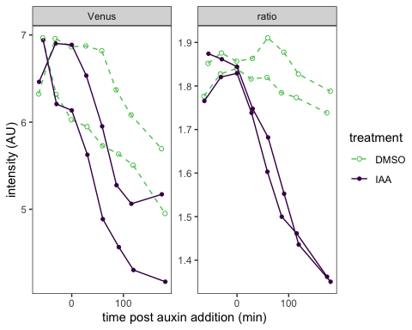

data <- flowTime::tidyFlow(flowSet, ploidy = "diploid", only = "singlets")  
## [1] "No further gating applied."  
## [1] "Converting events..."

# get late time points for one strain  
last_reading <- tail(unique(data[which(data$yWL == 166), "name"]), 4) %>%  
 head(2)  
data <- dplyr::filter(data, yWL == "166" & name %in% last_reading)  
# clean this up, cut off zeros  
data <- subset(data, FL1.A > 1 & FL4.A > 1)  
data$FLratio <- data$FL1.A/data$FL4.A  
range(data$FL1.A)  
## [1] 21 697262  
# calculate cvs  
sd(data$FLratio)/mean(data$FLratio)  
## [1] 0.1842678  
range(data$FLratio)  
## [1] 0.002628614 3.836085188

## Single-fusion CV plot

# calculate normalized values  
data$Venus <- data$FL1.A/median(data$FL1.A)  
data$mScarlet <- data$FL4.A/median(data$FL4.A)  
data$ratio <- data$FLratio/median(data$FLratio)  
# make a tidy, long dataset  
data_long <- data %>%  
 dplyr::select(treatment, Venus, mScarlet, ratio) %>%  
 pivot_longer(cols = c(Venus, mScarlet, ratio), names_to = "parameter", values_to = "value")  
  
# need to also format CVs approriately for annotating  
cv <- function(x) return(round(sd(x)/mean(x), 2))  
CVs <- data %>%  
 group_by(treatment) %>%  
 summarise(across(where(is_double), cv))  
CVs <- CVs %>%  
 dplyr::select(treatment, Venus, mScarlet, ratio) %>%  
 pivot_longer(cols = c(Venus, mScarlet, ratio), names_to = "parameter", values_to = "value")  
  
CV_plot <- ggplot(data = data_long, mapping = aes(x = value, color = treatment)) +  
 geom_density() + coord_cartesian(x = c(0, 2)) + labs(x = "median normalized intensity",  
 color = "treatment") + facet_grid(fct_relevel(parameter, "Venus") ~ .) + theme_test() +  
 geom_text(data = subset(CVs, treatment == "IAA"), aes(label = paste0("CV = ",  
 value)), x = 0.3, y = 2) + geom_text(data = subset(CVs, treatment == "DMSO"),  
 aes(label = paste0("CV = ", value)), x = 1.8, y = 2) + scale_color_viridis_d(option = "D",  
 end = 0.75, direction = -1)  
CV_plot

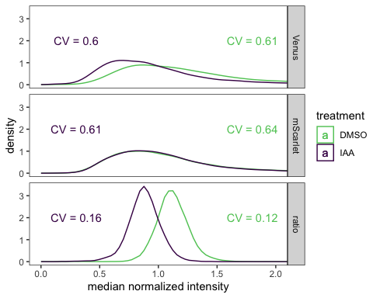

layout <- "  
AAAAB  
CCCCC  
"  
CV_plot + guide_area() + deg_plot + plot_annotation(tag_levels = "A") + plot_layout(guides = "collect",  
 heights = c(5, 2), design = layout)

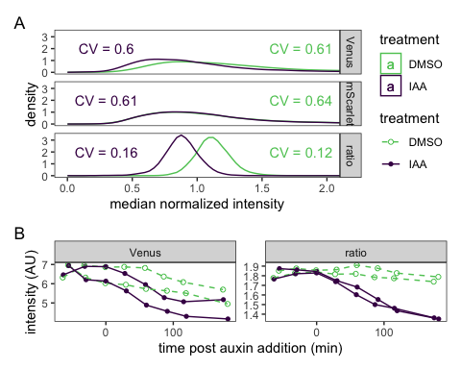

ggsave("ratio-deg.pdf", width = 5, height = 5)  
ggsave("ratio-deg.png", width = 5, height = 5)

# Dose-response curves of dual-fusion AFB2 and TIR1 biosensors

## AFB2-based biosensor (yWL210 AFB2 dual-fusion, single ratiometric construct)

plate_all_210 <- read.plateSet(path = "~/Google Drive/Shared drives/PlantSynBioLab/Pat/Experiments/Does-response assay/11212022_DRA_overlaydata/Combine Data_yWL210/All data/",  
 pattern = "DRA-*")

annotation <- createAnnotation(yourFlowSet = plate_all_210)  
write.csv(annotation, "/Users/patchaisupa/Google Drive/Shared drives/PlantSynBioLab/Pat/Experiments/Does-response assay/11212022_DRA_overlaydata/overlaydata_annotation_yWL210_datagated_exJan31.csv")

annotation <- read.csv("~/Google Drive/Shared drives/PlantSynBioLab/Pat/Experiments/Does-response assay/11212022_DRA_overlaydata/overlaydata_annotation_yWL210_datagated_exJan31.csv")  
  
aplate_all_210 <- annotateFlowSet(yourFlowSet = plate_all_210, annotation_df = annotation,  
 mergeBy = "name")  
head(rownames(pData(aplate_all_210)))  
head(pData(aplate_all_210))  
write.flowSet(aplate_all_210, outdir = "flowSets/AFB2-dual-yWL210-dose-response")

aplate_all_210 <- read.flowSet(path = "flowSets/AFB2-dual-yWL210-dose-response",  
 phenoData = "annotation.txt")  
  
plate_all_210_sum <- summarizeFlow(aplate_all_210, channel = NA, gated = TRUE)  
## [1] "Summarizing all events..."

###Dose-response curve

#### Comparing log-logistic and Weibull models

(Figure 2 in Ritz (2009))

fitdrc.m1 <- drm(YL1.Amean/BL1.Amean ~ dose, data = plate_all_210_sum, fct = LL.4())  
fitdrc.m2 <- drm(YL1.Amean/BL1.Amean ~ dose, data = plate_all_210_sum, fct = W1.4())  
# fitdrc.m3 <- drm(YL1.Amean/BL1.Amean~dose, data=plate_all_210_sum, fct =  
# W2.4()) Error in drmOpt(opfct, opdfct1, startVecSc, optMethod, constrained,  
# warnVal, : Convergence failed  
  
summary(fitdrc.m1)  
##   
## Model fitted: Log-logistic (ED50 as parameter) (4 parms)  
##   
## Parameter estimates:  
##   
## Estimate Std. Error t-value p-value   
## b:(Intercept) -1.5032417 0.6338695 -2.3715 0.01985 *   
## c:(Intercept) 0.0526074 0.0020790 25.3043 < 2e-16 ***  
## d:(Intercept) 0.0845079 0.0021128 39.9976 < 2e-16 ***  
## e:(Intercept) 0.0403739 0.0159429 2.5324 0.01306 *   
## ---  
## Signif. codes: 0 '***' 0.001 '**' 0.01 '*' 0.05 '.' 0.1 ' ' 1  
##   
## Residual standard error:  
##   
## 0.01246335 (90 degrees of freedom)  
summary(fitdrc.m2)  
##   
## Model fitted: Weibull (type 1) (4 parms)  
##   
## Parameter estimates:  
##   
## Estimate Std. Error t-value p-value   
## b:(Intercept) -0.7846961 0.2493021 -3.1476 0.002233 **   
## c:(Intercept) 0.0522487 0.0021769 24.0009 < 2.2e-16 ***  
## d:(Intercept) 0.0847793 0.0022414 37.8241 < 2.2e-16 ***  
## e:(Intercept) 0.0189778 0.0111048 1.7090 0.090902 .   
## ---  
## Signif. codes: 0 '***' 0.001 '**' 0.01 '*' 0.05 '.' 0.1 ' ' 1  
##   
## Residual standard error:  
##   
## 0.01263587 (90 degrees of freedom)  
# summary(fitdrc.m3)

The 4-parameter log-logistic model has a slightly lower residual standard error.

model.LL4_all_210 <- drm(YL1.Amean/BL1.Amean ~ dose, data = plate_all_210_sum, fct = LL.4(names = c("Slope",  
 "Lower Limit", "Upper Limit", "ED50")))  
plot(model.LL4_all_210, broken = TRUE, type = "none", lty = 1, lwd = 5, xlab = "Extracellular IAA concentration (µM)",  
 ylab = "Response Signal")  
# plot(model.LL4_all_210, broken = TRUE, col = 'black', add=TRUE)  
plot(model.LL4_all_210, broken = TRUE, type = "confidence", col = "black", add = TRUE)

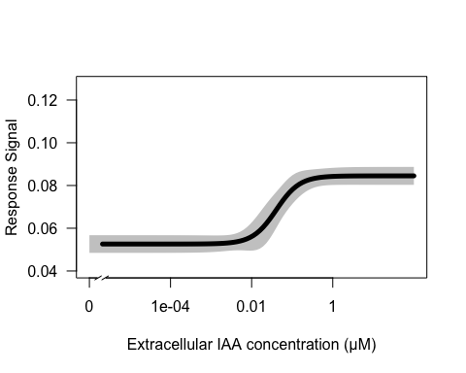

summary(model.LL4_all_210)  
##   
## Model fitted: Log-logistic (ED50 as parameter) (4 parms)  
##   
## Parameter estimates:  
##   
## Estimate Std. Error t-value p-value   
## Slope:(Intercept) -1.5032417 0.6338695 -2.3715 0.01985 *   
## Lower Limit:(Intercept) 0.0526074 0.0020790 25.3043 < 2e-16 ***  
## Upper Limit:(Intercept) 0.0845079 0.0021128 39.9976 < 2e-16 ***  
## ED50:(Intercept) 0.0403739 0.0159429 2.5324 0.01306 *   
## ---  
## Signif. codes: 0 '***' 0.001 '**' 0.01 '*' 0.05 '.' 0.1 ' ' 1  
##   
## Residual standard error:  
##   
## 0.01246335 (90 degrees of freedom)

### Individual replicate dose-response curves

replicate1_210 <- drm(YL1.Amean/BL1.Amean ~ dose, data = subset(plate_all_210_sum,  
 replicate == "1"), fct = LL.4())  
replicate2_210 <- drm(YL1.Amean/BL1.Amean ~ dose, data = subset(plate_all_210_sum,  
 replicate == "2"), fct = LL.4())  
replicate3_210 <- drm(YL1.Amean/BL1.Amean ~ dose, data = subset(plate_all_210_sum,  
 replicate == "3"), fct = LL.4())  
replicate4_210 <- drm(YL1.Amean/BL1.Amean ~ dose, data = subset(plate_all_210_sum,  
 replicate == "4"), fct = LL.4())  
replicate5_210 <- drm(YL1.Amean/BL1.Amean ~ dose, data = subset(plate_all_210_sum,  
 replicate == "5"), fct = LL.4())  
replicate6_210 <- drm(YL1.Amean/BL1.Amean ~ dose, data = subset(plate_all_210_sum,  
 replicate == "6"), fct = LL.4())  
replicate7_210 <- drm(YL1.Amean/BL1.Amean ~ dose, data = subset(plate_all_210_sum,  
 replicate == "7"), fct = LL.4())  
  
plot(replicate1_210, broken = TRUE, type = "all", col = "dark green", lty = 2)  
plot(replicate2_210, broken = TRUE, add = TRUE, type = "all", col = "dark blue",  
 lty = 2)  
plot(replicate3_210, broken = TRUE, add = TRUE, type = "all", col = "yellow", lty = 2)  
plot(replicate4_210, broken = TRUE, add = TRUE, type = "all", col = "dark grey",  
 lty = 2)  
plot(replicate5_210, broken = TRUE, add = TRUE, type = "all", col = "dark orange",  
 lty = 2)  
plot(replicate6_210, broken = TRUE, add = TRUE, type = "all", col = "brown", lty = 2)  
plot(replicate7_210, broken = TRUE, add = TRUE, type = "all", col = "dark red", lty = 2)  
plot(model.LL4_all_210, broken = TRUE, add = TRUE, type = "none", lty = 1, lwd = 5,  
 xlab = "Extracellular IAA concentration (µM)", ylab = "Response Signal")  
# plot(model.LL4_all_210, broken = TRUE, col = 'black', add=TRUE)  
plot(model.LL4_all_210, broken = TRUE, type = "confidence", col = "black", add = TRUE)

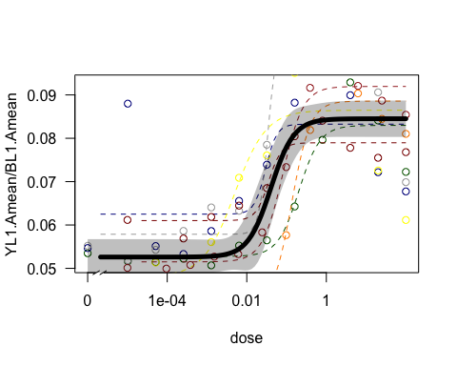

## TIR1-based biosensor (yWL209 TIR dual-fusion, single ratiometric construct)

plate_all_209 <- read.plateSet(path = "~/Google Drive/Shared drives/PlantSynBioLab/Pat/Experiments/Does-response assay/11212022_DRA_overlaydata/Combine Data_yWL209/",  
 pattern = "DRA-*")

annotation <- createAnnotation(yourFlowSet = plate_all_209)  
write.csv(annotation, "/Users/patchaisupa/Google Drive/Shared drives/PlantSynBioLab/Pat/Experiments/Does-response assay/11212022_DRA_overlaydata/overlaydata_annotation_yWL209.csv")

annotation <- read.csv("~/Google Drive/Shared drives/PlantSynBioLab/Pat/Experiments/Does-response assay/11212022_DRA_overlaydata/overlaydata_annotation_yWL209.csv")  
  
aplate_all_209 <- annotateFlowSet(yourFlowSet = plate_all_209, annotation_df = annotation,  
 mergeBy = "name")  
head(rownames(pData(aplate_all_209)))  
head(pData(aplate_all_209))  
  
write.flowSet(aplate_all_209, outdir = "flowSets/TIR1-dual-yWL209-dose-response")

aplate_all_209 <- read.flowSet(path = "flowSets/TIR1-dual-yWL209-dose-response",  
 phenoData = "annotation.txt")  
  
dat_sum_overlaydata_209 <- summarizeFlow(aplate_all_209, gated = TRUE)  
## [1] "Summarizing all events..."

###Dose-response curve

model.LL4_rep1_209 <- drm(YL1.Amean/BL1.Amean ~ dose, data = subset(dat_sum_overlaydata_209,  
 replicate == "1"), fct = LL.4(names = c("Slope", "Lower Limit", "Upper Limit",  
 "ED50")))  
plot(model.LL4_rep1_209, type = "all", col = "red", lty = 1, lwd = 2, xlab = "Extracellular IAA concentration (µM)",  
 ylab = "Red/Green Fluorescent Ratio")  
plot(model.LL4_rep1_209, broken = TRUE, type = "confidence", col = "red", add = TRUE)

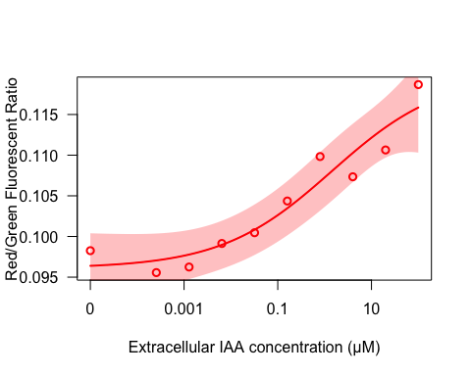

print(summary(model.LL4_rep1_209))  
##   
## Model fitted: Log-logistic (ED50 as parameter) (4 parms)  
##   
## Parameter estimates:  
##   
## Estimate Std. Error t-value p-value   
## Slope:(Intercept) -0.3671010 0.1395354 -2.6309 0.03901 *   
## Lower Limit:(Intercept) 0.0960915 0.0019149 50.1808 4.201e-09 ***  
## Upper Limit:(Intercept) 0.1200258 0.0068403 17.5470 2.198e-06 ***  
## ED50:(Intercept) 1.4438822 2.8035445 0.5150 0.62496   
## ---  
## Signif. codes: 0 '***' 0.001 '**' 0.01 '*' 0.05 '.' 0.1 ' ' 1  
##   
## Residual standard error:  
##   
## 0.002705295 (6 degrees of freedom)  
  
  
model.LL4_rep2_209 <- drm(YL1.Amean/BL1.Amean ~ dose, data = subset(dat_sum_overlaydata_209,  
 replicate == "2"), fct = LL.4(names = c("Slope", "Lower Limit", "Upper Limit",  
 "ED50")))  
plot(model.LL4_rep2_209, type = "all", col = "blue", lty = 1, lwd = 2, xlab = "Extracellular IAA concentration (µM)",  
 ylab = "Red/Green Fluorescent Ratio")  
plot(model.LL4_rep2_209, broken = TRUE, type = "confidence", col = "blue", add = TRUE)

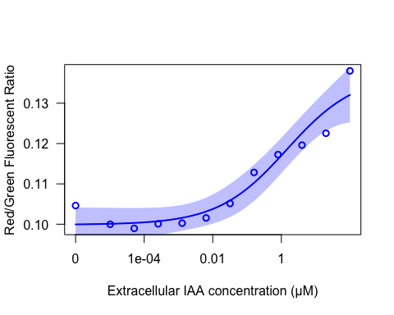

print(summary(model.LL4_rep2_209))  
##   
## Model fitted: Log-logistic (ED50 as parameter) (4 parms)  
##   
## Parameter estimates:  
##   
## Estimate Std. Error t-value p-value   
## Slope:(Intercept) -0.4323121 0.1153679 -3.7472 0.005646 **   
## Lower Limit:(Intercept) 0.0998826 0.0018914 52.8084 1.833e-11 ***  
## Upper Limit:(Intercept) 0.1372100 0.0062312 22.0197 1.910e-08 ***  
## ED50:(Intercept) 1.4546642 1.4213107 1.0235 0.336036   
## ---  
## Signif. codes: 0 '***' 0.001 '**' 0.01 '*' 0.05 '.' 0.1 ' ' 1  
##   
## Residual standard error:  
##   
## 0.003755989 (8 degrees of freedom)  
  
  
model.LL4_rep3_209 <- drm(YL1.Amean/BL1.Amean ~ dose, data = subset(dat_sum_overlaydata_209,  
 replicate == "3"), fct = LL.4(names = c("Slope", "Lower Limit", "Upper Limit",  
 "ED50")))  
plot(model.LL4_rep3_209, type = "all", col = "dark green", lty = 1, lwd = 2, xlab = "Extracellular IAA concentration (µM)",  
 ylab = "Red/Green Fluorescent Ratio")  
plot(model.LL4_rep3_209, broken = TRUE, type = "confidence", col = "dark green",  
 add = TRUE)

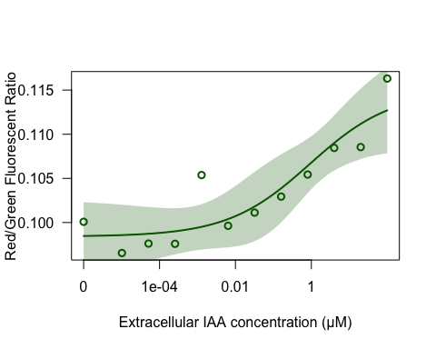

print(summary(model.LL4_rep3_209))  
##   
## Model fitted: Log-logistic (ED50 as parameter) (4 parms)  
##   
## Parameter estimates:  
##   
## Estimate Std. Error t-value p-value   
## Slope:(Intercept) -0.4007190 0.2177393 -1.8404 0.1030   
## Lower Limit:(Intercept) 0.0984103 0.0018186 54.1128 1.509e-11 ***  
## Upper Limit:(Intercept) 0.1148849 0.0037802 30.3916 1.492e-09 ***  
## ED50:(Intercept) 0.9199369 1.1883595 0.7741 0.4611   
## ---  
## Signif. codes: 0 '***' 0.001 '**' 0.01 '*' 0.05 '.' 0.1 ' ' 1  
##   
## Residual standard error:  
##   
## 0.002908608 (8 degrees of freedom)  
  
  
  
model.LL4_all_209 <- drm(YL1.Amean/BL1.Amean ~ dose, data = dat_sum_overlaydata_209,  
 fct = LL.4(names = c("Slope", "Lower Limit", "Upper Limit", "ED50")))  
plot(model.LL4_all_209, type = "all", col = "black", lty = 1, lwd = 3)  
plot(model.LL4_all_209, broken = TRUE, col = "black", add = TRUE)  
plot(model.LL4_all_209, broken = TRUE, type = "confidence", col = "black", add = TRUE)  
print(summary(model.LL4_all_209))  
##   
## Model fitted: Log-logistic (ED50 as parameter) (4 parms)  
##   
## Parameter estimates:  
##   
## Estimate Std. Error t-value p-value   
## Slope:(Intercept) -0.3420811 0.0895742 -3.8190 0.0004353 ***  
## Lower Limit:(Intercept) 0.0973731 0.0014017 69.4690 < 2.2e-16 ***  
## Upper Limit:(Intercept) 0.1337956 0.0109331 12.2377 1.972e-15 ***  
## ED50:(Intercept) 10.9140480 20.3972838 0.5351 0.5954208   
## ---  
## Signif. codes: 0 '***' 0.001 '**' 0.01 '*' 0.05 '.' 0.1 ' ' 1  
##   
## Residual standard error:  
##   
## 0.004904408 (42 degrees of freedom)  
  
replicate1_209 <- drm(YL1.Amean/BL1.Amean ~ dose, data = subset(dat_sum_overlaydata_209,  
 replicate == "1"), fct = LL.4())  
replicate2_209 <- drm(YL1.Amean/BL1.Amean ~ dose, data = subset(dat_sum_overlaydata_209,  
 replicate == "2"), fct = LL.4())  
replicate3_209 <- drm(YL1.Amean/BL1.Amean ~ dose, data = subset(dat_sum_overlaydata_209,  
 replicate == "3"), fct = LL.4())  
  
  
plot(replicate1_209, broken = TRUE, add = TRUE, type = "none", col = "red", lty = 2)  
plot(replicate2_209, broken = TRUE, add = TRUE, type = "none", col = "blue", lty = 2)  
plot(replicate3_209, broken = TRUE, add = TRUE, type = "none", col = "dark green",  
 lty = 2)

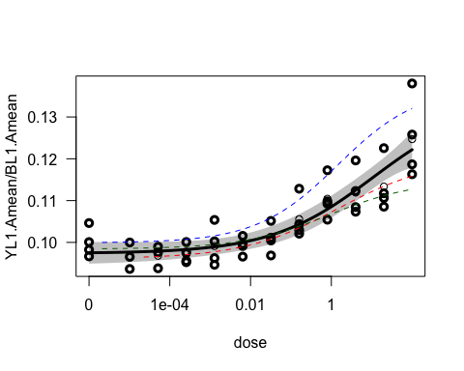

## Combined Dose-response curveswith ggplot

pm210 <- expand.grid(treatment = exp(seq(log(1e-05), log(100), length = 1000)))  
pm210 <- cbind(pm210, predict(model.LL4_all_210, newdata = pm210, interval = "confidence"))  
  
plot210 <- ggplot(plate_all_210_sum, aes(x = dose, y = YL1.Amean/BL1.Amean)) + scale_x_log10() +  
 geom_ribbon(data = pm210, aes(x = treatment, y = Prediction, ymin = Lower, ymax = Upper),  
 alpha = 0.4) + geom_line(data = pm210, aes(x = treatment, y = Prediction),  
 linewidth = 1.2) + ylab("mScarlet-I/Venus") + xlab("Auxin (IAA, µM)") + scale_x_log10(labels = scales::label_number(drop0trailing = TRUE)) +  
 scale_color_viridis_c() + geom_point(aes(color = replicate), size = 1, alpha = 0.6) +  
 theme_classic() + theme(legend.position = "none", plot.title = element_text(hjust = 0.5),  
 plot.title.position = "plot") + ggtitle("AFB2")  
plot210

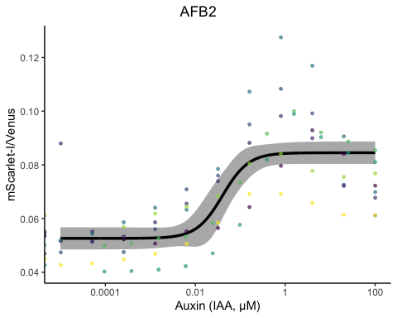

pm209 <- expand.grid(treatment = exp(seq(log(1e-05), log(100), length = 1000)))  
pm209 <- cbind(pm209, predict(model.LL4_all_209, newdata = pm209, interval = "confidence"))  
  
plot209 <- ggplot(dat_sum_overlaydata_209, aes(x = dose, y = YL1.Amean/BL1.Amean)) +  
 scale_x_log10() + geom_ribbon(data = pm209, aes(x = treatment, y = Prediction,  
 ymin = Lower, ymax = Upper), alpha = 0.4) + geom_line(data = pm209, aes(x = treatment,  
 y = Prediction), linewidth = 1.2) + ylab("mScarlet-I/Venus") + xlab("Auxin (IAA, µM)") +  
 scale_x_log10(labels = scales::label_number(drop0trailing = TRUE)) + scale_color_viridis_c() +  
 geom_point(aes(color = replicate), size = 1, alpha = 0.6) + theme_classic() +  
 theme(legend.position = "none", plot.title = element_text(hjust = 0.5), plot.title.position = "plot") +  
 # ylim(0.095, 0.12) +  
ggtitle("TIR1")  
plot209

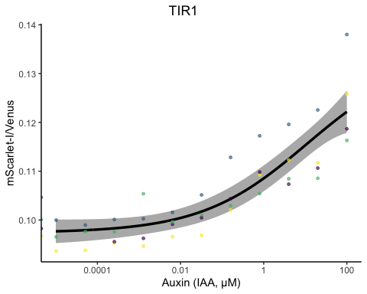

plot210 + plot209 + patchwork::plot_annotation(tag_levels = "A")

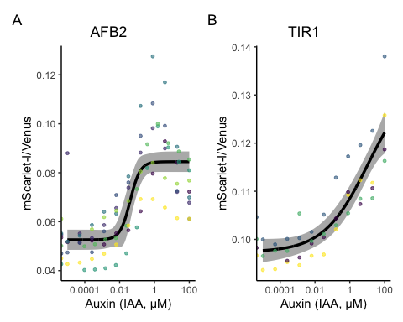

ggsave(plot = plot210 + plot209 + patchwork::plot_annotation(tag_levels = "A"), filename = "dose-response.pdf",  
 width = 6, height = 3)  
ggsave(plot = plot210 + plot209 + patchwork::plot_annotation(tag_levels = "A"), filename = "dose-response.png",  
 width = 6, height = 3)

# LCMS measurements of intracellular auxin

plate_08052022 <- read.plateSet(path = "~/Google Drive/Shared drives/PlantSynBioLab/Pat/Experiments/Does-response assay/08052022_yWL210_DRA-LCMS-R2/Alldata/",  
 pattern = "DRA*")

annotation <- read.csv("~/Google Drive/Shared drives/PlantSynBioLab/Pat/Experiments/Does-response assay/08052022_yWL210_DRA-LCMS-R2/08052022_alldata_annotation.csv")  
  
aplate_08052022 <- annotateFlowSet(yourFlowSet = plate_08052022, annotation_df = annotation,  
 mergeBy = "name")  
head(rownames(pData(aplate_08052022)))  
head(pData(aplate_08052022))  
write.flowSet(aplate_08052022, "flowSets/AFB2-dual-DR-LCMS")

aplate_08052022 <- read.flowSet(path = "flowSets/AFB2-dual-DR-LCMS", phenoData = "annotation.txt")  
plate_08052022_sum <- summarizeFlow(aplate_08052022, gated = TRUE)  
## [1] "Summarizing all events..."  
model.LL4_08052022 <- drm(YL1.Amean/BL1.Amean ~ dose, data = subset(plate_08052022_sum,  
 reading == "10"), fct = LL.4(names = c("Slope", "Lower Limit", "Upper Limit",  
 "ED50")))  
summary(model.LL4_08052022)  
##   
## Model fitted: Log-logistic (ED50 as parameter) (4 parms)  
##   
## Parameter estimates:  
##   
## Estimate Std. Error t-value p-value   
## Slope:(Intercept) -1.0145173 0.2536243 -4.0001 0.003949 **   
## Lower Limit:(Intercept) 0.0485554 0.0019439 24.9779 7.061e-09 ***  
## Upper Limit:(Intercept) 0.0735356 0.0010291 71.4543 1.639e-12 ***  
## ED50:(Intercept) 0.0987332 0.0305612 3.2307 0.012045 *   
## ---  
## Signif. codes: 0 '***' 0.001 '**' 0.01 '*' 0.05 '.' 0.1 ' ' 1  
##   
## Residual standard error:  
##   
## 0.002267079 (8 degrees of freedom)  
pm_08052022 <- expand.grid(treatment = exp(seq(log(0.001), log(100), length = 1000)))  
pm_08052022 <- cbind(pm_08052022, predict(model.LL4_08052022, newdata = pm_08052022,  
 interval = "confidence"))  
  
plot_08052022 <- ggplot(data = subset(plate_08052022_sum, reading == "10"), aes(x = dose,  
 y = YL1.Amean/BL1.Amean)) + geom_ribbon(data = pm_08052022, aes(x = treatment,  
 y = Prediction, ymin = Lower, ymax = Upper), alpha = 0.4) + geom_line(data = pm_08052022,  
 aes(x = treatment, y = Prediction)) + xlab("Extracellular IAA (µM)") + ylab("AFB2-mScarlet-/Venus-IAA17") +  
 scale_x_log10(labels = scales::label_number(drop0trailing = TRUE)) + geom_point(color = "black") +  
 theme_classic(base_size = 12) + theme(legend.position = "none")  
plot_08052022

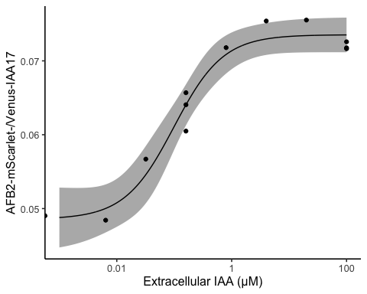

LCMSdata <- read.csv("08052022_yWL210_DRA-LCMS_data.csv")  
  
model.LL4_08052022_LCMS <- drm(Observed_IAA_in_uM ~ Dose_IAA, data = LCMSdata, fct = LL.4(names = c("Slope",  
 "Lower Limit", "Upper Limit", "ED50")))  
summary(model.LL4_08052022_LCMS)  
##   
## Model fitted: Log-logistic (ED50 as parameter) (4 parms)  
##   
## Parameter estimates:  
##   
## Estimate Std. Error t-value p-value   
## Slope:(Intercept) -5.6514e-01 8.9868e-02 -6.2885 4.016e-05 ***  
## Lower Limit:(Intercept) 3.7324e-02 3.6766e-01 0.1015 0.9208   
## Upper Limit:(Intercept) 2.6037e+02 2.7474e+02 0.9477 0.3620   
## ED50:(Intercept) 1.1866e+05 2.1885e+05 0.5422 0.5976   
## ---  
## Signif. codes: 0 '***' 0.001 '**' 0.01 '*' 0.05 '.' 0.1 ' ' 1  
##   
## Residual standard error:  
##   
## 1.019652 (12 degrees of freedom)  
  
plot(model.LL4_08052022_LCMS, type = "all", col = "black", lty = 1, lwd = 3, xlab = "Extracellular concentrations of IAA (uM)",  
 ylab = "Observed IAA (uM)")

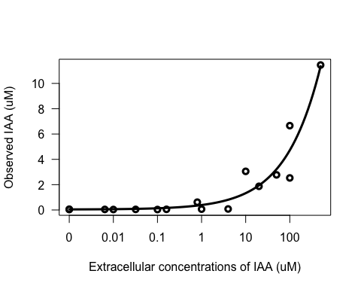

pm_08052022_LCMS <- expand.grid(treatment = exp(seq(log(0.001), log(500), length = 1000)))  
pm_08052022_LCMS <- cbind(pm_08052022_LCMS, predict(model.LL4_08052022_LCMS, newdata = pm_08052022_LCMS,  
 interval = "confidence"))  
LCMS_intracellular <- ggplot(data = LCMSdata, mapping = aes(x = Dose_IAA, y = Observed_IAA_in_uM)) +  
 geom_point() + geom_ribbon(data = pm_08052022_LCMS, aes(x = treatment, y = Prediction,  
 ymin = Lower, ymax = Upper), alpha = 0.4) + geom_line(data = pm_08052022_LCMS,  
 aes(x = treatment, y = Prediction)) + scale_x_log10(labels = scales::label_number(drop0trailing = TRUE)) +  
 theme_classic(base_size = 13) + theme(legend.position = "none") + ylab("Intracellular IAA (µM)") +  
 xlab("Extracellular IAA (µM)")  
  
plot_08052022 + LCMS_intracellular + plot_annotation(tag_levels = "A")

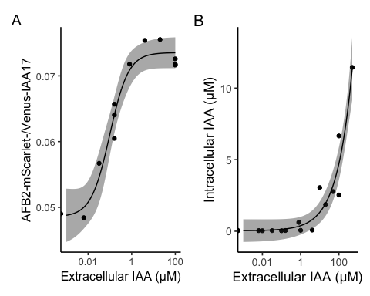

ggsave("LCMS-comparison.pdf", width = 6, height = 3)  
ggsave("LCMS-comparison.png", width = 6, height = 3)

# Auxin-induced degradation time-course assay for the dual-fusion biosensors in different yeast strains

Two isolated colonies from each strain were selected at random and tested in auxin-induced protein degradation assay. IAA working solution was added to obtain the IAA concentration at 50 µM in each culture. The assay was carried out using ThermoFisher Attune NxT B/Y flow cytometer.

Strains:

* yWL185 (TIR1 dual-fusion in W303)
* yWL186 (AFB2 dual-fusion in W303)
* yWL209 (TIR1 dual-fusion in YPH499)
* yWL210 (AFB2 dual-fusion in YPH499)

plate_03112022 <- read.plateSet(path = "~/Google Drive/Shared drives/PlantSynBioLab/Pat/Experiments/Time course assays/03112022_Time-course assay/10readings/onlyPatstrains/",  
 pattern = "TCA*")

annotation <- createAnnotation(yourFlowSet = plate_03112022)  
write.csv(annotation, "~/Google Drive/Shared drives/PlantSynBioLab/Pat/Experiments/Time course assays/03112022_Time-course assay/03112022_Time-course assay_10platesPatStrains2.csv")

annotation <- read.csv("~/Google Drive/Shared drives/PlantSynBioLab/Pat/Experiments/Time course assays/03112022_Time-course assay/03112022_Time-course assay_10platesPatStrains2.csv")  
aplate_03112022 <- annotateFlowSet(yourFlowSet = plate_03112022, annotation_df = annotation,  
 mergeBy = "name")  
head(rownames(pData(aplate_03112022)))  
head(pData(aplate_03112022))  
  
write.flowSet(aplate_03112022, outdir = "flowSets/dual-time-course")

aplate_03112022 <- read.flowSet(path = "flowSets/dual-time-course/", phenoData = "annotation.txt")  
plate_03112022_sum <- summarizeFlow(aplate_03112022, gated = TRUE)  
## [1] "Summarizing all events..."  
  
  
plate_03112022_sum <- plate_03112022_sum %>%  
 mutate(background_p = case_when(strain %in% c("yWL185", "yWL186") ~ "W303", strain %in%  
 c("yWL209", "yWL210") ~ "YPH499"), receptor_p = case_when(strain %in% c("yWL185",  
 "yWL209") ~ "TIR1", strain %in% c("yWL186", "yWL210") ~ "AFB2"))

# The time auxin addition is equal to time zero  
time0 <- "303112022-Pat-TCA03_Time-course assay_Auxin_yWL185-C1.fcs"  
# or whatever well was being read when auxin was added  
  
plate_03112022_sum$time <- plate_03112022_sum$btime - plate_03112022_sum[[which(plate_03112022_sum$name ==  
 time0), "btime"]]  
# single bracket -->extracting the all name, 2 brackets extract just single  
# 'value' or 'values'

# To normalize data  
  
plate_03112022_sum <- plate_03112022_sum %>%  
 mutate(ratio = BL1.Amean/YL1.Amean) %>%  
 group_by(background_p, receptor_p) %>%  
 mutate(normalizedratio = ratio/mean(ratio))

ratio <- ggplot(data = subset(plate_03112022_sum), aes(x = time, y = normalizedratio,  
 group = interaction(factor(colony), factor(treatment)), linetype = factor(treatment),  
 shape = factor(treatment), color = factor(treatment))) + geom_point(aes(color = treatment),  
 size = 2) + geom_line(aes(color = treatment), linewidth = 1) + xlab("Time post auxin addition (min)") +  
 scale_shape_manual(values = c(19, 1)) + ylab("Normalized Venus/mScarlet-I") +  
 facet_grid(background_p ~ receptor_p) + scale_color_manual(values = c("#5499C7",  
 "#999999")) + theme_base() + theme(legend.position = "none", panel.grid.minor = element_line(linewidth = 0.3,  
 linetype = "solid", colour = "white"), axis.line = element_line(colour = "black",  
 linewidth = 1, linetype = "solid"))  
ratio

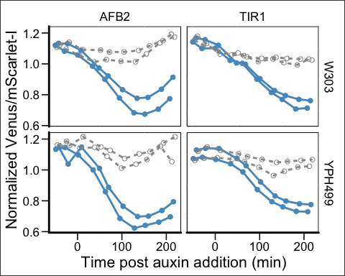

Without normalization

ratio_raw <- ggplot(data = subset(plate_03112022_sum), aes(x = time, y = ratio, group = interaction(factor(colony),  
 factor(treatment)), linetype = factor(treatment), shape = factor(treatment),  
 color = factor(treatment))) + geom_point(aes(color = treatment), size = 2) +  
 geom_line(aes(color = treatment), linewidth = 1) + xlab("Time post auxin addition (min)") +  
 scale_shape_manual(values = c(19, 1)) + ylab("Venus/mScarlet-I") + facet_grid(background_p ~  
 receptor_p, scales = "free") + scale_color_manual(values = c("#5499C7", "#999999")) +  
 theme_base() + theme(legend.position = "none", panel.grid.minor = element_line(linewidth = 0.3,  
 linetype = "solid", colour = "white"), axis.line = element_line(colour = "black",  
 linewidth = 1, linetype = "solid"))  
ratio_raw

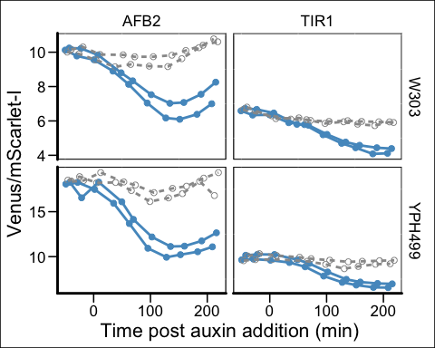

ratio_raw/ratio + plot_annotation(tag_levels = "A") & theme(plot.background = element_blank())

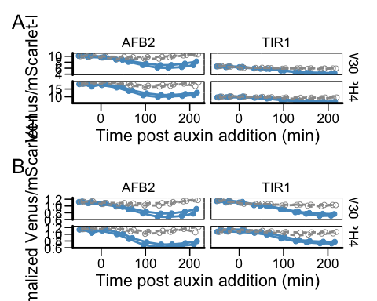

ggsave("tc-strains.pdf", width = 5, height = 7)  
ggsave("tc-strains.png", width = 5, height = 7)

# normalize green and red fluorescent expression  
plate_03112022_sum <- plate_03112022_sum %>%  
 mutate(green = BL1.Amean) %>%  
 group_by(background_p, receptor_p) %>%  
 mutate(normalized_Greenexpression = BL1.Amean/mean(BL1.Amean)) %>%  
 mutate(red = YL1.Amean) %>%  
 mutate(normalized_Redexpression = YL1.Amean/mean(YL1.Amean))  
  
normgreen <- qplot(x = time, y = normalized_Greenexpression, data = plate_03112022_sum,  
 group = interaction(factor(colony), factor(treatment)), linetype = factor(treatment),  
 shape = factor(treatment), color = factor(treatment)) + geom_point(aes(color = treatment),  
 size = 2) + geom_line(aes(color = treatment), linewidth = 1) + xlab("Time post first reading (min)") +  
 scale_shape_manual(values = c(19, 1)) + ylab("Normalized Venus expression") +  
 facet_grid(receptor_p ~ background_p) + scale_color_manual(values = c("#F1C40F",  
 "#85929E")) + theme_minimal() + theme(legend.position = "none", panel.grid.major = element_line(linewidth = 0.3,  
 linetype = "solid", colour = "white"), axis.line = element_line(colour = "black",  
 linewidth = 1, linetype = "solid"))  
  
normgreen

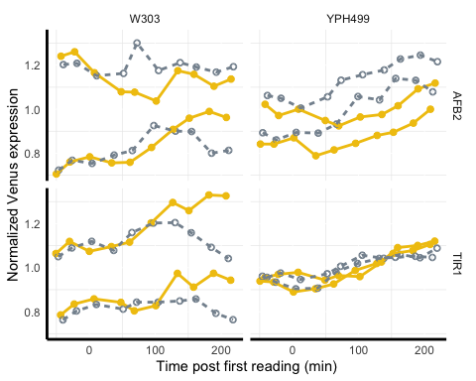

normred <- qplot(x = time, y = normalized_Redexpression, data = plate_03112022_sum,  
 group = interaction(factor(colony), factor(treatment)), linetype = factor(treatment),  
 shape = factor(treatment), color = factor(treatment)) + geom_point(aes(color = treatment),  
 size = 2) + geom_line(aes(color = treatment), linewidth = 1) + xlab("Time post first reading (min)") +  
 scale_shape_manual(values = c(19, 1)) + ylab("Normalized mScarlet expression") +  
 facet_grid(receptor_p ~ background_p) + scale_color_manual(values = c("#EC7063",  
 "#616A6B")) + theme_minimal() + theme(legend.position = "none", panel.grid.major = element_line(linewidth = 0.3,  
 linetype = "solid", colour = "white"), axis.line = element_line(colour = "black",  
 linewidth = 1, linetype = "solid"))  
normred

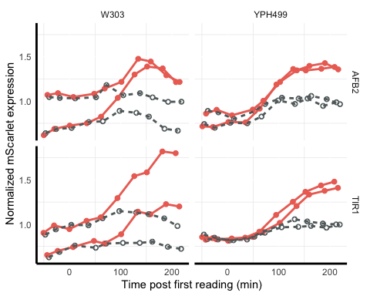

green <- qplot(x = time, y = BL1.Amean, data = plate_03112022_sum, group = interaction(factor(colony),  
 factor(treatment)), linetype = factor(treatment), shape = factor(treatment),  
 color = factor(treatment)) + geom_point(aes(color = treatment), size = 2) + geom_line(aes(color = treatment),  
 linewidth = 1) + xlab("Time post first reading (min)") + scale_shape_manual(values = c(19,  
 1)) + ylab("Normalized Venus expression") + facet_grid(receptor_p ~ background_p) +  
 scale_color_manual(values = c("#F1C40F", "#85929E")) + theme_minimal() + theme(legend.position = "none",  
 panel.grid.major = element_line(linewidth = 0.3, linetype = "solid", colour = "white"),  
 axis.line = element_line(colour = "black", linewidth = 1, linetype = "solid"))  
green

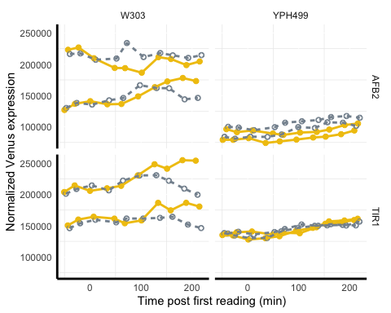

red <- qplot(x = time, y = YL1.Amean, data = plate_03112022_sum, group = interaction(factor(colony),  
 factor(treatment)), linetype = factor(treatment), shape = factor(treatment),  
 color = factor(treatment)) + geom_point(aes(color = treatment), size = 2) + geom_line(aes(color = treatment),  
 linewidth = 1) + xlab("Time post first reading (min)") + scale_shape_manual(values = c(19,  
 1)) + ylab("Normalized mScarlet expression") + facet_grid(receptor_p ~ background_p) +  
 scale_color_manual(values = c("#EC7063", "#616A6B")) + theme_minimal() + theme(legend.position = "none",  
 panel.grid.major = element_line(linewidth = 0.3, linetype = "solid", colour = "white"),  
 axis.line = element_line(colour = "black", linewidth = 1, linetype = "solid"))  
red

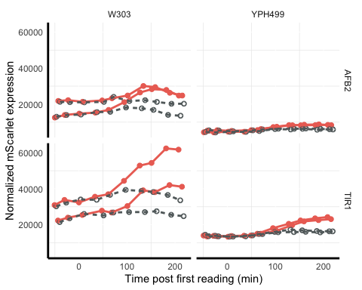

conc <- qplot(x = time, y = conc, data = plate_03112022_sum, group = interaction(factor(colony),  
 factor(treatment)), linetype = factor(treatment), shape = factor(treatment),  
 color = factor(treatment)) + geom_point(aes(color = treatment), size = 2) + geom_line(aes(color = treatment),  
 linewidth = 1) + xlab("Time post first reading (min)") + scale_shape_manual(values = c(19,  
 1)) + ylab("Normalized mScarlet expression") + facet_grid(receptor_p ~ background_p) +  
 scale_color_manual(values = c("black", "#616A6B")) + theme_minimal() + theme(legend.position = "none",  
 panel.grid.major = element_line(linewidth = 0.3, linetype = "solid", colour = "white"),  
 axis.line = element_line(colour = "black", linewidth = 1, linetype = "solid"))  
conc

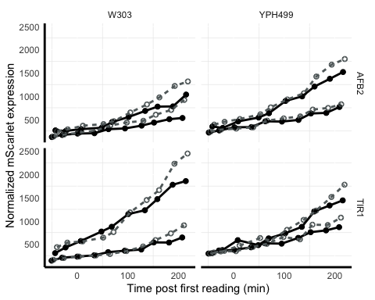

# CV plot

Using the above time course dataset we can compare coefficients of variation in the individual parameters and the ratio for each of the strains and biosensors at steady state.

## yWL185 (TIR1 dual-fusion, W303 yeast)

data185 <- steadyState(aplate_03112022, gated = TRUE)  
## [1] "No further gating applied."  
## [1] "Converting events..."  
data185 <- subset(data185, strain == "yWL185" & name %in% c("803112022-Pat-TCA08_Time-course assay_Auxin_yWL185-C1.fcs",  
 "803112022-Pat-TCA08_Time-course assay_Control_yWL185-C1.fcs"))  
  
cv <- function(x) return(round(sd(x)/mean(x), 2))  
  
  
data185 <- subset(data185, BL1.A > 1 & YL1.A > 1)  
data185$FLratio <- data185$BL1.A/data185$YL1.A  
range(data185$BL1.A)  
## [1] 45 1048575  
cv <- function(x) return(round(sd(x)/mean(x), 2))  
  
data185$Venus <- data185$BL1.A/median(data185$BL1.A)  
data185$mScarlet <- data185$YL1.A/median(data185$YL1.A)  
data185$FLratio <- data185$BL1.A/data185$YL1.A  
data185$ratio <- data185$FLratio/median(data185$FLratio)  
  
  
  
data_long185 <- data185 %>%  
 dplyr::select(treatment, Venus, mScarlet, ratio, strain) %>%  
 pivot_longer(cols = c(Venus, mScarlet, ratio), names_to = "parameter", values_to = "value") %>%  
 dplyr::mutate(parameter = fct_relevel(parameter, "Venus"))  
  
# need to also format CVs approriately for annotating  
  
CV185 <- data185 %>%  
 group_by(treatment) %>%  
 dplyr::summarise(across(dplyr::where(is_double), cv)) %>%  
 dplyr::select(treatment, Venus, mScarlet, ratio) %>%  
 pivot_longer(cols = c(Venus, mScarlet, ratio), names_to = "parameter", values_to = "value")  
  
# data185  
  
plot185 <- ggplot(data = data_long185, mapping = aes(x = value, color = treatment)) +  
 geom_density() + xlim(c(-1, 4)) + labs(x = "median normalized intensity", color = "treatment") +  
 theme_test() + geom_text(data = subset(CV185, treatment == "50 uM Auxin"), aes(label = paste0("CV = ",  
 value)), x = 2, y = 1) + geom_text(data = subset(CV185, treatment == "Control"),  
 aes(label = paste0("CV = ", value)), x = 0, y = 1) + scale_color_viridis_d(option = "D",  
 end = 0.75, direction = -1)  
  
  
  
  
venus185 <- ggplot(data185, aes(x = data185$Venus, group = treatment, fill = treatment,  
 color = treatment)) + geom_density(adjust = 1.5, alpha = 0.5) + labs(x = "Venus",  
 y = "Density") + xlim(-0.1, 2) + ylim(0, 2) + theme_classic() + theme(legend.position = "none") +  
 geom_text(data = subset(CV185, parameter == "Venus" & treatment == "50 uM Auxin"),  
 aes(label = paste0("CV = ", value)), x = 1.2, y = 1.1) + geom_text(data = subset(CV185,  
 parameter == "Venus" & treatment == "Control"), aes(label = paste0("CV = ", value)),  
 x = 0.55, y = 1.5) + scale_color_manual(values = c("#F1C40F", "#626567")) + scale_fill_manual(values = c("#F1C40F",  
 "#626567"))  
# venus185  
  
red185 <- ggplot(data185, aes(x = data185$mScarlet, group = treatment, fill = treatment,  
 color = treatment)) + geom_density(adjust = 1.5, alpha = 0.5) + labs(x = "mScarlet",  
 y = "Density") + xlim(-0.1, 2) + ylim(0, 2) + theme_classic() + theme(legend.position = "none") +  
 geom_text(data = subset(CV185, parameter == "mScarlet" & treatment == "50 uM Auxin"),  
 aes(label = paste0("CV = ", value)), x = 1.2, y = 1.1) + geom_text(data = subset(CV185,  
 parameter == "mScarlet" & treatment == "Control"), aes(label = paste0("CV = ",  
 value)), x = 0.55, y = 1.5) + scale_color_manual(values = c("#CB4335", "#626567")) +  
 scale_fill_manual(values = c("#CB4335", "#626567"))  
# red185  
  
  
ratio185 <- ggplot(data185, aes(x = data185$ratio, group = treatment, fill = treatment,  
 color = treatment)) + geom_density(adjust = 1.5, alpha = 0.5) + labs(x = "Venus/mScarlet ratio",  
 y = "Density") + xlim(-0.1, 2) + ylim(0, 3.5) + theme_classic() + theme(legend.position = "none") +  
 geom_text(data = subset(CV185, parameter == "ratio" & treatment == "50 uM Auxin"),  
 aes(label = paste0("CV = ", value)), x = 0.4, y = 2) + geom_text(data = subset(CV185,  
 parameter == "ratio" & treatment == "Control"), aes(label = paste0("CV = ", value)),  
 x = 1.6, y = 2) + scale_color_manual(values = c("#5499C7", "#626567")) + scale_fill_manual(values = c("#5499C7",  
 "#626567"))  
  
# ratio185  
  
plot185 <- grid.arrange(venus185, red185, ratio185, nrow = 3, ncol = 1)

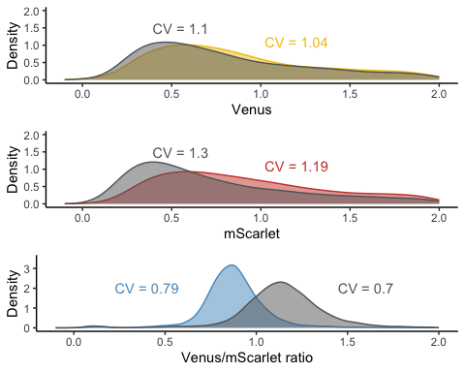

plot185  
## TableGrob (3 x 1) "arrange": 3 grobs  
## z cells name grob  
## 1 1 (1-1,1-1) arrange gtable[layout]  
## 2 2 (2-2,1-1) arrange gtable[layout]  
## 3 3 (3-3,1-1) arrange gtable[layout]

## yWL186 (AFB2 dual-fusion, W303 yeast)

data186 <- steadyState(aplate_03112022, gated = TRUE)  
## [1] "No further gating applied."  
## [1] "Converting events..."  
data186 <- subset(data186, strain == "yWL186" & name %in% c("803112022-Pat-TCA08_Time-course assay_Auxin_yWL186-C1.fcs",  
 "803112022-Pat-TCA08_Time-course assay_Control_yWL186-C1.fcs"))  
  
cv <- function(x) return(round(sd(x)/mean(x), 2))  
  
  
data186 <- subset(data186, BL1.A > 1 & YL1.A > 1)  
data186$FLratio <- data186$BL1.A/data186$YL1.A  
range(data186$BL1.A)  
## [1] 25 1048575  
cv <- function(x) return(round(sd(x)/mean(x), 2))  
  
data186$Venus <- data186$BL1.A/median(data186$BL1.A)  
data186$mScarlet <- data186$YL1.A/median(data186$YL1.A)  
data186$FLratio <- data186$BL1.A/data186$YL1.A  
data186$ratio <- data186$FLratio/median(data186$FLratio)  
  
  
  
data_long186 <- data186 %>%  
 dplyr::select(treatment, Venus, mScarlet, ratio, strain) %>%  
 pivot_longer(cols = c(Venus, mScarlet, ratio), names_to = "parameter", values_to = "value") %>%  
 dplyr::mutate(parameter = fct_relevel(parameter, "Venus"))  
  
# need to also format CVs approriately for annotating  
  
CV186 <- data186 %>%  
 group_by(treatment) %>%  
 dplyr::summarise(across(dplyr::where(is_double), cv)) %>%  
 dplyr::select(treatment, Venus, mScarlet, ratio) %>%  
 pivot_longer(cols = c(Venus, mScarlet, ratio), names_to = "parameter", values_to = "value")  
  
# data186  
  
plot186 <- ggplot(data = data_long186, mapping = aes(x = value, color = treatment)) +  
 geom_density() + xlim(c(-1, 4)) + labs(x = "median normalized intensity", color = "treatment") +  
 theme_test() + geom_text(data = subset(CV186, treatment == "50 uM Auxin"), aes(label = paste0("CV = ",  
 value)), x = 2, y = 1) + geom_text(data = subset(CV186, treatment == "Control"),  
 aes(label = paste0("CV = ", value)), x = 0, y = 1) + scale_color_viridis_d(option = "D",  
 end = 0.75, direction = -1)  
  
  
  
venus186 <- ggplot(data186, aes(x = data186$Venus, group = treatment, fill = treatment,  
 color = treatment)) + geom_density(adjust = 1.5, alpha = 0.4) + labs(x = "Venus (normalized median)",  
 y = "Density") + xlim(0, 2) + ylim(0, 2) + theme_classic() + theme(legend.position = "none") +  
 geom_text(data = subset(CV186, parameter == "Venus" & treatment == "50 uM Auxin"),  
 aes(label = paste0("CV = ", value)), x = 1.2, y = 1.1) + geom_text(data = subset(CV186,  
 parameter == "Venus" & treatment == "Control"), aes(label = paste0("CV = ", value)),  
 x = 0.55, y = 1.5) + scale_color_manual(values = c("#F1C40F", "#626567")) + scale_fill_manual(values = c("#F1C40F",  
 "#626567"))  
  
  
red186 <- ggplot(data186, aes(x = data186$mScarlet, group = treatment, fill = treatment,  
 color = treatment)) + geom_density(adjust = 1.5, alpha = 0.4) + labs(x = "mScarlet (normalized median)",  
 y = "Density") + xlim(0, 2) + ylim(0, 2) + theme_classic() + theme(legend.position = "none") +  
 scale_fill_manual(values = c("#EC7063", "#999999")) + geom_text(data = subset(CV186,  
 parameter == "mScarlet" & treatment == "50 uM Auxin"), aes(label = paste0("CV = ",  
 value)), x = 1.2, y = 1.1) + geom_text(data = subset(CV186, parameter == "mScarlet" &  
 treatment == "Control"), aes(label = paste0("CV = ", value)), x = 0.55, y = 1.5) +  
 scale_color_manual(values = c("#CB4335", "#626567")) + scale_fill_manual(values = c("#CB4335",  
 "#626567"))  
  
  
ratio186 <- ggplot(data186, aes(x = data186$ratio, group = treatment, fill = treatment,  
 color = treatment)) + geom_density(adjust = 1.5, alpha = 0.4) + labs(x = "Venus/mScarlet ratio",  
 y = "Density") + xlim(0, 2) + ylim(0, 3.5) + theme_classic() + theme(legend.position = "none") +  
 geom_text(data = subset(CV186, parameter == "ratio" & treatment == "50 uM Auxin"),  
 aes(label = paste0("CV = ", value)), x = 0.2, y = 2) + geom_text(data = subset(CV186,  
 parameter == "ratio" & treatment == "Control"), aes(label = paste0("CV = ", value)),  
 x = 1.3, y = 2) + scale_color_manual(values = c("#5499C7", "#626567")) + scale_fill_manual(values = c("#5499C7",  
 "#626567"))  
  
plot186 <- grid.arrange(venus186, red186, ratio186, nrow = 3, ncol = 1)

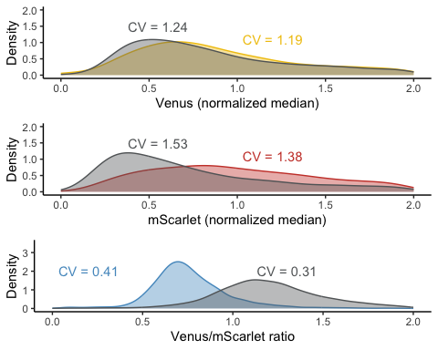

plot186  
## TableGrob (3 x 1) "arrange": 3 grobs  
## z cells name grob  
## 1 1 (1-1,1-1) arrange gtable[layout]  
## 2 2 (2-2,1-1) arrange gtable[layout]  
## 3 3 (3-3,1-1) arrange gtable[layout]

## yWL209 (TIR1 dual-fusion, YPH499 yeast)

data209 <- steadyState(aplate_03112022, gated = TRUE)  
## [1] "No further gating applied."  
## [1] "Converting events..."  
data209 <- subset(data209, strain == "yWL209" & name %in% c("803112022-Pat-TCA08_Time-course assay_Auxin_yWL209-C1.fcs",  
 "803112022-Pat-TCA08_Time-course assay_Control_yWL209-C1.fcs"))  
  
cv <- function(x) return(round(sd(x)/mean(x), 2))  
  
  
data209 <- subset(data209, BL1.A > 1 & YL1.A > 1)  
data209$FLratio <- data209$BL1.A/data209$YL1.A  
range(data209$BL1.A)  
## [1] 9 1048575  
cv <- function(x) return(round(sd(x)/mean(x), 2))  
  
data209$Venus <- data209$BL1.A/median(data209$BL1.A)  
data209$mScarlet <- data209$YL1.A/median(data209$YL1.A)  
data209$FLratio <- data209$BL1.A/data209$YL1.A  
data209$ratio <- data209$FLratio/median(data209$FLratio)  
  
  
  
data_long209 <- data209 %>%  
 dplyr::select(treatment, Venus, mScarlet, ratio, strain) %>%  
 pivot_longer(cols = c(Venus, mScarlet, ratio), names_to = "parameter", values_to = "value") %>%  
 dplyr::mutate(parameter = fct_relevel(parameter, "Venus"))  
  
# need to also format CVs approriately for annotating  
  
CV209 <- data209 %>%  
 group_by(treatment) %>%  
 dplyr::summarise(across(dplyr::where(is_double), cv)) %>%  
 dplyr::select(treatment, Venus, mScarlet, ratio) %>%  
 pivot_longer(cols = c(Venus, mScarlet, ratio), names_to = "parameter", values_to = "value")  
  
# data209  
  
plot209 <- ggplot(data = data_long209, mapping = aes(x = value, color = treatment)) +  
 geom_density() + xlim(c(-1, 4)) + labs(x = "median normalized intensity", color = "treatment") +  
 theme_test() + geom_text(data = subset(CV209, treatment == "50 uM Auxin"), aes(label = paste0("CV = ",  
 value)), x = 1.2, y = 1) + geom_text(data = subset(CV209, treatment == "Control"),  
 aes(label = paste0("CV = ", value)), x = 0, y = 1) + scale_color_viridis_d(option = "D",  
 end = 0.75, direction = -1)  
  
  
  
  
venus209 <- ggplot(data209, aes(x = data209$Venus, group = treatment, fill = treatment,  
 color = treatment)) + geom_density(adjust = 1.5, alpha = 0.4) + labs(x = "Venus",  
 y = "Density") + xlim(0, 2) + ylim(0, 2) + theme_classic() + theme(legend.position = "none") +  
 geom_text(data = subset(CV209, parameter == "Venus" & treatment == "50 uM Auxin"),  
 aes(label = paste0("CV = ", value)), x = 1.2, y = 1.1) + geom_text(data = subset(CV209,  
 parameter == "Venus" & treatment == "Control"), aes(label = paste0("CV = ", value)),  
 x = 0.55, y = 1.5) + scale_color_manual(values = c("#F1C40F", "#626567")) + scale_fill_manual(values = c("#F1C40F",  
 "#626567"))  
  
  
red209 <- ggplot(data209, aes(x = data209$mScarlet, group = treatment, fill = treatment,  
 color = treatment)) + geom_density(adjust = 1.5, alpha = 0.4) + labs(x = "mScarlet",  
 y = "Density") + xlim(0, 2) + ylim(0, 2) + theme_classic() + theme(legend.position = "none") +  
 geom_text(data = subset(CV209, parameter == "mScarlet" & treatment == "50 uM Auxin"),  
 aes(label = paste0("CV = ", value)), x = 1.2, y = 1.1) + geom_text(data = subset(CV209,  
 parameter == "mScarlet" & treatment == "Control"), aes(label = paste0("CV = ",  
 value)), x = 0.55, y = 1.5) + scale_color_manual(values = c("#CB4335", "#626567")) +  
 scale_fill_manual(values = c("#CB4335", "#626567"))  
  
  
ratio209 <- ggplot(data209, aes(x = data209$ratio, group = treatment, fill = treatment,  
 color = treatment)) + geom_density(adjust = 1.5, alpha = 0.4) + labs(x = "Venus/mScarlet ratio",  
 y = "Density") + xlim(0, 2) + ylim(0, 3.5) + theme_classic() + theme(legend.position = "none") +  
 geom_text(data = subset(CV209, parameter == "ratio" & treatment == "50 uM Auxin"),  
 aes(label = paste0("CV = ", value)), x = 0.3, y = 2) + geom_text(data = subset(CV209,  
 parameter == "ratio" & treatment == "Control"), aes(label = paste0("CV = ", value)),  
 x = 1.6, y = 2) + scale_color_manual(values = c("#5499C7", "#626567")) + scale_fill_manual(values = c("#5499C7",  
 "#626567"))  
  
  
plot209 <- grid.arrange(venus209, red209, ratio209, nrow = 3, ncol = 1)

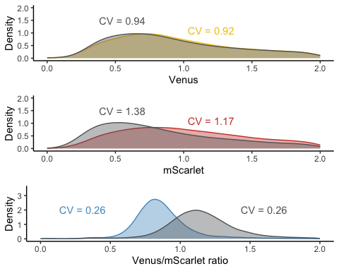

plot209  
## TableGrob (3 x 1) "arrange": 3 grobs  
## z cells name grob  
## 1 1 (1-1,1-1) arrange gtable[layout]  
## 2 2 (2-2,1-1) arrange gtable[layout]  
## 3 3 (3-3,1-1) arrange gtable[layout]

## yWL210 (AFB2 dual-fusion, YPH499 yeast)

data210 <- steadyState(aplate_03112022, gated = TRUE)  
## [1] "No further gating applied."  
## [1] "Converting events..."  
# data <- tidyFlow(aplate_20210619_W303)  
  
data210 <- subset(data210, strain == "yWL210" & name %in% c("803112022-Pat-TCA08_Time-course assay_Auxin_yWL210-C1.fcs",  
 "803112022-Pat-TCA08_Time-course assay_Control_yWL210-C1.fcs"))  
  
cv <- function(x) return(round(sd(x)/mean(x), 2))  
  
  
data210 <- subset(data210, BL1.A > 1 & YL1.A > 1)  
data210$FLratio <- data210$BL1.A/data210$YL1.A  
range(data210$BL1.A)  
## [1] 25 1048575  
cv <- function(x) return(round(sd(x)/mean(x), 2))  
  
data210$Venus <- data210$BL1.A/median(data210$BL1.A)  
data210$mScarlet <- data210$YL1.A/median(data210$YL1.A)  
data210$FLratio <- data210$BL1.A/data210$YL1.A  
data210$ratio <- data210$FLratio/median(data210$FLratio)  
  
  
  
data_long210 <- data210 %>%  
 dplyr::select(treatment, Venus, mScarlet, ratio, strain) %>%  
 pivot_longer(cols = c(Venus, mScarlet, ratio), names_to = "parameter", values_to = "value") %>%  
 dplyr::mutate(parameter = fct_relevel(parameter, "Venus"))  
  
# need to also format CVs approriately for annotating  
  
CV210 <- data210 %>%  
 group_by(treatment) %>%  
 dplyr::summarise(across(dplyr::where(is_double), cv)) %>%  
 dplyr::select(treatment, Venus, mScarlet, ratio) %>%  
 pivot_longer(cols = c(Venus, mScarlet, ratio), names_to = "parameter", values_to = "value")  
  
# data210  
  
plot210 <- ggplot(data = data_long210, mapping = aes(x = value, color = treatment)) +  
 geom_density() + xlim(c(-1, 4)) + labs(x = "median normalized intensity", color = "treatment") +  
 theme_test() + geom_text(data = subset(CV210, treatment == "50 uM Auxin"), aes(label = paste0("CV = ",  
 value)), x = 2, y = 1) + geom_text(data = subset(CV210, treatment == "Control"),  
 aes(label = paste0("CV = ", value)), x = 0, y = 1) + scale_color_viridis_d(option = "D",  
 end = 0.75, direction = -1) + facet_grid(parameter ~ .)  
  
  
  
  
venus210 <- ggplot(data210, aes(x = data210$Venus, group = treatment, color = treatment,  
 fill = treatment)) + geom_density(adjust = 1.5, alpha = 0.4) + labs(x = "Venus",  
 y = "Density") + xlim(0, 2) + ylim(0, 2) + theme_classic() + theme(legend.position = "none") +  
 geom_text(data = subset(CV210, parameter == "Venus" & treatment == "50 uM Auxin"),  
 aes(label = paste0("CV = ", value)), x = 1.5, y = 1) + geom_text(data = subset(CV210,  
 parameter == "Venus" & treatment == "Control"), aes(label = paste0("CV = ", value)),  
 x = 0.7, y = 1.5) + scale_color_manual(values = c("#F1C40F", "#626567")) + scale_fill_manual(values = c("#F1C40F",  
 "#626567"))  
  
  
red210 <- ggplot(data210, aes(x = data210$mScarlet, group = treatment, color = treatment,  
 fill = treatment)) + geom_density(adjust = 1.5, alpha = 0.4) + labs(x = "mScarlet",  
 y = "Density") + xlim(0, 2) + ylim(0, 2) + theme_classic() + theme(legend.position = "none") +  
 geom_text(data = subset(CV210, parameter == "mScarlet" & treatment == "50 uM Auxin"),  
 aes(label = paste0("CV = ", value)), x = 1.2, y = 1.2) + geom_text(data = subset(CV210,  
 parameter == "mScarlet" & treatment == "Control"), aes(label = paste0("CV = ",  
 value)), x = 0.4, y = 1.5) + scale_color_manual(values = c("#CB4335", "#626567")) +  
 scale_fill_manual(values = c("#CB4335", "#626567"))  
  
  
ratio210 <- ggplot(data210, aes(x = data210$ratio, group = treatment, color = treatment,  
 fill = treatment)) + geom_density(adjust = 1.5, alpha = 0.4) + labs(x = "Venus/mScarlet ratio",  
 y = "Density") + xlim(0, 2) + ylim(0, 3.5) + theme_classic() + theme(legend.position = "none") +  
 geom_text(data = subset(CV210, parameter == "ratio" & treatment == "50 uM Auxin"),  
 aes(label = paste0("CV = ", value)), x = 0.2, y = 1.8) + geom_text(data = subset(CV210,  
 parameter == "ratio" & treatment == "Control"), aes(label = paste0("CV = ", value)),  
 x = 1.6, y = 1.8) + scale_color_manual(values = c("#5499C7", "#626567")) + scale_fill_manual(values = c("#5499C7",  
 "#626567"))  
# ratio210  
  
plot210 <- grid.arrange(venus210, red210, ratio210, nrow = 3, ncol = 1)

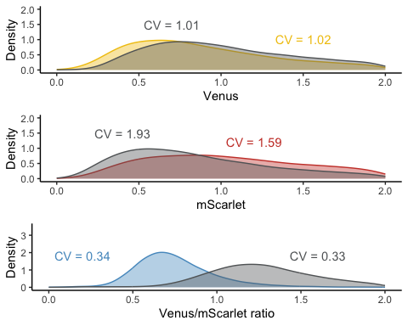

plot210  
## TableGrob (3 x 1) "arrange": 3 grobs  
## z cells name grob  
## 1 1 (1-1,1-1) arrange gtable[layout]  
## 2 2 (2-2,1-1) arrange gtable[layout]  
## 3 3 (3-3,1-1) arrange gtable[layout]

dual_fusion_cv <- (venus210 + ggtitle("AFB2") + theme(plot.title = element_text(hjust = 0.5)) |  
 venus209 + ggtitle("TIR1") + theme(plot.title = element_text(hjust = 0.5)))/(red210 |  
 red209)/(ratio210 | ratio209) + theme(title = element_text(hjust = 0))  
dual_fusion_cv

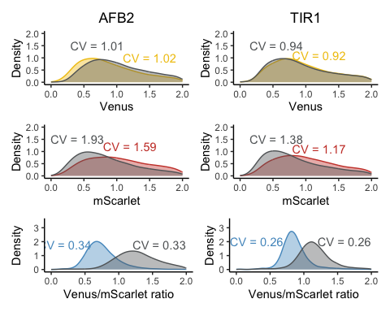

ggsave("dual_fusion_cv.pdf", width = 6.3, height = 6)  
ggsave("dual_fusion_cv.png", width = 6.3, height = 6)

# Single-fusion vs dual-fusion comparison in W303 yeast strain

* yWL161 (TIR1 single-fusion, W303 yeast)
* yWL162 (AFB2 single-fusion, W303 yeast)
* yWL185 (TIR1 dual-fusion, W303 yeast)
* yWL186 (AFB2 dual-fusion, W303 yeast)

plate_20210619_W303 <- read.plateSet(path = "~/Google Drive/Shared drives/PlantSynBioLab/Pat/Experiments/Time course assays/20210619/W303only/",  
 pattern = "r*")

annotation <- createAnnotation(yourFlowSet = plate_20210619_W303)  
write.csv(annotation, "/Users/patchaisupa/Google Drive/Shared drives/PlantSynBioLab/Pat/Experiments/Time course assays/20210619/20210619_W303only_annotation.csv")

annotation <- read.csv("~/Google Drive/Shared drives/PlantSynBioLab/Pat/Experiments/Time course assays/20210619/20210619_W303only_annotation.csv")  
aplate_20210619_W303 <- annotateFlowSet(yourFlowSet = plate_20210619_W303, annotation_df = annotation,  
 mergeBy = "name")  
head(rownames(pData(aplate_20210619_W303)))  
head(pData(aplate_20210619_W303))  
write.flowSet(aplate_20210619_W303, outdir = "flowSets/design-relative-expression")

aplate_20210619_W303 <- read.flowSet(path = "flowSets/design-relative-expression/",  
 phenoData = "annotation.txt")  
plate_20210619_W303_sum <- summarizeFlow(aplate_20210619_W303, gated = TRUE)  
## [1] "Summarizing all events..."  
  
  
# The time auxin addition is equal to time zero  
time0 <- "4E01.fcs"  
# or whatever well was being read when auxin was added  
  
plate_20210619_W303_sum$time <- plate_20210619_W303_sum$btime - plate_20210619_W303_sum[[which(plate_20210619_W303_sum$name ==  
 time0), "btime"]]  
# single bracket -->extracting the all name, 2 brackets extract just single  
# 'value' or 'values'

plate_20210619_W303_sum <- plate_20210619_W303_sum %>%  
 mutate(design = case_when(strain %in% c("yWL185", "yWL186") ~ "dual-fusion",  
 strain %in% c("yWL161", "yWL162") ~ "single-fusion"), fbox = case_when(strain %in%  
 c("yWL161", "yWL185") ~ "TIR1", strain %in% c("yWL162", "yWL186") ~ "AFB2")) %>%  
 mutate(design_construct = paste(fbox, design))  
  
plate_20210619_W303_sum <- plate_20210619_W303_sum %>%  
 mutate(ratio = FL1.Amean/FL4.Amean) %>%  
 group_by(design, fbox) %>%  
 mutate(normalizedratio = ratio/mean(ratio))  
  
plate_20210619_W303_sum <- plate_20210619_W303_sum %>%  
 mutate(green = FL1.Amean) %>%  
 group_by(design, fbox) %>%  
 mutate(normalized_Greenexpression = FL1.Amean/mean(FL1.Amean))  
  
plate_20210619_W303_sum <- plate_20210619_W303_sum %>%  
 mutate(red = FL4.Amean) %>%  
 group_by(design, fbox) %>%  
 mutate(normalized_Redexpression = FL4.Amean/mean(FL4.Amean))

TIR1_single <- qplot(x = time, y = FL1.Amean/FL4.Amean, data = subset(plate_20210619_W303_sum,  
 strain == "yWL161"), group = factor(treatment), linetype = factor(treatment),  
 shape = factor(treatment), color = factor(treatment)) + xlab("Time (min)") +  
 geom_point(aes(color = treatment, shape = treatment), size = 1) + geom_line(aes(color = treatment,  
 shape = treatment), linewidth = 0.5) + scale_shape_manual(values = c(19, 1)) +  
 ylab("Venus/Scarlet ratio") + scale_color_manual(values = c("#5499C7", "#626567")) +  
 theme_minimal() + theme(legend.position = "none", panel.grid.major = element_line(linewidth = 0.3,  
 linetype = "solid", colour = "white"), panel.grid.minor = element_line(linewidth = 0.3,  
 linetype = "solid", colour = "white")) + facet_wrap(~design_construct, scale = "free_y")  
  
  
AFB2_single <- qplot(x = time, y = FL1.Amean/FL4.Amean, data = subset(plate_20210619_W303_sum,  
 strain == "yWL162"), group = factor(treatment), linetype = factor(treatment),  
 shape = factor(treatment), color = factor(treatment)) + xlab("Time (min)") +  
 geom_point(aes(color = treatment, shape = treatment), size = 1) + geom_line(aes(color = treatment,  
 shape = treatment), linewidth = 0.5) + scale_shape_manual(values = c(19, 1)) +  
 ylab("Venus/Scarlet ratio") + scale_color_manual(values = c("#5499C7", "#626567")) +  
 theme_minimal() + theme(legend.position = "none", panel.grid.major = element_line(linewidth = 0.3,  
 linetype = "solid", colour = "white"), panel.grid.minor = element_line(linewidth = 0.3,  
 linetype = "solid", colour = "white")) + facet_wrap(~design_construct, scale = "free_y")  
  
TIR1_dual <- qplot(x = time, y = FL1.Amean/FL4.Amean, data = subset(plate_20210619_W303_sum,  
 strain == "yWL185"), group = factor(treatment), linetype = factor(treatment),  
 shape = factor(treatment), color = factor(treatment)) + geom_point(aes(color = treatment,  
 shape = treatment), size = 1) + geom_line(aes(color = treatment, shape = treatment),  
 linewidth = 0.5) + xlab("Time (min)") + scale_shape_manual(values = c(19, 1)) +  
 ylab("Venus/Scarlet ratio") + scale_color_manual(values = c("#5499C7", "#626567")) +  
 theme_minimal() + theme(legend.position = "none", panel.grid.major = element_line(linewidth = 0.3,  
 linetype = "solid", colour = "white"), panel.grid.minor = element_line(linewidth = 0.3,  
 linetype = "solid", colour = "white")) + facet_wrap(~design_construct, scale = "free_y")  
  
AFB2_dual <- qplot(x = time, y = FL1.Amean/FL4.Amean, data = subset(plate_20210619_W303_sum,  
 strain == "yWL186"), group = factor(treatment), linetype = factor(treatment),  
 shape = factor(treatment), color = factor(treatment)) + xlab("Time (min)") +  
 geom_point(aes(color = treatment, shape = treatment), size = 1) + geom_line(aes(color = treatment,  
 shape = treatment), linewidth = 0.5) + scale_shape_manual(values = c(19, 1)) +  
 ylab("Venus/Scarlet ratio") + scale_color_manual(values = c("#5499C7", "#626567")) +  
 theme_minimal() + theme(legend.position = "none", panel.grid.major = element_line(linewidth = 0.3,  
 linetype = "solid", colour = "white"), panel.grid.minor = element_line(linewidth = 0.3,  
 linetype = "solid", colour = "white")) + facet_wrap(~design_construct, scale = "free_y")  
  
grid.arrange(AFB2_single, TIR1_single, TIR1_dual, AFB2_dual, nrow = 2, ncol = 4)

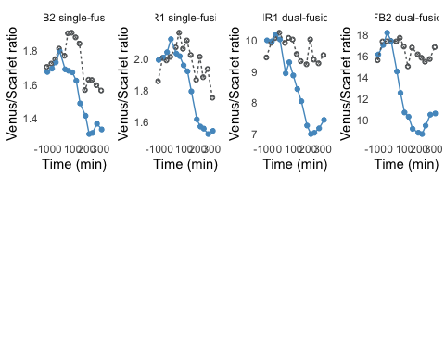

W303ratio <- qplot(x = time, y = normalizedratio, data = subset(plate_20210619_W303_sum),  
 group = factor(treatment), linetype = factor(treatment), shape = factor(treatment),  
 color = factor(treatment)) + xlab("Time (min)") + geom_point(aes(color = treatment),  
 size = 0.5) + geom_line(aes(color = treatment), linewidth = 1) + scale_shape_manual(values = c(19,  
 1)) + ylab("Venus") + scale_color_manual(values = c("#2E86C1", "#626567")) +  
 theme_minimal() + theme(legend.position = "bottom", panel.grid.major = element_line(linewidth = 0.3,  
 linetype = "solid", colour = "white"), panel.grid.minor = element_line(linewidth = 0.3,  
 linetype = "solid", colour = "white"), axis.line = element_line(colour = "black",  
 linewidth = 1, linetype = "solid")) + facet_wrap(~design_construct, scale = "free_y")  
  
W303venus <- qplot(x = time, y = normalized_Greenexpression, data = subset(plate_20210619_W303_sum),  
 group = factor(treatment), linetype = factor(treatment), shape = factor(treatment),  
 color = factor(treatment)) + xlab("Time (min)") + geom_point(aes(color = treatment),  
 size = 0.5) + geom_line(aes(color = treatment), linewidth = 1) + scale_shape_manual(values = c(19,  
 1)) + ylab("Venus/Scarlet") + scale_color_manual(values = c("#F1C40F", "#626567")) +  
 theme_minimal() + theme(legend.position = "bottom", panel.grid.major = element_line(linewidth = 0.3,  
 linetype = "solid", colour = "white"), panel.grid.minor = element_line(linewidth = 0.3,  
 linetype = "solid", colour = "white"), axis.line = element_line(colour = "black",  
 linewidth = 1, linetype = "solid")) + facet_wrap(~design_construct, scale = "free_y")  
  
grid.arrange(W303venus, W303ratio, nrow = 2, ncol = 2)

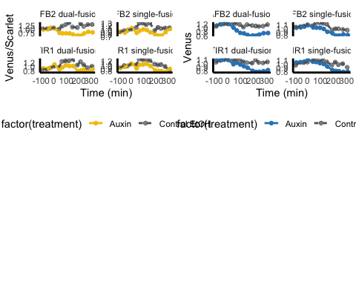

Venus_aov <- aov(FL1.Amean ~ design_construct * treatment * before_after, data = plate_20210619_W303_sum %>%  
 dplyr::filter(time <= 0 | time >= 200))  
summary(Venus_aov)  
## Df Sum Sq Mean Sq F value Pr(>F)  
## design_construct 3 5.902e+09 1.967e+09 108.760 < 2e-16  
## treatment 1 9.695e+08 9.695e+08 53.601 5.82e-09  
## before_after 1 4.570e+06 4.570e+06 0.253 0.618  
## design_construct:treatment 3 5.293e+07 1.764e+07 0.976 0.414  
## design_construct:before_after 3 9.180e+07 3.060e+07 1.692 0.184  
## treatment:before_after 1 6.641e+08 6.641e+08 36.715 3.56e-07  
## design_construct:treatment:before_after 3 3.063e+07 1.021e+07 0.564 0.642  
## Residuals 41 7.416e+08 1.809e+07   
##   
## design_construct ***  
## treatment ***  
## before_after   
## design_construct:treatment   
## design_construct:before_after   
## treatment:before_after ***  
## design_construct:treatment:before_after   
## Residuals   
## ---  
## Signif. codes: 0 '***' 0.001 '**' 0.01 '*' 0.05 '.' 0.1 ' ' 1  
(Venus_HSD.test <- agricolae::HSD.test(Venus_aov, trt = c("design_construct", "treatment",  
 "before_after"), console = TRUE))  
##   
## Study: Venus_aov ~ c("design_construct", "treatment", "before_after")  
##   
## HSD Test for FL1.Amean   
##   
## Mean Square Error: 18087298   
##   
## design_construct:treatment:before_after, means  
##   
## FL1.Amean std r Min Max  
## AFB2 dual-fusion:Auxin:after 24425.97 3887.943 4 19046.09 27855.18  
## AFB2 dual-fusion:Auxin:before 34631.51 2164.181 3 33214.07 37122.60  
## AFB2 dual-fusion:Control EtOH:after 43943.78 2563.443 4 40314.31 46305.36  
## AFB2 dual-fusion:Control EtOH:before 35281.28 747.563 3 34785.81 36141.17  
## AFB2 single-fusion:Auxin:after 48152.32 8233.437 4 41566.06 58870.26  
## AFB2 single-fusion:Auxin:before 52801.44 3789.368 3 49120.11 56690.32  
## AFB2 single-fusion:Control EtOH:after 61495.06 1241.776 4 59958.17 62859.15  
## AFB2 single-fusion:Control EtOH:before 53911.90 2286.620 3 51418.04 55909.91  
## TIR1 dual-fusion:Auxin:after 41225.93 2818.571 4 37362.85 43733.63  
## TIR1 dual-fusion:Auxin:before 46003.40 1595.801 3 44645.69 47761.17  
## TIR1 dual-fusion:Control EtOH:after 53108.52 5964.120 4 46969.08 60966.52  
## TIR1 dual-fusion:Control EtOH:before 44671.84 1768.004 3 43508.04 46706.33  
## TIR1 single-fusion:Auxin:after 53550.99 3388.730 4 50475.84 58381.61  
## TIR1 single-fusion:Auxin:before 63962.75 3201.204 3 61073.09 67403.85  
## TIR1 single-fusion:Control EtOH:after 65619.10 7089.748 5 53646.79 71126.31  
## TIR1 single-fusion:Control EtOH:before 64865.95 3237.883 3 61178.65 67245.10  
##   
## Alpha: 0.05 ; DF Error: 41   
## Critical Value of Studentized Range: 5.154955   
##   
## Groups according to probability of means differences and alpha level( 0.05 )  
##   
## Treatments with the same letter are not significantly different.  
##   
## FL1.Amean groups  
## TIR1 single-fusion:Control EtOH:after 65619.10 a  
## TIR1 single-fusion:Control EtOH:before 64865.95 ab  
## TIR1 single-fusion:Auxin:before 63962.75 ab  
## AFB2 single-fusion:Control EtOH:after 61495.06 ab  
## AFB2 single-fusion:Control EtOH:before 53911.90 bc  
## TIR1 single-fusion:Auxin:after 53550.99 bc  
## TIR1 dual-fusion:Control EtOH:after 53108.52 bc  
## AFB2 single-fusion:Auxin:before 52801.44 bcd  
## AFB2 single-fusion:Auxin:after 48152.32 cd  
## TIR1 dual-fusion:Auxin:before 46003.40 cde  
## TIR1 dual-fusion:Control EtOH:before 44671.84 cde  
## AFB2 dual-fusion:Control EtOH:after 43943.78 cde  
## TIR1 dual-fusion:Auxin:after 41225.93 de  
## AFB2 dual-fusion:Control EtOH:before 35281.28 ef  
## AFB2 dual-fusion:Auxin:before 34631.51 ef  
## AFB2 dual-fusion:Auxin:after 24425.97 f  
## $statistics  
## MSerror Df Mean CV  
## 18087298 41 49475.37 8.596028  
##   
## $parameters  
## test name.t ntr StudentizedRange alpha  
## Tukey design_construct:treatment:before_after 16 5.154955 0.05  
##   
## $means  
## FL1.Amean std r Min Max  
## AFB2 dual-fusion:Auxin:after 24425.97 3887.943 4 19046.09 27855.18  
## AFB2 dual-fusion:Auxin:before 34631.51 2164.181 3 33214.07 37122.60  
## AFB2 dual-fusion:Control EtOH:after 43943.78 2563.443 4 40314.31 46305.36  
## AFB2 dual-fusion:Control EtOH:before 35281.28 747.563 3 34785.81 36141.17  
## AFB2 single-fusion:Auxin:after 48152.32 8233.437 4 41566.06 58870.26  
## AFB2 single-fusion:Auxin:before 52801.44 3789.368 3 49120.11 56690.32  
## AFB2 single-fusion:Control EtOH:after 61495.06 1241.776 4 59958.17 62859.15  
## AFB2 single-fusion:Control EtOH:before 53911.90 2286.620 3 51418.04 55909.91  
## TIR1 dual-fusion:Auxin:after 41225.93 2818.571 4 37362.85 43733.63  
## TIR1 dual-fusion:Auxin:before 46003.40 1595.801 3 44645.69 47761.17  
## TIR1 dual-fusion:Control EtOH:after 53108.52 5964.120 4 46969.08 60966.52  
## TIR1 dual-fusion:Control EtOH:before 44671.84 1768.004 3 43508.04 46706.33  
## TIR1 single-fusion:Auxin:after 53550.99 3388.730 4 50475.84 58381.61  
## TIR1 single-fusion:Auxin:before 63962.75 3201.204 3 61073.09 67403.85  
## TIR1 single-fusion:Control EtOH:after 65619.10 7089.748 5 53646.79 71126.31  
## TIR1 single-fusion:Control EtOH:before 64865.95 3237.883 3 61178.65 67245.10  
## Q25 Q50 Q75  
## AFB2 dual-fusion:Auxin:after 22934.16 25401.31 26893.13  
## AFB2 dual-fusion:Auxin:before 33385.97 33557.87 35340.23  
## AFB2 dual-fusion:Control EtOH:after 43299.85 44577.73 45221.67  
## AFB2 dual-fusion:Control EtOH:before 34851.33 34916.85 35529.01  
## AFB2 single-fusion:Auxin:after 41748.87 46086.48 52489.94  
## AFB2 single-fusion:Auxin:before 50856.99 52593.87 54642.10  
## AFB2 single-fusion:Control EtOH:after 60845.16 61581.46 62231.36  
## AFB2 single-fusion:Control EtOH:before 52912.90 54407.76 55158.83  
## TIR1 dual-fusion:Auxin:after 40076.43 41903.61 43053.11  
## TIR1 dual-fusion:Auxin:before 45124.52 45603.34 46682.25  
## TIR1 dual-fusion:Control EtOH:after 49652.60 52249.25 55705.17  
## TIR1 dual-fusion:Control EtOH:before 43654.60 43801.16 45253.75  
## TIR1 single-fusion:Auxin:after 51941.54 52673.26 54282.71  
## TIR1 single-fusion:Auxin:before 62242.20 63411.32 65407.59  
## TIR1 single-fusion:Control EtOH:after 64830.36 68765.73 69726.29  
## TIR1 single-fusion:Control EtOH:before 63676.38 66174.10 66709.60  
##   
## $comparison  
## NULL  
##   
## $groups  
## FL1.Amean groups  
## TIR1 single-fusion:Control EtOH:after 65619.10 a  
## TIR1 single-fusion:Control EtOH:before 64865.95 ab  
## TIR1 single-fusion:Auxin:before 63962.75 ab  
## AFB2 single-fusion:Control EtOH:after 61495.06 ab  
## AFB2 single-fusion:Control EtOH:before 53911.90 bc  
## TIR1 single-fusion:Auxin:after 53550.99 bc  
## TIR1 dual-fusion:Control EtOH:after 53108.52 bc  
## AFB2 single-fusion:Auxin:before 52801.44 bcd  
## AFB2 single-fusion:Auxin:after 48152.32 cd  
## TIR1 dual-fusion:Auxin:before 46003.40 cde  
## TIR1 dual-fusion:Control EtOH:before 44671.84 cde  
## AFB2 dual-fusion:Control EtOH:after 43943.78 cde  
## TIR1 dual-fusion:Auxin:after 41225.93 de  
## AFB2 dual-fusion:Control EtOH:before 35281.28 ef  
## AFB2 dual-fusion:Auxin:before 34631.51 ef  
## AFB2 dual-fusion:Auxin:after 24425.97 f  
##   
## attr(,"class")  
## [1] "group"  
Venus_groups <- Venus_HSD.test$groups %>%  
 as_tibble(rownames = "names") %>%  
 separate(col = names, into = c("design_construct", "treatment", "before_after"),  
 sep = "\\:", remove = FALSE) %>%  
 left_join(Venus_HSD.test$means %>%  
 as_tibble(rownames = "names") %>%  
 dplyr::select(c(names, Max)), by = "names") %>%  
 mutate(treatment = fct_rev(treatment), before_after = fct_rev(before_after))

mScarlet_aov <- aov(FL4.Amean ~ design_construct * treatment * before_after, data = plate_20210619_W303_sum %>%  
 dplyr::filter(time <= 0 | time >= 200))  
summary(mScarlet_aov)  
## Df Sum Sq Mean Sq F value  
## design_construct 3 1.318e+10 4.393e+09 1152.935  
## treatment 1 2.843e+06 2.843e+06 0.746  
## before_after 1 7.962e+07 7.962e+07 20.894  
## design_construct:treatment 3 4.175e+06 1.392e+06 0.365  
## design_construct:before_after 3 6.634e+07 2.211e+07 5.803  
## treatment:before_after 1 7.820e+02 7.820e+02 0.000  
## design_construct:treatment:before_after 3 7.087e+06 2.362e+06 0.620  
## Residuals 41 1.562e+08 3.811e+06   
## Pr(>F)   
## design_construct < 2e-16 ***  
## treatment 0.39279   
## before_after 4.41e-05 ***  
## design_construct:treatment 0.77844   
## design_construct:before_after 0.00211 **   
## treatment:before_after 0.98864   
## design_construct:treatment:before_after 0.60610   
## Residuals   
## ---  
## Signif. codes: 0 '***' 0.001 '**' 0.01 '*' 0.05 '.' 0.1 ' ' 1  
(mScarlet_HSD.test <- agricolae::HSD.test(mScarlet_aov, trt = c("design_construct",  
 "treatment", "before_after"), console = TRUE))  
##   
## Study: mScarlet_aov ~ c("design_construct", "treatment", "before_after")  
##   
## HSD Test for FL4.Amean   
##   
## Mean Square Error: 3810672   
##   
## design_construct:treatment:before_after, means  
##   
## FL4.Amean std r Min  
## AFB2 dual-fusion:Auxin:after 2490.844 198.85812 4 2207.416  
## AFB2 dual-fusion:Auxin:before 2026.397 46.66275 3 1973.433  
## AFB2 dual-fusion:Control EtOH:after 2759.117 144.66745 4 2612.374  
## AFB2 dual-fusion:Control EtOH:before 2110.115 112.55555 3 2013.715  
## AFB2 single-fusion:Auxin:after 36197.490 5828.74906 4 31851.266  
## AFB2 single-fusion:Auxin:before 31074.988 1904.65789 3 29016.085  
## AFB2 single-fusion:Control EtOH:after 38385.588 1153.01803 4 36886.238  
## AFB2 single-fusion:Control EtOH:before 31251.821 936.56398 3 30193.587  
## TIR1 dual-fusion:Auxin:after 5753.411 381.70386 4 5202.843  
## TIR1 dual-fusion:Auxin:before 4582.236 107.55234 3 4483.615  
## TIR1 dual-fusion:Control EtOH:after 5556.851 452.28202 4 5075.024  
## TIR1 dual-fusion:Control EtOH:before 4557.292 144.44763 3 4390.506  
## TIR1 single-fusion:Auxin:after 34660.947 2185.28924 4 33220.282  
## TIR1 single-fusion:Auxin:before 31775.292 1187.70866 3 30675.467  
## TIR1 single-fusion:Control EtOH:after 34156.499 2380.95848 5 30640.164  
## TIR1 single-fusion:Control EtOH:before 33266.440 288.20961 3 32971.733  
## Max  
## AFB2 dual-fusion:Auxin:after 2666.530  
## AFB2 dual-fusion:Auxin:before 2061.453  
## AFB2 dual-fusion:Control EtOH:after 2929.881  
## AFB2 dual-fusion:Control EtOH:before 2233.807  
## AFB2 single-fusion:Auxin:after 44192.014  
## AFB2 single-fusion:Auxin:before 32774.074  
## AFB2 single-fusion:Control EtOH:after 39681.451  
## AFB2 single-fusion:Control EtOH:before 31973.960  
## TIR1 dual-fusion:Auxin:after 6084.835  
## TIR1 dual-fusion:Auxin:before 4696.914  
## TIR1 dual-fusion:Control EtOH:after 6086.477  
## TIR1 dual-fusion:Control EtOH:before 4642.111  
## TIR1 single-fusion:Auxin:after 37917.098  
## TIR1 single-fusion:Auxin:before 33034.740  
## TIR1 single-fusion:Control EtOH:after 37060.388  
## TIR1 single-fusion:Control EtOH:before 33547.680  
##   
## Alpha: 0.05 ; DF Error: 41   
## Critical Value of Studentized Range: 5.154955   
##   
## Groups according to probability of means differences and alpha level( 0.05 )  
##   
## Treatments with the same letter are not significantly different.  
##   
## FL4.Amean groups  
## AFB2 single-fusion:Control EtOH:after 38385.588 a  
## AFB2 single-fusion:Auxin:after 36197.490 ab  
## TIR1 single-fusion:Auxin:after 34660.947 ab  
## TIR1 single-fusion:Control EtOH:after 34156.499 ab  
## TIR1 single-fusion:Control EtOH:before 33266.440 ab  
## TIR1 single-fusion:Auxin:before 31775.292 b  
## AFB2 single-fusion:Control EtOH:before 31251.821 b  
## AFB2 single-fusion:Auxin:before 31074.988 b  
## TIR1 dual-fusion:Auxin:after 5753.411 c  
## TIR1 dual-fusion:Control EtOH:after 5556.851 c  
## TIR1 dual-fusion:Auxin:before 4582.236 c  
## TIR1 dual-fusion:Control EtOH:before 4557.292 c  
## AFB2 dual-fusion:Control EtOH:after 2759.117 c  
## AFB2 dual-fusion:Auxin:after 2490.844 c  
## AFB2 dual-fusion:Control EtOH:before 2110.115 c  
## AFB2 dual-fusion:Auxin:before 2026.397 c  
## $statistics  
## MSerror Df Mean CV  
## 3810672 41 19226.9 10.15293  
##   
## $parameters  
## test name.t ntr StudentizedRange alpha  
## Tukey design_construct:treatment:before_after 16 5.154955 0.05  
##   
## $means  
## FL4.Amean std r Min  
## AFB2 dual-fusion:Auxin:after 2490.844 198.85812 4 2207.416  
## AFB2 dual-fusion:Auxin:before 2026.397 46.66275 3 1973.433  
## AFB2 dual-fusion:Control EtOH:after 2759.117 144.66745 4 2612.374  
## AFB2 dual-fusion:Control EtOH:before 2110.115 112.55555 3 2013.715  
## AFB2 single-fusion:Auxin:after 36197.490 5828.74906 4 31851.266  
## AFB2 single-fusion:Auxin:before 31074.988 1904.65789 3 29016.085  
## AFB2 single-fusion:Control EtOH:after 38385.588 1153.01803 4 36886.238  
## AFB2 single-fusion:Control EtOH:before 31251.821 936.56398 3 30193.587  
## TIR1 dual-fusion:Auxin:after 5753.411 381.70386 4 5202.843  
## TIR1 dual-fusion:Auxin:before 4582.236 107.55234 3 4483.615  
## TIR1 dual-fusion:Control EtOH:after 5556.851 452.28202 4 5075.024  
## TIR1 dual-fusion:Control EtOH:before 4557.292 144.44763 3 4390.506  
## TIR1 single-fusion:Auxin:after 34660.947 2185.28924 4 33220.282  
## TIR1 single-fusion:Auxin:before 31775.292 1187.70866 3 30675.467  
## TIR1 single-fusion:Control EtOH:after 34156.499 2380.95848 5 30640.164  
## TIR1 single-fusion:Control EtOH:before 33266.440 288.20961 3 32971.733  
## Max Q25 Q50 Q75  
## AFB2 dual-fusion:Auxin:after 2666.530 2438.961 2544.714 2596.597  
## AFB2 dual-fusion:Auxin:before 2061.453 2008.869 2044.305 2052.879  
## AFB2 dual-fusion:Control EtOH:after 2929.881 2655.805 2747.106 2850.417  
## AFB2 dual-fusion:Control EtOH:before 2233.807 2048.269 2082.823 2158.315  
## AFB2 single-fusion:Auxin:after 44192.014 31870.387 34373.340 38700.443  
## AFB2 single-fusion:Auxin:before 32774.074 30225.445 31434.806 32104.440  
## AFB2 single-fusion:Control EtOH:after 39681.451 37980.543 38487.331 38892.376  
## AFB2 single-fusion:Control EtOH:before 31973.960 30890.752 31587.918 31780.939  
## TIR1 dual-fusion:Auxin:after 6084.835 5692.279 5862.984 5924.116  
## TIR1 dual-fusion:Auxin:before 4696.914 4524.898 4566.180 4631.547  
## TIR1 dual-fusion:Control EtOH:after 6086.477 5250.871 5532.952 5838.933  
## TIR1 dual-fusion:Control EtOH:before 4642.111 4514.882 4639.258 4640.685  
## TIR1 single-fusion:Auxin:after 37917.098 33608.882 33753.203 34805.267  
## TIR1 single-fusion:Auxin:before 33034.740 31145.568 31615.670 32325.205  
## TIR1 single-fusion:Control EtOH:after 37060.388 33524.915 34184.394 35372.637  
## TIR1 single-fusion:Control EtOH:before 33547.680 33125.820 33279.906 33413.793  
##   
## $comparison  
## NULL  
##   
## $groups  
## FL4.Amean groups  
## AFB2 single-fusion:Control EtOH:after 38385.588 a  
## AFB2 single-fusion:Auxin:after 36197.490 ab  
## TIR1 single-fusion:Auxin:after 34660.947 ab  
## TIR1 single-fusion:Control EtOH:after 34156.499 ab  
## TIR1 single-fusion:Control EtOH:before 33266.440 ab  
## TIR1 single-fusion:Auxin:before 31775.292 b  
## AFB2 single-fusion:Control EtOH:before 31251.821 b  
## AFB2 single-fusion:Auxin:before 31074.988 b  
## TIR1 dual-fusion:Auxin:after 5753.411 c  
## TIR1 dual-fusion:Control EtOH:after 5556.851 c  
## TIR1 dual-fusion:Auxin:before 4582.236 c  
## TIR1 dual-fusion:Control EtOH:before 4557.292 c  
## AFB2 dual-fusion:Control EtOH:after 2759.117 c  
## AFB2 dual-fusion:Auxin:after 2490.844 c  
## AFB2 dual-fusion:Control EtOH:before 2110.115 c  
## AFB2 dual-fusion:Auxin:before 2026.397 c  
##   
## attr(,"class")  
## [1] "group"  
mScarlet_groups <- mScarlet_HSD.test$groups %>%  
 as_tibble(rownames = "names") %>%  
 separate(col = names, into = c("design_construct", "treatment", "before_after"),  
 sep = "\\:", remove = FALSE) %>%  
 left_join(mScarlet_HSD.test$means %>%  
 as_tibble(rownames = "names") %>%  
 dplyr::select(c(names, Max)), by = "names") %>%  
 mutate(treatment = fct_rev(treatment), before_after = fct_rev(before_after))

boxvenus <- plate_20210619_W303_sum %>%  
 dplyr::filter(time <= 0 | time >= 200) %>%  
 ggplot(aes(x = fct_rev(before_after), y = FL1.Amean/1000, )) + geom_boxplot(aes(fill = fct_rev(treatment)),  
 alpha = 0.7, outlier.shape = NA, show.legend = FALSE) + geom_point(aes(color = fct_rev(treatment)),  
 position = position_dodge2(width = 0.55), size = 1) + geom_text(data = Venus_groups,  
 mapping = aes(y = 1.05 * Max/1000, label = groups), position = position_dodge2(width = 1),  
 color = "black") + scale_fill_manual(values = c("#8f8f8f", "#edc215")) + scale_color_manual(values = c("#8f8f8f",  
 "#edc215")) + ylab("Venus") + xlab("50 µM Auxin treatment") + facet_wrap(~fbox,  
 scale = "free_y") + facet_grid(~design_construct) + theme_classic() + labs(color = "")  
  
  
boxmScarlet <- plate_20210619_W303_sum %>%  
 dplyr::filter(time <= 0 | time >= 200) %>%  
 ggplot(aes(x = fct_rev(before_after), y = FL4.Amean/1000)) + geom_boxplot(aes(fill = fct_rev(treatment)),  
 alpha = 0.7, outlier.shape = NA, show.legend = FALSE) + geom_point(aes(color = fct_rev(treatment)),  
 position = position_dodge2(width = 0.55), size = 1) + geom_text(data = mScarlet_groups,  
 mapping = aes(y = 1.2 * Max/1000, label = groups), position = position_dodge2(width = 1),  
 color = "black") + scale_fill_manual(values = c("#8f8f8f", "#EC7063")) + scale_color_manual(values = c("#8f8f8f",  
 "#EC7063")) + ylab("mScarlet-I") + xlab("50 µM Auxin treatment") + facet_wrap(~fbox,  
 scale = "free_y") + facet_grid(~design_construct, scales = "free_y") + theme_classic() +  
 labs(color = "") + scale_y_log10()  
  
  
guide_area()/boxvenus/boxmScarlet + plot_annotation(tag_levels = "A") + plot_layout(guides = "collect",  
 heights = c(0.3, 1, 1)) & theme(legend.box = "horizontal", legend.spacing = unit(0,  
 "pt"), legend.justification = "top", legend.margin = margin(), legend.box.spacing = unit(0,  
 "pt"), legend.background = element_blank(), legend.box.background = element_blank(),  
 legend.title = element_blank(), legend.key = element_blank())

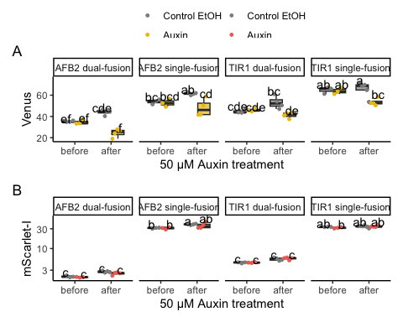

ggsave("relative-expression-box.pdf", width = 6, height = 5)  
ggsave("relative-expression-box.png", width = 6, height = 5)

plate_20210619_read3and12 <- read.flowSet(path = "~/Google Drive/Shared drives/PlantSynBioLab/Pat/Experiments/Time course assays/20210619/W303only_read3and12/",  
 alter.names = TRUE)

annotation <- createAnnotation(yourFlowSet = plate_20210619_read3and12)  
write.csv(annotation, "/Users/patchaisupa/Google Drive/Shared drives/PlantSynBioLab/Pat/Experiments/Time course assays/20210619/20210619_W303only_read3and12_annotation.csv")

annotation <- read.csv("~/Google Drive/Shared drives/PlantSynBioLab/Pat/Experiments/Time course assays/20210619/20210619_W303only_read3and12_annotation.csv")  
aplate_20210619_read3and12 <- annotateFlowSet(yourFlowSet = plate_20210619_read3and12,  
 annotation_df = annotation, mergeBy = "name")  
head(rownames(pData(aplate_20210619_read3and12)))  
## [1] "D01.fcs" "D02.fcs" "D03.fcs" "D04.fcs" "D07.fcs" "D08.fcs"  
head(pData(aplate_20210619_read3and12))  
## name X strain treatment reading before_after design_construct  
## D01.fcs D01.fcs 1 yWL161 Control EtOH 3 before TIR1 trans  
## D02.fcs D02.fcs 2 yWL162 Control EtOH 3 before AFB2 trans  
## D03.fcs D03.fcs 3 yWL185 Control EtOH 3 before TIR1 cis  
## D04.fcs D04.fcs 4 yWL186 Control EtOH 3 before AFB2 cis  
## D07.fcs D07.fcs 5 yWL161 Auxin 3 before TIR1 trans  
## D08.fcs D08.fcs 6 yWL162 Auxin 3 before AFB2 trans

W303_read3and12 <- summarizeFlow(aplate_20210619_read3and12, gated = TRUE)  
## [1] "Summarizing all events..."  
W303_read3and12 <- W303_read3and12 %>%  
 mutate(design = str_extract(design_construct, "(?<=\\s).*")) %>%  
 mutate(design = str_extract(design_construct, ".*(?=\\s)"))  
  
venus3and12_unnorm <- ggplot(W303_read3and12, aes(x = design_construct, y = FL1.Amean,  
 alpha = fct_rev(before_after), group = treatment)) + geom_point(aes(colour = factor(treatment),  
 shape = factor(treatment)), size = 2, position = position_jitterdodge(dodge.width = 0.7,  
 jitter.width = 0.5)) + scale_color_manual(values = c("#F1C40F", "#5F6A6A")) +  
 ylab("Venus") + theme_classic() + theme(axis.text.x = element_text(angle = 45,  
 hjust = 1)) + scale_alpha_manual(values = c(0.3, 0.8))  
  
mScarlet3and12_unnorm <- ggplot(W303_read3and12, aes(x = design_construct, y = FL4.Amean,  
 alpha = fct_rev(before_after), group = treatment)) + geom_point(aes(colour = factor(treatment),  
 shape = factor(treatment)), size = 2, position = position_jitterdodge(dodge.width = 0.7,  
 jitter.width = 0.5)) + scale_color_manual(values = c("#E74C3C", "#5F6A6A")) +  
 ylab("mScarlet-I") + theme_classic() + theme(axis.text.x = element_text(angle = 45,  
 hjust = 1)) + scale_alpha_manual(values = c(0.3, 0.8))  
  
guide_area()/(venus3and12_unnorm | mScarlet3and12_unnorm) + plot_layout(guides = "collect",  
 heights = c(1, 3)) + plot_annotation(tag_levels = "A") & theme(legend.position = "top",  
 legend.direction = "vertical", legend.title = element_blank(), axis.title.x = element_blank(),  
 legend.justification = "left", legend.box.just = "left", legend.margin = margin())

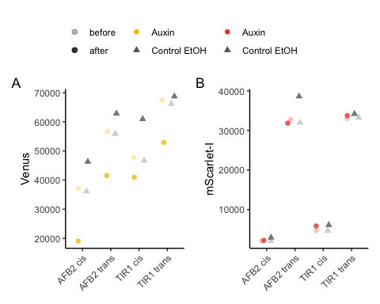

ggsave("relative-expression.png", width = 4, height = 3)  
ggsave("relative-expression.pdf", width = 4, height = 3)

Coefficient of variation (CV) analysis

data <- steadyState(aplate_20210619_W303, gated = TRUE)  
## [1] "No further gating applied."  
## [1] "Converting events..."  
# data <- tidyFlow(aplate_20210619_W303)  
  
data <- subset(data, strain == "yWL161" & name %in% c("11L01.fcs", "11L07.fcs"))  
  
# range(data$FL1.A) sd(data$FLratio)/mean(data$FLratio) range(data$FLratio)  
data <- subset(data, FL1.A > 1 & FL4.A > 1)  
data$FLratio <- data$FL1.A/data$FL4.A  
range(data$FL1.A)  
## [1] 722 2579491  
# calculate cvs  
sd(data$FLratio)/mean(data$FLratio)  
## [1] 1.821223  
range(data$FLratio)  
## [1] 0.06052985 488.44186047  
cv <- function(x) return(round(sd(x)/mean(x), 2))  
  
# calculate normalized values  
data$Venus <- data$FL1.A/median(data$FL1.A)  
data$mScarlet <- data$FL4.A/median(data$FL4.A)  
data$ratio <- data$FLratio/median(data$FLratio)  
CVs <- data %>%  
 group_by(treatment) %>%  
 summarise(across(where(is_double), cv))  
# make a tidy, long dataset  
  
data_long <- data %>%  
 dplyr::select(treatment, Venus, mScarlet, ratio) %>%  
 pivot_longer(cols = c(Venus, mScarlet, ratio), names_to = "parameter", values_to = "value")  
# need to also format CVs appropriately for annotating  
CVs <- CVs %>%  
 dplyr::select(treatment, Venus, mScarlet, ratio) %>%  
 pivot_longer(cols = c(Venus, mScarlet, ratio), names_to = "parameter", values_to = "value")  
  
# data  
CV_plot <- ggplot(data = data_long, mapping = aes(x = value, color = treatment)) +  
 geom_density() + xlim(c(-1, 4)) + labs(x = "median normalized intensity", color = "treatment") +  
 facet_grid(parameter ~ .) + theme_test() + geom_text(data = subset(CVs, treatment ==  
 "Auxin"), aes(label = paste0("CV = ", value)), x = 0.1, y = 0.6) + geom_text(data = subset(CVs,  
 treatment == "Control EtOH"), aes(label = paste0("CV = ", value)), x = 1.8, y = 0.6) +  
 scale_color_viridis_d(option = "D", end = 0.75, direction = -1)  
CV_plot

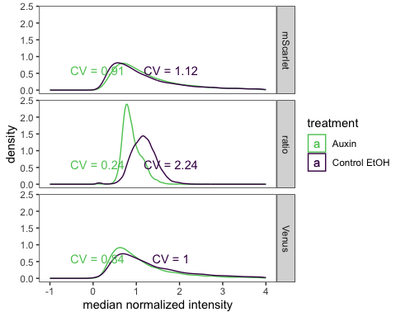

# Auxin prodcution in stationary phase

Read in annotated flowSet

flowSet <- read.flowSet(path = paste0("~/Google Drive/Shared drives/PlantSynBioLab/Auxin Biosensor Manuscript/Auxin Biosensor Data/FlowSets/",  
 experiment_date, "_", experiment_name), phenoData = "annotation.txt")  
write.flowSet(flowSet, "flowSets/auxin-biosynthesis")

flowSet <- read.flowSet(path = "flowSets/auxin-biosynthesis/", phenoData = "annotation.txt")

## Summary Analysis

load("PSB_Accuri_W303.RData")  
dat_sum <- summarizeFlow(flowSet, ploidy = "haploid", only = "yeast") # These gates might not work well for YPH499, but there was a lot of debris  
## [1] "Gating with haploid yeast gate..."  
## [1] "Summarizing all yeast events..."

dat_sum <- mutate(.data = dat_sum, across(starts_with("FL"), as.numeric)) %>%  
 mutate(strain = str_remove(strain, " ratiometric sensor") %>%  
 str_replace(pattern = "in trans", replacement = "single-fusion") %>%  
 str_replace(pattern = "in cis", replacement = "dual-fusion"))  
dat_sum$pred_auxin <- dat_sum$FL4.Amean/dat_sum$FL1.Amean  
dat_sum$pred_auxin_SE <- with(dat_sum, sqrt((FL4.Asd/100/FL4.Amean)^2 + (FL1.Asd/100/FL1.Amean)^2) *  
 pred_auxin)  
dat_sum$pred_auxin_sd <- with(dat_sum, sqrt((FL4.Asd/FL4.Amean)^2 + (FL1.Asd/FL1.Amean)^2) *  
 pred_auxin)

ggplot(data = dat_sum, aes(x = fct_reorder(treat, pred_auxin), y = pred_auxin, color = factor(strain))) +  
 geom_point() + theme(axis.text.x = element_text(angle = 45, hjust = 1, vjust = 1)) +  
 facet_grid(. ~ strain, scales = "free_x") + coord_flip() + theme(legend.position = "bottom",  
 legend.direction = "vertical") + labs(x = "", y = "Predicted auxin (mScarlet-I/Venus-IAA17)",  
 color = "strain")

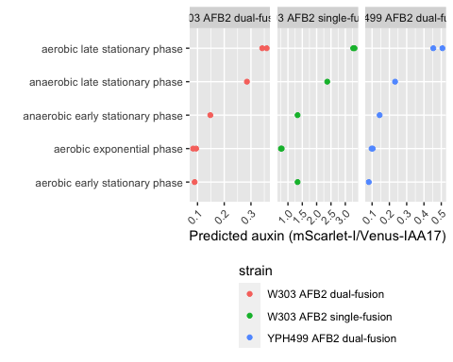

ggsave("strain_sensor_comparison_raw.pdf", width = 8, height = 3)

dat_sum <- dat_sum %>%  
 group_by(strain) %>%  
 mutate(norm_pred_auxin = pred_auxin/mean(pred_auxin[which(.data$treat == "aerobic exponential phase")]))  
  
ggplot(data = dat_sum, aes(x = fct_reorder(treat, norm_pred_auxin), y = norm_pred_auxin,  
 color = factor(strain))) + geom_point(position = position_jitter(width = 0.2)) +  
 theme(axis.text.x = element_text(angle = 45, hjust = 1, vjust = 1)) + coord_flip() +  
 theme(legend.position = "top", legend.direction = "vertical") + labs(x = "",  
 y = "Normalized Predicted auxin (mScarlet-I/Venus-IAA17)", color = "strain")

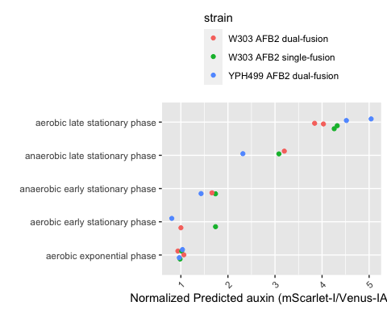

ggsave("strain_sensor_comparison_norm.pdf", width = 5, height = 5)

Full distributions

data <- steadyState(flowset = flowSet, ploidy = "haploid", only = "yeast")  
## [1] "Gating with haploid yeast gate..."  
## [1] "Converting events..."  
  
hist(x = log(data$FL1.A, 10))

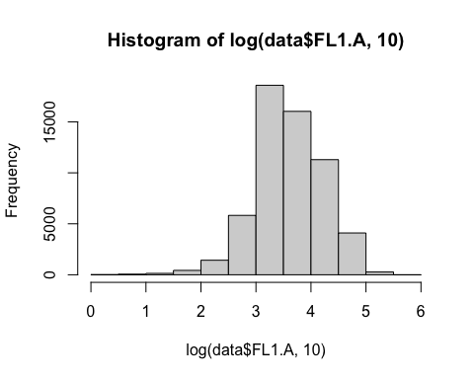

hist(x = log(data$FL4.A, 10))

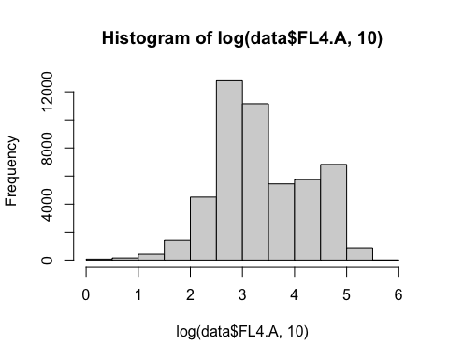

data$pred_auxin <- data$FL4.A/data$FL1.A  
data <- data %>%  
 dplyr::filter(FL1.A > 1 & FL4.A > 1)  
data$treat <- data$treat %>%  
 str_remove("phase")

endog_auxin <- ggplot(data = subset(data, strain == "W303 ratiometric sensor AFB2 in cis" &  
 pred_auxin < 2), aes(x = pred_auxin, y = fct_reorder(treat, .x = pred_auxin,  
 .fun = median, .desc = TRUE) %>%  
 fct_relevel("aerobic exponential ", after = Inf), fill = factor(stat(quantile)))) +  
 stat_density_ridges(geom = "density_ridges_gradient", calc_ecdf = TRUE, quantiles = 4,  
 color = "grey", alpha = 0.5) + scale_fill_viridis_d(name = "Quartiles") +  
 theme(legend.position = NULL) + #facet_wrap(.~treat) + theme(legend.position  
 theme(legend.position = NULL) + #facet_wrap(.~treat) + = NULL) +  
 theme(legend.position = NULL) + #facet_wrap(.~treat) + #facet_wrap(.~treat)  
 theme(legend.position = NULL) + #facet_wrap(.~treat) + +  
xlim(c(-0.1, 1)) + labs(y = NULL, x = "Predicted relative auxin production (AU) \n (AFB2-mScarlet-I/Venus-IAA17)") +  
 theme_ridges() + theme(legend.position = "none")  
ggsave("20210626_auxin_production_quartiles.pdf", width = 5, height = 4)  
endog_auxin

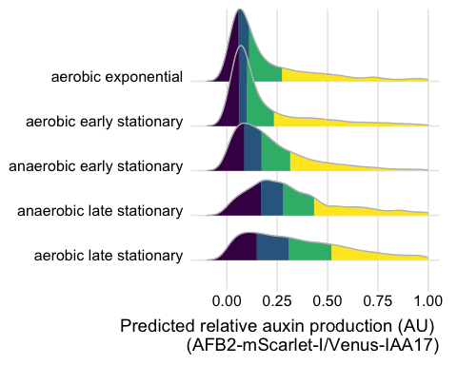

## Biosensor sensitivity at stationary phase

plate_09282022 <- read.plateSet(path = "~/Google Drive/Shared drives/PlantSynBioLab/Pat/Experiments/Does-response assay/09282022_yWL210_DRA-stationary/Data/",  
 pattern = "S-DRA*")

annotation_09282022 <- read.csv("~/Google Drive/Shared drives/PlantSynBioLab/Pat/Experiments/Does-response assay/09282022_yWL210_DRA-stationary/09282022_stationaryphase_annotation.csv")  
  
aplate_09282022 <- annotateFlowSet(yourFlowSet = plate_09282022, annotation_df = annotation_09282022,  
 mergeBy = "name")  
head(rownames(pData(aplate_09282022)))  
head(pData(aplate_09282022))  
write.flowSet(aplate_09282022, "flowSets/AFB2-dual-stationary")

aplate_09282022 <- read.flowSet(path = "flowSets/AFB2-dual-stationary/", phenoData = "annotation.txt")  
  
dat_sumGr_09282022 <- summarizeFlow(aplate_09282022, gated = TRUE)  
## [1] "Summarizing all events..."  
  
model.LL4_09282022 <- drm(YL1.Amean/BL1.Amean ~ dose, data = subset(dat_sumGr_09282022,  
 set == "4"), fct = LL.4(names = c("Slope", "Lower Limit", "Upper Limit", "ED50")))  
  
pm210stat <- expand.grid(treatment = exp(seq(log(1e-05), log(100), length = 1000)))  
pm210stat <- cbind(pm210stat, predict(model.LL4_09282022, newdata = pm210stat, interval = "confidence")) #m2all = model of 210 data  
  
plot210_stat <- ggplot(subset(dat_sumGr_09282022, set == "4"), aes(x = dose, y = YL1.Amean/BL1.Amean)) +  
 geom_ribbon(data = pm210stat, aes(x = treatment, y = Prediction, ymin = Lower,  
 ymax = Upper), alpha = 0.2) + geom_line(data = pm210stat, aes(x = treatment,  
 y = Prediction)) + ylab("AFB2-mScarlet-I/Venus-IAA17") + xlab("Exogenous Auxin (µM)") +  
 scale_x_log10(labels = scales::label_number(drop0trailing = TRUE)) + scale_color_viridis_d() +  
 geom_point() + theme_classic(base_size = 14) + theme(legend.position = "none")  
plot210_stat

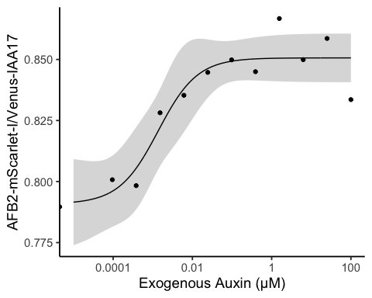

## Combined figure

endog_auxin + plot210_stat + plot_annotation(tag_levels = "A")

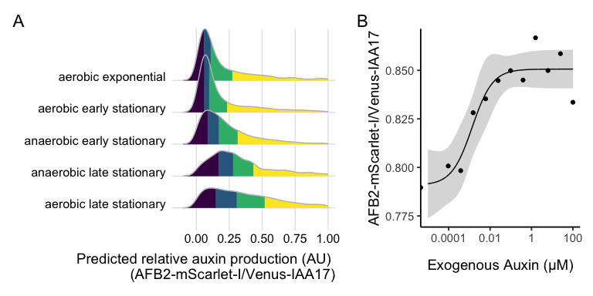

ggsave("auxin-accumulation.pdf", width = 8, height = 4)  
ggsave("auxin-accumulation.png", width = 8, height = 4)

# Mutant library analysis

Here we aim to test auxin induced Venus-IAA17 degradation relative to the bicistronic mScarlet-I control with AFB2 expressed from the p1 plasmid in the OrthoRep continuous mutagenesis system.

## Procedure

Temperature 30 degree celcius Shaking at 250rpm DO-URA-HIS, starting volume: 10 mL Overnight concentration: 30 events/uL 1PM started from 2 colonies

Initial reading ~10AM Auxin concentration: 100 uM (.1% DMSO) After 4th reading: B04.fcs

###Importing and annotating data

aplate1 <- read.flowSet(path = "flowSets/OrthoRep", phenoData = "annotation.txt")  
dat_sum <- summarizeFlow(aplate1, gated = TRUE)  
## [1] "Summarizing all events..."

data <- flowTime::tidyFlow(aplate1, gated = TRUE)  
## [1] "No further gating applied."  
## [1] "Converting events..."  
data <- subset(data, FL4.A > 1)  
range(data$FL1.A)  
## [1] 0 15867629  
range(data$FL4.A)  
## [1] 6 7690137  
data$ratio <- data$FL1.A/data$FL4.A  
data <- subset(data, data$ratio < 10)

Make a kernel density plot overlapping mutant population with parent, DMSO and IAA that we can then stack a few timepoints with facets. For timepoints it looks like the 2nd, 7th and 12th would be a good demonstration of the timecourse.

wells <- dat_sum %>%  
 # Get well/file names of the 2nd, 7th and 12th readings of the 4 strains.  
dplyr::slice(1:4 + unlist(lapply((c(2, 7, 12) - 1) * 4, rep, 4))) %>%  
 dplyr::pull("name")  
data <- dplyr::filter(data, name %in% wells)  
  
data$approxtime <- signif(data$etime, digits = 1)  
signif(unique(data$approxtime), 1)  
## [1] 30 200 600  
data$approxtime <- as.factor(data$approxtime) %>%  
 fct_recode(`0 hour` = "30", `1 hour` = "200", `6 hour` = "600")  
data$strain <- fct_recode(data$strain, `high fidelity` = "wild", `error prone` = "mutant")  
data <- data %>%  
 mutate(Venus = FL1.A, mScarlet = FL4.A, ratio = Venus/mScarlet)  
  
cv <- function(x) return(round(sd(x)/mean(x), 2))  
CVs <- data %>%  
 group_by(treatment, strain) %>%  
 dplyr::summarise(across(where(is_double), cv))  
CVs <- CVs %>%  
 dplyr::select(treatment, Venus, mScarlet, ratio) %>%  
 pivot_longer(cols = c(Venus, mScarlet, ratio), names_to = "parameter", values_to = "value")  
  
kernel_plot <- ggplot(data = data, mapping = aes(x = ratio, color = treatment, linetype = strain)) +  
 geom_density() + coord_cartesian(x = c(0.5, 2)) + facet_grid(approxtime ~ .) +  
 theme_test() + scale_color_viridis_d(option = "D", end = 0.75, direction = -1) +  
 labs(x = "Venus-IAA17/mScarlet ratio", linetype = "polymerase")  
kernel_plot

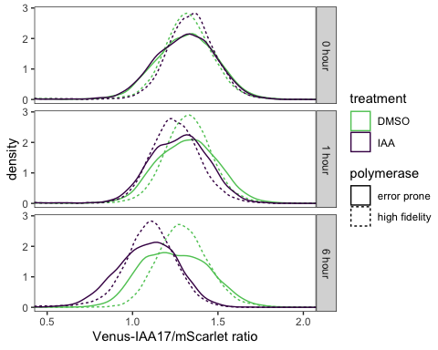

ggsave("orthorep_degradation.pdf", height = 4, width = 4)  
ggsave("orthorep_degradation.png", height = 4, width = 4)

## Gating Strategy

data <- aplate1[wells]

To gate out the high FSC-A debris we will use only the lower 99.5% of the data

g <- gate_quantile(fr = data[[1]], channel = "FSC.A", probs = 0.995)  
autoplot(data[[1]], x = "FSC-A") + geom_gate(g)

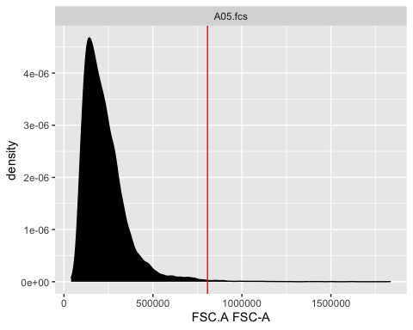

Subset(data[[1]], !g)  
## flowFrame object 'A05.fcs'  
## with 9950 cells and 14 observables:  
## name desc range minRange maxRange  
## $P1 FSC.A FSC-A 16777216 0 16777216  
## $P2 SSC.A SSC-A 16777216 0 16777216  
## $P3 FL1.A FL1-A 16777216 0 16777216  
## $P4 FL2.A FL2-A 16777216 0 16777216  
## $P5 FL3.A FL3-A 16777216 0 16777216  
## ... ... ... ... ... ...  
## $P10 FL2.H FL2-H 16777216 0 16777216  
## $P11 FL3.H FL3-H 16777216 0 16777216  
## $P12 FL4.H FL4-H 16777216 0 16777216  
## $P13 Width Width 16777216 0 16777216  
## $P14 Time Time 16777216 0 16777216  
## 161 keywords are stored in the 'description' slot  
autoplot(Subset(data[[3]], !g), x = "FSC-A", "SSC-A")

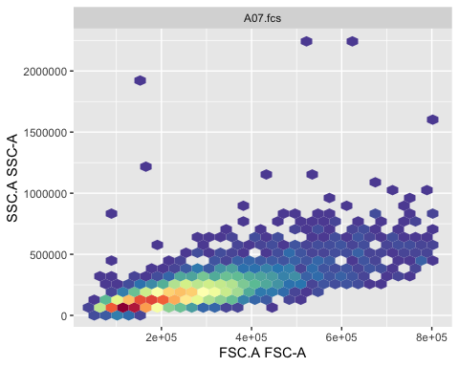

autoplot(data[[3]], "FSC-A", "SSC-A") + geom_gate(g)

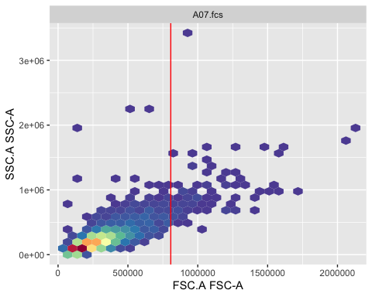 Now we need to gate out only singlet cells

chnl <- c("FSC-A", "FSC-H")  
singlets <- gate_singlet(x = Subset(data[[1]], !g), area = "FSC.A", height = "FSC.H",  
 prediction_level = 0.999, maxit = 20)  
autoplot(data[[1]], "FSC-A", "FSC-H") + geom_gate(singlets)

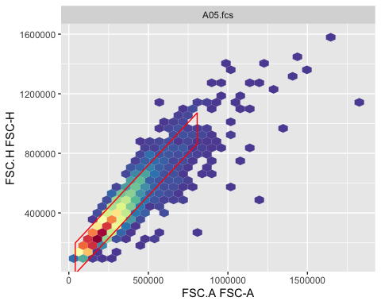 Now we can assess this singlets gate over for several frames

length(data)  
## [1] 12  
autoplot(data, x = "FSC-A", y = "FSC-H") + geom_gate(singlets) + facet_wrap("name",  
 ncol = 4)

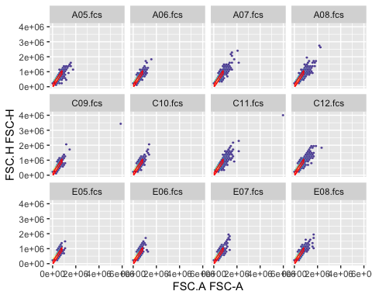

autoplot(Subset(data, !g) %>%  
 Subset(singlets), x = "FL1-A") + facet_wrap("name", ncol = 4)

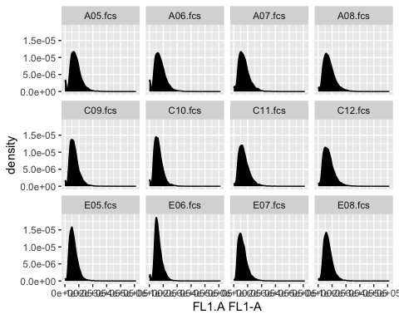

autoplot(Subset(data, !g | singlets), x = "FSC-A", y = "SSC-A") + facet_wrap("name",  
 ncol = 4)

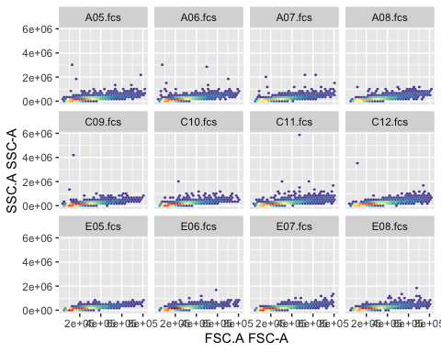

This looks very consistent across the course of this experiment. We can summarize this gating across the whole experiment, but will not show this here.

# summary(filter(data, !g & singlets))  
data <- Subset(data, !g & singlets)

Plot Fluorescence vs. Time

dat_sum <- summarizeFlow(data, gated = TRUE)  
## [1] "Summarizing all events..."  
  
ggplot(data = dat_sum, aes(x = time, y = FL1.Amean/FL4.Amean, color = factor(strain),  
 linetype = factor(treatment))) + geom_line() + xlab("Time post first reading (min)") +  
 ylab("Reporter Fluorescence, FL1 (AU)") + geom_text(aes(label = name))

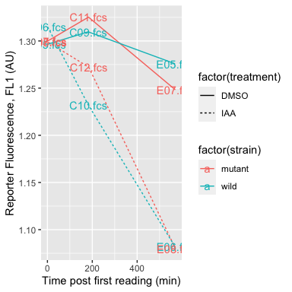

ggplot(data = dat_sum, aes(x = time, y = conc, color = factor(strain), linetype = factor(treatment))) +  
 geom_line() + xlab("Time post first reading (min)") + ylab("Reporter Fluorescence, FL1 (AU)")

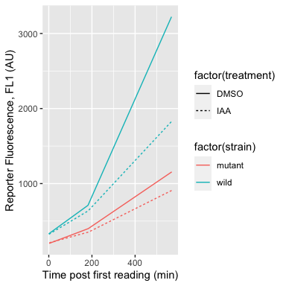 Define a gate containing ~95% of the untreated cells expressing the wildtype polymerase.

logt <- estimateLogicle(data[["E05.fcs"]], channels = c("FL4.A", "FL1.A"))  
data <- transform(data[c("E05.fcs", "E06.fcs", "E07.fcs", "E08.fcs")], logt)  
untreated <- gate_flowclust_2d(data[["E05.fcs"]], xChannel = "FL4.A", yChannel = "FL1.A",  
 K = 1, quantile = 0.9, filterId = "untreated")  
treated <- gate_flowclust_2d(data[["E06.fcs"]], xChannel = "FL4.A", yChannel = "FL1.A",  
 K = 1, quantile = 0.9, filterId = "treated")  
  
  
  
ggcyto(data, aes(x = "FL4.A", y = "FL1.A")) + geom_point(color = "green4", alpha = 0.1,  
 size = 0.5) + ggthemes::theme_base() + labs(x = "mScarlet-I (free FP)", y = "Venus-IAA17") +  
 facet_grid(fct_rev(strain) %>%  
 fct_recode(`wild-type` = "wild") ~ treatment) + coord_cartesian(xlim = c(1.4,  
 2.6), ylim = c(1.4, 2.6)) + geom_gate(untreated, colour = "magenta", linetype = 2) +  
 geom_gate(treated, colour = "magenta") + geom_stats(adjust = c(0.1, 0.05), size = 4.5,  
 alpha = 0.5)

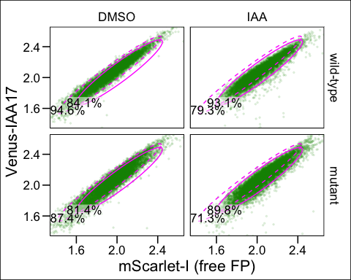

ggsave("sorting-strategy.pdf", height = 4.5, width = 6)  
ggsave("sorting-strategy.png", height = 4.5, width = 6)

## Mutation frequency calculation

As an overestimate, these cells were cultured for ~12 generations over 24 hours. So this results in 212 cells for each initial.

AFB2 is 1725 bps, and the mutation rate of the error prone polymerase is calculated to be substitutions per base. We will assume there is only 1 copy of the p1 plasmid per cell. We will also assume withing this coding sequence, for every 2.1 substitutions (sub) there is 1 nonsynonymous substitution (nsub), per the average across the codon table, not factoring in codon usage across TIR1.

So on the low end, ~0.0164286 percent of cells have a nonsynonymous substitution in *TIR1*. But because this substitution rate is really compounding over 12 generations, this estimate is quite low.

Based on this baseline rate per cell (or generation, cell duplication) , we can then compound this over generations, to find the compounded rate .

And on the high end, which is a more accurate measure, ~22% of our population contains a nonsynonymous substitution in *TIR1*.

# Session Info

sessionInfo()  
## R Under development (unstable) (2022-10-30 r83209)  
## Platform: aarch64-apple-darwin20 (64-bit)  
## Running under: macOS Ventura 13.2.1  
##   
## Matrix products: default  
## BLAS: /Library/Frameworks/R.framework/Versions/4.3-arm64/Resources/lib/libRblas.0.dylib  
## LAPACK: /Library/Frameworks/R.framework/Versions/4.3-arm64/Resources/lib/libRlapack.dylib  
##   
## locale:  
## [1] en_US.UTF-8/en_US.UTF-8/en_US.UTF-8/C/en_US.UTF-8/en_US.UTF-8  
##   
## attached base packages:  
## [1] stats graphics grDevices utils datasets methods base   
##   
## other attached packages:  
## [1] agricolae_1.3-5 ggthemes_4.2.4 patchwork_1.1.2   
## [4] wesanderson_0.3.6 flowClust_3.37.0 flowStats_4.11.0   
## [7] ggcyto_1.27.4 flowWorkspace_4.11.0 ncdfFlow_2.45.0   
## [10] BH_1.78.0-0 openCyto_2.11.1 gridExtra_2.3   
## [13] drc_3.0-1 MASS_7.3-58.1 lubridate_1.9.2   
## [16] forcats_1.0.0 purrr_1.0.1 readr_2.1.4   
## [19] tibble_3.1.8 tidyverse_2.0.0 tidyr_1.3.0   
## [22] dplyr_1.1.0 ggridges_0.5.4 stringr_1.5.0   
## [25] ggplot2_3.4.1 flowTime_1.23.1 flowCore_2.11.0   
##   
## loaded via a namespace (and not attached):  
## [1] RColorBrewer_1.1-3 rstudioapi_0.14 magrittr_2.0.3   
## [4] TH.data_1.1-1 rainbow_3.7 farver_2.1.1   
## [7] rmarkdown_2.19 ragg_1.2.5 zlibbioc_1.45.0   
## [10] vctrs_0.5.2 RCurl_1.98-1.9 htmltools_0.5.4   
## [13] haven_2.5.2 plotrix_3.8-2 deSolve_1.34   
## [16] hdrcde_3.4 pracma_2.4.2 KernSmooth_2.23-20   
## [19] plyr_1.8.8 sandwich_3.0-2 zoo_1.8-11   
## [22] mime_0.12 lifecycle_1.0.3 pkgconfig_2.0.3   
## [25] Matrix_1.5-3 R6_2.5.1 fastmap_1.1.0   
## [28] shiny_1.7.4 digest_0.6.31 klaR_1.7-1   
## [31] colorspace_2.0-3 S4Vectors_0.37.3 textshaping_0.3.6   
## [34] labeling_0.4.2 cytolib_2.11.0 fansi_1.0.3   
## [37] timechange_0.2.0 abind_1.4-5 compiler_4.3.0   
## [40] withr_2.5.0 carData_3.0-5 DBI_1.1.3   
## [43] highr_0.9 hexbin_1.28.2 corpcor_1.6.10   
## [46] gtools_3.9.4 tools_4.3.0 rrcov_1.7-2   
## [49] httpuv_1.6.9 glue_1.6.2 IDPmisc_1.1.20   
## [52] questionr_0.7.8 nlme_3.1-161 promises_1.2.0.1   
## [55] grid_4.3.0 cluster_2.1.4 generics_0.1.3   
## [58] gtable_0.3.1 fda_6.0.5 labelled_2.10.0   
## [61] tzdb_0.3.0 data.table_1.14.6 hms_1.1.2   
## [64] car_3.1-1 utf8_1.2.2 BiocGenerics_0.45.0  
## [67] pillar_1.8.1 later_1.3.0 robustbase_0.95-0   
## [70] splines_4.3.0 lattice_0.20-45 AlgDesign_1.2.1   
## [73] survival_3.4-0 deldir_1.0-6 ks_1.14.0   
## [76] RProtoBufLib_2.11.0 tidyselect_1.2.0 RBGL_1.75.0   
## [79] fds_1.8 miniUI_0.1.1.1 knitr_1.41   
## [82] stats4_4.3.0 xfun_0.35 Biobase_2.59.0   
## [85] matrixStats_0.63.0 DEoptimR_1.0-11 stringi_1.7.8   
## [88] yaml_2.3.6 evaluate_0.19 codetools_0.2-18   
## [91] interp_1.1-3 Rgraphviz_2.43.0 graph_1.77.1   
## [94] cli_3.6.0 flowViz_1.63.0 systemfonts_1.0.4   
## [97] xtable_1.8-4 munsell_0.5.0 Rcpp_1.0.9   
## [100] png_0.1-8 XML_3.99-0.13 parallel_4.3.0   
## [103] ellipsis_0.3.2 mclust_6.0.0 latticeExtra_0.6-30  
## [106] jpeg_0.1-10 bitops_1.0-7 viridisLite_0.4.1   
## [109] mvtnorm_1.1-3 scales_1.2.1 pcaPP_2.0-3   
## [112] combinat_0.0-8 rlang_1.0.6 formatR_1.14   
## [115] multcomp_1.4-22 mnormt_2.1.1

1. Biological Systems Engineering, Virginia Tech, Blacksburg, VA , USA, co-first author
2. Biological Systems Engineering, Virginia Tech, Blacksburg, VA, USA, co-first author
3. Fralin Life Sciences Institute, Virginia Tech, Blacksburg, VA, USA
4. Biological Systems Engineering, Virginia Tech, Blacksburg, VA, USA
5. Biological Systems Engineering, Virginia Tech, Blacksburg, VA, USA
6. Biochemistry and Fralin Life Sciences Institute, Virginia Tech, Blacksburg, VA, USA
7. Biological Systems Engineering, Fralin Life Sciences Institute, and Translational Plant Sciences Center, Virginia Tech, Blacksburg, VA, USA, [wrightrc@vt.edu](mailto:wrightrc@vt.edu)