How Can I Create a Rounded, Oval, or Tower Garden?
In addition to traditional square and rectangular gardens, you can now create rounded, oval, or tower gardens (including GreenStalk gardens) in Planter!

Note: The ability to create multiple gardens is a Planter Premium feature.

<<EMBED RECORDING>>
- Tap New Garden
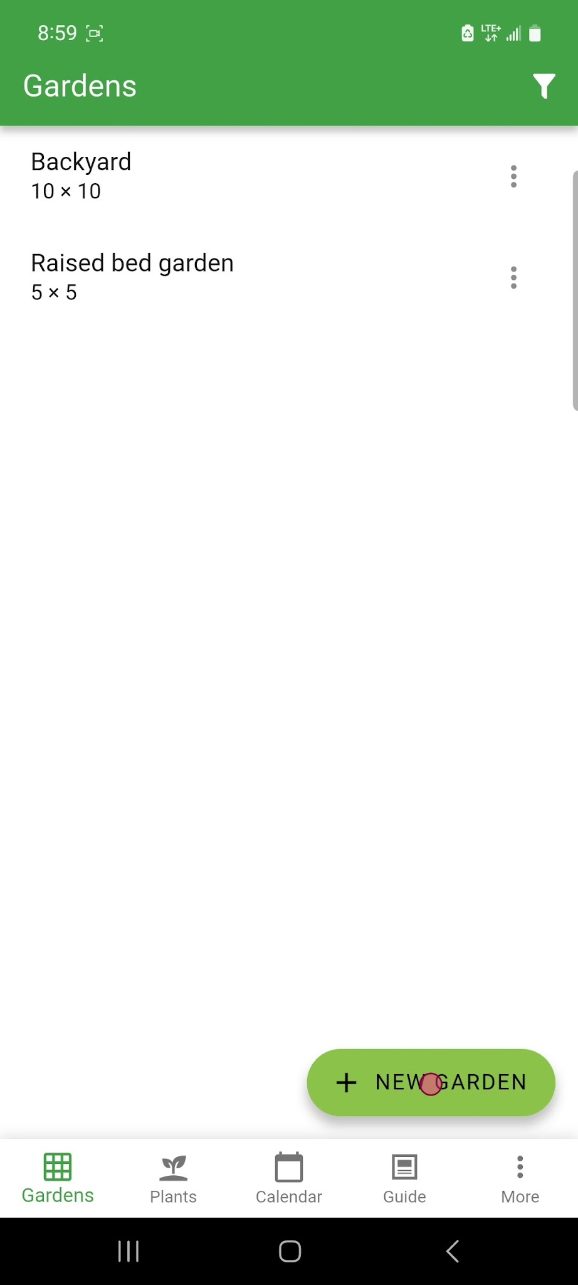
On the Gardens screen, tap the green "NEW GARDEN" button located at the bottom right.
- Select New Garden Planner
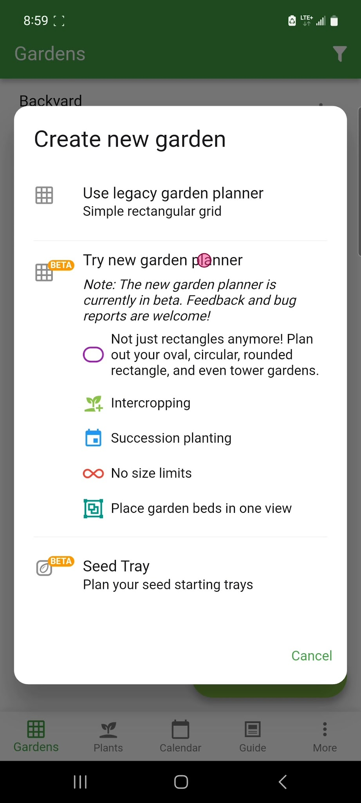
In the "Create new garden" dialog, tap the "Try new garden planner" option.
- Enter a Garden Name
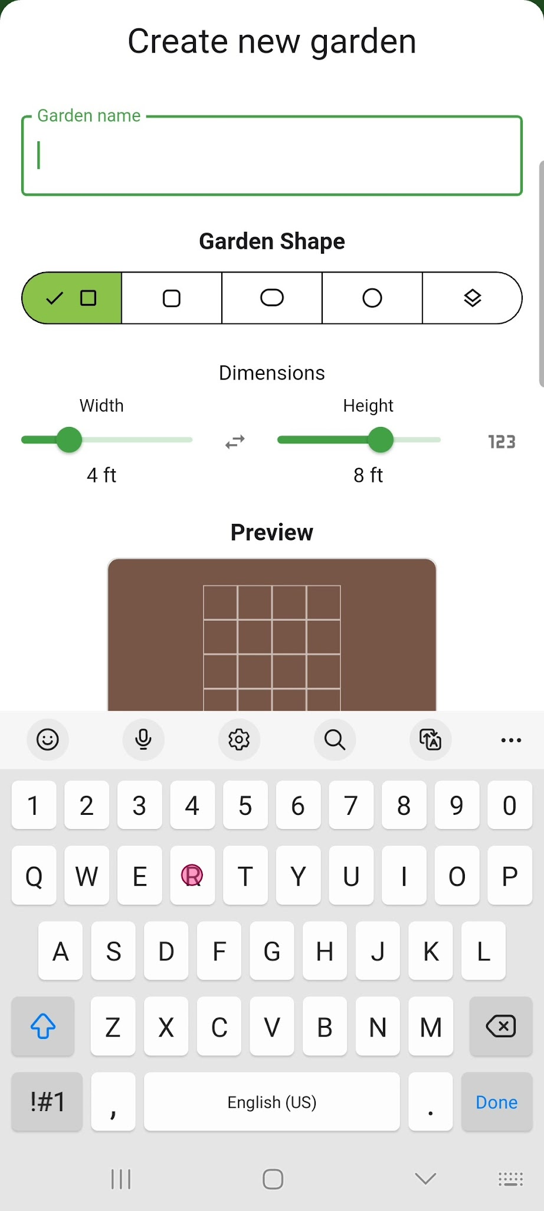
In the "Garden name" field, type a name for the new garden.
- Choose The Desired Garden Shape
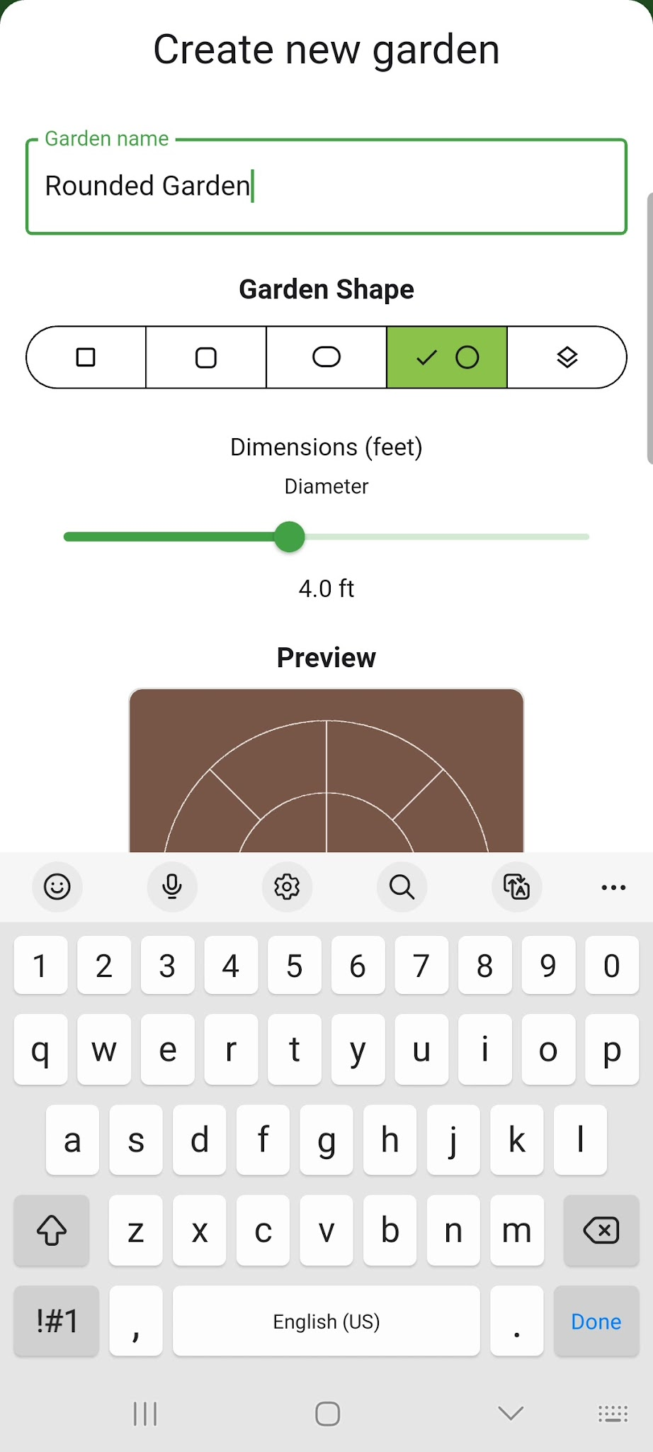
Under "Garden Shape", tap the icon representing the desired garden shape (in order from left to right: rectangular, rounded corners, oval, round, or tower).
- Adjust Garden Diameter
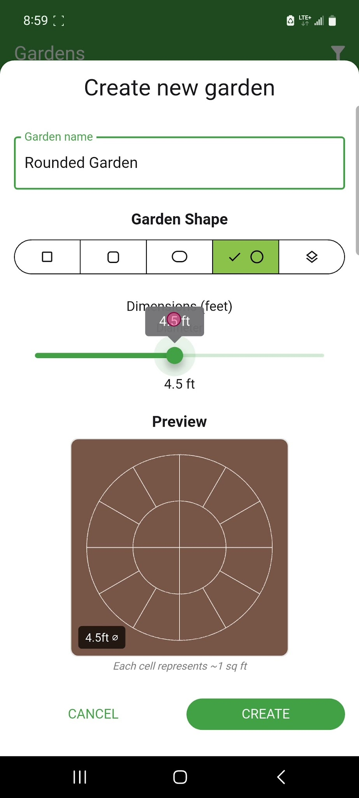
Drag the "Diameter" slider to set the garden's diameter.
- Create Garden
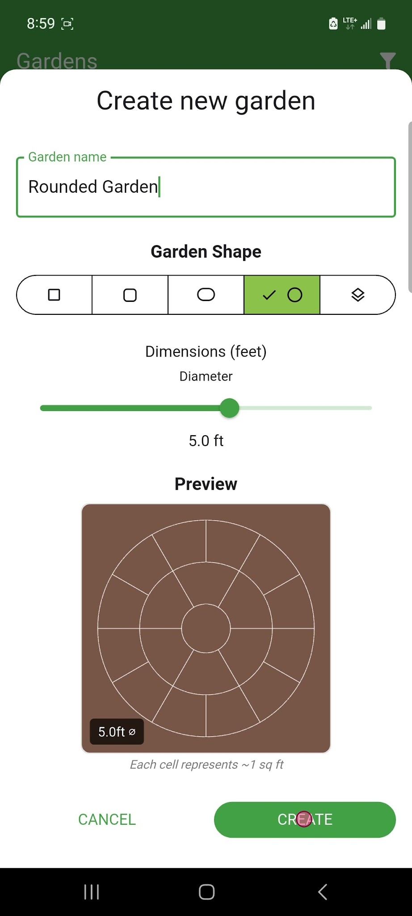
Tap the "CREATE" button at the bottom right of the screen to finalize the new rounded garden creation.

