How Can I Combine Multiple Garden Beds in One View?

Planter now lets you plan garden beds individually then combine them together in a combined layout!

To combine garden beds, create a new garden to be the garden layout into which individual garden beds can be added.

Note: The ability to create multiple garden beds is a Planter Premium feature.

<< EMBED RECORDING>>

1. Create a Garden Layout

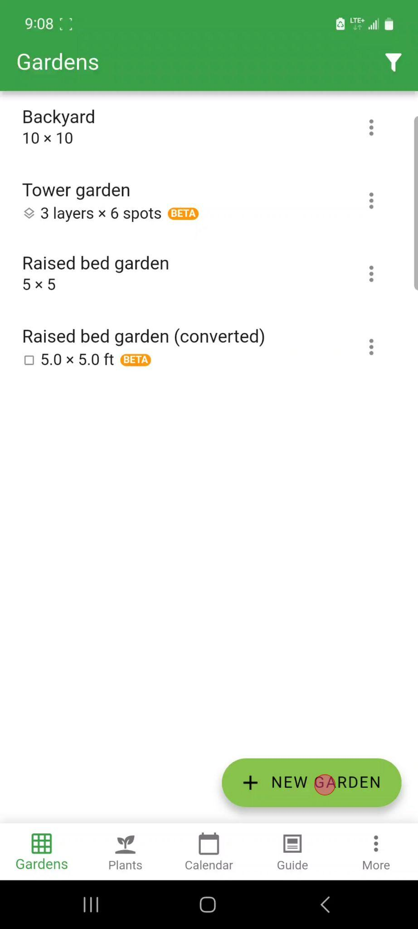

On the Gardens screen, tap the green "NEW GARDEN" button located at the bottom right. This new garden will be the empty garden layout.

2. Select New Garden Planner

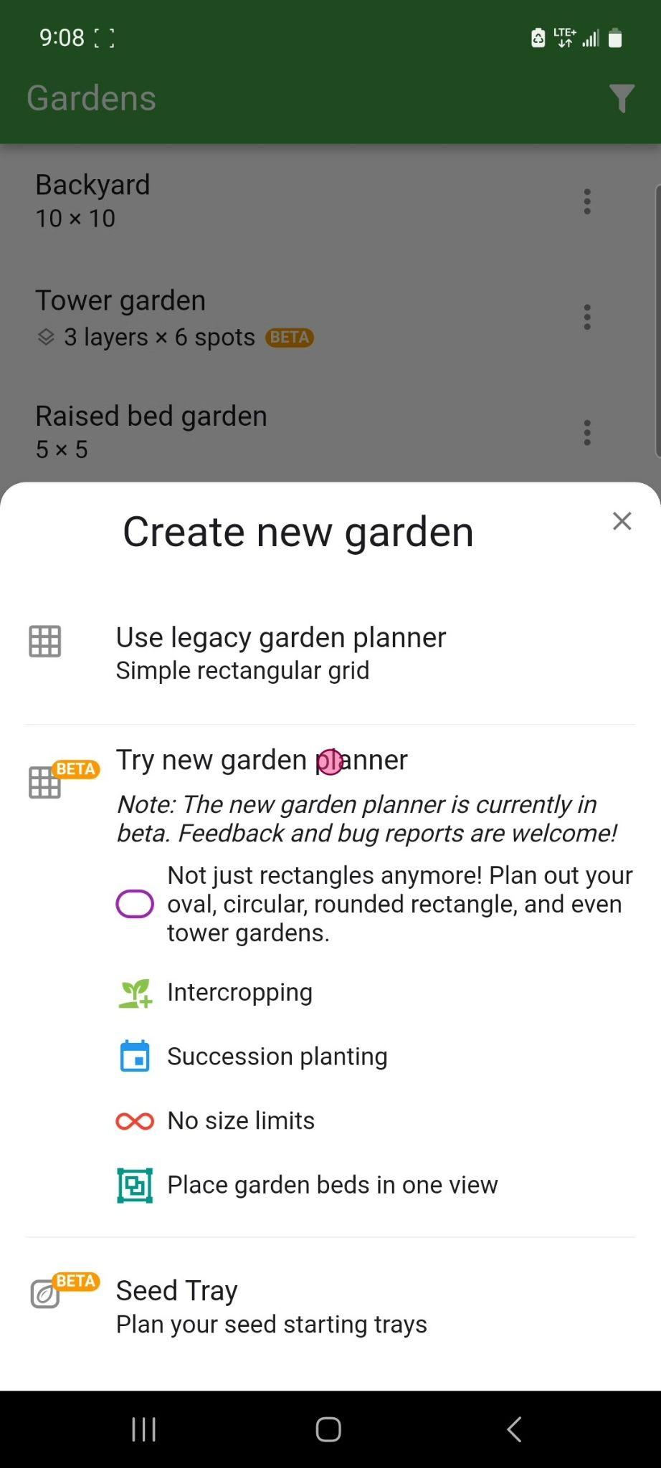

From the "Create new garden" dialog, select "Try new garden planner".

3. Enter Garden Name
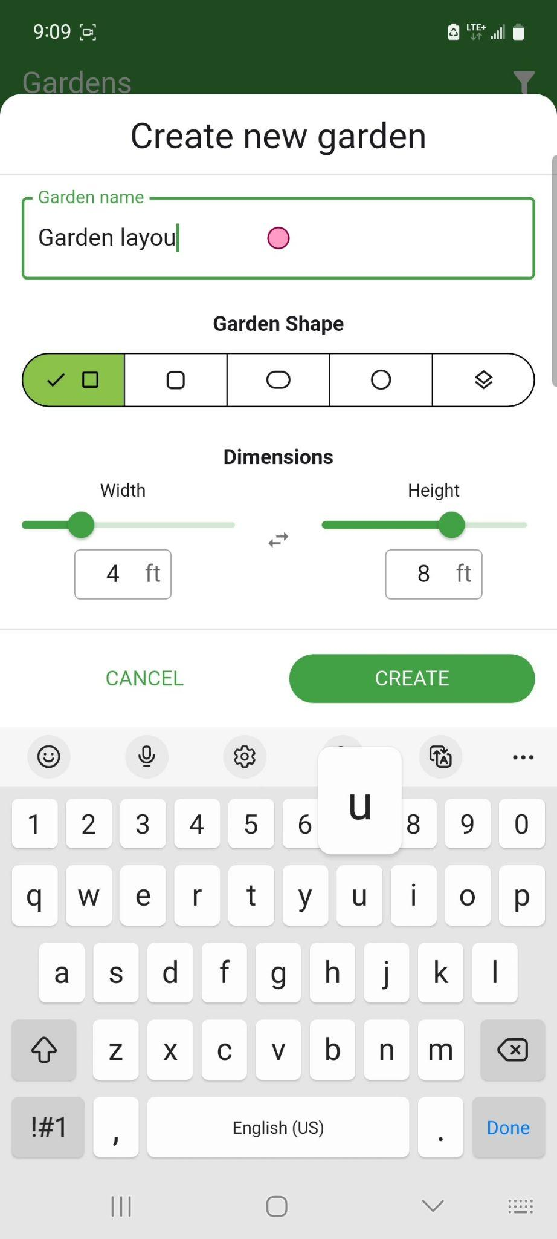

Type a name for the garden layout into the "Garden name" field.

4. Adjust Garden Width and Height

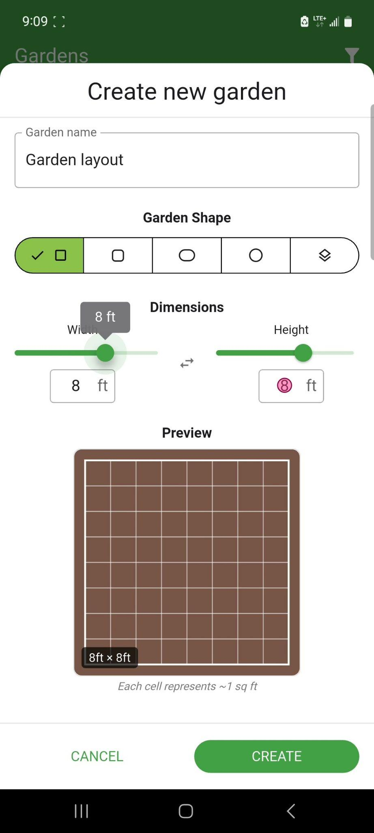

Leave the garden shape as a rectangular shape and drag the 'Width' and ‘Height’ sliders to set the garden layout width and height (consider the widths and heights of the gardens you wish to combine).
Note: Only rectangular garden shapes can be used as garden layouts. The maximum height and width at creation is 12'x12' but you can [add additional rows and columns](https://info.planter.garden/garden/resize/) after.

5. Create Garden

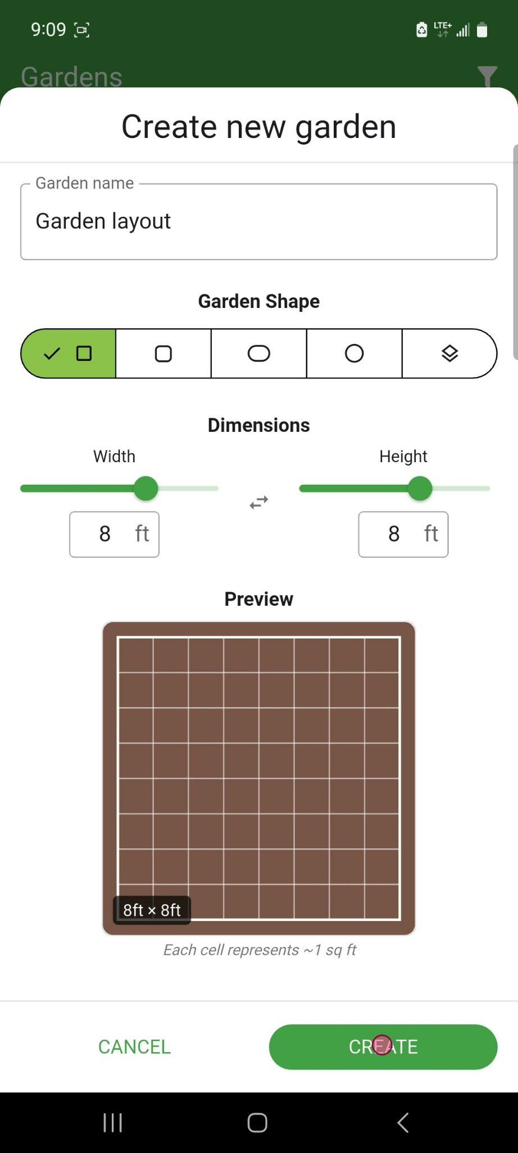

Tap the 'CREATE' button at the bottom right of the screen to finalize the new garden creation.

6. Open the “Three Dot” Options Menu

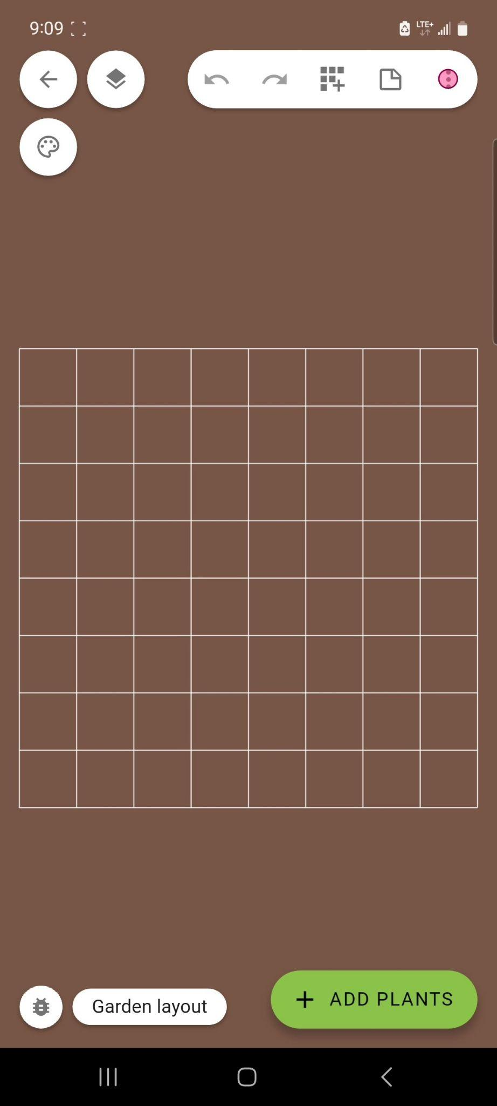

Tap the three vertical dots icon in the top right corner of the screen to open the garden options menu.

7. Add Garden Bed

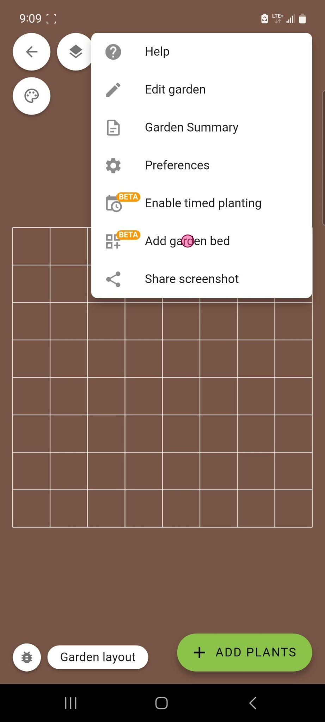

From the dropdown menu, select 'Add garden bed' to add a garden bed to the current view.

8. Select a Garden Bed to Add

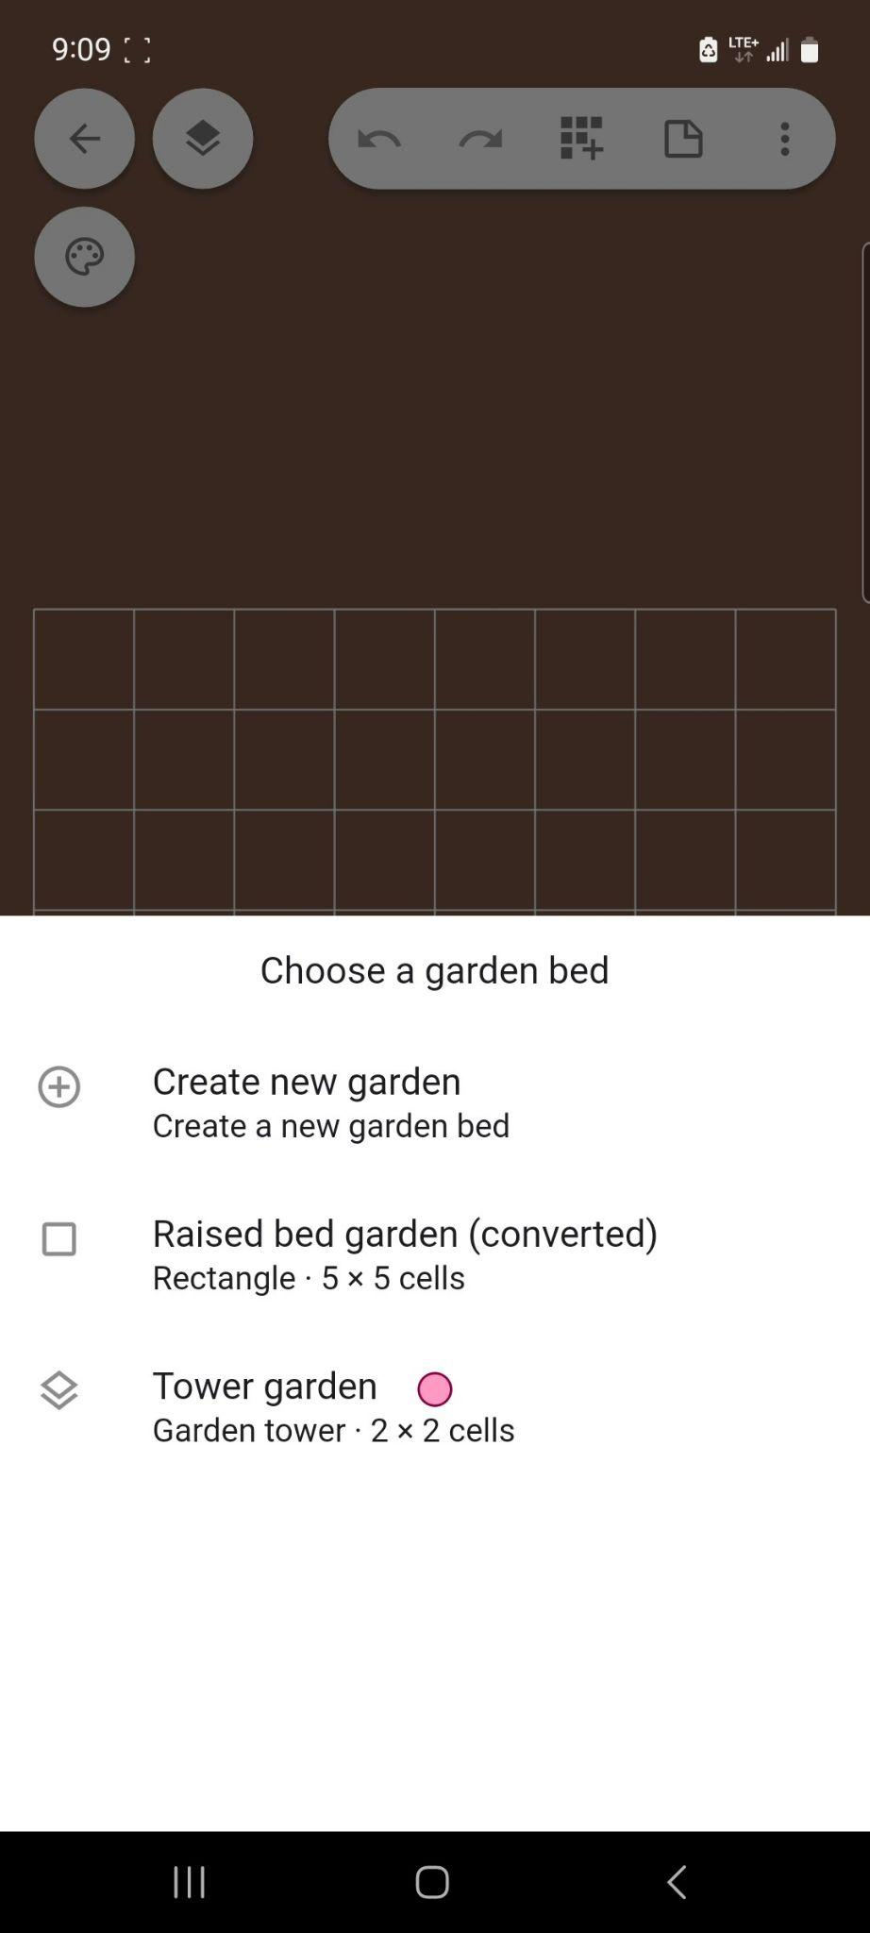

In the 'Choose a garden bed' dialog, select a garden bed to add from the list of available garden beds (or, choose “Create new garden” to create a new bed to add).

Note: If the garden has less than 100 squares, a prompt will appear asking whether to use it as a garden layout or whether to add it to a new garden layout.

Only Gardens 2.0 garden beds can be combined. [Convert existing garden beds](https://info.planter.garden/new-features/convert-garden-format/) first if needed.

9. Place Garden Bed

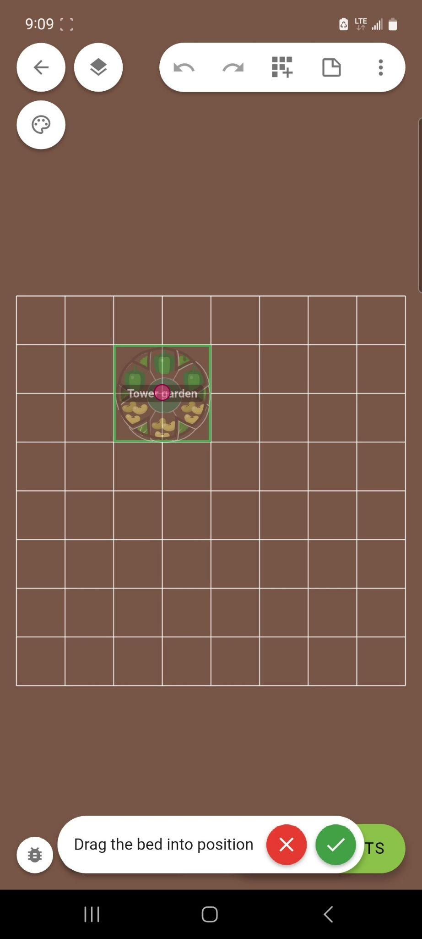

Drag the bed to set the desired position in the garden layout, then press the green checkmark to confirm.

10. Repeat for Additional Beds

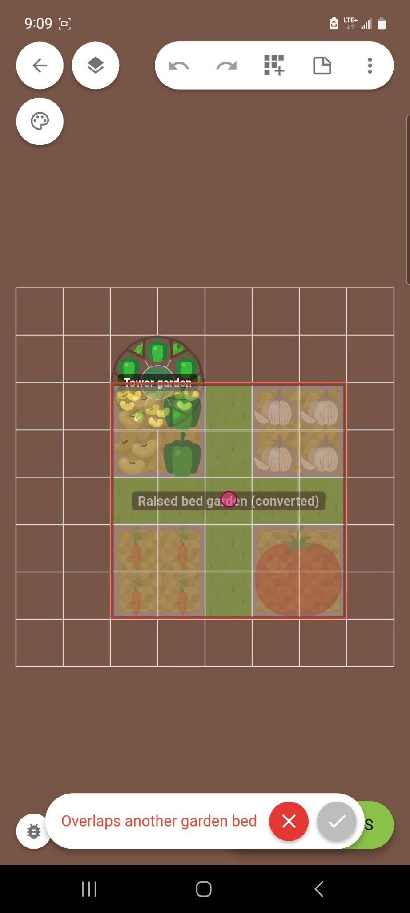

Repeat the steps above to add additional beds to the garden layout. A warning will appear if the beds are overlapping.

12. Move a Bed

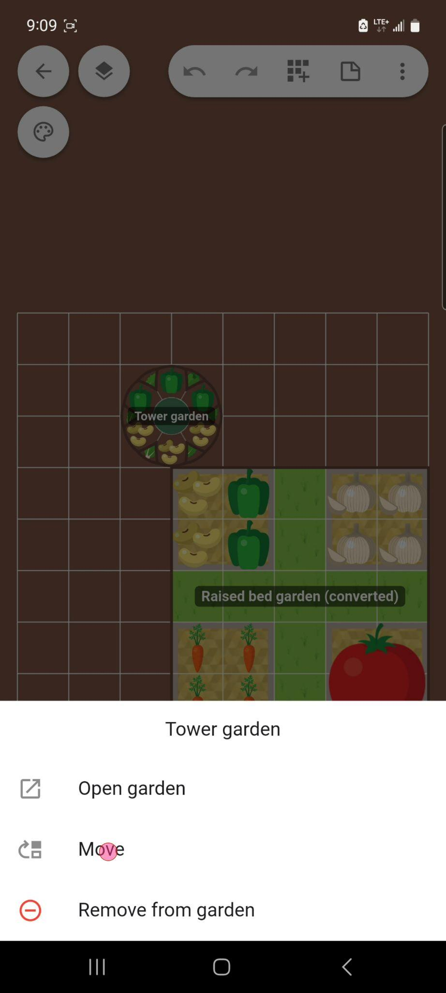

To move a bed in the combined garden view, long-press on the bed then select ‘Move’. Drag the sliders to the new row and column position then tap ‘Move garden bed’.

13. Remove a Bed

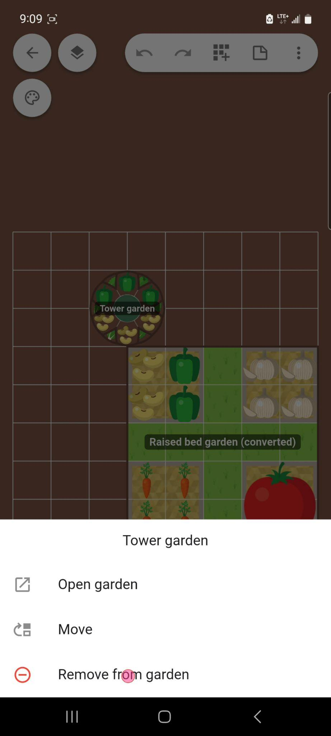

To remove a bed from the combined garden view, long-press on the bed then select “Remove from garden”. The garden bed will still be visible in the Gardens list as an individual bed.

