Plastiks Smart Contract Technical Documentation
Table of Contents
Plastiks Smart Contract Technical Documentation 1
1. Architectural Overview 2
1.1 Smart Contract Components 2
1.2 Core Data Structures 3
PlastiksDatum (State Representation) 3
PlastiksRedeemer (State Transition) 3
1.3 Validation Logic 3
2. Transaction Lifecycle 4
2.1 State Transition Diagram 4
2.2 Key Operations 4
3. Security Model 5
3.1 Authorization Details 5
3.2 Validation Checks 5
4. Testing Strategy 5
4.1 Test Coverage Details 5
4.2 Test Execution Flow 5
5. Deployment Architecture 6
5.1 Environment Configuration 6
5.2 Smart Contract Compilation Workflow 6
6. Error Handling 6
6.1 Validation Errors 6
6.2 Operational Errors 6
7. References 7
1. Plinth User guide: 7
2. Cardano Developer Portal: 7
3. Hackage: 7
4. Extended UTXO Model Paper: 7
5. Real-world Plutus Contracts (e.g., Mlabs): 7
6. Plutus Pioneer Program: 7
7. IOHK YouTube – Plutus Playlist(Plutus Pioneer Program) 7

1. Architectural Overview
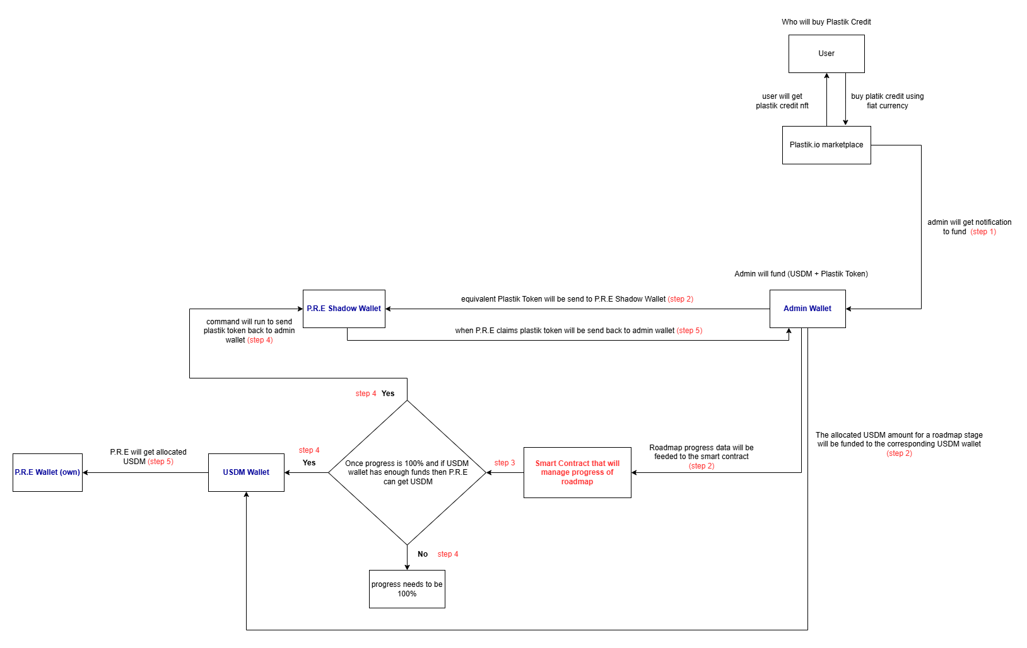

1.1 Smart Contract Components

Component Hierarchy:

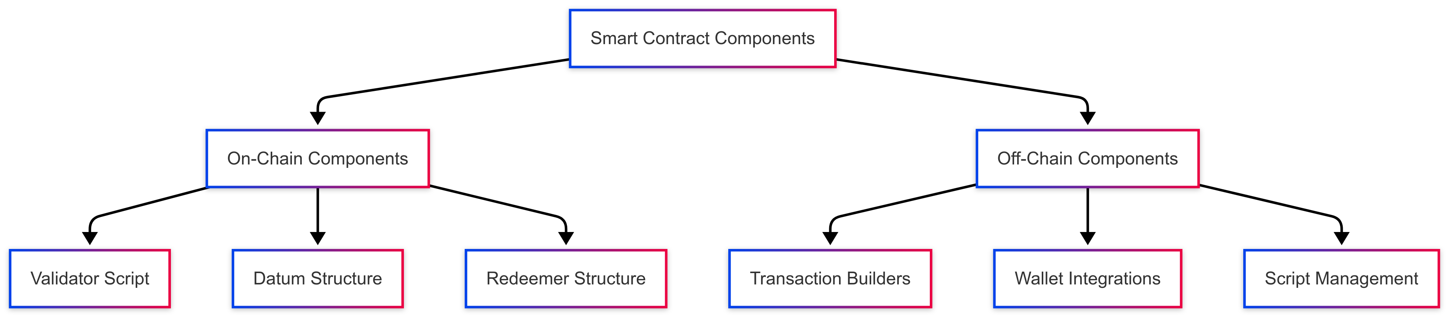

1.2 Core Data Structures

PlastiksDatum (State Representation)
data PlastiksDatum = PlastiksDatum
{ preId :: BuiltinByteString -- Unique project identifier
, roadmapId :: BuiltinByteString -- Roadmap reference
, progress :: Integer -- Completion percentage (0-100)
, adminPkh :: PubKeyHash -- Admin authority
, prePkh :: PubKeyHash -- Project owner
, totalPlasticCredits :: Integer -- Total available credits
, soldPlasticCredits :: Integer -- Credits sold
, totalPlasticTokens :: Integer -- Total tokens minted
, sentPlasticTokens :: Integer -- Tokens distributed
}

PlastiksRedeemer (State Transition)

data PlastiksRedeemer
= UpdateProgress Integer -- Progress update operation
| Release -- Fund release operation

1.3 Validation Logic
validate :: PlastiksDatum -> PlastiksRedeemer -> ScriptContext -> Bool
validate datum redeemer ctx =
case redeemer of
UpdateProgress newProgress ->
traceIfFalse "Admin not signed" (txSignedBy info (adminPkh datum)) &&
traceIfFalse "Invalid progress update" (newProgress > progress datum && newProgress <= 100)

Release ->
traceIfFalse "Admin not signed" (txSignedBy info (adminPkh datum)) &&
traceIfFalse "Progress not complete" (progress datum == 100)
where
info :: TxInfo
info = scriptContextTxInfo ctx

2. Transaction Lifecycle

2.1 State Transition Diagram
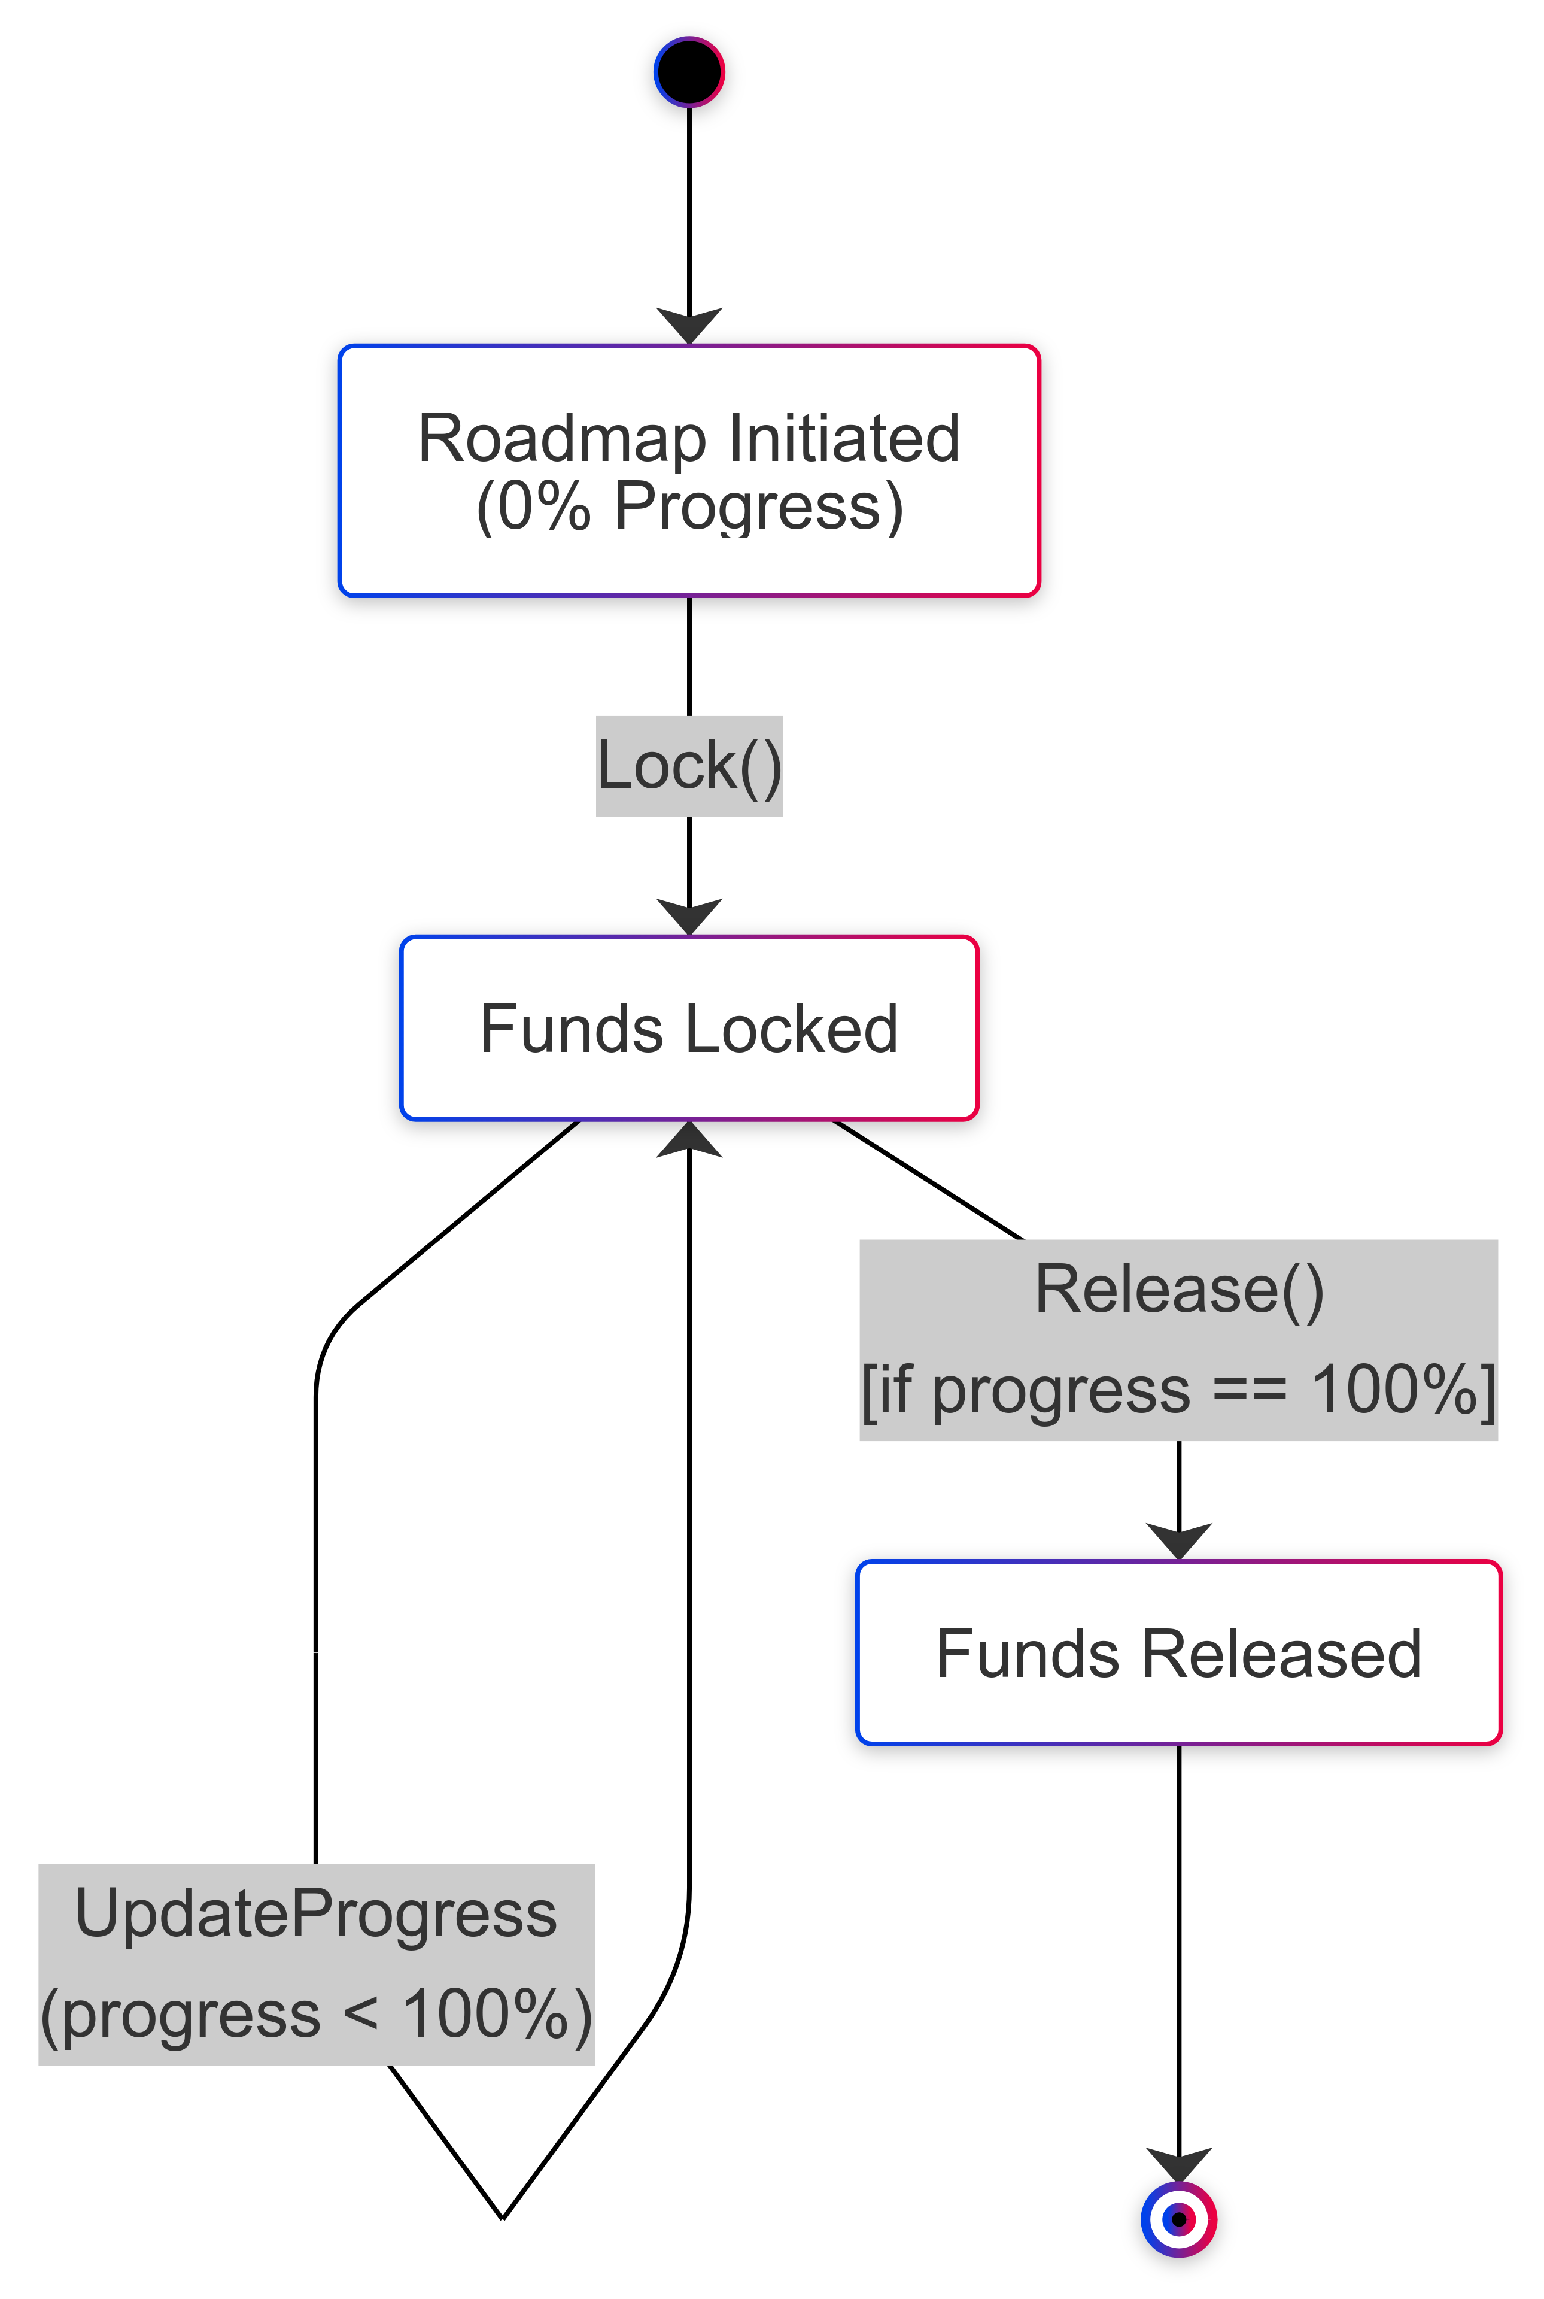

2.2 Key Operations
Operation | Script | Parameters | Required Signatures
Contract Lock | lock.sh | Initial datum | N/A
Progress Update | lock-update.sh | New progress value | Admin
Fund Release | unlock.sh | Release redeemer | Admin

3. Security Model

3.1 Authorization Details
Role | Update Progress | Release Funds | Modify Parameters
Admin | ✓ | ✓ | ✓
Third Party | ✗ | ✗ | ✗

3.2 Validation Checks
-- Progress update constraints
newProgress > currentProgress && newProgress ≤ 100

-- Release constraints
progress ≡ 100 && txSignedBy adminPkh

-- Universal checks
¬(totalPlasticCredits < soldPlasticCredits) &&
¬(totalPlasticTokens < sentPlasticTokens)

4. Testing Strategy

4.1 Test Coverage Details
Test Case | Validator Path | Expected Outcome
Valid Progress Update | UpdateProgress | Success
Unauthorized Progress Update | Missing Admin Sig | Failure
Progress Regression | Lower Value | Failure
Premature Release | Progress < 100 | Failure
Valid Fund Release | Progress = 100 | Success

4.2 Test Execution Flow
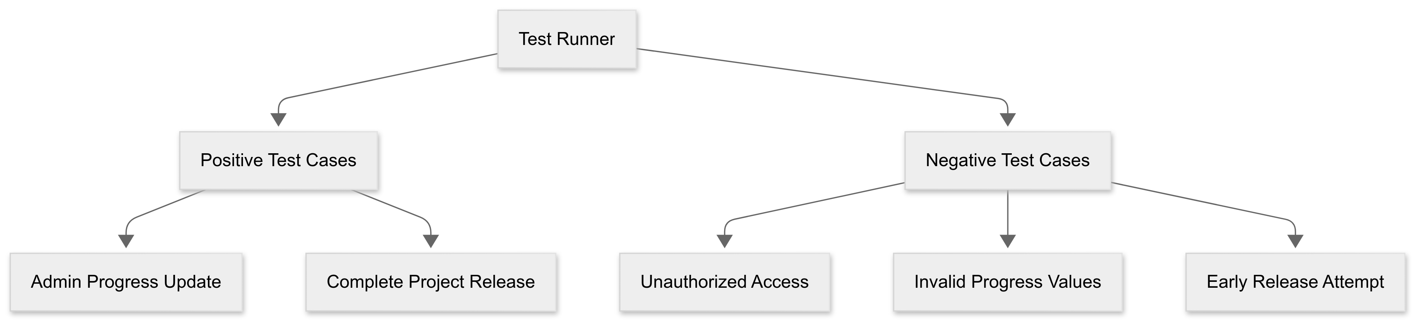

5. Deployment Architecture

5.1 Environment Configuration
network: preprod
node_version: 1.35.5
plutus_version: 2.0.0
required_tools:
- cardano-cli
- cardano-wallet
- plutus-script-utils

5.2 Smart Contract Compilation Workflow
# Compilation Process
cabal build → Generate Haskell Executable
↓
Compile Plutus Script → refi.json
↓
Generate Script Address → refi.addr

6. Error Handling

6.1 Validation Errors
Error Code | Message | Resolution
VAL001 | Admin not signed | Verify transaction signature
VAL002 | Invalid progress update | Check progress constraints
VAL003 | Progress not complete | Achieve 100% before release

6.2 Operational Errors
{
"error": "INSUFFICIENT_FUNDS",
"solution": [
"Verify wallet balance",
"Check UTXO selection",
"Confirm network parameters"
]
}

7. References

1. Plinth User guide:
Official documentation covering Plutus Core, PlutusTx, and writing validators.
🔗 https://plutus.cardano.intersectmbo.org/docs/

2. Cardano Developer Portal:
A must-visit hub for all things Cardano dev — tools, APIs, smart contracts, and examples.
🔗 https://developers.cardano.org/

3. Hackage:
The Haskell Package Repository
🔗 https://hackage.haskell.org/

4. Extended UTXO Model Paper:
Understand how Cardano differs from Ethereum's account model (important for designing contracts).
🔗 https://iohk.io/en/research/library/papers/the-extended-utxo-model/

5. Real-world Plutus Contracts (e.g., Mlabs):
Contains production-grade smart contracts and patterns used in real-world DApps.
🔗 https://github.com/mlabs-haskell/plutus-use-cases

6. Plutus Pioneer Program:
IOHK's official beginner-to-advanced course with guided code examples and videos.
🔗 https://github.com/input-output-hk/plutus-pioneer-program

7. IOHK YouTube – Plutus Playlist(Plutus Pioneer Program)
🔗 https://youtube.com/playlist?list=PLnPTB0CuBOBypVDf1oGcsvnJGJg8h-LII&si=1k_r3XkFSTjhTvB5

