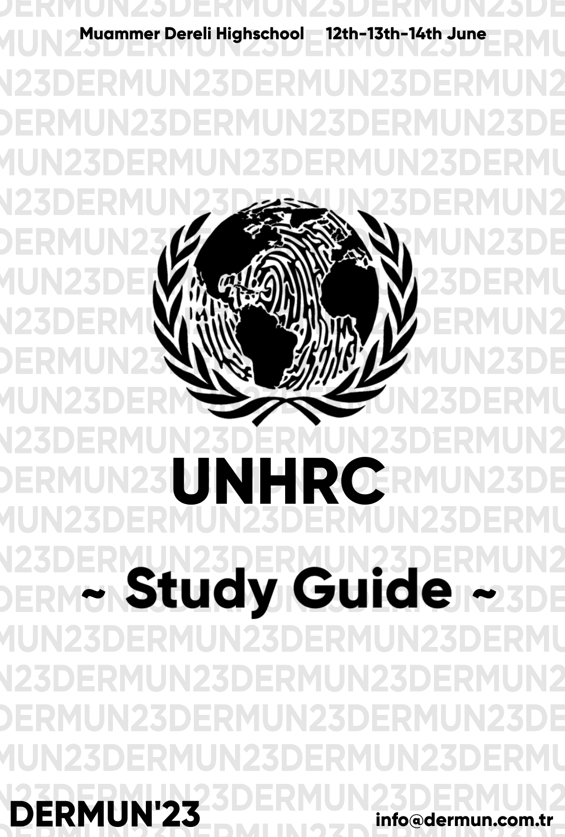

**UNHRC STUDY GUIDE TABLE OF CONTENTS**

1. Welcoming Letters
   1. Letter From Secretary General
   2. Letter From Chairboard
2. Introduction to the United Nations Human Rights Council (UNHRC)
   1. What is UNHRC
3. Agenda Items

a. Violation of Women Rights around the world

b. Violation of Human Rights in conflict zones

c. Member States

1. Definition of Key Terms
2. Violence Against Women
3. Violation of Women’s Rights Around the world
   1. Iran
   2. The Taliban in Afghanistan
   3. The USA
   4. What Did Countries Do?
4. Violation of Human Rights in Conflict Zones
   1. Violation of Children’s and Women’s Rights
   2. Examples

**1.Welcoming Letters**

1. **Letter From The Secretary General**

Dear Participants,

On behalf of DERMUN’23 Model United Nations (MUN) Conference, it is our great pleasure to extend a warm welcome to all participants attending this esteemed event. As the Secretary-General’s, we are honored to have the opportunity to address you all and witness the culmination of your diligent preparations and intellectual prowess.

DERMUN’23 Conference serves as a platform for aspiring young leaders like yourselves to engage in substantive discussions, exchange diverse perspectives, and collectively seek solutions to the world's most pressing issues. This year, we have meticulously curated a diverse range of committees to stimulate robust debates and foster innovative thinking. We have got five committees,3 English-2 Turkish, which includes General Assembly(GA) like SOCHUM and Special Committees.

We are confident that DERMUN’23 Conference will not only provide you with an enriching experience but also enable you to forge lifelong connections with like-minded individuals who share your passion for international affairs. Embrace the diversity of perspectives within this conference, seize every opportunity for collaboration, and let your ideas inspire positive change.

*Eylül Yaman*

*Kenan Mirzaoğlu*

1. **Letter From The Chairboard**

Esteemed delegates of UNHRC,

As your board, it is our utmost pleasure to welcome you to the United Nations Human Rights Council. We are deeply honored to witness your willingness to participate in DERMUN, especially in our council, so as to gain knowledge upon the procedure and function of the United Nations, become eloquent public speakers, develop your debate and communication skills and discover a new insight on world issues, such as the topic of our committee. Very interesting yet demanding topics was selected to let you experience the real essence of

the Human Rights Council; violation of women’s rights around the world and violation of human’s rights in conflict zones.

The information within this study guide will be more than sufficient to fully comprehend the topic under discussion and be ready for our debates in the conference. But in order to produce a sustainable resolution for this goal, your active involvement in the debate is crucial.

Additionally, we ought to point out that we are always at your disposal in case you have any questions regarding our committee and/or our topic

We are beyond excited to work with you and we promise to deliver to the best

of our abilities!

Kind regards,

Hilal Turpçu, Chair

Pelin Taşova, Co-Chair

1. **Introduction to the United Nations Human Rights Council (UNHRC)**
   1. **What is UNHRC**

The UN Human Rights Council (UNHRC) is a United Nations body whose purpose is to promote and defend human rights around the world. Its role in the international community is to examine human rights violations and recommend how they should be addressed.

The Council also aims to promote fundamental human rights and freedoms universally – at the international legal level. It investigates violators of the rules set out in the UN Charter of Human Rights and addresses violations of these rights, from freedom of expression to religious rights. With these responsibilities in mind, UNHRC seeks to discuss issues of global concern, taking into account universally applicable standards of humane treatment UNHCR is critical in raising awareness, delivering human stories and our message.

**3.Agenda Items**

* 1. Violation of Women Rights around the world
  2. Violation of Human Rights in conflict zones

c) Member States

**MEMBER STATES**

INDIA

USA

RUSSIA

ISRAEL

YEMEN

IRAQ

FRANCE

VIETNAM

EGYPT

PAKISTAN

SYRIA

SWITZERLAND

UKRAINE

NORWAY

TURKIYE

SAUDI ARABIA

GERMANY

JAPAN

CANADA

UNITED KINGDOM

CHINA

IRAN

POLAND

AFGHANISTAN

**4. Definition Of Key Terms**

**Violence:** The intentional use of physical force or power, threatened or actual, against oneself, another person, or against a group or community, which either results in or has a high likelihood of resulting in injury, death, psychological harm, maldevelopment, or deprivation.

**Abuse:** Abuse is the improper usage or treatment of a thing, often to unfairly or improperly gain benefit. Abuse can come in many forms, such as: physical or verbal maltreatment, injury, assault, violation, rape, unjust practices, crimes, or other types of aggression.

**Abortion:** Abortion is the termination of a pregnancy by removal or expulsion of an embryo or fetus.

**Gender Inequalities:** Gender inequality is the social phenomenon in which men and women are not treated equally. The treatment may arise from distinctions regarding biology, psychology, or cultural norms prevalent in the society.

**Pro-choice:** Supporting the belief that a pregnant woman should have the freedom to choose an abortion if she does not want to have a baby

**Pro-life:** Supporting the belief that it is immoral for a pregnant woman to have the freedom to choose to have an abortion if she does not want to have a baby

**Female Genital Mutilation/Cutting (FGM/C):** Female genital mutilation (FGM), also known as female circumcision, is the ritual cutting or removal of some or all of the external female genitalia.

**Human Trafficking:** Human Trafficking is the recruitment, transportation, transfer, harbouring or receipt of people through force, fraud or deception, with the aim of exploiting them for profit. Men, women and children of all ages and from all backgrounds can become victims of this crime, which occurs in every region of the world.

**One Million Signatures:** The One Million Signatures Campaign, is an effort designed to raise awareness among the public through face to face discussions and collection of signatures of citizens on a petition addressed to the Iranian parliament.

**Supreme Court of the United States:** The Supreme Court of the United States (SCOTUS) is the highest court in the federal judiciary of the United States.

**5. Violence Against Women**

While progress has been made, we are far from ending violence against women and girls. Gender inequality persists worldwide and fuels gender-based violence. Here are six ways women’s human rights are violated every day around the world through gender-based violence:

**a. Intimate Partner Violence**

Intimate partner violence (IPV) is domestic violence by a current or former spouse or partner in an intimate relationship against the other spouse or partner. IPV can take a number of forms, including physical, verbal, emotional, economic and sexual abuse. The World Health Organization (WHO) defines IPV as "any behavior within an intimate relationship that causes physical, psychological or sexual harm to those in the relationship, including acts of physical aggression, sexual coercion, psychological abuse and controlling behaviors." IPV is sometimes referred to simply as battery, or as spouse or partner abuse. The most extreme form of IPV is termed intimate terrorism, coercive controlling violence, or simply coercive control. In such situations, one partner is systematically violent and controlling. This is generally perpetrated by men against women, and is the most likely of the types to require medical services and the use of a women's shelter. Resistance to intimate terrorism, which is a form of self-defense, and is termed violent resistance, is usually conducted by women.

Studies on domestic violence against men suggest that men are less likely to report domestic violence perpetrated by their female intimate partners. On the other hand, men are more likely to commit acts of severe domestic battery, and women are more likely to suffer serious injury as a result.

The most common but less injurious form of intimate partner violence is

situational couple violence (also known as situational violence), which is

conducted by men and women nearly equally, and is more likely to occur among younger couples, including adolescents (see teen dating violence) and those of college age.

One in 3 women worldwide has experienced physical or sexual violence. Most often, this violence is committed by an intimate partner.

Some national studies show that up to 70 per cent of women have experienced physical and/or sexual violence from an intimate partner in their lifetime. According to UNICEF, around the world, approximately 15 million adolescent girls (aged 15 to 19) have experienced forced sex at some point in their life.

The physical and mental health consequences are severe:

It’s estimated that 38 per cent of all murders of women are committed by male intimate partners.

Women who experience intimate partner violence are 1.5 times more likely to acquire HIV and a range of other sexually transmitted diseases.

Women exposed to violence are twice as likely to experience depression.

**b. Female Genital Mutilation/Cutting**

Today 200 million women worldwide are living with female genital cutting/mutilation, a practice that includes many health risks, including hemorrhage, infertility, ongoing severe pelvic pain, complications in childbirth, HIV, psychological trauma and death. Female genital mutilation/cutting (FGM/C) can affect a woman's mental health long after the procedure, into her adult life. Women with FGM/C often show signs of psychological trauma: anxiety, somatization, depression, post-traumatic stress and other mood disorders. Trauma stems from both the mutilation/cutting itself as well as having to recount the experience to others. When doctors react with shock or disgust when discovering a woman's FGM/C, women can feel afraid, embarrassed, and stressed. As a consequence, women may simply no longer be willing to discuss their FGM/C with their doctor.

Women who have undergone genital mutilation may also experience:

1. *Isolation*
2. *Frustration and confusion*
3. *Anger*

**c. Child Marriage**

Child marriage is one of the most damaging forms of violence. Child marriage refers to any formal marriage or informal union between a child under the age of 18 and an adult or another child.

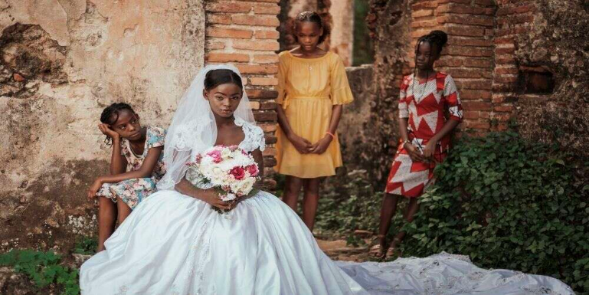

While the prevalence of child marriage has decreased worldwide – from one in four girls married a decade ago to approximately one in five today – the practice remains widespread. Before the COVID-19 pandemic, more than 100 million girls were expected to marry before their eighteenth birthday in the next decade. Now, up to 10 million more girls will be at risk of becoming child brides as a result of the pandemic.

Child marriage is often the result of entrenched gender inequality, making girls disproportionately affected by the practice. Globally, the prevalence of child marriage among boys is just one sixth that among girls.

Child marriage robs girls of their childhood and threatens their lives and health. Girls who marry before 18 are more likely to experience domestic violence and less likely to remain in school. They have worse economic and health outcomes than their unmarried peers, which are eventually passed down to their own children, further straining a country’s capacity to provide quality health and education services. Girls who marry in childhood are at greater risk for intimate partner violence than girls of the same age who marry later. Tragically, child brides face higher risks of death in childbirth. Globally, complications in pregnancy and childbirth are the leading cause of death among 15 to 19-year-old girls. Early pregnancy driven by child marriage also makes girls particularly vulnerable to pregnancy-related injuries such as obstetric fistula.

Nine out of ten of the countries with the highest rates of child marriage are in fragile states. Child marriage impacts a girl’s health, future and family, it imposes substantial economic costs at the national level, too, with major implications for development and prosperity.

**d. Humanitarian Crises**

Humanitarian crises, including conflict and post-conflict situations, increase women’s vulnerability to violence.

In some crisis-affected countries, 70 percent of women experience gender-based violence. More than half of all maternal, newborn and child deaths occur in humanitarian settings.

Yet, in humanitarian assistance, gender equality is not prioritized. According to recent statistics, only five percent of foreign aid to fragile states is targeted to gender equality.

**e. Human Trafficking**

Living in fragile and humanitarian contexts and forced migration puts women and girls at increased risk for human trafficking. The 2016 Report on Human Trafficking showed that 71 percent of all trafficking victims worldwide are women and girls. 75 percent of trafficked women and girls are trafficked for sexual slavery.

**f. Economic Inequalities**

Violence against women and girls negatively impacts women’s capacity to fully access the right to education, employment and civic life.

Violence has a serious impact on women’s right to livelihood. The earnings of women in formal paid work exposed to severe partner violence are estimated to be 60 per cent lower than women who are not.

It also has a major economic cost to society.

The cost of violence against women was estimated by the UN in 2016 at 2 percent of the global gross domestic product (GDP). That’s approximately $1.5 trillion, or the size of the economy of Canada. Costs of the healthcare systems, include emergency room visits, primary care visits, mental health counselling and related services. Taking a comprehensive approach, including healthcare costs, McKinsey researchers calculated recently that violence against women costs the United States upwards of $500 billion annually.

1. **Violation of Women’s Rights Around the World**
   1. **Iran**

The current protests gripping Iran show no signs of abating. More than forty days since the death of Iranian Kurdish woman Mahsa Amini–who died after being arrested by Iran’s morality police for breach of the country’s strict dress code–the wave of fury unleashed at compulsory hijab laws, security forces’ brutality, and wider government repression continues to rage.

This uprising has been different. Men and women of various ethnic backgrounds have marched under the banner of women’s rights. Across Iran crowds have shouted the women’s movement chant in both Kurdish “Jin, Jian, Azadi!” and in Farsi “Zan, Zendagi, Azadi!,” which means “Woman, Life, Freedom!,” understanding that freedom for women means freedom for all.

In recent weeks, we have seen courageous schoolgirls and students at universities take the helm: raising up their scarves, marching through streets, and chasing off government officials. But the crackdown has resulted in mass arrests and, reportedly, killings of hundreds of people, including girls.

The demands are for fundamental change, and it is no surprise that girls and young women are on the front lines. Jina, Mahsa’s Kurdish name, was only 22 when she died in Iranian police custody, and has come to symbolize the injustice of the state’s restrictive rules for women. As girls, they are required to wear the hijab upon reaching puberty. As women, they continue to be denied their choice of dress which impacts their right to take part in all aspects of public life including study, work and even leaving their home.

They may find, as Jina did, that they can be arrested simply because a morality police official considers that the way they wear the hijab is not “proper.” They can be fined or hauled into detention to be “educated,” beaten, harassed, and, if they are deemed to have protested against the dress code, even sentenced to prison.

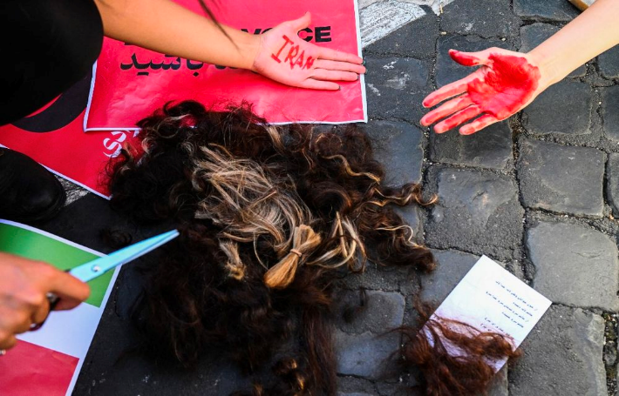Women have been fighting against compulsory dress code for decades and are now openly defying it as an act of resistance by simply going out to live their lives without the hijab. While the dress code is the most visible form of discrimination, it is just one aspect of the systemic discrimination they face.

The economic crisis that predated this uprising has pushed many in Iranian society to the margins of poverty, affecting women disproportionately. Iran’s laws and policies discriminate against women’s access to employment including by restricting the professions women can enter into and denying equal benefits to women in the workforce. Over 50 percent of Iran’s university graduates are women, but women’s unemployment rate is more than double that of their male counterparts–a troubling trend that has only widened since the Covid-19 pandemic.

Indeed, women’s labor force participation in 2019 was barely 18 percent, and fell to 14 per cent in 2020. Men’s participation, by contrast, was 72 per cent in 2019, falling to 70 per cent in 2020. In 2017, Human Rights Watch found that employers routinely advertise jobs for men over women, and some require written consent from husbands and fiancés, with no law to sanction them for such outright discrimination.

Instead of dealing with women’s economic struggles and their unequal access to opportunities to shape their own lives, Iranian authorities are trying to force women to marry earlier and have more children to increase the national population. Where the government once received international accolades for promoting family planning, women today are contending with severe limitations on their access to sexual and reproductive rights. A population law passed last November outlawed sterilization and free distribution of contraceptives in the public health care system unless a pregnancy threatens a woman’s health, and further limited access to safe abortion.

The same law provided incentives for early marriage such as interest free loans to those who marry at 25 and younger. With many families being driven into poverty, they may force girls and women into marriage earlier to have one less person to feed. The government’s own reports show child marriage is on the rise. Iran’s civil code provides that girls can marry at 13 and boys at age 15, as well as at younger ages if authorized by a judge.

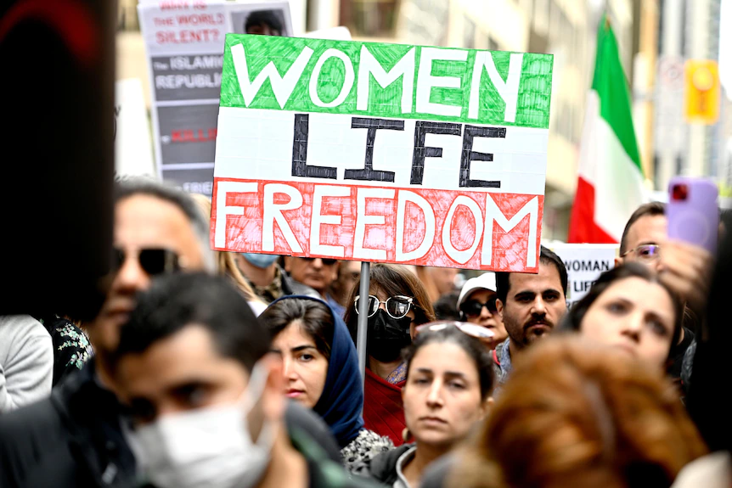Once married, girls and women often face further abuse. Iran’s laws grant husbands significant control over their wives’ lives. Under the Civil Code, the husband has the right to choose where they live and he can prevent his wife from having certain jobs if he deems them against “family values.” Under the Passports Law, a woman needs her husband’s permission to obtain a passport and travel outside the country.

Iran does not have policies in place to prevent abuse, protect women, and prosecute domestic violence, despite increasing reports of horrific femicides and women risking their lives to escape abuse. In many femicide cases, prosecutors, and judges often do not press for adequate penalties.

More than 40 years ago, Iranian authorities sought to marginalize women from public life. Despite discrimination, Iranian women are highly educated and have broken barriers in many professional fields. Women have pushed against discriminatory laws and policies, like the dress code and sexual harassment, achieving some reforms. But they have faced arrest, torture, imprisonment, and even death sentences. Notably, Iranian authorities have imprisoned the leaders of the “One Million Signatures” campaign.

Iranian girls and women are protesting discriminatory rules and calling for wholesale change to achieve their fundamental rights and freedoms. The Iranian authorities – and the world – should listen.

**b. The Taliban In Afghanistan**

The Taliban are a predominantly Pashtun, Islamic fundamentalist group that returned to power in Afghanistan in 2021 after waging a twenty-year insurgency.

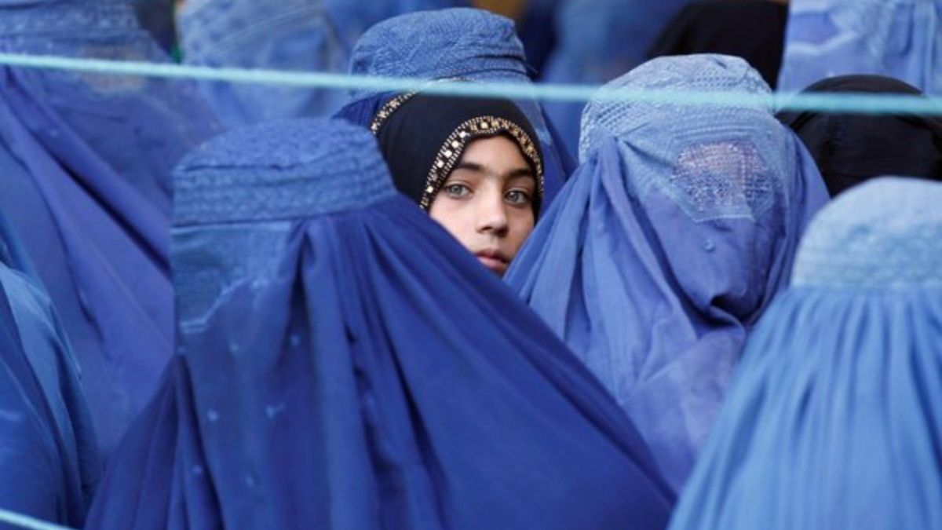The Taliban have imposed a harsh interpretation of Islamic law despite pledges to respect the rights of women and minority communities and provide amnesty for people who supported U.S. efforts. Meanwhile, as they have transitioned from an insurgent group to a functional government, the Taliban have struggled to provide Afghans with security, adequate food, and economic opportunities.

In less than a year, the Taliban have decimated the rights of women and girls in Afghanistan. They have violated women’s and girls’ rights to education, work and free movement; demolished the system of support for women and girls fleeing domestic violence; arbitrarily detained women and girls for infractions of the Taliban’s discriminatory rules; and contributed to a surge in the rates of child, early and forced marriage. Under Taliban rule even mannequins in women's dress shops across Afghanistan's capital Kabul have been cloaked in aluminum foil, cloth sacks or wrapped in black plastic bags. Women who peacefully protested against these restrictions and policies have been harassed, threatened, arrested, forcibly disappeared, arbitrarily detained and tortured. The scope, magnitude and severity of the Taliban’s violations against women and girls are increasing month by month. Within a year of its takeover of Afghanistan, the group’s draconian policies are depriving millions of women and girls of the opportunity to lead safe, free and fulfilling lives. They are being sentenced, as one Afghan woman put it, to death in slow motion.

**c. Abortion Rights In The USA**

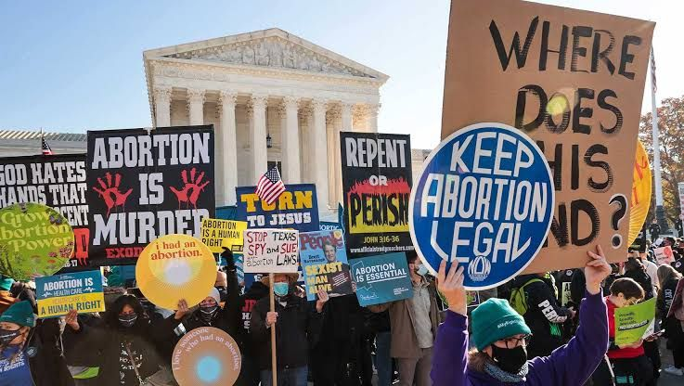Abortion in the United States and its territories is a divisive issue in American politics and culture wars, with widely different abortion laws in U.S. states. Since 1976, the Republican Party has generally sought to restrict abortion access based on the stage of pregnancy or to criminalize abortion, whereas the Democratic Party has generally defended access to abortion and has made contraception easier to obtain. The abortion-rights movement advocates for patient choice and bodily autonomy, while the anti-abortion movement maintains the fetus has a right to live. Historically framed as a debate between the pro-choice and pro-life labels, most Americans agree with some positions of each side. Support for abortion gradually increased in the U.S. beginning in the early 1970s, and stabilized during the 2010s.

The abortion rate has continuously declined from a peak in 1980 of 30 per 1,000 women of childbearing age (15–44) to 11.3 by 2018. In 2018, 78% of abortions were performed at 9 weeks or less gestation, and 92% of abortions

were performed at 13 weeks or less gestation. By 2020, medication abortions accounted for more than 50% of all abortions. Almost 25% of women will have had an abortion by age 45, with 20% of 30 year olds having had one. In 2019, 60% of women who had abortions were already mothers, and 50% already had two or more children. Increased access to birth control has been statistically linked to reductions in the abortion rate.

Before the Supreme Court of the United States decisions of Roe v. Wade and Doe v. Bolton had decriminalized abortion nationwide in 1973, abortion was already legal in several states; the decision in the former case imposed a federally mandated uniform framework for state legislation on the subject. It also established a minimal period during which abortion is legal, with more or fewer restrictions throughout the pregnancy. That basic framework, modified in Planned Parenthood v. Casey (1992), remained nominally in place, although the effective availability of abortion varied significantly from state to state, as many counties had no abortion providers. Casey held that a law could not place legal restrictions imposing an undue burden for "the purpose or effect of placing a substantial obstacle in the path of a woman seeking an abortion of a nonviable fetus". In December 2021, the FDA legalized telemedicine provision of medication abortion pills with delivery by mail, but many states have laws which restrict this option.

In 2022, Roe and Casey were overturned in Dobbs v. Jackson Women's Health Organization, ending protection of abortion rights by the United States Constitution and allowing individual states to regulate any aspect of abortion not pre-empted by federal law.

As of 2022, California, Michigan, and Vermont are the only U.S. states to have explicit rights to abortion in their state constitutions. Other states have implicit rights to abortion subject to state judicial review, such as Kansas and Montana, or simply protect it via state law such as Colorado. The state constitutions Alabama, Louisiana, Tennessee, and West Virginia explicitly contain no right to an abortion.

As of 2022, California, Michigan, and Vermont are the only U.S. states to have explicit rights to abortion in their state constitutions. Other states have implicit rights to abortion subject to state judicial review, such as Kansas and Montana, or simply protect it via state law such as Colorado. The state constitutions Alabama, Louisiana, Tennessee, and West Virginia explicitly contain no right to an abortion.

**7. What Did Countries Do?**

**The progress has been made about women’s rights**

**a. Women’s suffrage**

Women's suffrage has been achieved at various times in countries throughout the world. In many nations, women's suffrage was granted before universal suffrage, in which cases women and men from certain socioeconomic classes or races still unable to vote. Some of the countries granted suffrage to both sexes at the same time.

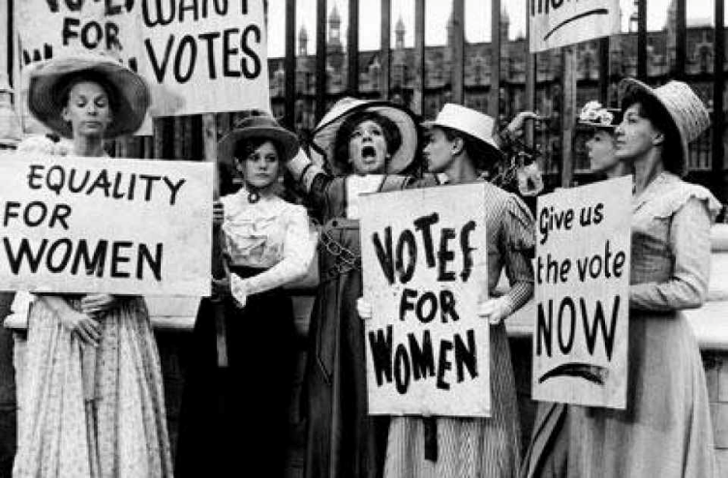During the 19th and early 20th centuries people began to agitate for the right of women to vote. In 1893 New Zealand became the first country to give women the right to vote on a national. The colony of South Australia allowed women to both vote and stand for election in 1894. In Sweden, conditional women's suffrage was granted during the age of liberty between 1718 and 1772. But it was not until the year 1919 that equality was achieved, where women's votes were valued the same as men's 1906, the autonomous Grand Duchy of Finland, which later became the Republic of Finland, was the first country in the world to give all women and all men both the right to vote and the right to run for office. Finland was also the first country in Europe to give women the right to vote. The world's first female members of parliament were elected in Finland the following year. World War I and its aftermath speeded up the enfranchisement of women in the countries of Europe and elsewhere today women’s suffrage is a right under the Convention on the Elimination of All Forms of Discrimination Against Women in U.S. provides that “women shall be entitled to vote in all elections on equal terms with men, without any discrimination.”



**b. Abortion Rights**

**Abortion laws** vary widely among countries and territories, and have changed over time. Such laws range from abortion being freely available on request, to regulation or restrictions of various kinds, to outright prohibition in all

circumstances. Many countries and territories that allow abortion have gestational limits for the procedure depending on the reason; with the majority being up to 12 weeks for abortion on request. Abortion continues to be a [controversial subject](https://en.wikipedia.org/wiki/Abortion_debate) in many societies on [religious,](https://en.wikipedia.org/wiki/Religion_and_abortion) [moral,](https://en.wikipedia.org/wiki/Philosophical_aspects_of_the_abortion_debate#Philosophical_argumentation_on_the_moral_issue) ethical, practical, and political grounds. Though it has been banned and otherwise limited by law in many jurisdictions, abortions continue to be common in many areas, even where they are illegal. As of 2022, countries that legally allow abortion on request or for socioeconomic reasons comprise about 60% of the world's population.

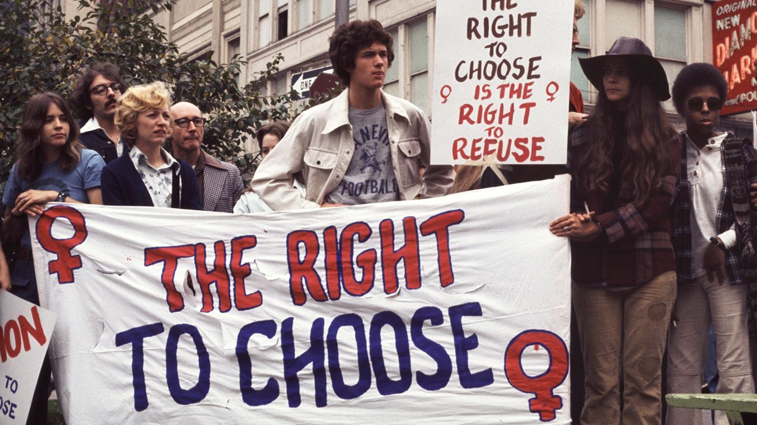

According to a 2007 study conducted by the Guttmacher Institute and the World Health Organization, abortion rates are similar in countries where the procedure is legal and in countries where it is not, due to unavailability of modern [contraceptives](https://en.wikipedia.org/wiki/Birth_control) in areas where abortion is illegal. Also according to the study, the number of abortions worldwide is declining due to increased access to contraception. By the first half of the 20th century, many countries had begun to liberalize abortion laws, at least when performed to protect the woman's life and in some cases on the woman's request.

The Soviet Union became the first modern state in legalizing abortions on request. The Soviet state recognized that banning abortion would not stop the practice because women would continue using the services of private abortionists. In rural areas, these were often old women who had no medical training, which made their services very dangerous to women's health. In November 1920 the Soviet regime legalized abortion in state hospitals. In the 1930s, several countries (Poland, Turkey, Denmark, Sweden, Iceland, Mexico) legalized abortion in some special cases. In the United Kingdom, the Abortion Act of 1967 clarified and prescribed abortions as legal up to 28 weeks . Other countries soon followed, including Canada, the United States. However, these countries vary greatly in the circumstances under which abortion was to be permitted. In 1975, the West German Supreme Court [struck down](https://en.wikipedia.org/wiki/German_Federal_Constitutional_Court_abortion_decision) a law legalizing abortion, holding that they contradict the constitution's human rights guarantees. In jurisdictions governed under sharia law, abortion after the 120th day from conception is illegal, especially for those who follow the recommendations of the Hanafi legal school, while most jurists of the Maliki

legal school "believe that [ensoulment](https://en.wikipedia.org/wiki/Ensoulment) occurs at the moment of [conception,](https://en.wikipedia.org/wiki/Fertilisation) and they tend to forbid abortion at any point

**c. Girls’ access to education**

Girls who receive an education are less likely to marry young and more likely to lead healthy, productive lives. They earn higher incomes, participate in the decisions that most affect them, and build better futures for themselves and their families. Education for girls is about more than access to school. It’s also about girls feeling safe in classrooms and supported in the subjects and careers they choose to pursue – including those in which they are often under-represented. women and girls face explicit barriers to entry to school, for example, violence against women or prohibitions of girls from going to school, while other problems are more systematic and less explicit, for example, science, technology, engineering and mathematics (STEM) education disparities are deep rooted, even in Europe

In China, in the 1980s, Chinese central government passed a new education law, which required local governments to promote 9-year obligation education nationwide. The new education law guaranteed education rights until middle school. Before the 1960s, female enrollment in elementary school was 20%. 20 years after publishment of education law, in the year 1995, this percentage had increased to 98.2%. By 2003, proportion of female who dropped from middle school decreased to 2.49%In the 21st century, university education is becoming more prevalent. The total enrollment goes up. Compare to the year of 1977, which is the first year when college entrance examination was recovered, the admission rate increased from 4.8% to 74.86%.Before and after Independence, India has been taking active steps towards women's status and education. The 86th Constitutional Amendment Act, 2001, has been a path breaking step towards the growth of education, especially for females. According to this act, elementary education is a fundamental right for children between the ages of 6 and 14. The government has undertaken to provide this education free of cost and make it compulsory for those in that age group. This undertaking is more widely known as Sarva Shiksha Abhiyan.

**8. Violation of Human Rights in Conflict Zones**

In recent decades, armed conflict has blighted the lives of millions of civilians. Many people's rights are being taken away, especially women's and children's. Serious violations of international humanitarian and human rights law are common in many armed conflicts. In certain circumstances, some of these violations may even constitute genocide, war crimes or crimes against humanity.

Warfare is a phenomenon in constant change, so international human rights law and international humanitarian law must adjust constantly to avoid gaps in the protection they provide. International human rights law and international humanitarian law share the goal of preserving the dignity and humanity of all.

**a. Violation Of Children’s And Women’s Rights**

Millions of people lost their lives in wars and armed conflicts, were forced to fight, became crippled, forced to live in inhumane conditions during the war, and those who survived the war became unable to survive in the debris left behind. Although wars undoubtedly affect the living conditions of people of all ages and walks of life, we can say that their effects on children are irreversible. The reason why children are most affected by wars is that many of them lost their families during the war, had to leave their homes, in short, they were forced to adapt to a new order in which they tried to survive by breaking away from the living conditions they were accustomed to. Violations of the right to life and right to health that children are exposed to in this new order cause the death of many children in wars and the obstacles that others will carry throughout their lives due to the wounds they have received. The bombing of hospitals during the war, the inability of people to leave the places where they took shelter to survive, the participation of health workers in the war, the

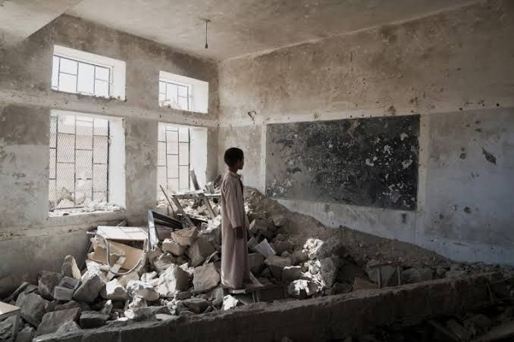departure of the country, etc. Restricting access to health services for reasons aggravates violations of the right to life and right to health.

Although it does not seem like one of the rights that should be observed in the first place during wars and armed conflicts, the right to education is one of the most fundamental rights of the child that should not be overlooked. The use of the right to education by children who took refuge in other countries as refugees or conditional refugees varies depending on the situation of the countries they took refuge in, but because it often takes time for them to adapt to a different culture, a long-term result can be obtained.

In the Middle East, where peace still seems far away, besides many people have lost their lives there are broken families, wounded people, destroyed buildings, shattered hopes. There is a picture that is getting more and more severe, and this is hitting women the most. Because women do not only fight on the front line when necessary, but also become the direct addressee of the trauma experienced in war. In wars throughout history, the victorious countries have not only destroyed the historical and cultural values of the places they conquered and plundered their assets, but have also reinforced their sovereignty by raping the women of the defeated country. Women, who are the primary subjects of sexual violence in war-torn societies, are subjected to lasting effects such as unwanted pregnancy, sexually transmitted diseases and ostracization from society after the conflict.

**b. Examples**

The 2nd Congo Civil War, which lasted between 1998-2003 and is one of the bloodiest wars in history, is the war of soldiers who were recruited. During this war, even children under the age of 15 were recruited and forced to fight. In interviews conducted by Amnesty International with some Congolese children who were forcibly recruited in 2003, we see that children are exposed to gross human rights violations. 15-year-old Kalami was forced to fight as a soldier for 6 years and said that during that time she had to kill many people, her life was

ruined and she couldn't sleep thinking about what she had done. On the other hand, 10-year-old Gaston stated that he did not know anything about military service because he was very young when he was drafted into the army, that he was very afraid and that he was ordered to kill another child in the camp in order to overcome this fear and that he had to do this. Not only boys but also girls were recruited into the army, 16-year-old Natalia watched her family get murdered in front of her eyes, thought that if she joined the army, she would at least survive, but she was sexually abused and abused many times during her time in the army.

While the Russia-Ukraine crisis was raging, Russia's bombing of hospitals and health centers shows us how the devastating effect of the war caused violations of the right to life and right to health. Many people, including children, lose their lives during the bombing of hospitals, and people's right to access health services is restricted under wartime conditions. On March 9, 2022, the Russian Air Force bombed the Maternity Hospital No. 3, which serves as both a children's hospital and a maternity hospital, in Mariupol, causing at least 4 deaths, 17 injuries and 1 stillbirth of a baby. The damage done to the hospital in the bombing was described by the Ukrainian authorities as colossal; It was stated that the walls collapsed, the medical equipment was covered with rubble, and a large part of the hospital became unusable. Ukrainian President Volodymyr Zelenski said in a statement after the bombing that the number of dead and wounded was minimized because people hid from the attack in time. In this incident, which shows the brutality of the war, we see a direct violation of Article 6 of the Convention on the Rights of the Child, which regulates the fundamental right to life, and Article 24, which regulates the right of the child to benefit from health services and the necessity of providing appropriate care to the mother before and after birth.

In these conditions, it is very difficult for children and babies who start to live in shelters or metro stations with their families or family members in order to protect themselves from the devastating effects of the war in the ongoing Russian intervention in Ukraine, to receive treatment if they are sick. We can say that pregnant women who have to give birth in non-sterile environments

in shelters and babies who open their eyes to the war environment are exposed to a serious violation of their right to health.

**Bibliography**

[https://www.humanrights.is/en/human-rights-education-project/human-](https://www.humanrights.is/en/human-rights-education-project/human-rights-concepts-ideas-and-fora/human-rights-in-relation-to-other-topics/human-rights-and-armed-conflict)

rights-concepts-ideas-and-fora/human-rights-in-relation-to-other-

topics/human-rights-and-armed-conflict

<https://www.amnesty.org/en/documents/asa11/5685/2022/en/>

[https://canwach.ca/article/violence-against-women-6-ways-womens-human-](https://canwach.ca/article/violence-against-women-6-ways-womens-human-rights-are-violated-around-world/)

rights-are-violated-around-world/

[https://www.kff.org/womens-health-policy/press-release/abortion-in-the-](https://www.kff.org/womens-health-policy/press-release/abortion-in-the-united-states/)

united-states/

<https://www.ohchr.org/en/protecting-human-rights-conflict-situations>