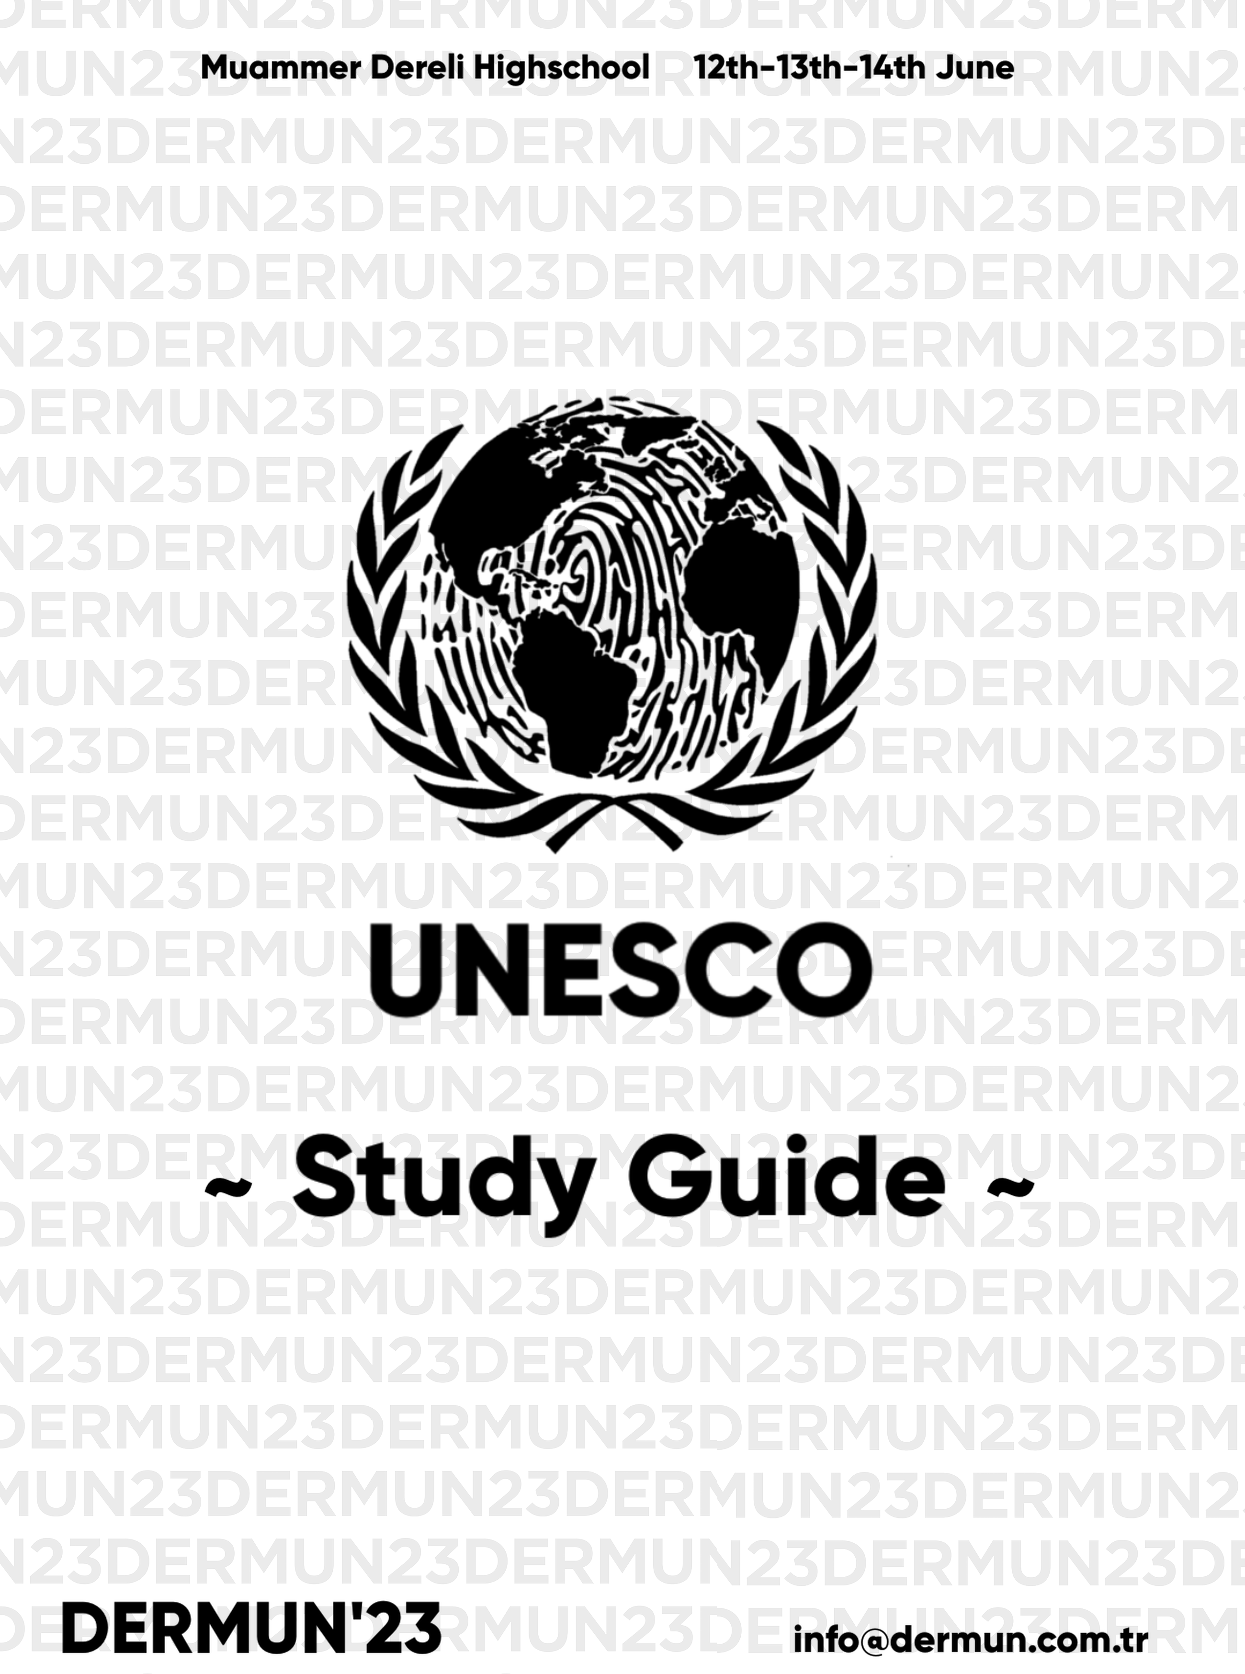

**Contents**

Welcoming Letters 3

Introduction to UNESCO 4

Introduction to the Committee… 5

Member States… 6

Agenda Item… 7

Topic A… 7

Topic B 13

The British Museum… 17

Questions to Consider 19

Bibliography………………………………….…..……………………………..……………………………20

**Welcoming Letters**

**Letter from Chairboard**

Dear Delegates,

It is an utmost pleasure to welcome you to DERMUN 2023 and most especially to this demanding committee, UNESCO. We are delighted to be serving as the Board Members of this committee and are excited to meet you all. We will give our best to provide you with the best experience possible. We are sure that intense debates will take place regarding this unique topic *“Illegal Traﬃcking of Cultural Heritage”*and all of you will be able to express their country’s policy directly. As the board of this marvellous committee, we kindly ask you to start your research and preparation as soon as possible. With a productive reading, this study guide will help you a lot; but to access broader information, we recommend you to do a comprehensive research about the policies, particularly the policy of your country. We are looking forward to meet you and to board this committee. Let’s put an end to this letter with a UNESCO quote, shall we? *“Peace must be built upon the intellectual and moral solidarity of humanity.”*

**Letter from Secretary General**

Dear Participants,

On behalf of DERMUN’23 Model United Nations (MUN) Conference, it is our great pleasure to extend a warm welcome to all participants attending this esteemed event. As the Secretary-General’s, we are honored to have the opportunity to address you all and witness the culmination of your diligent preparations and intellectual prowess.

DERMUN’23 Conference serves as a platform for aspiring young leaders like yourselves to engage in substantive discussions, exchange diverse perspectives, and collectively seek solutions to the world's most pressing issues. This year, we have meticulously curated a diverse range of committees to stimulate robust debates and foster innovative thinking. We have got five committees,3 English-2 Turkish, which includes General Assembly(GA) like SOCHUM and Special Committees.

We are confident that DERMUN’23 Conference will not only provide you with an enriching experience but also enable you to forge lifelong connections with like-minded individuals who share your passion for international affairs. Embrace the diversity of perspectives within this conference, seize every opportunity for collaboration, and let your ideas inspire positive change.

*Eylül Yaman*

*Kenan Mirzaoğlu*

# Introduction to UNESCO

In 1942, European countries who were confronting Nazi Germany met for the Conference of Allied Ministers of Education (CAME). After the war ended, representative of 44 countries

established UNESCO. United Nations Educational, Scientiﬁc and Cultural Organization contributes to peace and security by promoting international cooperation in education, sciences, culture, communication and information. It works to create the conditions for dialogue among civilisations, cultures and peoples, based upon respect for commonly shared values. The countries that are members of this

organisation are the Member-States of the United Nations. Each one of the 58 members has one vote in UNESCO’s General Conference that is held every two years in order to set the organisation’s budgets and evaluate the contributions of each member to live up to the goals set by the agency. In our committee you, our beloved delegates, will be one of these members to represent the countries perfectly.

**Introduction to the Committee**

Our committee takes place in 2027. World needs UNESCO, due to the fact that the countries we stated below, are struggling with a world war, which has been on for 3 years. In 2023, in the middle of Russia- Ukraine War, Greece sent an ultimatum to England. Their occasion for war was the fact that England traﬃcked the Greek heritage as well as the other historical works, and are exhibiting them in The British Museum.

Subsequently, French colonies in Africa rebelled against France due to the same reason. In the sequel, the countries whom cultural heritage has been traﬃcked or destructed deliberately(like Turkey, Egypt etc.), started to rebel. And all these events caused a worldwide war.

The aim of this committee is initially, to stop this war and reconcile the opponents. And most importantly, to prohibit the traﬃcking and deliberate destruction of historical works, which particularly takes place in times of war. We are going to be debating with this purpose.

**Member States**

1. United Kingdom

2. United States of America

3. Greece

4. France

5. Turkey

6. Denmark

7. Egypt

8. Switzerland

9. Germany

10. Iraq

11. Russia

12. Ukraine

13. Italy

14. Afghanistan

15. Syria

16. Canada

17. China

18. Pakistan

19. Yemen

20. Spain

21. Libya

**Agenda Items**

The two agenda items for our committee,

*Topic A: Illegal Trafficking of Cultural Heritage*

*Topic B: Deliberate Destruction of Cultural Heritage*

*Another Topic to discuss: The British Museum*

**Topic A: Illegal Traﬃcking of Cultural Heritage**

**Summary**

Illegal traﬃcking of cultural property is a type of smuggling where the materials in direct relation with the cultural heritage of a nation and values of humanity are in question.

Traﬃcking in cultural property is becoming an important source for the laundering of the proceeds of crime, and has been recently identiﬁed as a possible source of ﬁnancing for terrorist groups. It involves several acts that may ultimately result in the loss, destruction, removal or theft of irreplaceable items.

**Background**

From past to the present, there has been many acts of illicit traﬃcking especially in times of armed conﬂict. UNESCO is ﬁghting against these acts, such as;

Convention on the Means of Prohibiting and Preventing the Illicit Import, Export and Transfer of Ownership of Cultural Property (1970 UNESCO Convention)

It is the pioneer and most broadly ratiﬁed international convention that exists on the issue of illicit traﬃcking in cultural property. The Convention clearly states that “the export and transfer of ownership of cultural property under compulsion arising directly or indirectly from the occupation of a country by a foreign power shall be regarded as illicit”.

*It deﬁnes preventative measures State Parties should undertake, including:*

1. The creation of inventories, export certiﬁcates, monitoring trade, the imposition of penal or administrative sanctions, and educational campaigns.;

2. The implementation of measures, consistent with national legislation, which prevent museums and similar institutions within their territories from acquiring cultural property originating in another State Party which has been illegally exported;

3. Prohibiting the import of stolen cultural property in another State Party to this Convention.

4. States Parties undertake, at the request of the State Party of origin, to take appropriate steps to recover and return any such imported cultural property.

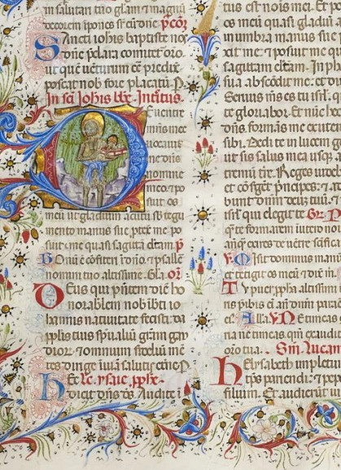*D****ue to the articles of this convention,***

1. On 18 March 2022, *the Germany handed over four illegally transferred cultural objects to Italy*, that were seized in Germany

2. On 4 March 2021, *Germany returned four precious artefacts to Egypt.* The objects were confisticated by German Police authorities in 2017. They were illegally excavated from the tomb of the Late Period vizier Baken-Re-Nef at the Saqqara Necropolis in Egypt.

3. On 16 March 2015, more than 60 Iraqi cultural treasures illegally brought into *the United States* were returned to *the Republic of Iraq*.

4. On 26 October, *France* restituted to *Egypt* eight archaeological pieces seized by the French customs in January 2010.

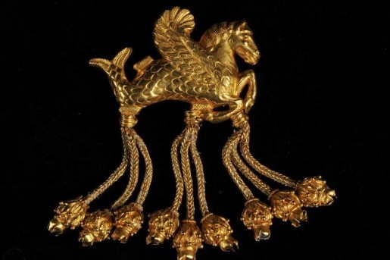

5. On March 2013, a gold brooch depicting a ‘’winged seahorse’’ was returned from *Germany* to *Turkey.* The brooch, stolen from a museum in Usak, Turkey, in 2005, was seized by the German authorities in 2012.

#### **The Acts of Governments**

1. *Greece* wanted historical artefacts and cultural assets that *Britain* have smuggled nearly 200 years ago(according to Greece's allegations), to be one of the prerequisites for post-Brexit trade

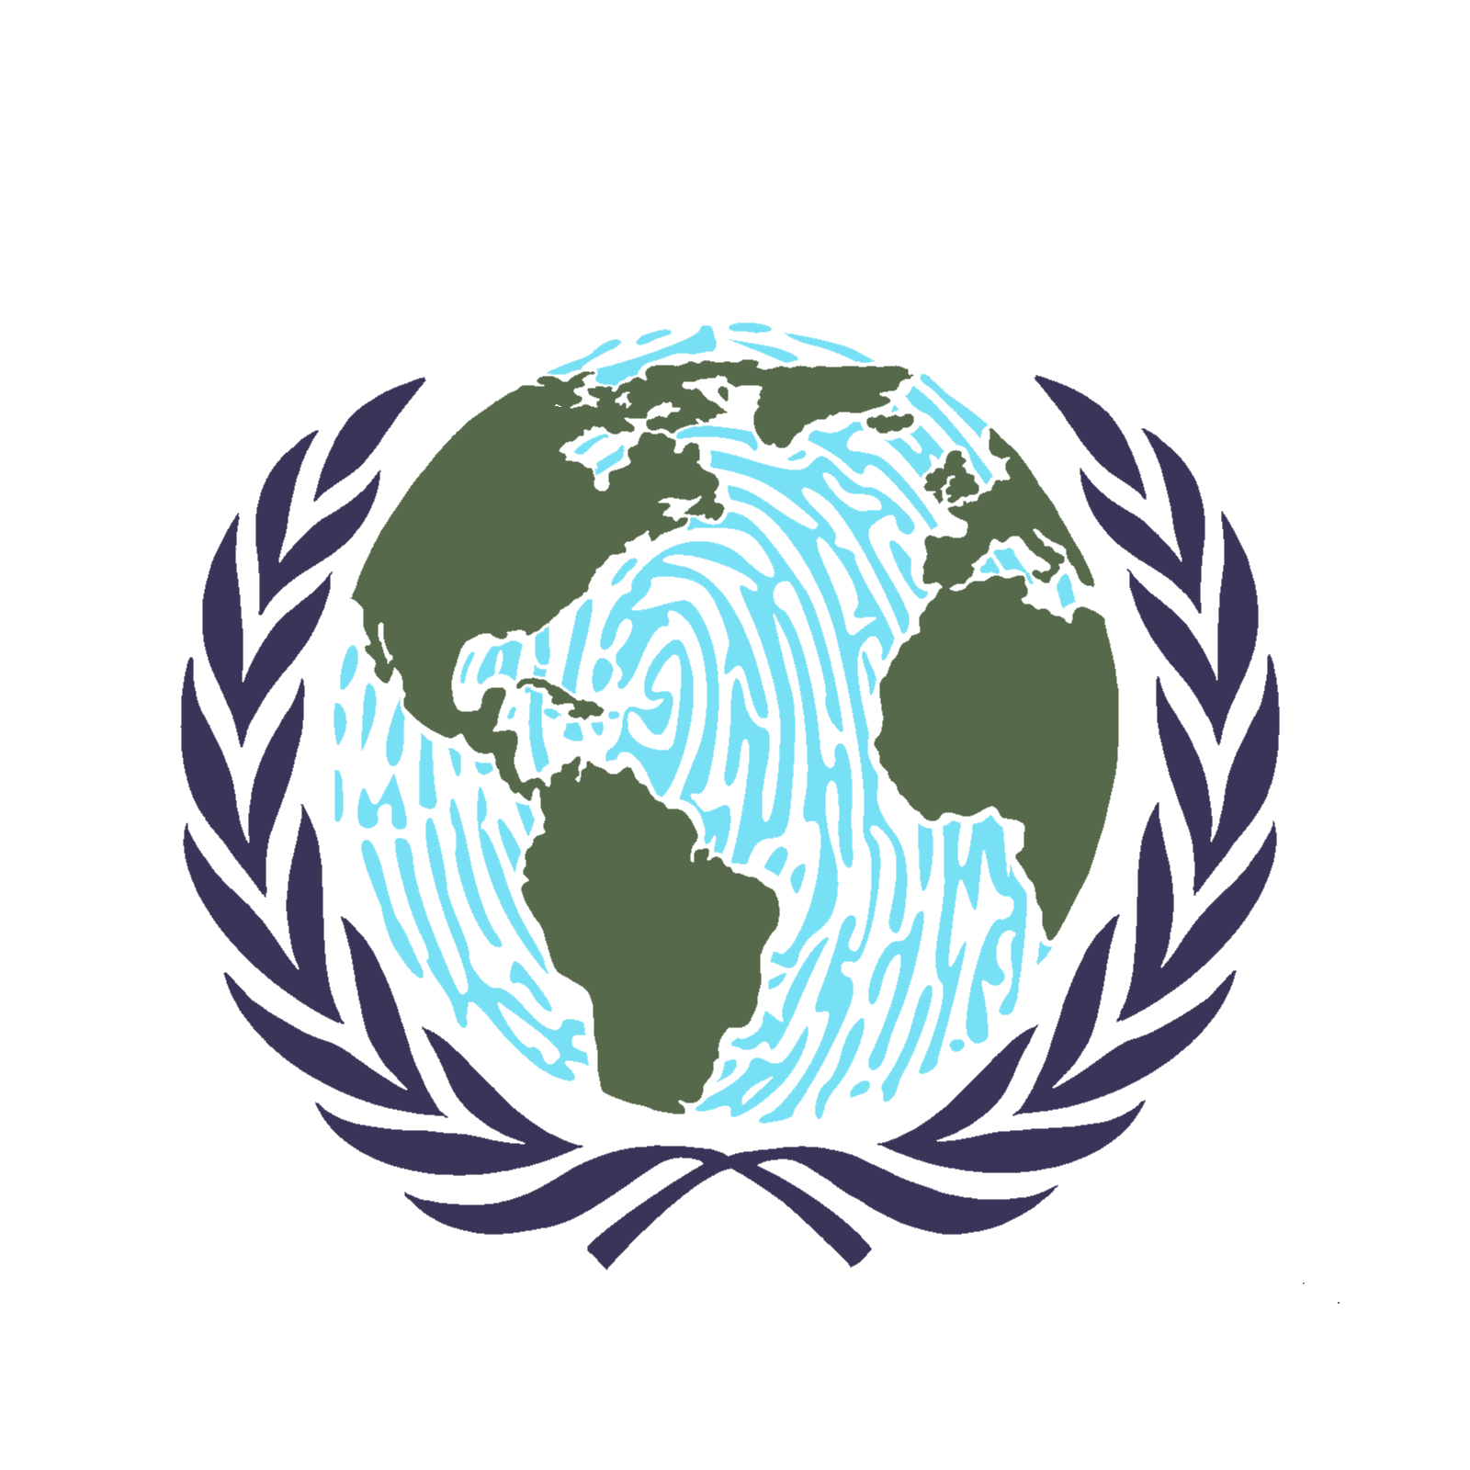negotiations. Greece has been demanding the return of the "Elgin marbles" exhibited in *the British Museum*in London for a long time. UNESCO oﬀered to mediate in the resolution of this dispute between Greece and England in 2014, but the British Museum rejected the proposal, arguing that the organisation could only work between governments, not museums.

b. The Louvre permit of to artefact smuggling. According to the news in the *French*press, Martinez, the former director of the Louvre, was detained. It is stated that the countries mentioned in the investigation regarding the smuggling of historical artefacts are *Egypt and Syria.*

1. c. The David Collection in Copenhagen, the capital of **Denmark,** hosts important Islamic artefacts in Europe. In the museum, which houses a rich art collection from the birth of Islam to the 19th century, the artefacts smuggled from **Turkey** and which Ankara has oﬃcially requested to be returned draw attention. There is also a sarcophagus whose ﬁgure belongs to the Akşehir Seydi Mahmud Hayrani Tomb, and a candlestick from the Hacı Bayram Veli Tomb.
2.  d. In New York City, **USA**, it has been made compulsory by law to provide information about the history of artworks looted by the Nazis during World War II and exhibited in museums today. The law requires museums to put up signs identifying items looted by the **Nazis** from 1933 to 1945. The Metropolitan Museum of Art determined that 53 works in its collection were seized or sold under pressure during the Nazi period. Among those works, there is a **Turkish helmet**. According to experts, at least 600,000 works of art from the Jews were looted during the war.

## **Topic B: Deliberate Destruction of Cultural Heritage**

### **Summary**

According to Lazare Eloundou Assomo, director of UNESCO’s World Heritage Centre, the damage to historic sites is having terrible consequences on the country’s cultural identity. Cultural heritage is an important component of the cultural identity of communities, groups and individuals, and of social cohesion, so that its intentional destruction may have adverse consequences on human dignity and human rights.

### **Background**

The General Conference of the United Nations Educational, Scientiﬁc and Cultural Organisation meeting in Paris at its thirty second session in 2003,

*Recalls* the tragic destruction of the Buddhas of Bamiyan that aﬀected the international community as a whole,

*Recalls* the principles of all UNESCO’s conventions, recommendations, declarations and charters for the protection of cultural heritage,

*Adopts and solemnly proclaims* the present declaration ; *The international community recognises the importance of the protection of cultural heritage and reaﬃrms its commitment to ﬁght against its intentional destruction in any form so that such cultural heritage may be transmitted to the succeeding generations.*

**UNESCO: Deliberate Destruction of Ukraine’s Cultural Heritage Could Be Considered as a War Crime**

Since the *Russian*oﬀensive began on 24th February 2022, the damage or destruction of nearly 100 culturally important sites in *Ukraine* have been veriﬁed by the UNESCO. Several theatres, museums, churches, and other historical buildings in attacked cities have had their windows shattered, their walls laced with bullet holes or have been entirely crumbled to pieces from shelling.

**Afghanistan - UNESCO Calls for the Protection of Cultural Heritage in its Diversity**

The Buddhas of Bamiyan (or Bamyan) were the 6th century monumental statues carved into the side of a cliﬀ in the Bamyan valley of Hazarajat region in central *Afghanistan.* On orders from Taliban founder Mullah Omar, the statues were destroyed in March after the Taliban government declared that they were idols. International and local opinion strongly condemned the destruction of the Buddhas. Amid the rapidly unfolding events, and twenty years after the deliberate destruction of the Bamiyan Buddhas, Audrey Azoulay “calls for the preservation of Afghanistan’s cultural heritage in its diversity, in full respect of international law, and for taking all necessary precautions to spare and protect cultural heritage from damage and looting.

**UNESCO Condemns the Intentional Destruction of a Historical Mosque and Mausoleum in the Hodeida Governorate of Yemen**

UNESCO condemns the intentional destruction of the Ahmed Al-Faz Mosque and Mausoleum in Hodeida, located on the coast approximately 30 km from the World Heritage property of the Historic Town of Zabid. The General Organisation of Antiquities and Museums (GOAM) in *Yemen*conﬁrmed, in a statement published on 23rd October, that the building was destroyed by extremists on the previous day.

**Another Topic to Discuss: The British Museum**

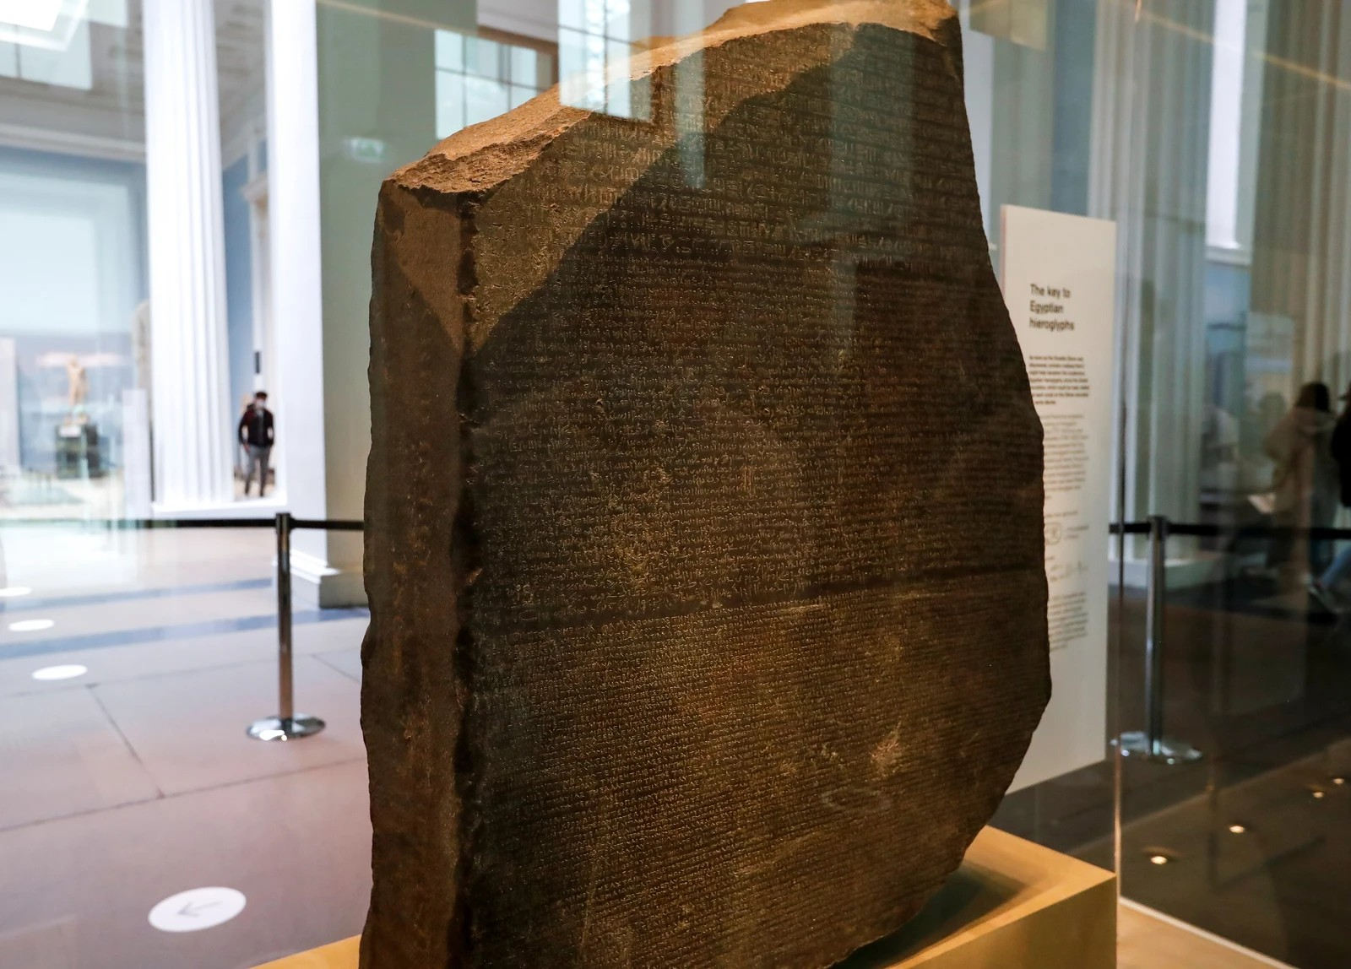The British Museum is a public museum which is dedicated to human history, art and culture. Its permanent

collection of eight million works is among the largest and most comprehensive in existence. However many of these artefacts – around 99

percent of which are not placed on public

display, but hoarded away in the institution’s

The Rosetta Stone

private archives – **were forcibly taken** has led to decades-long demands for their restitution.

Such as the controversial traﬃcking of Rosetta Stone, which is claimed to **belong to Egypt.** What is very problematic is that Rosetta Stone became a part of British Culture even though it is a war spoil.

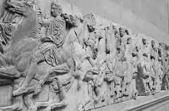It is also claimed that they display Elgin Marbles **originally from the Pantheon in Athens.** Despite pressure from the Greek government to return the sculptures, the British Museum argued that they are the rightful owners of the art and refuse to remove them from the museum’s collection. The British Museum argued that Lord Elgin acquired the Greek sculptures for the United Kingdom in 1801 when Lord Elgin was the ambassador in the Ottoman Empire for Britain Therefore, the British Museum holds that Greece has no current legal claim to the sculptures.

Elgin Marbles

**Questions to Consider**

1. What are the acts of your country regarding the deliberate destruction or the illegal traﬃcking of cultural heritage in history? How would they act in 2027 according to their perspectives erstwhile?

2. What would your country do to stop the war and compromise between the opponents ?

3. What are your countries political relationships with the other countries listed above, throughout the history? (In order to make an alliance or assault)

**Tip from the Board!**

Make sure that you do an extensive research about your country’s former acts and policy throughout the history in order to respond other countries’ accusations.

# 

# Bibliography

https://en.wikipedia.org/wiki/List_of_destroyed_heritage https://en.unesco.org/fighttrafficking https://en.unesco.org/campus-unesco/campus_key_topics https://imuna.org/nhsmun/nyc/committees/unesco-educational-

scientific-and-cultural-organization/ https://schsmun.weebly.com/uploads/3/9/1/6/39166347/

model_un_vocabulary.pdf

https://tr.euronews.com/my-europe/2014/07/17/unesco-savas-cikan- ulkelerdeki-tarihi-eserleri-nasil-koruyor

https[://w](http://www.unodc.org/unodc/en/organized-crime/intro/emerging-)ww[.unodc.or](http://www.unodc.org/unodc/en/organized-crime/intro/emerging-)g[/unodc/en/organized-crime/intro/emerging-](http://www.unodc.org/unodc/en/organized-crime/intro/emerging-) crimes/trafficking-in-cultural-property.html

https[://w](http://www.unesco.org/en/legal-affairs/convention-means-prohibiting-)ww[.un](http://www.unesco.org/en/legal-affairs/convention-means-prohibiting-)e[sco.org/en/legal-affairs/convention-means-prohibiting-](http://www.unesco.org/en/legal-affairs/convention-means-prohibiting-) and-preventing-illicit-import-export-and-transfer-ownership-cultural

https[://w](http://www.artloss.com/)ww[.a](http://www.artloss.com/)r[tloss.com/](http://www.artloss.com/) https[://w](http://www.vice.com/en/article/3abdd3/unfiltered-history-tour-ten-)ww[.vic](http://www.vice.com/en/article/3abdd3/unfiltered-history-tour-ten-)e[.com/en/article/3abdd3/unfiltered-history-tour-ten-](http://www.vice.com/en/article/3abdd3/unfiltered-history-tour-ten-)

disputed-artefacts-british-museum

https[://w](http://www.cardozociclr.com/post/trafficked-the-british-museum-s-role-)ww[.c](http://www.cardozociclr.com/post/trafficked-the-british-museum-s-role-)a[rdozociclr.com/post/trafficked-the-british-museum-s-role-](http://www.cardozociclr.com/post/trafficked-the-british-museum-s-role-) in-the-illicit-art-trade

https://en.wikipedia.org/wiki/British_Museum

https://tr.euronews.com/2020/02/23/yunanistan-ingiltere-nin-200-yil- once-kacirdigi-elgin-mermerlerini-istiyor