**PSpice Analysis for Maximum Power Transfer**

**Step-1:**

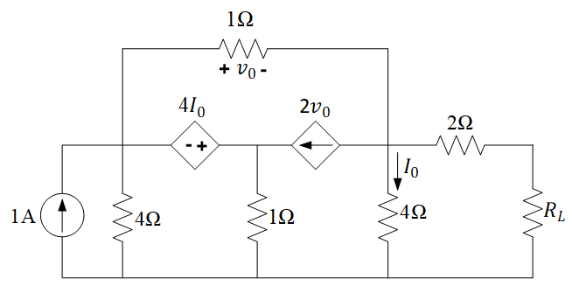

**Figure 1. Theoretical Circuit.**

**PSpice Analysis:**

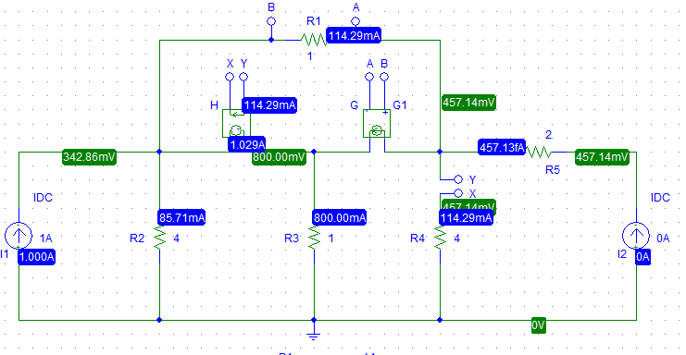

**Figure 2. Circuit Diagram to Measure the Open Circuit Voltage.**

First, we need to disconnect the RL and connect 0A current source to determine the VOC.

Here after PSpice simulation we get, **VOC = 457.14mV**

Now,

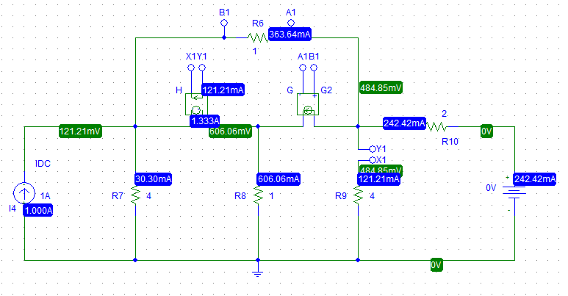

**Figure 3. Circuit Diagram to Measure the Short Circuit Current.**

We need to disconnect RL and connect 0V voltage source to determine the ISC.

Here, after simulation we get, ISC = 242.42mA

For RTh,

RTh = = Ω =1.885Ω.

**Step-2:**

**Theoretical Calculation and Solution:**

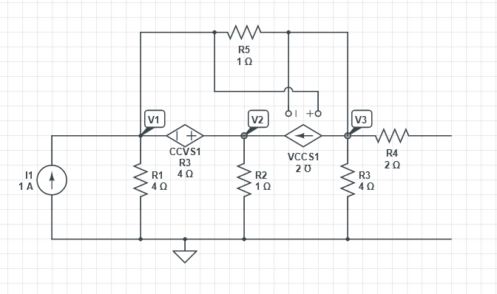

**Figure 4. Theoretical Circuit Diagram to Measure the Open Circuit Voltage.**

Here,

V3 =VTH

Applying KVL at Loop-1:

V2 – V1 = 4I0 [V3 = 4I0]

Or, V2 – V1 = V3

Or, V2 – V1 -V3 = 0 …………... (1)

Applying KCL at super node:

1 + 2V0 =

Or, 1 + 2=+

Or, 2 $V1-2V3-\frac{ V1}{4}- V2-V1+V3=-1$

Or, V1 $\left(2-\frac{1}{4}-1\right)-V2+V3\left(-2+1\right)=-1$

Or, $V1\left(\frac{3}{4}\right)-V2-V3=-1$………………. (2)

Applying KCL at Node 3:

$\frac{V1-V3}{1}=2V0+\frac{V3}{4}$

Or, $V1-V3-\frac{V3}{4}-2V1+2V3=0$

Or, $V1\left(1-2\right)+V3\left(-\frac{1}{4}-1+2\right)=0$

Or, $-V1+V3\left(\frac{3}{4}\right)=0$…………... (3)

After solving the equation 1,2,3:

V1 = 0.342 V

V2 = 0.8 V

V3 = VTH = 0.45714 V = 457.14 mV

Now,

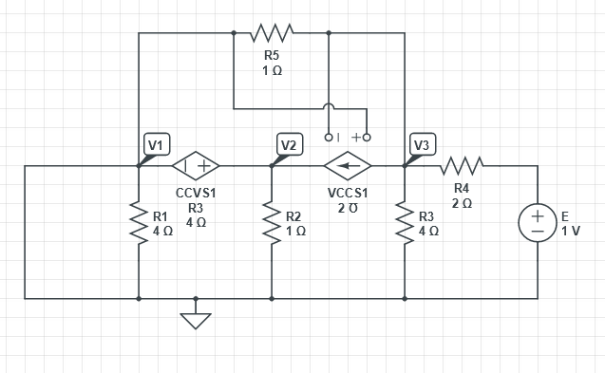

**Figure 5. Theoretical Circuit Diagram to Measure the Short Circuit Current.**

Applying KVL at Loop 1:

Or, [I0 = ] ………… (1)

Applying KCL at SN1:

$V1-V3+\frac{V1}{4}+V2=2V0$

Or, $V1-V3+\frac{V1}{4}+V2-2V1+2V3=0$

Or, $V1\left(-\frac{3}{4}\right)+V2+V3=0$………. (2)

Applying KCL at node 3:

$V1-V3=2V0+\frac{V3}{4}+\frac{V3-1}{2}$

Or, $V1-V3=2V1-2V2+\frac{V3}{4}+\frac{V3-1}{2}$

Or, $-V1+V3 \left(\frac{1}{4}\right)=-\frac{1}{2}$………(3)

After solving the equation 1,2,3:

V1 = 0.484 V

V2 =0.424 V

V3 = -0.0606V

= -60.0 mV

ISC =

RTh

Pmax

**PSpice Simulation:**

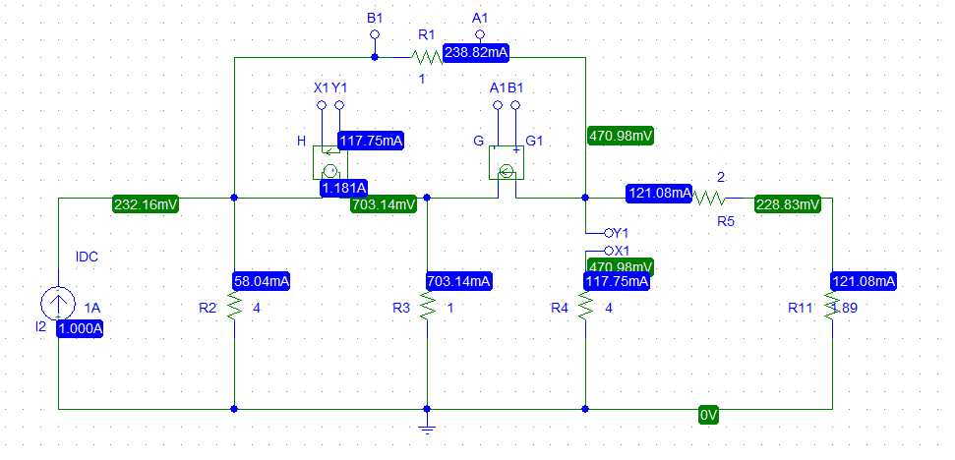

**Figure 6. Circuit Diagram to Replace the Resistor RL by the Thevenin Equivalent Resistance.**

Here, we need to replace the resistor RL by the Thevenin equivalent resistance which is 1.885Ω or 1.89Ω. We see from simulation, the voltage and current through RL is 228.83mV and 121.08mA.

Multiplying these current and voltage we get,

0.027706W

=27.706x10-3 W

We get, Pmax = 27.706mW.

**Step-3:**

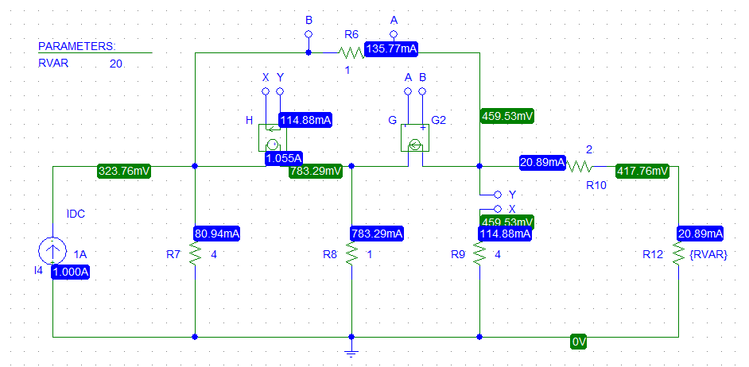

**Figure 7. Circuit Diagram of PSpice Simulation with Resistance Sweep.**

Here, we clicked analysis and checked if DC sweep is selected and clicked on global parameter then set the name as “RVAR” then set the starting value 0.001 and ending value 3.5 and increment 0.001.

We know that our maximum power is $27.706mW$

Then we got the graph below,

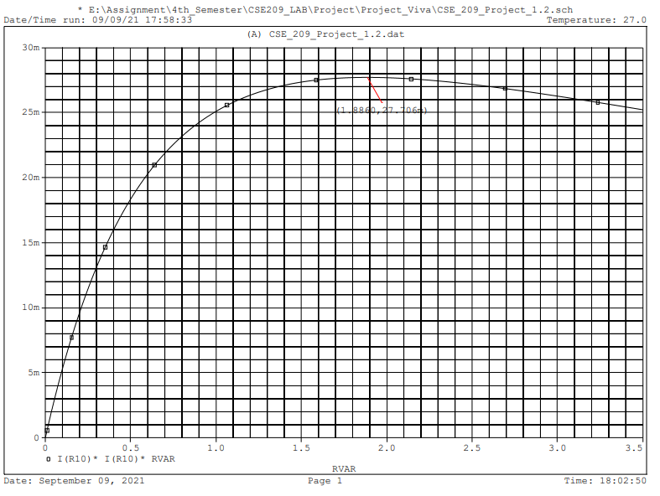

**Figure 8. Maximum Power Transfer and Resistance Sweep Curve Graph from PSpice.**

From the graph,

We see that, the value for maximum power transfer ($P_{max}$) is 27.706mW.

**Step 4:**

**Table 1. Comparison Between Theoretical Values and PSpice Simulation Values.**

|  |  |
| --- | --- |
| **Theoretical Value** | **Simulation Value** |
| RL =1.885Ω | RL = 1.886Ω |
| Pmax =27.699mW | Pmax = 27.706mW |

So, we can say that, the simulated values and the theoretical values are quite same. But even though there is a slight discrepancy yet we can see that the difference is very small.