Experiment No. 3

Aim : Programming exercises in HBASE
Theory :
Apache HBase is a distributed NoSQL database that provides scalable and fault-tolerant storage for Big Data applications. It is modeled after Google's Bigtable and is designed to work seamlessly with Hadoop. HBase stores data in tables consisting of rows and column families, where each row is uniquely identified using a row key. Since HBase follows a schema-less design within column families, it can efficiently handle sparse and dynamically changing datasets.
Unlike relational database management systems (RDBMS), HBase does not use SQL for querying data. Instead, it provides an interactive HBase Shell through which users can perform database operations such as creating tables, inserting data, updating records, scanning tables, retrieving rows, deleting data, and managing tables. It also supports APIs in Java and integrates with technologies such as Apache Avro, REST, Thrift, Hive, and MapReduce for application development and analytics.
HBase uses HDFS as its underlying storage layer, ensuring data reliability through Hadoop's replication mechanism. It also relies on Apache ZooKeeper for distributed coordination, leader election, and maintaining the health of the HBase cluster. Data is automatically distributed across multiple RegionServers, allowing the system to scale horizontally by simply adding more machines to the cluster.
The HBase shell provides numerous administrative and data manipulation commands. Commands such as create, list, describe, disable, enable, alter, exists, drop, put, scan, get, delete, count, and truncate allow users to perform complete database management operations. These commands are essential for managing HBase tables and efficiently handling large-scale distributed datasets in real-time environments.

Advantages
- Provides real-time random read and write access to Big Data.
- Highly scalable and capable of storing billions of rows.
- Built on HDFS, ensuring fault tolerance and high availability.
- Supports automatic data partitioning across multiple servers.
- Handles sparse and semi-structured datasets efficiently.
- Offers high write performance compared to traditional relational databases.
- Integrates seamlessly with the Hadoop ecosystem, including Hive, MapReduce, and Spark.
- Supports horizontal scaling without significant performance degradation.

Disadvantages
- Does not support SQL queries like traditional relational databases.
- More complex to install, configure, and administer.
- Not suitable for complex joins or multi-row transactions.
- Requires ZooKeeper for cluster coordination.
- Higher memory usage compared to many traditional databases.
- Less efficient for small datasets and simple applications.

Real-Life Applications
- Social media platforms for storing user profiles and activity logs.
- Real-time fraud detection in banking and financial services.
- Internet of Things (IoT) applications for storing sensor data.
- Healthcare systems for managing large volumes of patient records.
- Telecommunications for storing call detail records (CDRs).
- Recommendation systems for e-commerce websites.
- Web indexing and search engine data storage.
- Log management and real-time monitoring systems.
- Smart city applications involving continuous data collection.
- Big Data analytics platforms requiring fast random access to large datasets.

Architecture Diagram:
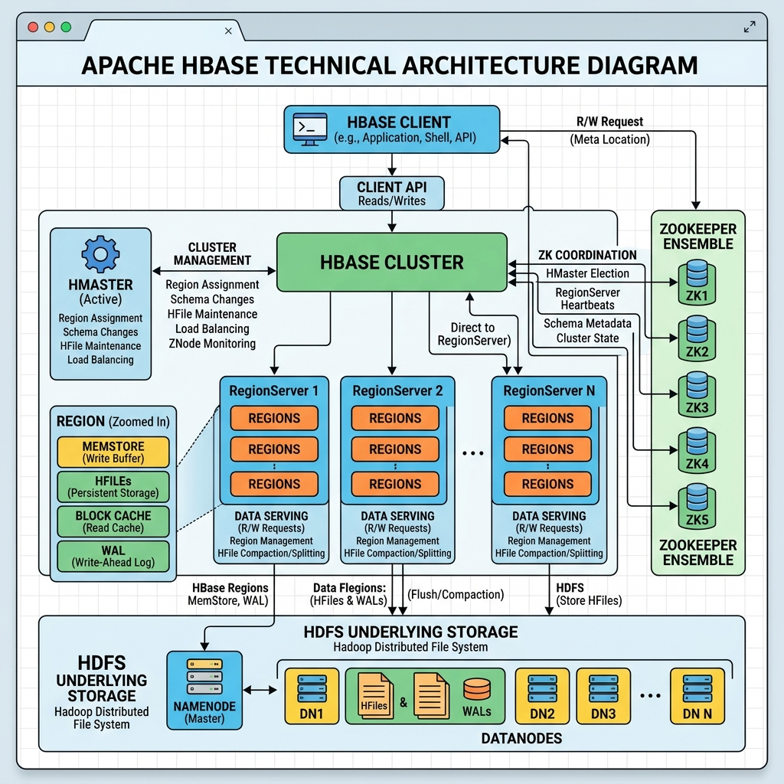

STEP 1
Starting the HBase shell in VMware and checking the installed Hadoop and HBase versions via terminal commands.
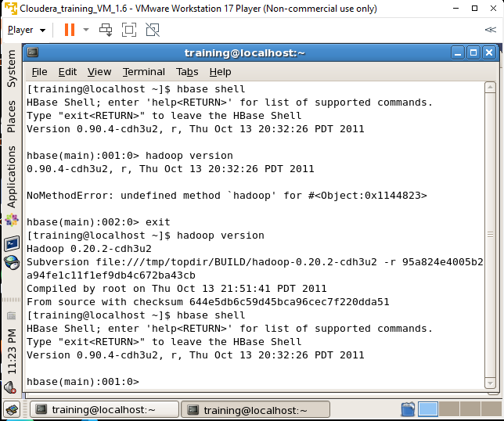

STEP 2
Creating a new HBase table named 'register1' along with column families 'accno', 'name', 'password', 'email', and 'age'.
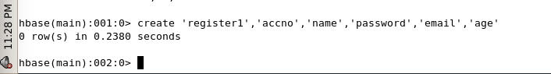

STEP 3
Executing the list command in the HBase shell to view all existing tables, confirming the presence of 'register1'.
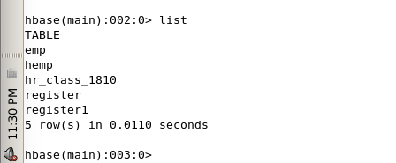

STEP 4
Disabling table 'register1' using the disable command and verifying its disabled state with is_disabled.
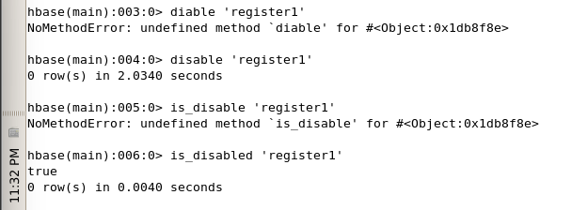

STEP 5
Enabling the disabled HBase table 'register1' using the enable command to resume database operations.
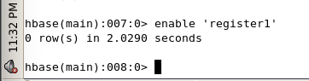

STEP 6
Running the describe 'register1' command to inspect the schema details and parameters of the column families.
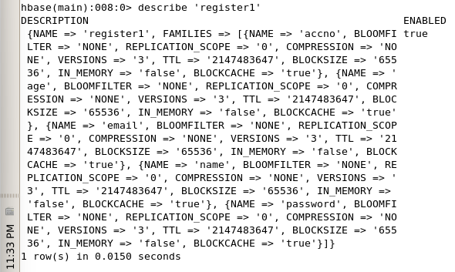

STEP 7
Modifying the table schema using the alter command to increase maximum column versions for 'name' to 5, then describing the table to verify changes.
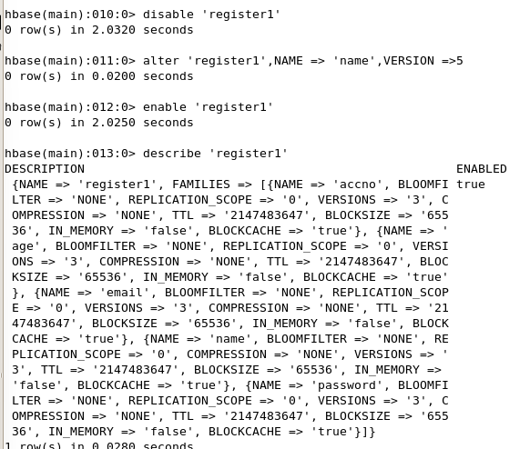

STEP 8
Re-verifying the altered schema parameters of table 'register1' to confirm the updated version count for the 'name' column family.
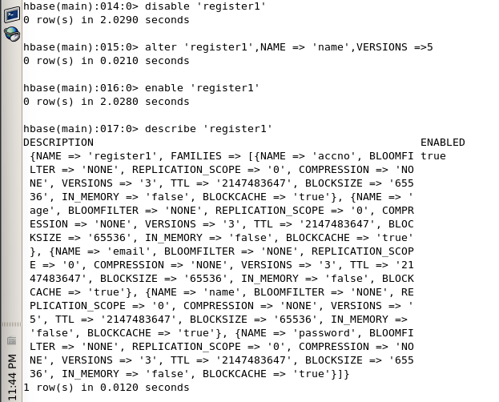

STEP 9
Checking if table 'register1' exists in the HBase database using the exists command.
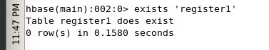

STEP 10
Disabling table 'register1' and permanently deleting it from the database using the drop command.
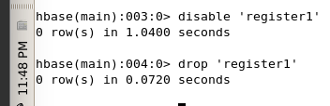

STEP 11
Demonstrates that a table must be disabled before it can be successfully dropped.
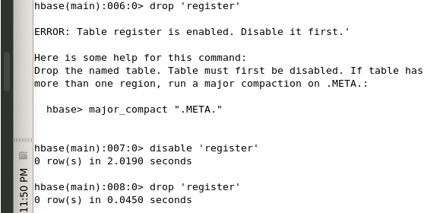

STEP 12
Inserts a name value into a specific table row and column.
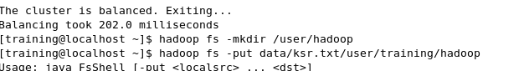

STEP 13
Inserts an age value into the same table row.
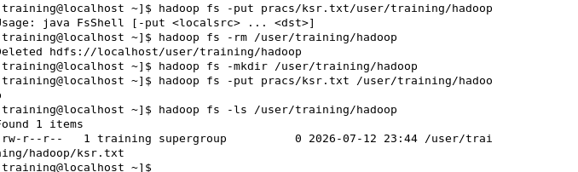

STEP 14
Inserts an email value into the same table row.
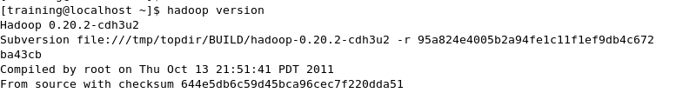

STEP 15
Inserts an account number under a different column family for that row.
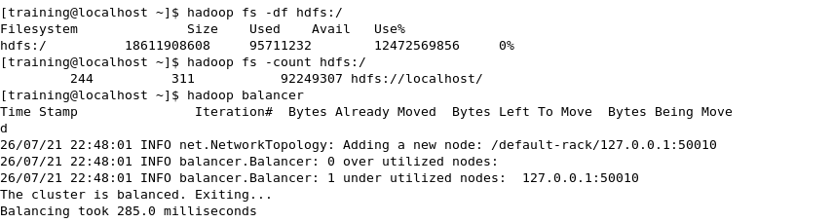

STEP 16
Scans and displays all rows, column families, timestamps, and values in the table.
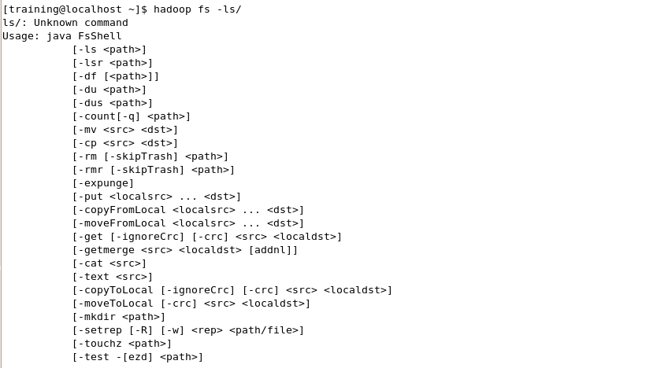

STEP 17
Retrieves all stored attributes and timestamps for a single specific row ID.
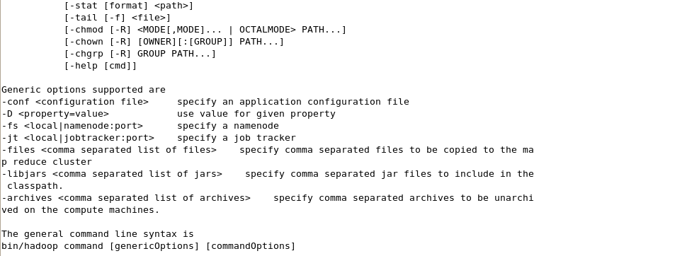

STEP 18
Deletes a specific column entry from a row using its precise timestamp.
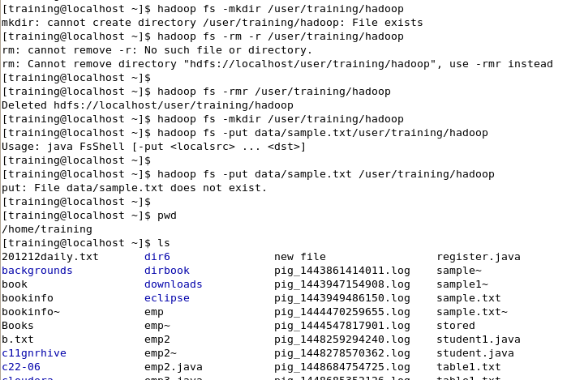

STEP 19
Counts and returns the total number of rows present in the specified table.
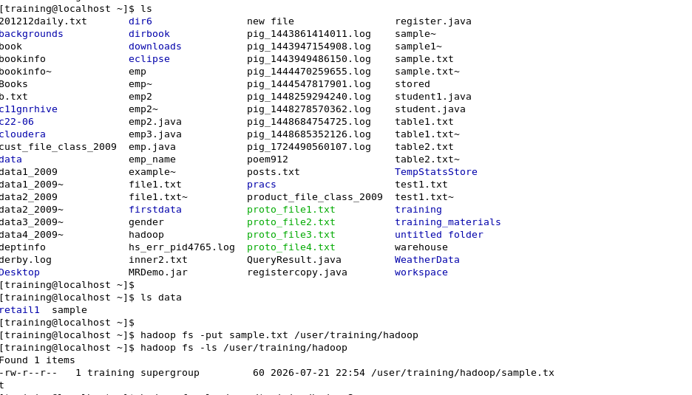

STEP 20
Truncates the table by disabling, dropping, and recreating it to clear all stored data while preserving its structure.
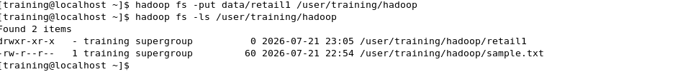

Conclusion :
Through this experiment, the fundamental concepts and operational mechanics of Apache HBase were successfully explored. Various HBase shell commands were executed to create and alter tables, manipulate schema parameters, insert and scan row data, and manage table states through enabling, disabling, and dropping. This provided practical experience in handling distributed, column-oriented databases within the Hadoop ecosystem.

