Assignment 2
Q. Mining Social-Network Graphs
- Clustering of social graph using Girvan–Newman algorithm
- Direct discovery of communities in social graph using Clique Percolation Method (CPM)
Q1
Ans
Mining Social-Network Graphs
Social networks generate massive amounts of interconnected data that represent people, their interactions, and the communities they form. Mining social-network graphs involves analyzing these connections to understand patterns of relationships, detect community structures, and track influence spread. This analysis is widely applied in marketing, sociology, recommendation systems, fraud detection, and biological networks.
Social-network graph mining relies heavily on graph theory, where individuals are represented as nodes, and their relationships or interactions are represented as edges. Two primary methods for detecting communities within such networks are the Girvan–Newman Algorithm and the Clique Percolation Method (CPM).
1. Clustering Social Graphs Using the Girvan–Newman Algorithm
The Girvan–Newman algorithm is one of the popular methods for community detection in social networks. Its core idea is to identify and remove edges that act as bridges between communities, allowing the network to naturally split into clusters.
How It Works
- Edge Betweenness: Measures how often an edge appears on shortest paths between pairs of nodes. Edges with high betweenness are likely to connect different communities.
- Iterative Removal: High-betweenness edges are removed iteratively, causing the network to break into separate communities over time.
Step-by-Step Process
- Create the Graph: Represent the network with nodes and edges.
- Compute Edge Betweenness: Calculate betweenness centrality for all edges. Example scores:
- ('A', 'B') = 0.12; ('B', 'C') = 0.27; ('C', 'D') = 0.27; ('D', 'E') = 0.12; ('E', 'F') = 0.12; ('F', 'G') = 0.27; ('G', 'C') = 0.13; ('G', 'H') = 0.27; ('H', 'B') = 0.1; ('H', 'A') = 0.12; ('D', 'F') = 0.1.
- Remove the Highest Betweenness Edge(s): Remove edges with the maximum score, such as (B, C), (C, D), (F, G), and (G, H) in the example.
- Recompute Betweenness: After each removal, recalculate betweenness scores for affected edges.
- Repeat Until Communities Emerge: Continue removing edges until the network splits into well-defined communities.
- Extract Communities: Connected components of the resulting network represent distinct communities.
Example of resulting communities:
- Community 1: {B, A, H}
- Community 2: {G, D, F, C, E}
Advantages
- Effective Community Detection: Clearly identifies well-separated clusters.
- Intuitive: Relies on the straightforward concept of edge betweenness.
- Hierarchical Insight: Produces a dendrogram showing community divisions at multiple levels.
- No Predefined Number of Communities Required: Discovers communities naturally.
- Works Well on Small and Medium Networks: Produces meaningful results without excessive complexity.
Disadvantages
- Computationally Expensive: Calculating and recalculating edge betweenness is costly.
- Not Ideal for Very Large Networks: Performance drops with thousands or millions of nodes.
- Assumes Clear Community Boundaries: Struggles with overlapping or loosely connected communities.
- May Remove Wrong Edges in Dense Networks: High betweenness does not always indicate community bridges.
- Static Analysis Only: Designed for static graphs and does not handle evolving networks.
Applications
- Social Networks: Detect friend groups, interest clusters, and influencers on platforms like Facebook, Twitter, and LinkedIn.
- Biological Networks: Identify functional modules in protein–protein interaction networks.
- Collaboration & Citation Networks: Detect research communities or groups of actors working together.
- E-commerce & Marketing: Identify customer communities based on purchase patterns for targeted marketing.
- Web Graph & Internet Structure: Detect communities of interlinked websites for improved search rankings.
- Telecommunications: Detect frequent caller groups or potential fraud clusters.
- Fraud & Crime Detection: Identify hidden communities in criminal networks.
- Recommendation Systems: Recommend products, movies, or music to members within the same community.
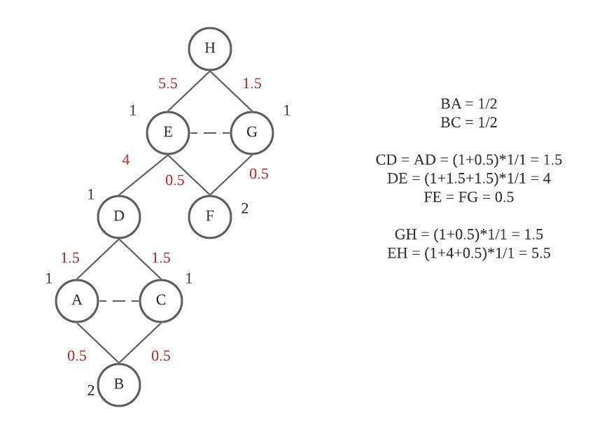
Q2
Ans
2. Direct Community Detection Using the Clique Percolation Method (CPM)
The Clique Percolation Method (CPM), introduced by Palla et al. (2005), is designed to detect overlapping communities, which are common in real-world networks where individuals belong to multiple groups. Unlike partition-based methods like Girvan–Newman, CPM allows nodes to be part of multiple communities.
Core Concept
- A community is a union of adjacent k-cliques.
- A k-clique is a complete subgraph of k nodes, where each node connects to every other node.
- Two k-cliques are adjacent if they share k − 1 nodes.
- Communities form by percolating through overlapping k-cliques.
Example:
- For k = 4, consider two cliques {A, B, C, D} and {B, C, D, E}.
- They overlap in {B, C, D} (3 nodes = k − 1).
- Both cliques belong to the same community.
Step-by-Step Process
- Input Graph: Nodes represent people, and edges represent relationships.
- Choose k (clique size): Small k detects smaller, looser communities (e.g., triangles, k = 3); large k detects stricter, denser communities (e.g., k = 5).
- Find All k-Cliques: Use algorithms such as Bron–Kerbosch.
- Build Clique Adjacency Graph: Nodes represent k-cliques; edges exist between cliques sharing k − 1 nodes.
- Identify Communities: Connected components in the clique graph correspond to communities in the original network.
- Output: Dense, overlapping communities are detected.
Example with k = 3:
- Cliques: {1,2,3}, {1,3,4}, {4,5,6}, {5,6,7}, {5,6,8}, {5,7,8}, {6,7,8}.
- Resulting communities: {1,2,3,4} and {4,5,6,7,8}.
- Node 4 belongs to both communities, demonstrating overlap.
Disadvantages
- Computationally Expensive: Finding all k-cliques can be computationally demanding.
- Parameter Sensitivity: Small k may produce too many communities; large k may produce few or none.
- Dense Graph Bias: Detects dense clusters and may ignore weaker but meaningful communities.
- Poor Performance on Sparse Graphs: Sparse networks may lack large k-cliques.
- Interpretability Issues: Large networks can produce many overlapping groups, complicating analysis.
Applications
- Social Networks: Identify overlapping interest groups and friend circles.
- Biological Networks: Detect overlapping protein complexes.
- Collaboration Networks: Identify researchers or actors participating in multiple domains.
- Marketing & Influence Detection: Discover overlapping customer segments for targeted campaigns.
- Fraud Detection: Uncover hidden relationships and collusion in financial networks.
