CryptoCalc: User Interface

# Personas

## Mark

He is not very familiar with the different types of cryptocurrency but is interested in them and wants to see how they relate. He needs to be able to get an idea how the different currencies stack up to each other as well as how they compare to the dollar.

## Madeline

She has some money invested into some of the semi-popular cryptocurrencies. She would like to be able to easily see the relationship between the amounts of money she has in each one.

## Billy

He is an avid cryptocurrency follower. Normally, he gets all his information from the exchanges he is on. However, he is tired of having to always manually convert between some of the smaller currencies he has been watching lately.

# Wireframe

This is based on the simple one page MVP case.

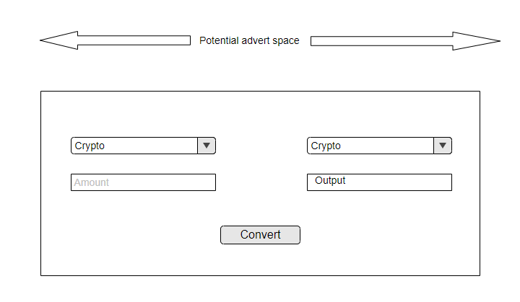

# Storyboards

Due to the simplistic nature of the user interface it is reasonable to assume that all users will have the same interaction sequence for the application. They will come to the page, select the drop down options for their currency, enter the amount they want to convert, and push the button.

# Style Guide

Note: This could be important for the addition of a profiles page in the future.

We are going to be using bootstrap without colors. Everything should be done in black, white, and grey. There is no need for a special CSS as bootstrap will default to the use of black text on a white background. The buttons should be grey.