Reliability and Safety Analysis

Year: 2018 Semester: Fall Team: 07 Project:Handi_glove

Creation Date: September 17, 2018 Last Modified: November 2, 2018

Member 1: Yaodong Shen Email: shen234@purdue.edu

Member 2: Jia En Chua Email: chuaj@purdue.edu

Member 3: Yao Chen Email: chen1748@purdue.edu

Member 4: Carol Lo Email: lo40@purdue.edu

Assignment Evaluation:

|  |  |  |  |  |
| --- | --- | --- | --- | --- |
| **Item** | **Score (0-5)** | **Weight** | **Points** | **Notes** |
| **Assignment-Specific Items** | | | | |
| **Reliability Analysis** | 5 | x2 | 10 |  |
| **MTTF Tables** | 5 | x3 | 15 |  |
| **FMECA Analysis** | 4.5 | x2 | 9 |  |
| **Schematic of Functional Blocks (Appendix A)** | 5 | x2 | 10 |  |
| **FMECA Worksheet (Appendix B)** | 4.5 | x3 | 13.5 |  |
| **Writing-Specific Items** | | | | |
| **Spelling and Grammar** | 4 | x2 | 8 |  |
| **Formatting and Citations** | 3 | x1 | 3 | Please do not change the layout of pages |
| **Figures and Graphs** | 5 | x2 | 10 |  |
| **Technical Writing Style** | 4 | x3 | 12 |  |
| **Total Score** | 90.5 | | |  |

5: Excellent 4: Good 3: Acceptable 2: Poor 1: Very Poor 0: Not attempted

Comments:

*~~Comments from the grader will be inserted here.~~*

*Please check the comments.*

1. Reliability Analysis

Components that are most likely to fail in our project are TPS54332 switching power regulator, STM32L152ZET6 microcontroller and TPS56528 switching power regulator. The model used to determine the failure rate was found in the Military Handbook (MIL-HDBK-217f) [1]: λP = (C1 πT + C2 πE) πQ πL and mean time to failure (MTTF) in years: MTTF = 106 / (24 * 365 * λP) years.

TPS56528 Switching Power Regulator [2]

TPS56528 switching power regulator is selected to convert 12V from wall to 0.8V for Peltier Cooler and the cooler’s operating current is around 3A with a maximum current of 5A. The regulator is estimated to have around 1 to 100 linear MOSFETs. According to Military Handbook, the die complexity is 0.01 and temperature factor for voltage regulator at junction temperature TJ of 85oC is 3.0. The packaging failure coefficient for a 8-pin hermetic surface mount technology is 0.0026 based on the handbook. The environmental factor for mobile device is 4.0, quality factor for commercial part is 10 and learning factor is 1.0 for device which has more than 2 years production period according to the handbook.

|  |  |  |  |
| --- | --- | --- | --- |
| Parameter name | Description | Value | Comments |
| C1 | Die complexity | 0.01 | Based on the Military Handbook for regulator with 101 to 300 linear MOSFETs |
| πT | Temperature coeff. | 3.0 | Based on the Military Handbook for regulator with TJ of 85oC |
| C2 | Packaging Failure coeff. | 0.0026 | Based on the Military Handbook for 8-pin Hermetic SMT |
| πE | Environmental Factor | 4.0 | Based on the handbook for mobile devices, GM. |
| πQ | Quality Factor | 10 | Commercial part |
| πL | Learning Factor | 1.0 | More than 2 years in production |
| λP | Failures rate per million hours | 0.404 |  |
| MTTF | Mean Time To Failure | 282.56 years |  |

Table 1. TPS56528 Switching Power Regulator Analysis

TPS54332 Switching Power Regulator [3]

TPS54332 switching power regulator is selected to regulate the power input for servo which is utilized to control robotic fingers and motion restraint. It is a 28-V, 3.5A converter that integrates a low-RDS high-side MOSFET. The regulator is estimated to have around 101 to 300 linear MOSFETs. According to Military Handbook, the die complexity is 0.02 and temperature factor for voltage regulator at junction temperature TJ of 150oC is 6.7. The packaging failure coefficient for a 8-pin hermetic surface mount technology is 0.0026. The environmental factor for mobile device is 4.0, quality factor for commercial part is 10 and learning factor is 1.0 for device which has more than 2 years production period according to the handbook.

|  |  |  |  |
| --- | --- | --- | --- |
| Parameter name | Description | Value | Comments |
| C1 | Die complexity | 0.02 | Based on the Military Handbook for regulator with 101 to 300 linear MOSFETs |
| πT | Temperature coeff. | 6.7 | Based on the Military Handbook for regulator with TJ of 150oC |
| C2 | Packaging Failure coeff. | 0.0026 | Based on the Military Handbook for 8-pin Hermetic SMT |
| πE | Environmental Factor | 4.0 | Based on the handbook for mobile devices, GM. |
| πQ | Quality Factor | 10 | Commercial part |
| πL | Learning Factor | 1.0 | More than 2 years in production |
| λP | Failures rate per million hours | 1.444 |  |
| MTTF | Mean Time To Failure | 79.05 years |  |

Table 2. TPS54332 Switching Power Regulator Analysis

STM32L152ZET6 Microcontroller [4]

STM32L152ZET6 is selected mainly because of its sufficient amount of ADC and PWM channel for the project’s need. According to Military Handbook, the die complexity is 0.56 for our 32 bit microcontroller and temperature factor for junction temperature TJ of 85oC is 5.7. The packaging failure coefficient for the 128-pin SMT microcontroller is 0.0053. The environmental factor for mobile device is 4.0, quality factor for commercial part is 10 and learning factor is 1.0 for device which has more than 2 years production period according to the handbook.

|  |  |  |  |
| --- | --- | --- | --- |
| Parameter name | Description | Value | Comments |
| C1 | Die complexity | 0.56 | Based on the Military Handbook for 32-bit microcontroller |
| πT | Temperature coeff. | 5.7 | Based on the Military Handbook for TJ of 85oC |
| C2 | Packaging Failure coeff. | 0.0053 | Based on the Military Handbook for 128-pin Hermetic SMT |
| πE | Environmental Factor | 4.0 | Based on the handbook for mobile devices, GM. |
| πQ | Quality Factor | 10 | Commercial part |
| πL | Learning Factor | 1.0 | More than 2 years in production |
| λP | Failures rate per million hours | 32.132 |  |
| MTTF | Mean Time To Failure | 3.55 years |  |

Table 3. STM32L152ZET6

The overall system of this project is considerably reliable because MTTFs for all three components that are most likely to fail are fairly long. In addition, these components are selected because of their attractive price. The project’s reliability can certainly be improved by ~~replace~~ replacing these components with higher pricing solution and that totally depends on the user need.

1. Failure Mode, Effects, and Criticality Analysis (FMECA)

Power Modules:

A shorted bypass capacitor on the SS pin will cause the module lost the slow-start feature, which has no influence to the system.

A shorted flyback diode or filtering capacitor on the output will cause a voltage drop. The power consumed on the shorted point may fry the component. This failure is critical to the system. (The diode used in the module is recommended by the regulator datasheet)

Dry out may happen~~s~~ on the capacitors in the -12v power module. The drop of the capacitance will lower the maximum current supply capability, which will not influence the system, since the -12v supply is used for logic operation. The short of the capacitor may cause a voltage drop to the output, the criticality of this failure depends on the magnitude of the voltage drop: A voltage just above the Vth of the H-bridge may fry the H-bridge(High Criticality), and a voltage below the Vth may cause the H-bridge remain open(fail to control the Peltier cooler Low Criticality)

Microcontroller：

The microcontrollers are supposed to have good reliability. However, given decoupling capacitor shorted, the microcontroller might not be able to reprogram again. Also, if input voltage suddenly drops, the capacitors might not be able to provide the power to keep the voltage stable. This will not damage other parts of the circuit board, the user will not need to reprogram the microcontroller. Another pitfall is that even the trivial noise in the circuit caused by perhaps insufficient capacitive decoupling near the MCU or switching the power supplies may cause~~s~~ errors on the UART communication and consequently leads to potential damage to users. Users may experience bi-polar temperature caused by the miscommunication of two microcontrollers. This may induces the temperature feedback system cannot work.

DC Motor Driver Module：

There might be a high possibility of overheating the DC motors in our project due to the fact that users may constantly by using the robotic hand. High ambient temperature comes along with the overheating issue can also damages other components around the motor.

H-Bridge Module:

The H-bridge is an important subsystem of our temperature feedback system. Our temperature feedback system includes a voltage regulator, an H-bridge, and the Peltier cooler. The Peltier cooler works by relying on the polarities of the input voltage. The polarities of the input voltage coming from the output of the H-bridge module. In the case where the H-bridge drives current less than 3A or outputs voltage less than |0.8|V, the Peltier cooler will not heat up or cool down enough for the human skin to detect a change in temperature. This would directly result in the failure of our temperature feedback system. The potential causes of these failures would be either the input voltage to the H-bridge being incorrect or the logic input voltage being incorrect. These two input voltages are the VDS and VGS values of the MOSFETs inside of the H-bridge and will impact the current and output voltage of the system to the cooler.

**2.1 Levels of Criticality**

The levels of criticality are divided into three levels: Low, Medium and High.

‘Low’ criticality indicates the failure mode is not harmful to the user and does not damage the rest of functionality that’s critical to the user experiences. Low criticality levels are intended to have a failure rate of 10^-6 or less.

‘Medium’ criticality indicates the failure mode is not harmful to the user but can damage the rest of functionality that’s critical to the user experiences. Medium criticality levels are intended to have a failure rate of 10^-7 or less.

‘High’ criticality indicates the failure mode can be harmful to the user and can damage the rest of functionality that’s critical to the user experiences. High criticality levels are intended to have a failure rate of 10^-9 or less.

There are several major hardware components: power modules, DC motor driver module, microcontroller, comparator module and H-Bridge module. We anticipate that the most common failures modes will be high current drawn by the servos, communication lag between the different modules, and mechanical failure of the robot arm chassis.

3.0 Sources Cited:

[1] “Military Handbook,”1 1990. [Online]. Available: http://snebulos.mit.edu/projects/reference/MIL-STD/MIL-HDBK-217F-Notice2.pdf [Accessed 11 5 2014].

[2] Texas Instruments, “Step-Down DC-DC Converter With Eco-Mode,” TPS54332 datasheet, Sept. 2013 [Revised Feb. 2016].

[3] Diodes Incorporated, “30V COMPLEMENTARY ENHANCEMENT MODE MOSFET H-BRIDGE,” DMHC3025LSD datasheet, n.d. [Revised Jan. 2018].

[4] Texas Instruments, “5-A Synchronous Step-Down Converter With Advanced Eco-Mode,” TPS56528 datasheet, Sept. 2013 [Revised Feb. 2016].

[5] STMicroelectonics, “Ultra-low-power 32-bit MCU,” STM32L151xE STM32L152xE datasheet, Sept. 2013 [Revised Feb. 2016].

[6] AlphaElectrics, “The Five Most Common Faults That Will Happen in AC and DC Motors,” *alphaelectrics.com*, n.d.. [Online]. Available: http://alphaelectrics.com/the-five-most-common-faults-that-will-happen-in-ac-and-dc-motors/. [Accessed Nov. 1, 2018].

Appendix A: Schematic Functional Blocks

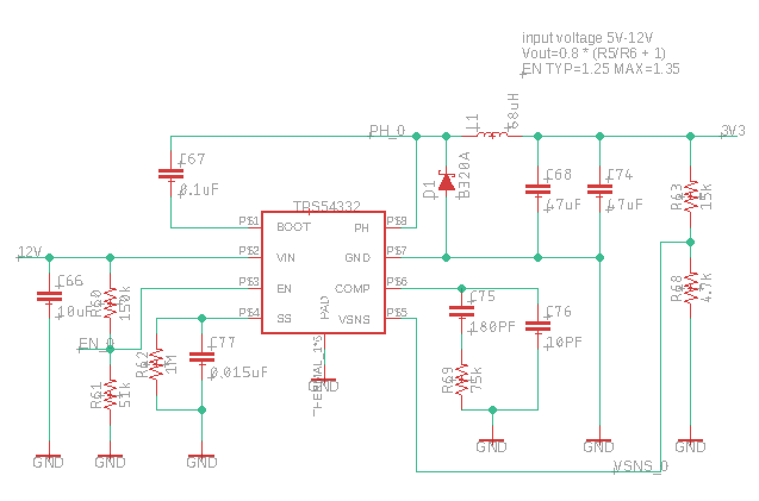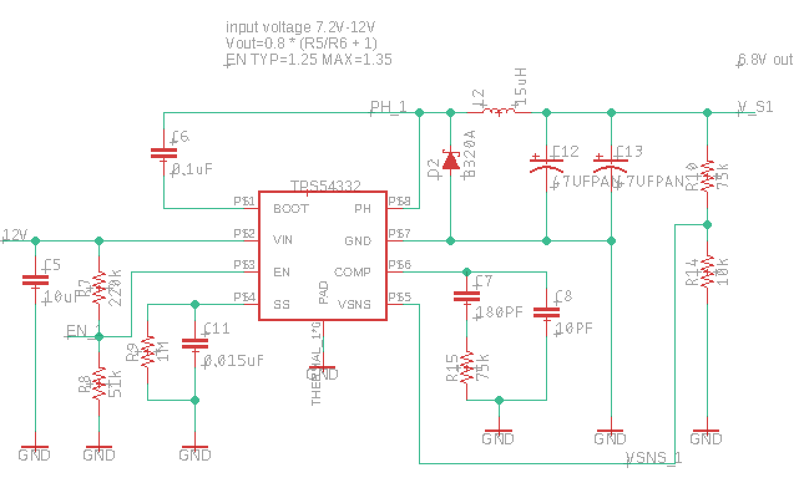

*3.3v power module* *6.8v power module*

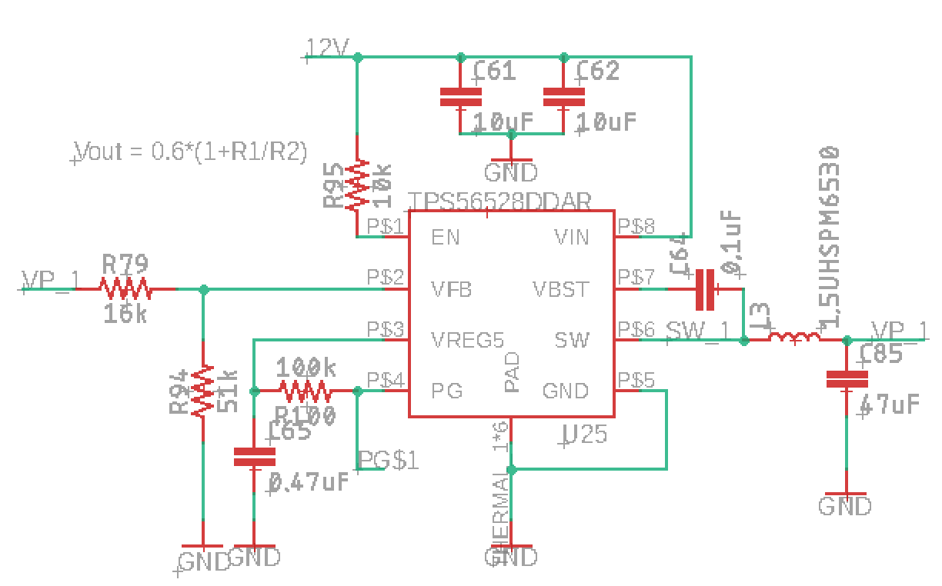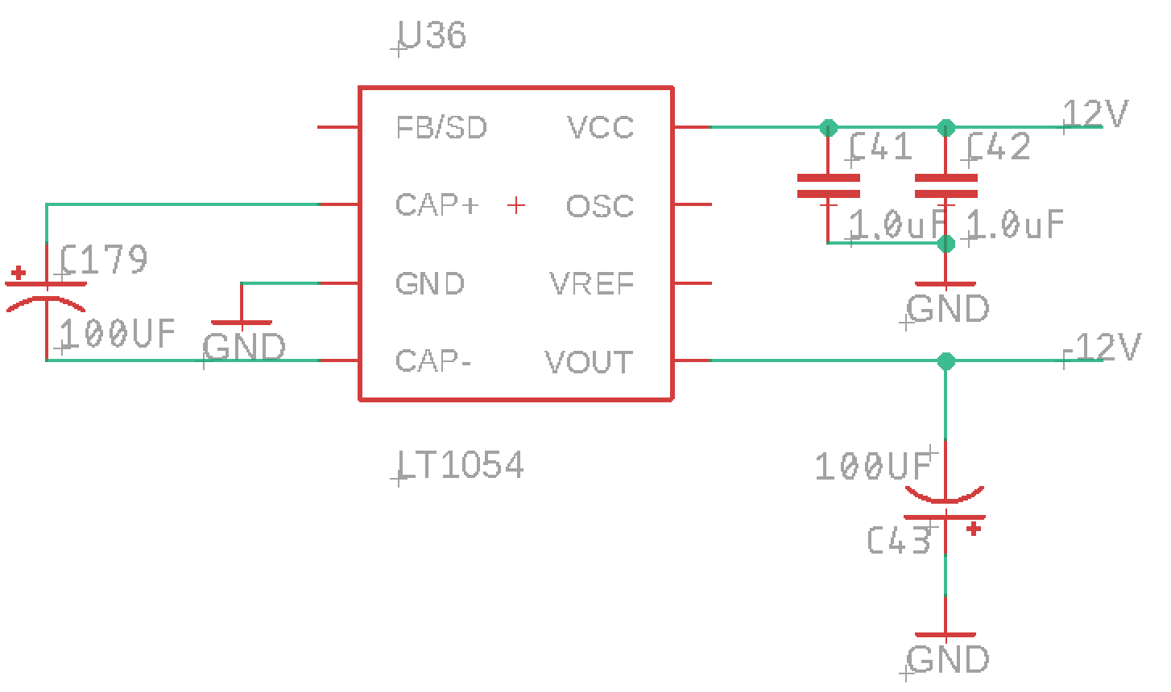

*0.8v power module -12v voltage inverter module*

Power Modules

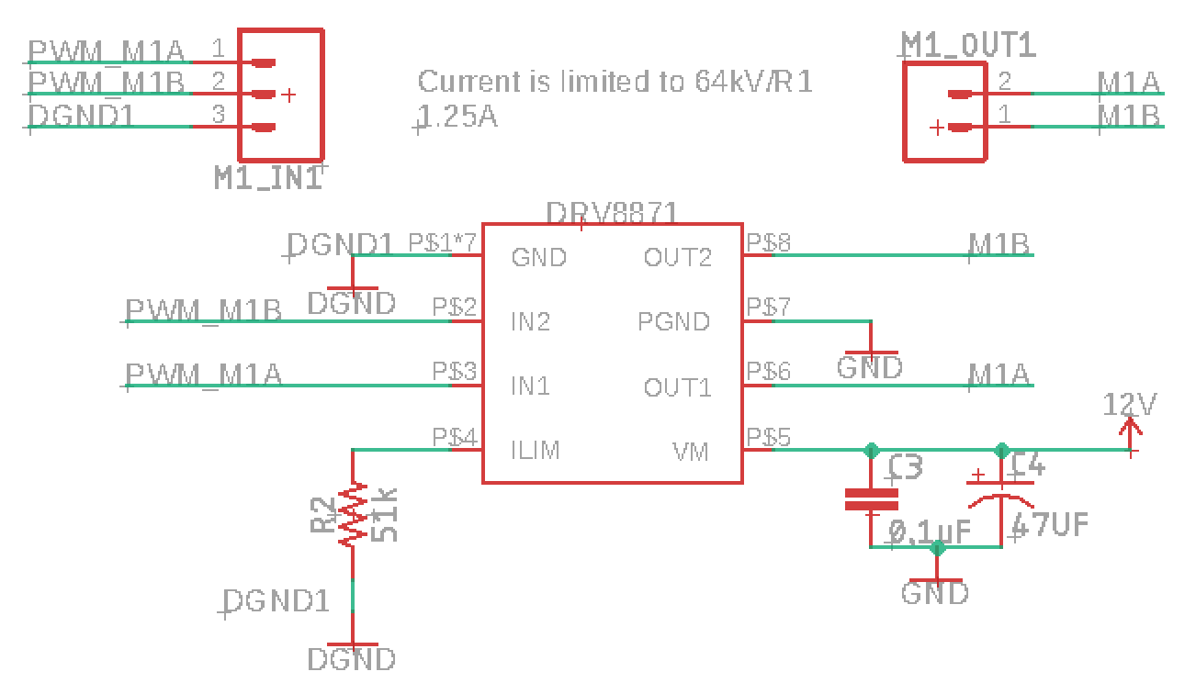

*DC Motor Driver Module*

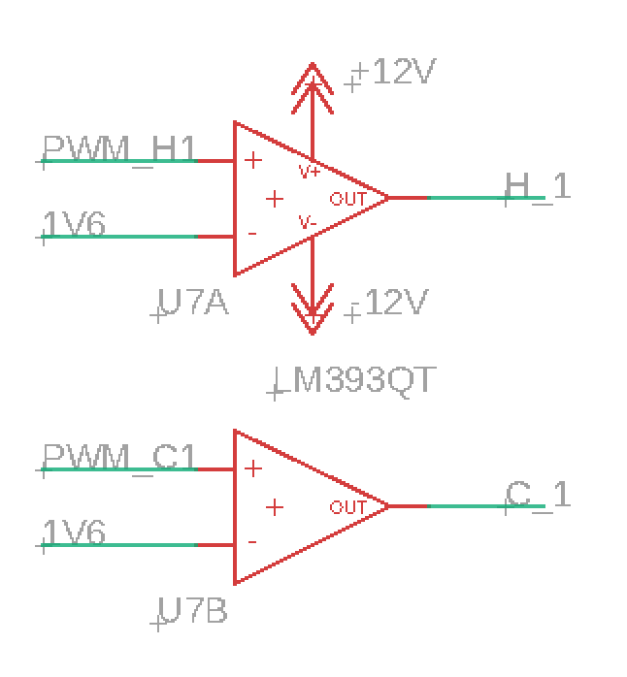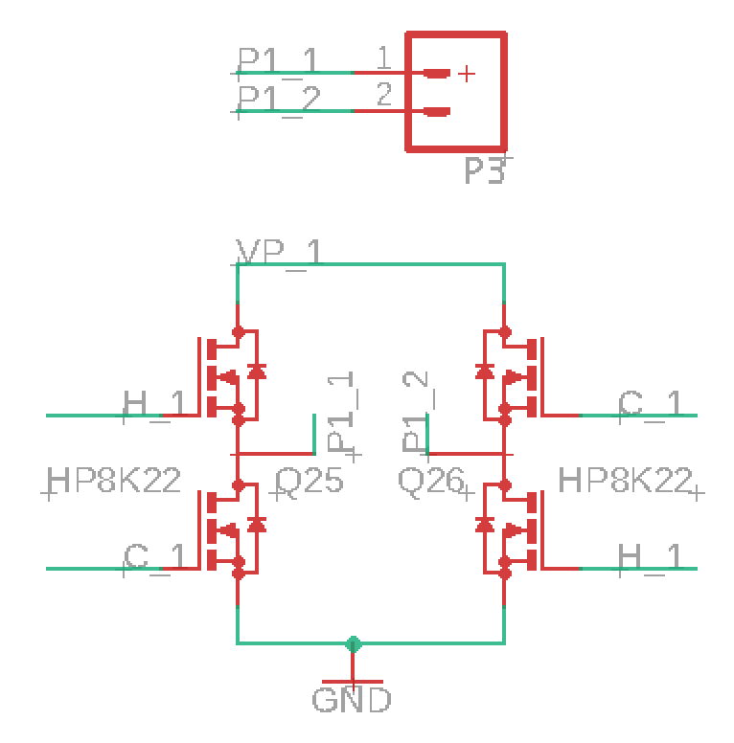

*Comparator Module H-Bridge Module*

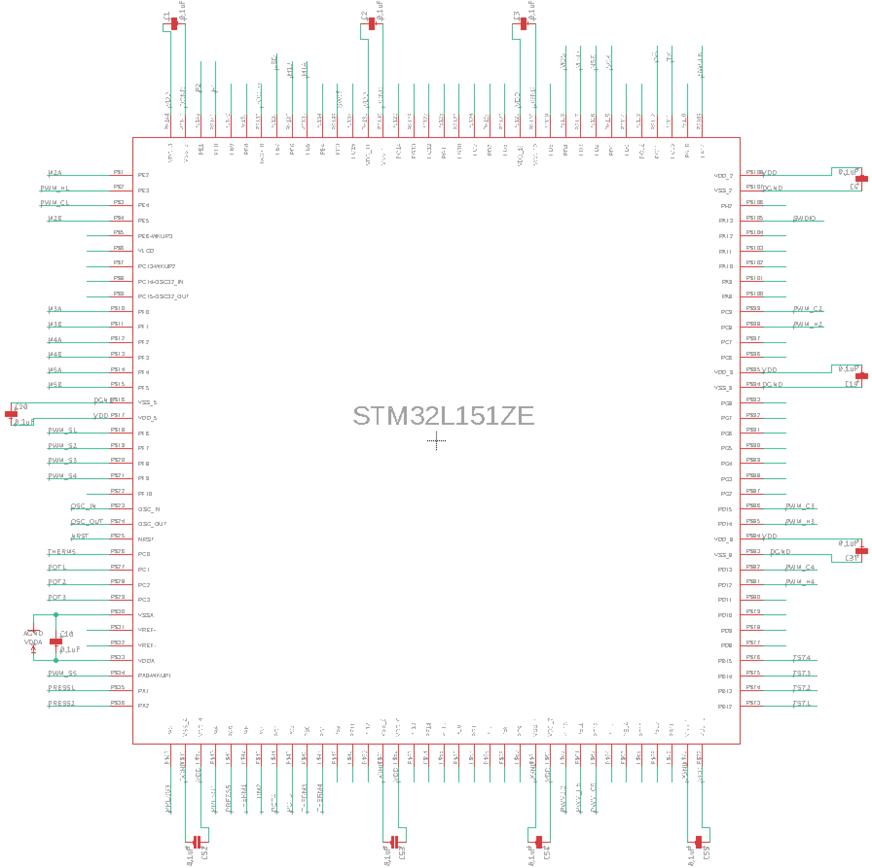

*Microcontroller*

*Sensor Array*

Appendix B: FMECA Worksheet

*~~For each group of failures corresponding to one subsystem, make a separate table and label it with the name of the corresponding subsystem. Add more rows to this table as necessary to provide a complete analysis.~~*

[~~https://engineering.purdue.edu/ece477/Course/Assignments/Example/ReliabilityAndSafetyEx1.pdf~~](https://engineering.purdue.edu/ece477/Course/Assignments/Example/ReliabilityAndSafetyEx1.pdf)

[~~https://engineering.purdue.edu/ece477/Course/Assignments/Example/ReliabilityAndSafetyEx2.pdf~~](https://engineering.purdue.edu/ece477/Course/Assignments/Example/ReliabilityAndSafetyEx2.pdf)

**Subsystems A: Power Modules**

|  |  |  |  |  |  |  |
| --- | --- | --- | --- | --- | --- | --- |
| **Failure No.** | **Failure Mode** | **Possible Causes** | **Failure Effects** | **Method of Detection** | **Criticality** | **Remarks** |
| A1 | Low 0.8 Voltage on board | Voltage regulator failure, shorted output bypass capacitor | Peltier cooler not responding, or slow responding | observation,  multimeter | Medium |  |
| A2 | High 0.8 Voltage on board | Voltage regulator failure, feedback resistor open circuit, heavy load on output | Peltier cooler too hot or too cold | observation | High | may damage other components |
| A3 | Low 3.3 Voltage on board | Voltage regulator failure, shorted output bypass capacitor, shorted flyback diode | System stop working, LED dim | observation,  multimeter | Medium |  |
| A4 | High 3.3 Voltage on board | Voltage regulator failure, feedback resistor open circuit, heavy load on output | System stop working, microcontroller over temperature,  LED too bright | observation, multimeter, | Medium | may damage other components |
| A5 | Low 6.8 Voltage on board | Voltage regulator failure, shorted output bypass capacitor, shorted flyback diode | Servos respond slowly, servos stop working | observation,  multimeter | Medium |  |
| A6 | High 6.8 Voltage on board | Voltage regulator failure, feedback resistor open circuit, heavy load on output | Servos stop working, servos over temperature | observation,  multimeter | Medium | may damage other components |
| A7 | Low -12 Voltage on board (absolute value) | Voltage regulator failure, shorted output bypass capacitor, shorted input decoupling capacitors, 12v main power malfunctioning | H-bridges over temperature, Peltier coolers stop working | observation,  multimeter | Medium | may damage other components |
| A8 | High -12 Voltage on board (absolute value) | Voltage regulator failure, 12v main power malfunctioning | H-bridge Gate breakdown, comparator breakdown, Peltier coolers remain working, or Peltier coolers stop working | observation, multimeter | High(if cooler remains heating)  Medium (else) | low failure rate,  may damage other components |

Subsystems B: Microcontroller

|  |  |  |  |  |  |  |
| --- | --- | --- | --- | --- | --- | --- |
| **Failure No.** | **Failure Mode** | **Possible Causes** | **Failure Effects** | **Method of Detection** | **Criticality** | **Remarks** |
| B1 | Microcontroller resets | Reset switch is open on pull-up resistor; reset switch is stuck on close; decoupling capacitor is open; unstable supply voltage | Device restarts | Visual observation | low |  |
| B2 | Miscommunication between two UART modules | Intense power supplies switching and insufficient capacitive decoupling near MCU pins | Robotic hand and glove are not synchronized. Temperature and pressure feedback does not work | Skin feeling | medium |  |
| B3 | Microcontroller is not able to reprogramming | Insufficient capacitive decoupling near MCU pins | Microcontroller is not able to reprogramming | Observation | Low |  |

Subsystems C: H-Bridge

|  |  |  |  |  |  |  |
| --- | --- | --- | --- | --- | --- | --- |
| **Failure No.** | **Failure Mode** | **Possible Causes** | **Failure Effects** | **Method of Detection** | **Criticality** | **Remarks** |
| C1 | Incorrect/opposite polarities switching | Incorrect pin connection | Opposite intended temperature effect experienced | Visual observation/sensor observation | low |  |
| C2 | Less than 0.8V output | Incorrect VGS or VDS fed into H-bridge | Peltier cooler not powered | Visual observation/sensor observation | low |  |
| C3 | Less than 3A output | Incorrect VGS or VDS fed into H-bridge | Peltier cooler not powered | Visual observation/sensor observation | low |  |

Subsystems D: DC Motor Driver Module

|  |  |  |  |  |  |  |
| --- | --- | --- | --- | --- | --- | --- |
| **Failure No.** | **Failure Mode** | **Possible Causes** | **Failure Effects** | **Method of Detection** | **Criticality** | **Remarks** |

|  |  |  |  |  |  |  |
| --- | --- | --- | --- | --- | --- | --- |
| D1 | Overheating | The torque of the motor is too small | Motor overheats and even stop working. Ambient temperature can break other components next to the motor. | Visual observation. Odor detection | low |  |