Mechanical Overview

Year: 2018 Semester: Fall Team: 07 Project:Handi_glove

Creation Date: September 17, 2018 Last Modified: September 21, 2018

Member 1: Yaodong Shen Email: shen234@purdue.edu

Member 2: Jia En Chua Email: chuaj@purdue.edu

Member 3: Yao Chen Email: chen1748@purdue.edu

Member 4: Carol Lo Email: lo40@purdue.edu

Assignment Evaluation:

|  |  |  |  |  |
| --- | --- | --- | --- | --- |
| **Item** | **Score (0-5)** | **Weight** | **Points** | **Notes** |
| **Assignment-Specific Items** | | | | |
| **Commercial Packaging Analysis 1** |  | x2 |  |  |
| **Commercial Packaging Analysis 2** |  | x2 |  |  |
| **CAD Model Illustrations** |  | x4 |  |  |
| **Project Packaging Specifications** |  | x2 |  |  |
| **PCB Footprint Layout** |  | x2 |  |  |
| **Writing-Specific Items** | | | | |
| **Spelling and Grammar** |  | x2 |  |  |
| **Formatting and Citations** |  | x1 |  |  |
| **Figures and Graphs** |  | x2 |  |  |
| **Technical Writing Style** |  | x3 |  |  |
| **Total Score** |  | | |  |

5: Excellent 4: Good 3: Acceptable 2: Poor 1: Very Poor 0: Not attempted

Comments:

*Comments from the grader will be inserted here.*

1. Commercial Product Packaging
   1. Product #1

**Robo-Glove**

<https://technology.nasa.gov/patent/MSC-TOPS-37>

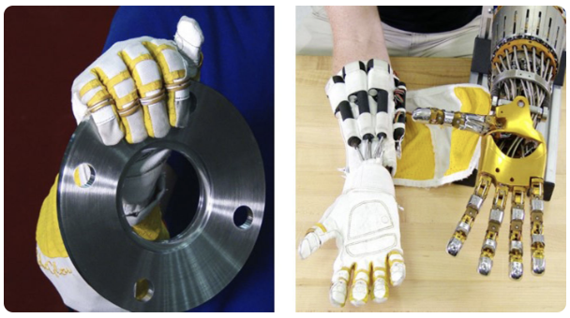

Robo-Glove, a wearable assist device which is designed by GM and NASA to help reduce the grasping force needed by industrial worker to operate tools for a long period of time or when performing tasks that have repetitive motion. The positive aspect of this product is the round finger which can grasp object more firmly than our project because there is a sensor board on each fingertip for our project. However, the servo is placed on the glove for Robo-Glove and thus it increases the glove’s weight. Also, Robo-Glove has no pressure and temperature feedback.

The aspect of Robo-Glove that we can adapt is the small and compact design of exoskeleton for the glove to provide assistance for human hand. However we will improve and enhance the design by adding more feature into like motion restraint. Also, we will place sensors on robotic hand to provide feedback system and these will be our differentiation from this commercial product.

* 1. Product #2

*Dexmo exoskeleton glove*

The Dexmo Exoskeleton Glove is a motion capture and force feedback device created for VR applications. The purpose of this product is to provide realistic haptic feedback to the user based on what object they come into contact with. For example, the user would be able to differentiate between holding a virtual rock versus holding a virtual baby chicken due to the magnitude of the force feedback. The user would not, however, be able to identify different textures.

One crucial aspect of this commercial packaging is the consideration in the design where the user’s motions would not be restricted by the exoskeleton. This aspect is something that should be carefully integrated into our exoskeleton design. If the exoskeleton of our design becomes too bulky to the point where the motions of the user becomes limited, then the user experience would be greatly taken away. In addition, this design is very light weight, which is also something we plan to integrate.

In our project, we would design our exoskeleton with the intention of integrating Peltier coolers and our own design of the force feedback units. Our device would have more components attached to it.

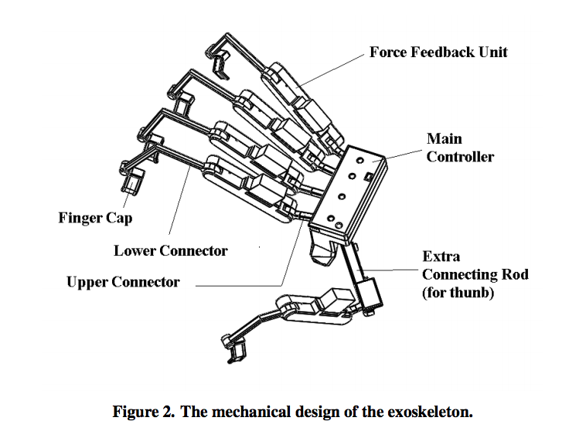

3.0 Sources Cited

[1] NASA, “Dexmo: An Inexpensive and Lightweight Mechanical Exoskeleton for Motion Capture and Force Feedback in VR,” n.d.. [Online serial]. Available: https://technology.nasa.gov//t2media/tops/pdf/MSC-TOPS-37.pdf. [Accessed Sept. 20, 2018].

[2] X. Gu, “Robo-Glove Wearable technology that reduces the force needed to operate tools,” n.d.. [Online serial]. Available: https://core.ac.uk/download/pdf/42340361.pdf. [Accessed Sept. 20, 2018].

[3] cpester1997, “Exoskeleton Hand,” [https://www.thingiverse.com/](https://www.thingiverse.com/thing:1108397), n.d.. [Online]. Available: https://www.thingiverse.com/thing:1108397. [Accessed Sept. 20, 2018].

Appendix 1: CAD Model Illustrations

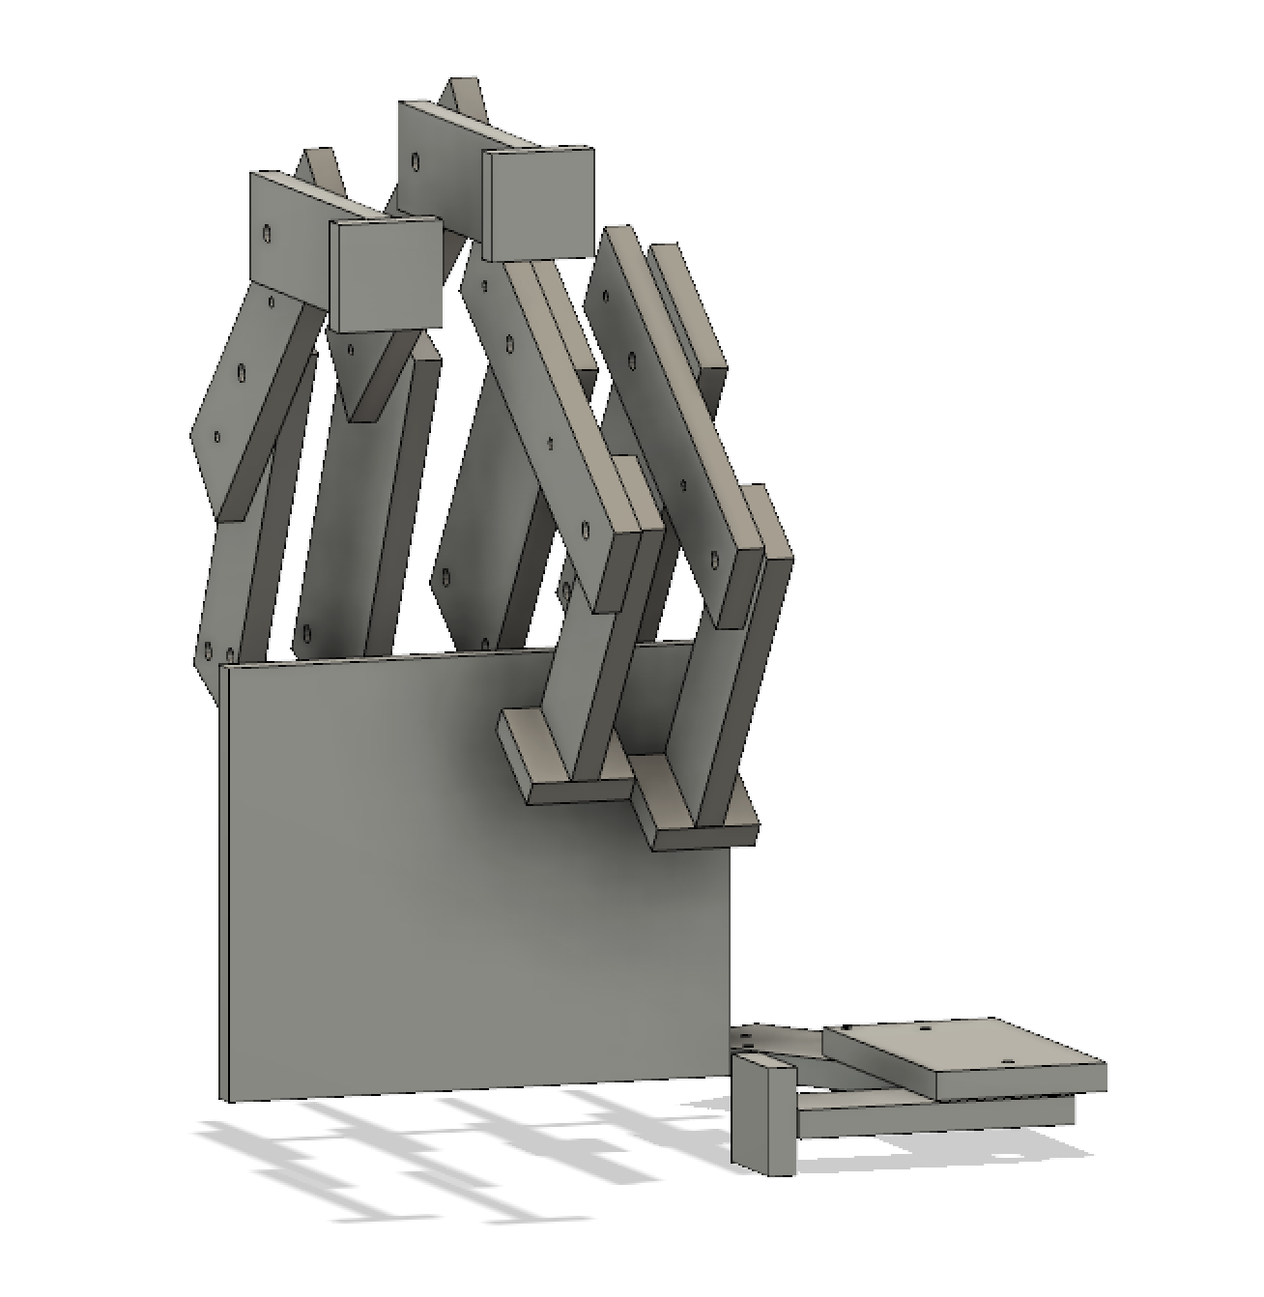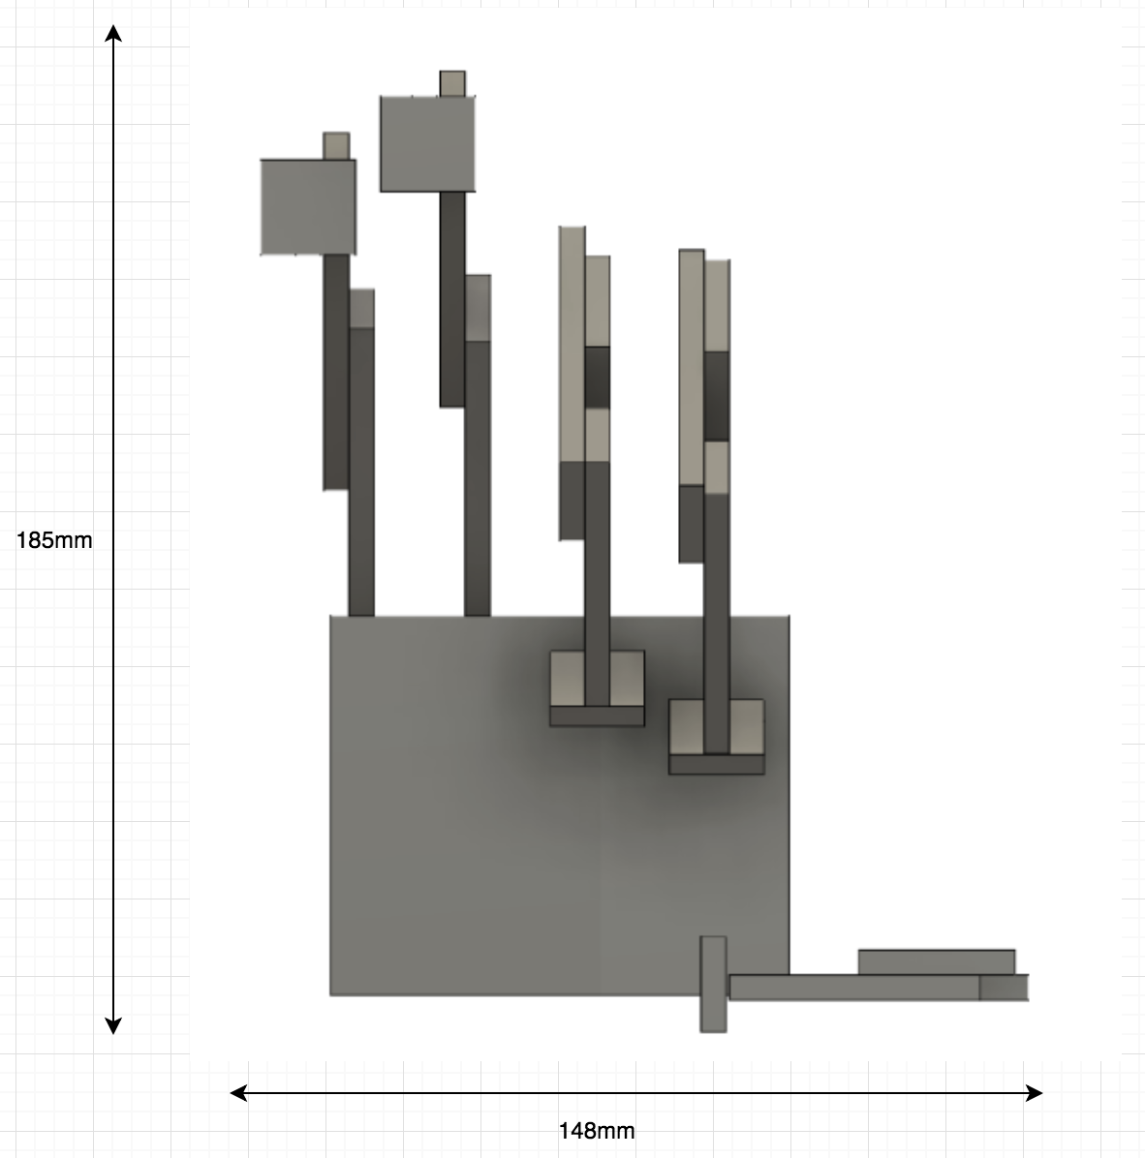

Figure 1.1 Overview of robotic hand Figure 1.2 Front view of robotic hand

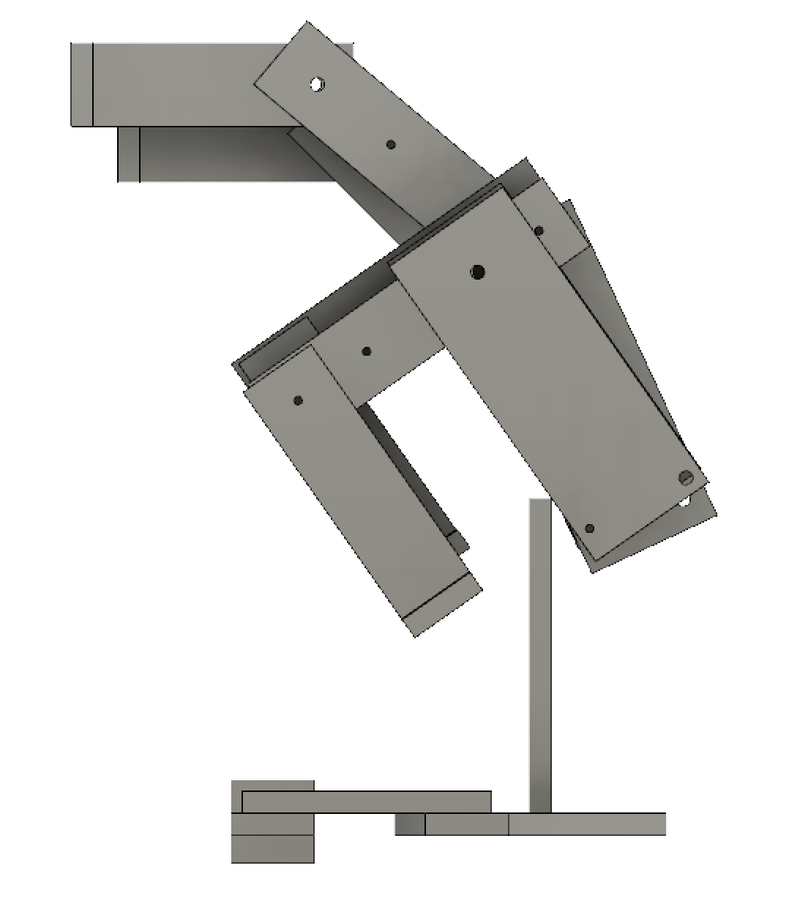 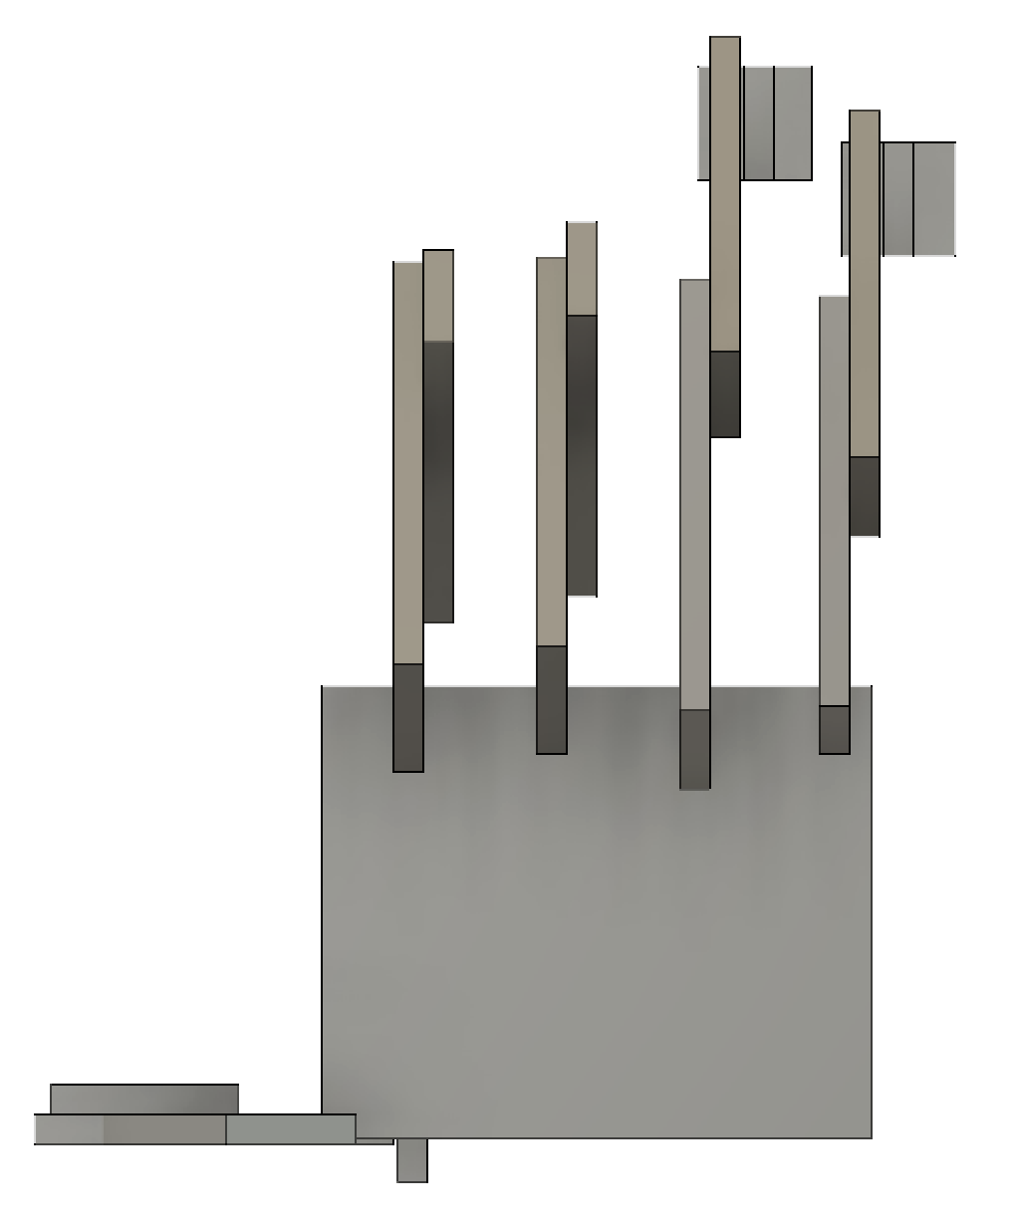

Figure 1.3 Right side view of robotic hand Figure 1.4 Back view of robotic hand

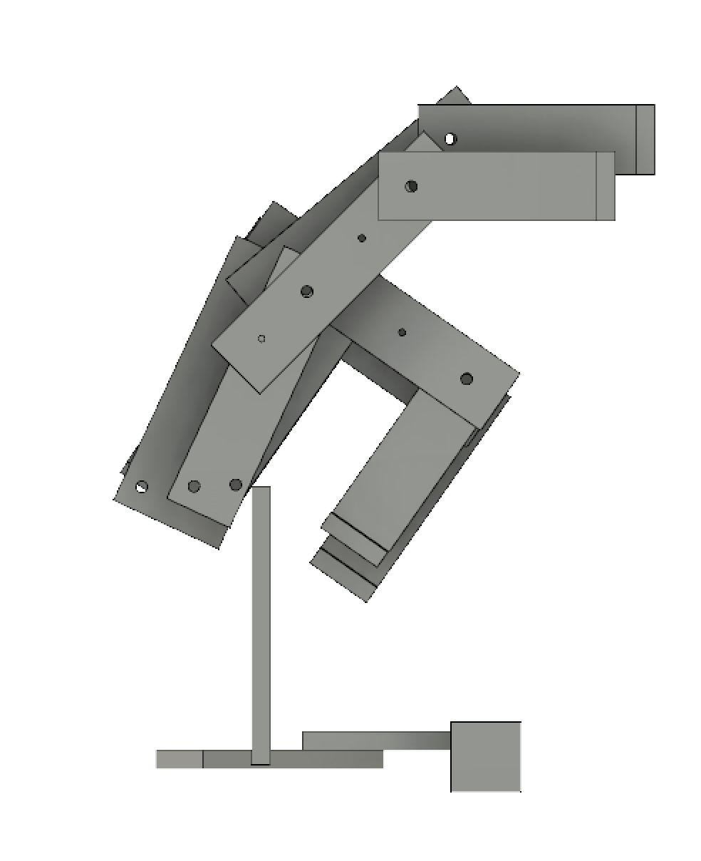 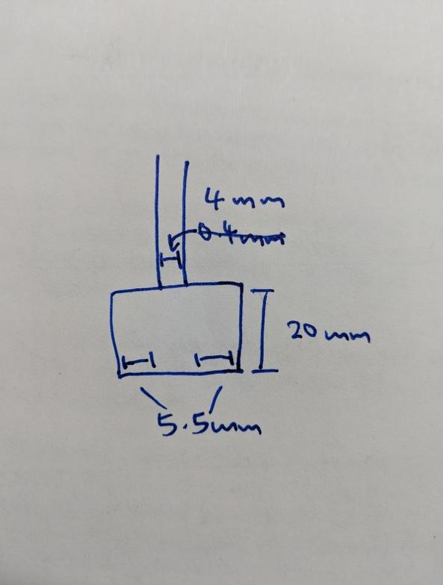

Figure 1.5 Left side view of robotic hand Figure 1.6 Fingertip with sensor board

Each finger is 15mm apart and we will have a platform as shown above placed on each fingertip to hold pressure and temperature sensors. The platform will have a width of 15mm and height of 20mm. Thus there is a width of 5.5mm on each side and remember we have 15mm between each fingers. Therefore there will certainly have enough space between each board on the fingertip.

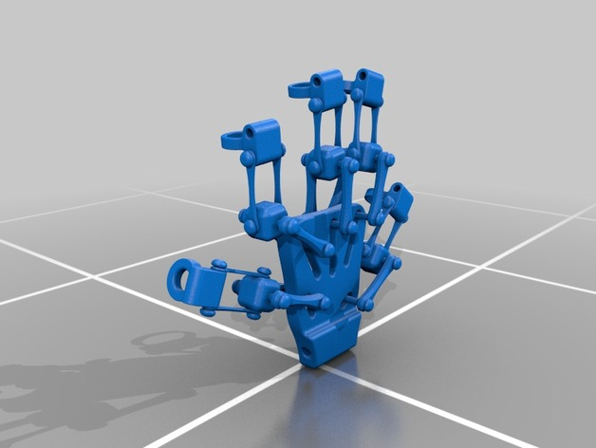

Figure 1.7 Control glove exoskeleton[3]

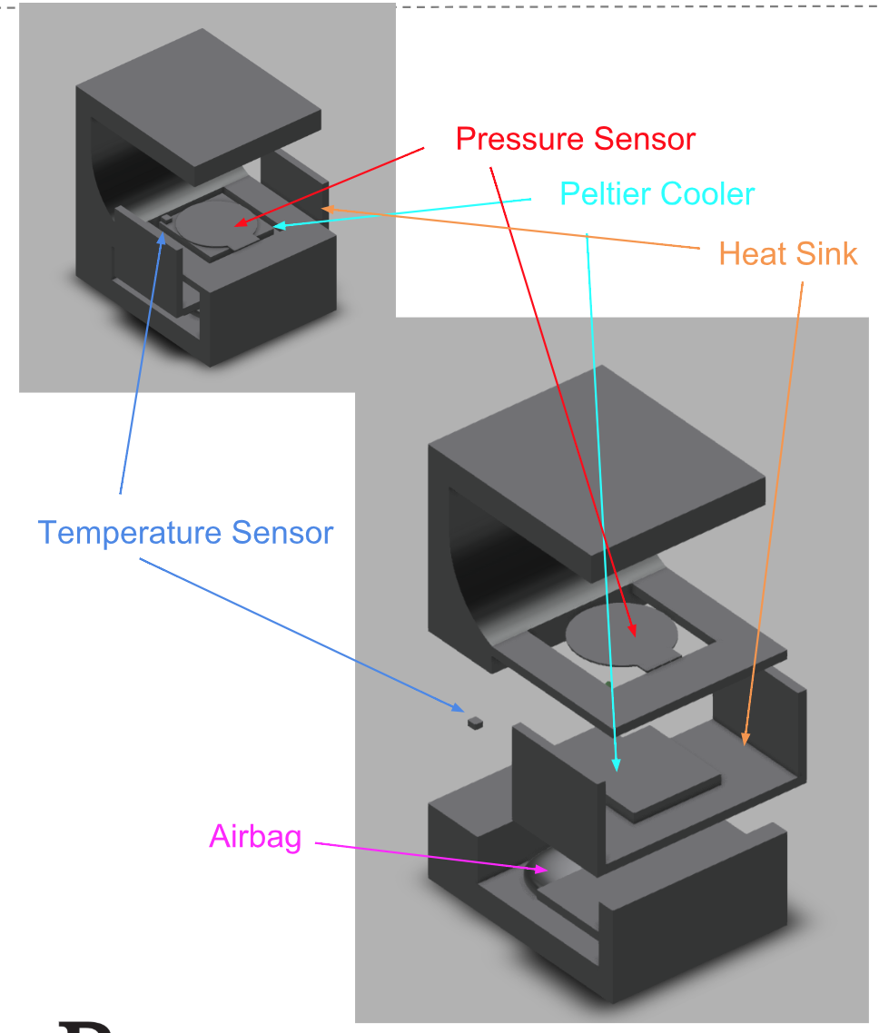 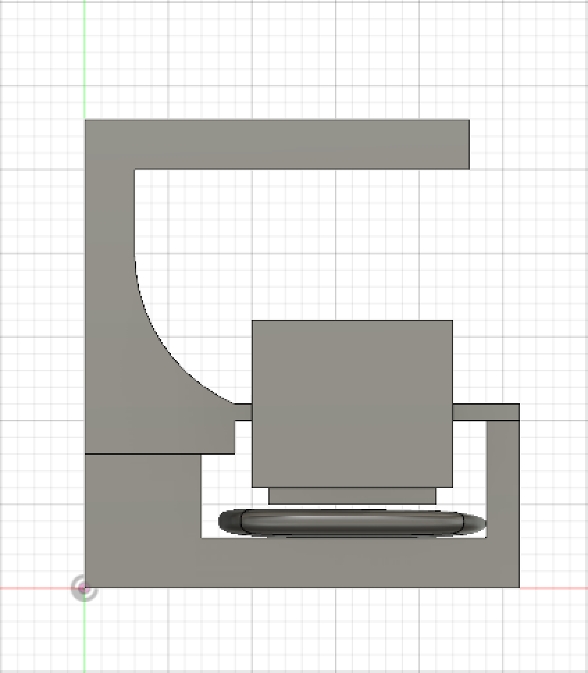

Figure 1.8 Glove fingertip holder Figure 1.9 left view of fingertip holder

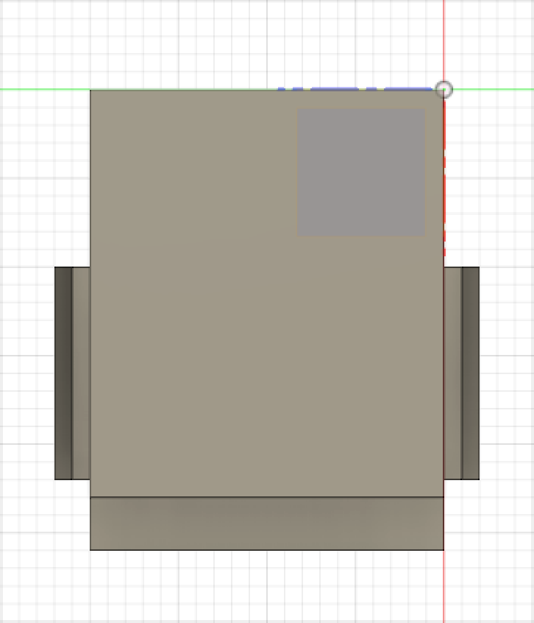 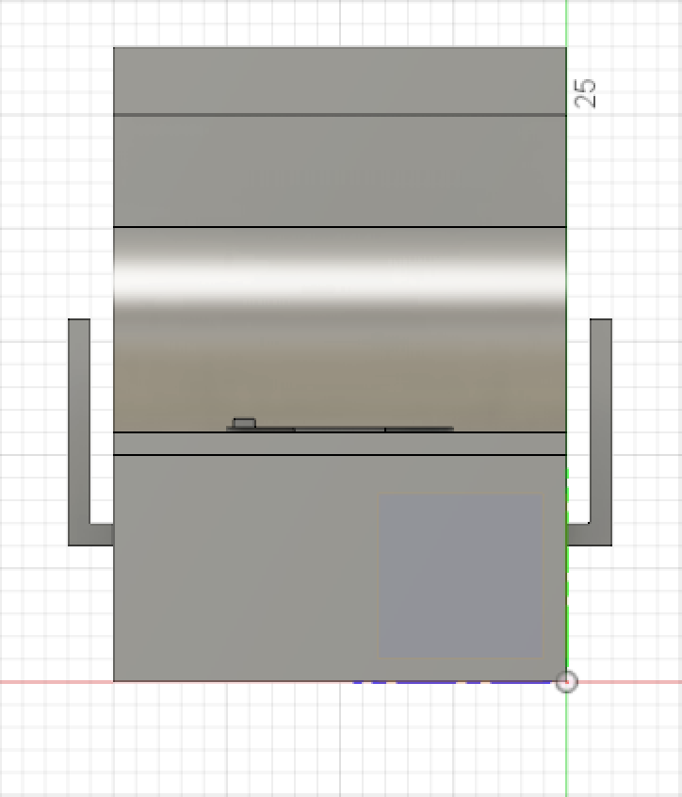

Figure 1.10 top view of fingertip holder Figure 1.11 front view of fingertip holder

Fingertip holder will be placed on user’s fingertip.It contains pressure sensor, temperature sensor, Peltier cooler, aluminum heat sink, and air bag. (in pictures above, one unit block is 1mm)

Appendix 2: Project Packaging Specifications

|  |  |  |  |
| --- | --- | --- | --- |
| **Materials** | **Tools** | **Weight** | **Cost** |
| Plastic Box | Glue | 0.22 kg | $ 4.00 |
| Screws | Screwdriver | 0.3 kg | $ 5.00 |
| Robotic hand | Screwdriver | 1.36 kg | $ 250 |
| ABS filament | 3D printer | 0.5 kg | $ 20 |
| Aluminum sheet | Saw | 0.054kg | $ 5 |
| Gloves | Screwdriver | 0.15 kg | $ 10 |
|  | Total | 2.53kg | $289 |

Appendix 3: PCB Footprint Layout

