Project CASA: Project Plan
Last update: May 3 2017

Contents
1. Project information 1
2. Overall project 2
A. Baseline – Initial project schedule 2
B. Current status 2
3. Development plan 3
A. Baseline – Initial development plan 3
B. Current status 3
4. Testing plan 5
A. Baseline 5
B. Current status 5

Project information
Project CASA is part of a larger ongoing academic project, information on it can be found here:
Quality Assurance and testing methodology for IoT
Since the main deliverable of the project is having working code at the end, we have opted for agile project management, which means less strict rotation of project roles with more iterations between shorter development phases.
The main use case is to recreate the original CASA program 1 to 1 in relation to structure. Some parts of the program, namely the “sat” and “minisat” packages might be online in Java already, which will save time.

Overall project

Baseline – Initial project schedule
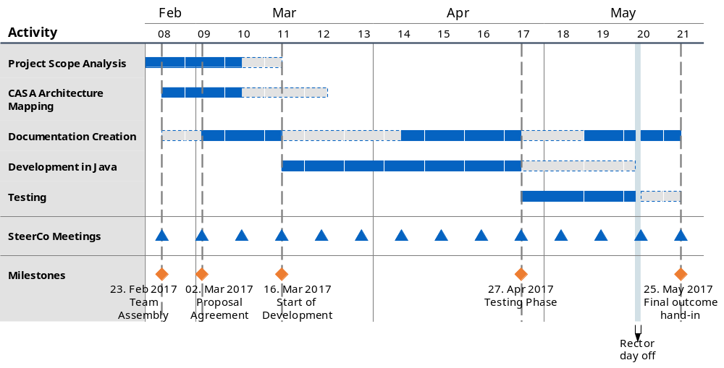

Current status
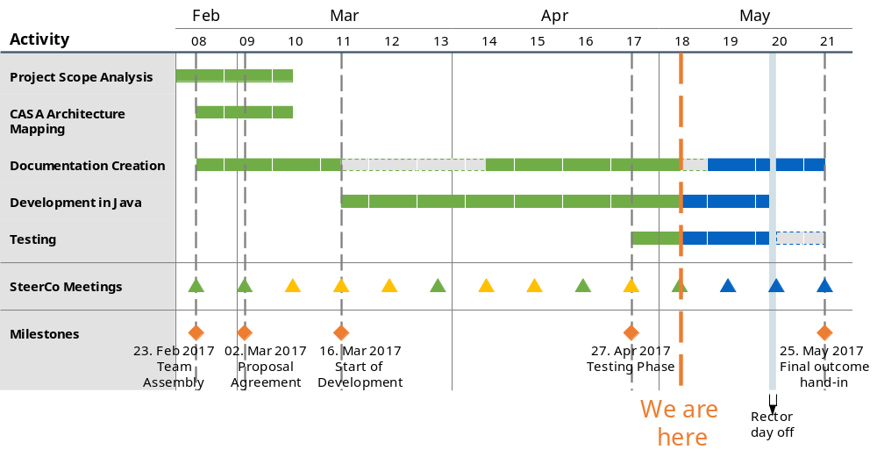

Development plan

Baseline – Initial development plan
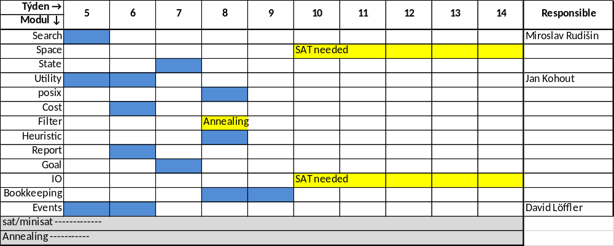

Current status
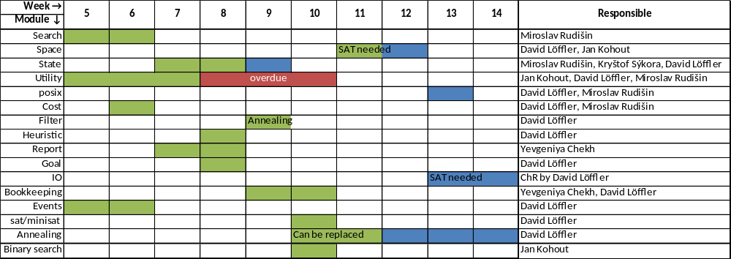
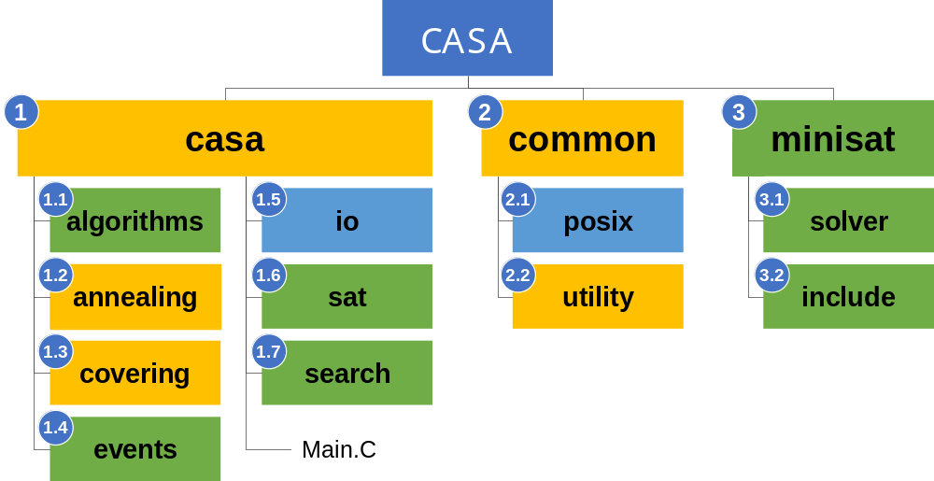

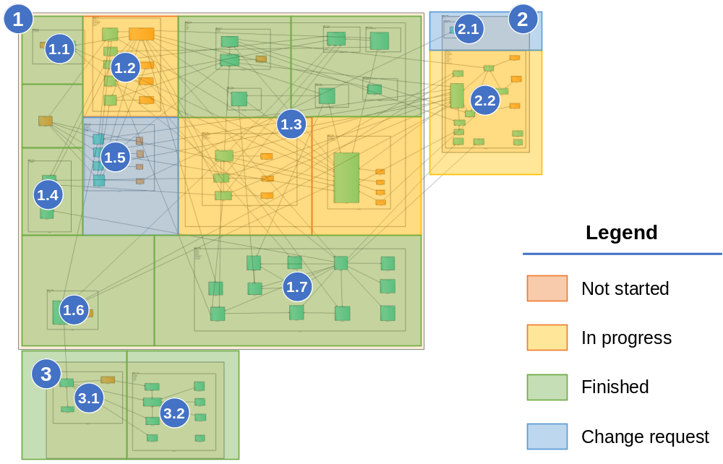

Testing plan

Baseline
There was no specific covering plan set

Current status
