Software Requirements Specification

for Project Staffr

Prepared by   
Kryštof Sýkora, Marek Szeles  
ČVUT FEL SIT,   
Enterprise architectures

Version 1.0  
1. 10. 2017

Table of Contents

1. Introduction 1

1.1 Purpose 1

1.2 Intended Audience and Reading Suggestions 1

2. Overall Description 2

2.1 Product Perspective 2

2.2 Product Functions 2

2.3 User Classes and Characteristics 2

2.4 Operating Environment 3

2.5 Design and Implementation Constraints 3

2.6 User Documentation 3

3. External Interface Requirements 4

3.1 User Interfaces 4

3.2 Software Interfaces 5

3.3 Communications Interfaces 5

4. System Features – Use Cases 6

4.1 Basic features to be implemented within project scope 6

4.2 Advanced features NOT to be implemented within project scope 7

5. Other Nonfunctional Requirements 8

5.1 Performance Requirements 8

5.2 Security Requirements 8

5.3 Software Quality Attributes 8

5.4 Business Rules 8

6. Other Requirements 9

Revision History

|  |  |  |  |
| --- | --- | --- | --- |
| **Name** | **Date** | **Reason For Changes** | **Version** |
| Marek Szeles | 12. 7. 2017 | Document initialization | 0.1 |
| Marek Szeles | 26. 7. 2017 | First chapters written | 0.2 |
| Kryštof Sýkora | 10. 8. 2017 | Domain Model v1 | 0.3 |
| Marek Szeles | 12. 8. 2017 | First half of chapters done | 0.4 |
| Marek Szeles | 16. 8. 2017 | Use cases updated | 0.5 |
| Marek Szeles | 20. 8. 2017 | Graphics update | 0.6 |
| Kryštof Sýkora | 24. 9. 2017 | Domain Model v2 | 0.7 |
| Marek Szeles | 29. 9. 2017 | Revison | 0.8 |
| Marek Szeles | 1. 10. 2017 | Doc finalization | 1.0 |
|  |  |  |  |

# Introduction

## Purpose

The product of this project will be a Java EE and ReactJS based Maven compilable program that allows for staff administration to a company representative with appropriate rights.

Within the EAR project scope, we are aiming to create a system for staff administration for businesses. The primary use is for managers to have a clear overview of available staff they could assign positions on ongoing projects.

The project output is especially intended for larger international corporations in need of sourcing its projects from broad selection of available staff on hand, with various areas of expertise.

## Intended Audience and Reading Suggestions

This document is intended for anyone interested to learn about the concepts and architecture used in the Staffr project.

# Overall Description

## Product Perspective

This is a standalone product, completely independent in its basic functions. If its planned advanced functions are to be implemented, some use of external APIs is to be expected.

## Product Functions

### Basic functions to be implemented within project scope

* User roles
  + There are to be three levels of user power within the system:
    - Admin – Has all the administrative rights to the system – i.e. to create and edit users, administer their contracts and administer the login credentials of other users
    - Project leader – Has the rights only to search for staff to assign to a project
    - Standard User – Same as project leader, but can only view own profile
* Staff search through filtering
  + The staff (standard users) will have several attributes (specialties/expertise) through which they can be searched. For example, I can search for staff with at least n years of experience in a given field of expertise.
* Basic user administration
  + The admin user is going to be able to edit details about other users, such as personal details, location and areas of expertise (resumé).

### More advanced functions NOT to be implemented within project scope

* Project pages
  + Editable pages for individual projects with participants, user roles and goals listed.
* KPI tracking
  + Key performance indicators and deadline tracking for projects

## User Classes and Characteristics

Apart from the state before logging in, there are only three expected user classes defined within the Staffr project – user, project leader and admin. Both have very similar functions, only overall rights are different. The roles are not overlapping and thus are exclusive.

### Everyone (before logging in)

Anyone accessing the server/side program through a browser will be presented a simple form to log into the system using a username and password.

### Standard User

After logging in, a user can review his account, review the history of the account, and manage own personal details.

### Project leader

Has the rights only to search for staff to assign to a project. Can also edit project pages.

### Admin

An admin has all the rights a project leader has, but also has all the administrative rights to the system – i.e. to create and edit users, administer their contracts and administer the login credentials of other users.

## Operating Environment

The backend source code of the program is assembled mainly using Java Enterprise Edition. It is deployed on a Tomcat server environment, using a PostgreSQL database to store inputted information. The frontend is created using the ReactJS library.

## Design and Implementation Constraints

If some of the advanced functions are to be implemented, the development is likely to be limited by external APIs – for example, if using an external API to recognize text, or when connecting to an external API handling access to different systems (mailbox handlers, other enterprise applications, etc.)

## User Documentation

Overview and development documentation will be provided, along with a simple user manual in the form of pdf files.

# External Interface Requirements

## User Interfaces

The GUI is going to be design with minimalism and simplicity in mind in order to allow for intuitive user flow of work. The layout is to be clearly separated into functional and passive parts, with labels describing all buttons and functions.

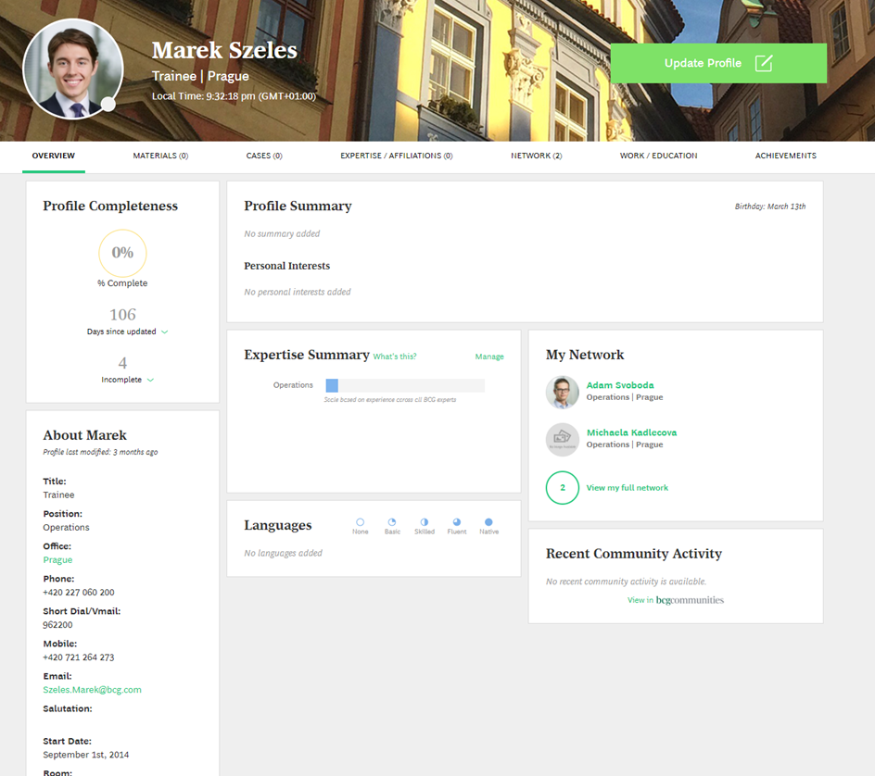Here is a draft of how the interface may look like:

Figure 1: User screen

## Software Interfaces

The program in its basic functions is fully integrated with itself and needs no access to outside sources. If and when the advanced functions are implemented, they will by definition need interfaces to access outside systems, however these systems and the nature of such transactions are to be determined when it comes to the relevant phase of development.

## Communications Interfaces

Communication between the server and the user is going to take place through a web browser, using the HTTP protocol. All other communication is translated directly into code and objects within the program itself.

# System Features – Use Cases

This section describes the features to be implemented in the project and features planned for future development.

## Basic features to be implemented within project scope

### Create new user

#### Description and Priority

The administrator will be able to register using a username and a password of his choosing

**High priority**

#### Stimulus/Response Sequences

The admin selects create new user > Fills out their username and password, which he inputs twice for confirmation > Registration complete

#### Functional Requirements

The software is required to assign unique Ids to all new users, check for database consistency (no duplicate usernames) and handle security (hash passwords)

### Login

#### Description and Priority

The user will be able to login using a combination of username and password

**High priority**

#### Stimulus/Response Sequences

The user selects login > Fills out their username and password > System checks if an entry in database equals to input > Login complete

#### Functional Requirements

The software is required to keep track of each login session and not mix up requests.

### Add/remove user

#### Description and Priority

The admin will be able to add new users and delete them

**High priority**

#### Stimulus/Response Sequences

The user selects to add user > Fills out information about the user > confirms > New user added

#### Functional Requirements

The software is required to keep and store all accounts and show them only to their respective owners

### Show user overview

#### Description and Priority

The user will be able to view his account overview

**Medium priority**

#### Stimulus/Response Sequences

The user selects overview > User accounts overview is shown

#### Functional Requirements

The software is required to show all transactions stored relevant to particular account

## Advanced features NOT to be implemented within project scope

### Creation of project pages

#### Description and Priority

The project leaders will be able to create and administer the projects they are leading and staff assigned to them, including KPI tracking, etc.

**Medium priority**

#### Stimulus/Response Sequences

The project leader selects create new project > selects assign staff > system periodically refreshes project staff capacity status > at end of project, PL inserts outcome evaluation

#### Functional Requirements

The software is required to repeatedly and correctly refresh connection to project pages

### Creation of a user using Google or Facebook

#### Description and Priority

The admin will be able to register users using Google or Facebook for login credentials.

**Low priority**

#### Stimulus/Response Sequences

The user selects connect > Connect using Google/Facebook > Grants permission to Staffr to fetch email > Registration complete

#### Functional Requirements

The software is required to handle authorization communication with external servers.

### Login using Google or Facebook

#### Description and Priority

The user will be able to login using Google or Facebook for login credentials,

**Low priority**

#### Stimulus/Response Sequences

The user selects login > Login using Google/Facebook > System checks if user is registered > login complete

#### Functional Requirements

The software is required to handle authorization communication with external servers.

### Scanning CVs and other documents

#### Description and Priority

The system will be able to fetch relevant information from a digital copy of a CV, even a photo of it

**Low priority**

#### Stimulus/Response Sequences

The user selects scan CV > uploads picture > system fetches information from data and pre-fills form > asks user to confirm > new entry created

#### Functional Requirements

The software is required to efficiently and correctly fetch data from different digital sources

### Connect to MS Outlook/other widely used systems

#### Description and Priority

The system will connect to other present enterprise systems used by the organization

**Low priority**

#### Stimulus/Response Sequences

The user selects other systems > system to connect > computer monitors relevant data and informs user of development

#### Functional Requirements

The software is required to efficiently and correctly fetch data from different servers

# Other Nonfunctional Requirements

## Performance Requirements

The program is expected to handle all logged users with no noticeable delays. To assure this, sufficient hardware is needed for possible service overload.

## Security Requirements

Due to the nature of the stored data, the database and user login data is going to be secured using different methods, such as hashing passwords and passing data through secure connections, to which a separate security layer will be committed.

## Software Quality Attributes

The resulting software should be flexible and adaptable to different uses – it should be simple and intuitive to add new categories or tags for example. Also, if, in the future, a new world currency comes to exist which is going to be widely used, its retrospective implementation into the project should be simple as well.

## Business Rules

While all users can see other user’s profiles, only project leaders can assign employees to projects and only admins can create new users.

# Other Requirements

The project is required to have at least five database tables, have at least one M:N relation and use one dependency.

Appendix A: Glossary

Java EE – Java Enterprise Edition

GUI – Graphical User Interface

PL – Project Leader

Appendix B: Analysis Models

**Domain model**

