**Software Requirement Specification (SRS) for Employee Attendance System (EAS).**

**1. Introduction**

**1.1 Purpose**

The purpose of this document is to define the business requirements for the development of a Employee. Attendance System (EAS) for efficiently tracking and maintaining employee attendance records, and providing essential information to the HR department and employees.

**1.2 Scope**

The Employee Attendance System will track and manage employee attendance based on company policies. It will provide HR with attendance summaries. Employees will be able to access their own attendance.

**1.3 Audience**

This document is intended for project stakeholders, including the HR department, developers and other relevant personnel involved in the development and implementation of the Employee Attendance System.

**2. Diagrams**

**2.1. Use Case Diagram**

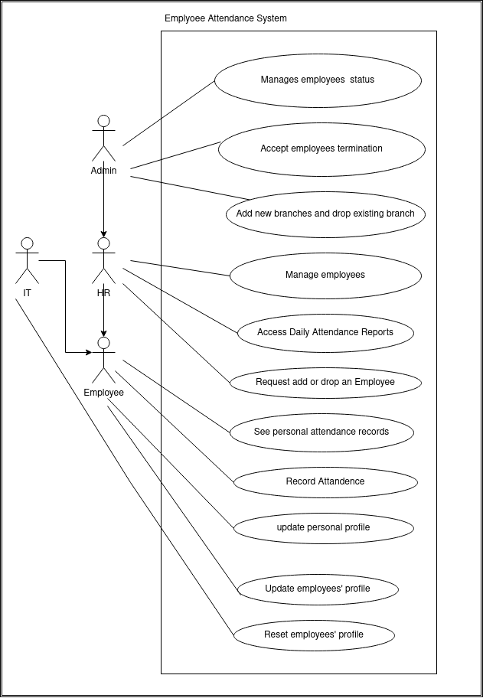

**2.2. Entity Relation Diagram (ERD)**

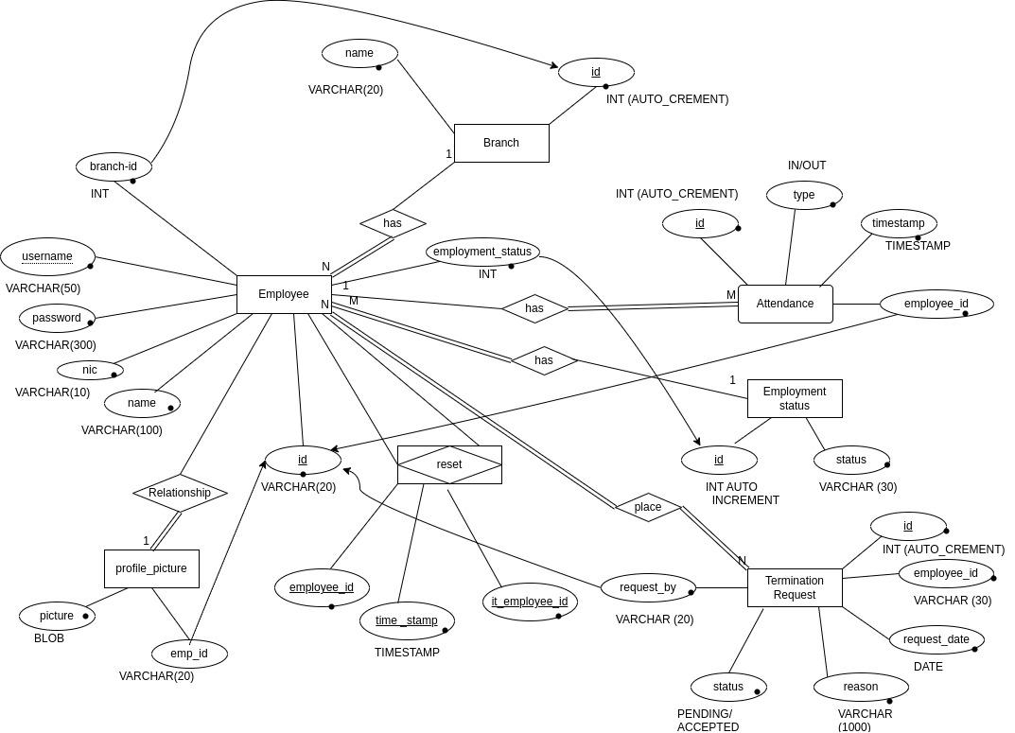

**2.3. WireFrame**

**2.3.1. Login Form**

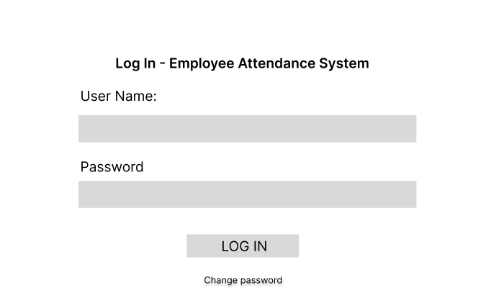

**2.3.1. Change Password**

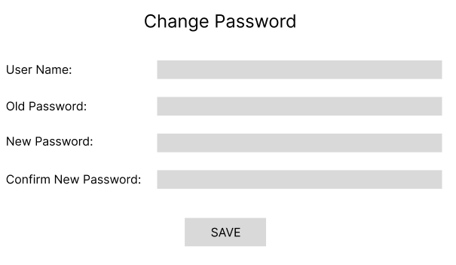

**2.3.2. Admin View**

**2.3.3. HR View**

**2.3.4. IT Person View**

**2.3.5. Employee Registration Form**

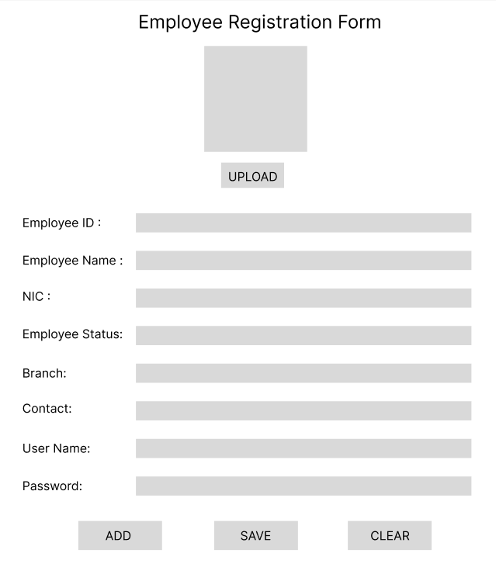

**2.3.6. Create New Branch**

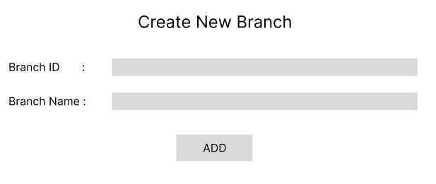

**2.3.7. Add Employee Status**

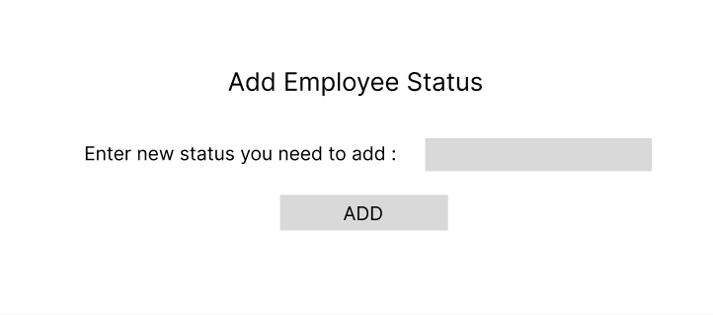

**2.3.8. Delete Employee Request**

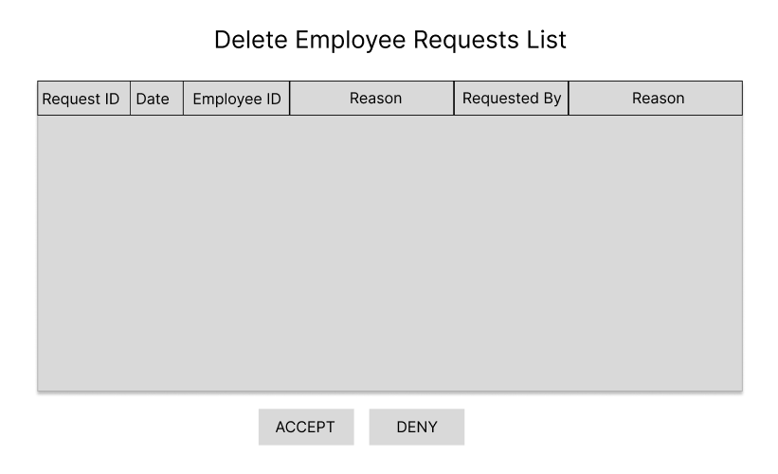

**2.3.8. Employee Attendance**

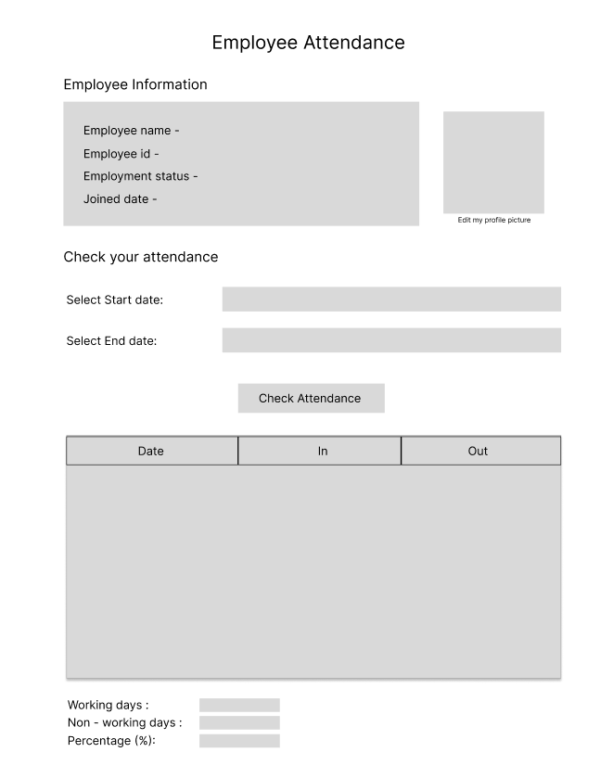

**2.3.9. Delete Request**