

PlayFab Account Management

*\* This sample is compatible with the April 2018 XDK*

# Description

This sample shows the information you can query about a player from their account and profile information. It also allows you to change accounts, create a new account, and set some account information.

# Using the sample

This sample is configured to work in the XDKS.1 sandbox.

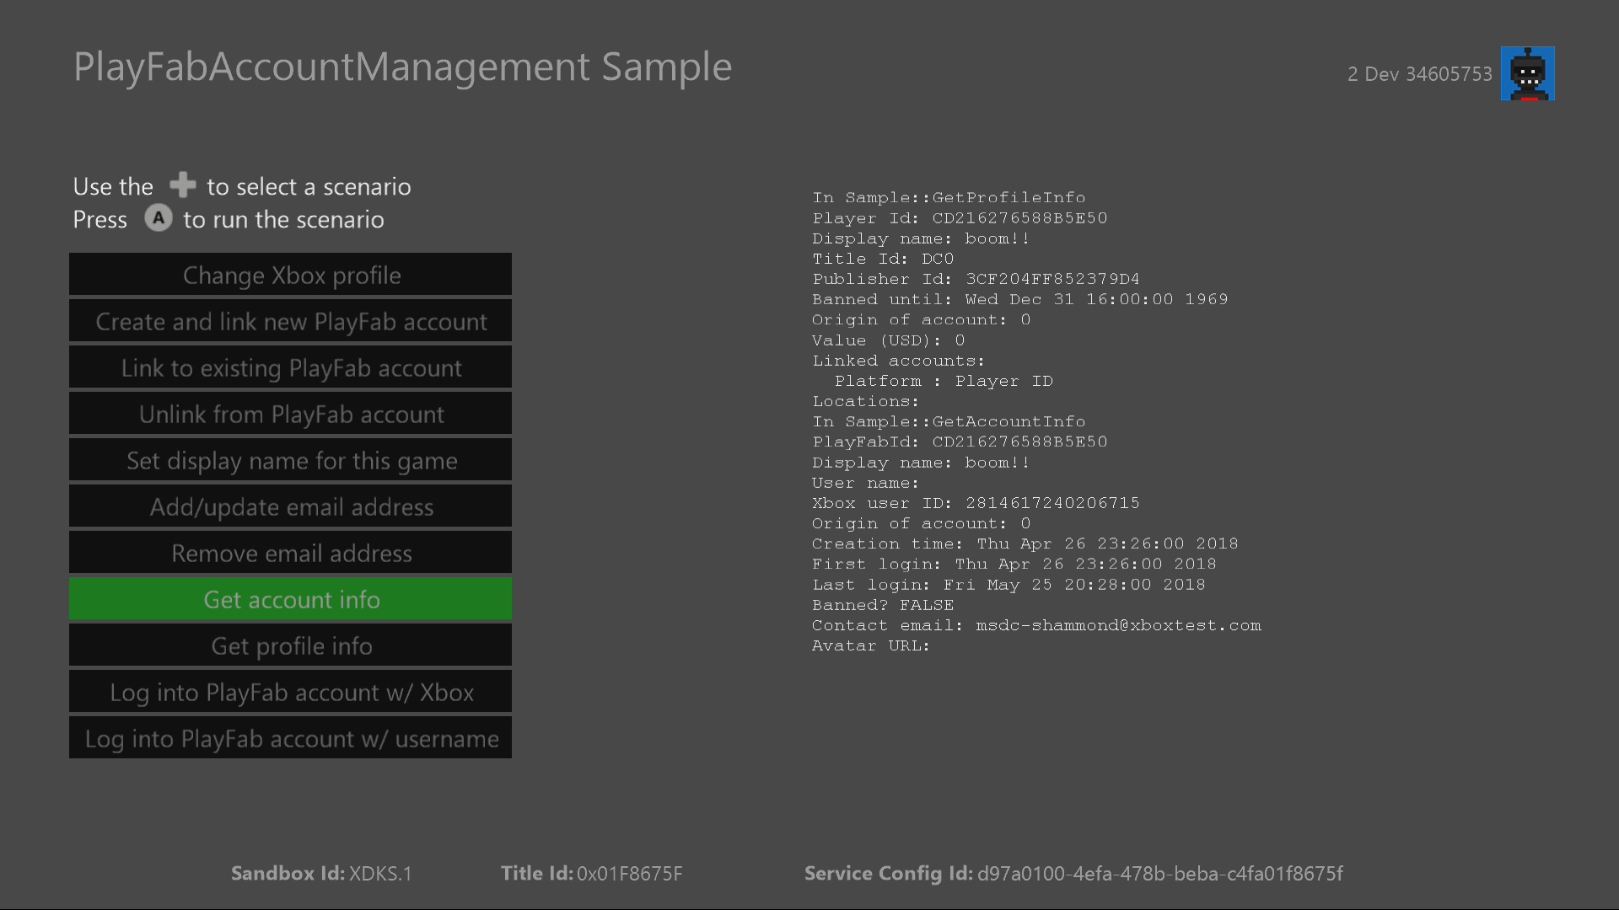

|  |  |
| --- | --- |
| Action | Gamepad |
| Select operation | D-pad |
| Execute action | A button |
| Exit | View button |

# Implementation notes

In this version of the XDK, the sample also requires your Xbox One console to use the XDKS.1 **SandboxID**. To switch to this **SandboxID**, in the Xbox One XDK command prompt, use:

xbconfig sandboxid=XDKS.1

The PlayFab title ID must be set in the sample initialization code. This sample uses the PlayFab title ID “DC0” which is assigned to the **PlayFabSettings::titleId** static field.

# Account and profile information

The PlayFab API allows implementation of profile and account management from within a game. This includes querying player information or updating account information, such as a player’s display name or contact email. It also allows games to query information about the player that can help drive user experience based on their playing habits. This includes login history, purchase history, or the physical location of logins if they were performed on GPS enabled devices.

# Update history

**Initial Release:** June 2018

# Privacy Statement

When compiling and running a sample, the file name of the sample executable will be sent to Microsoft to help track sample usage. To opt-out of this data collection, you can remove the block of code in Main.cpp labeled “Sample Usage Telemetry”.

For more information about Microsoft’s privacy policies in general, see the [Microsoft Privacy Statement](https://privacy.microsoft.com/en-us/privacystatement/).