

PlayFab News Feeds

*\* This sample is compatible with the April 2018 XDK*

# Description

This sample demonstrates the PlayFab newsfeed API. It pulls content from the PlayFab servers to be displayed in-game.

# Using the sample

This sample is configured to work in the XDKS.1 sandbox.

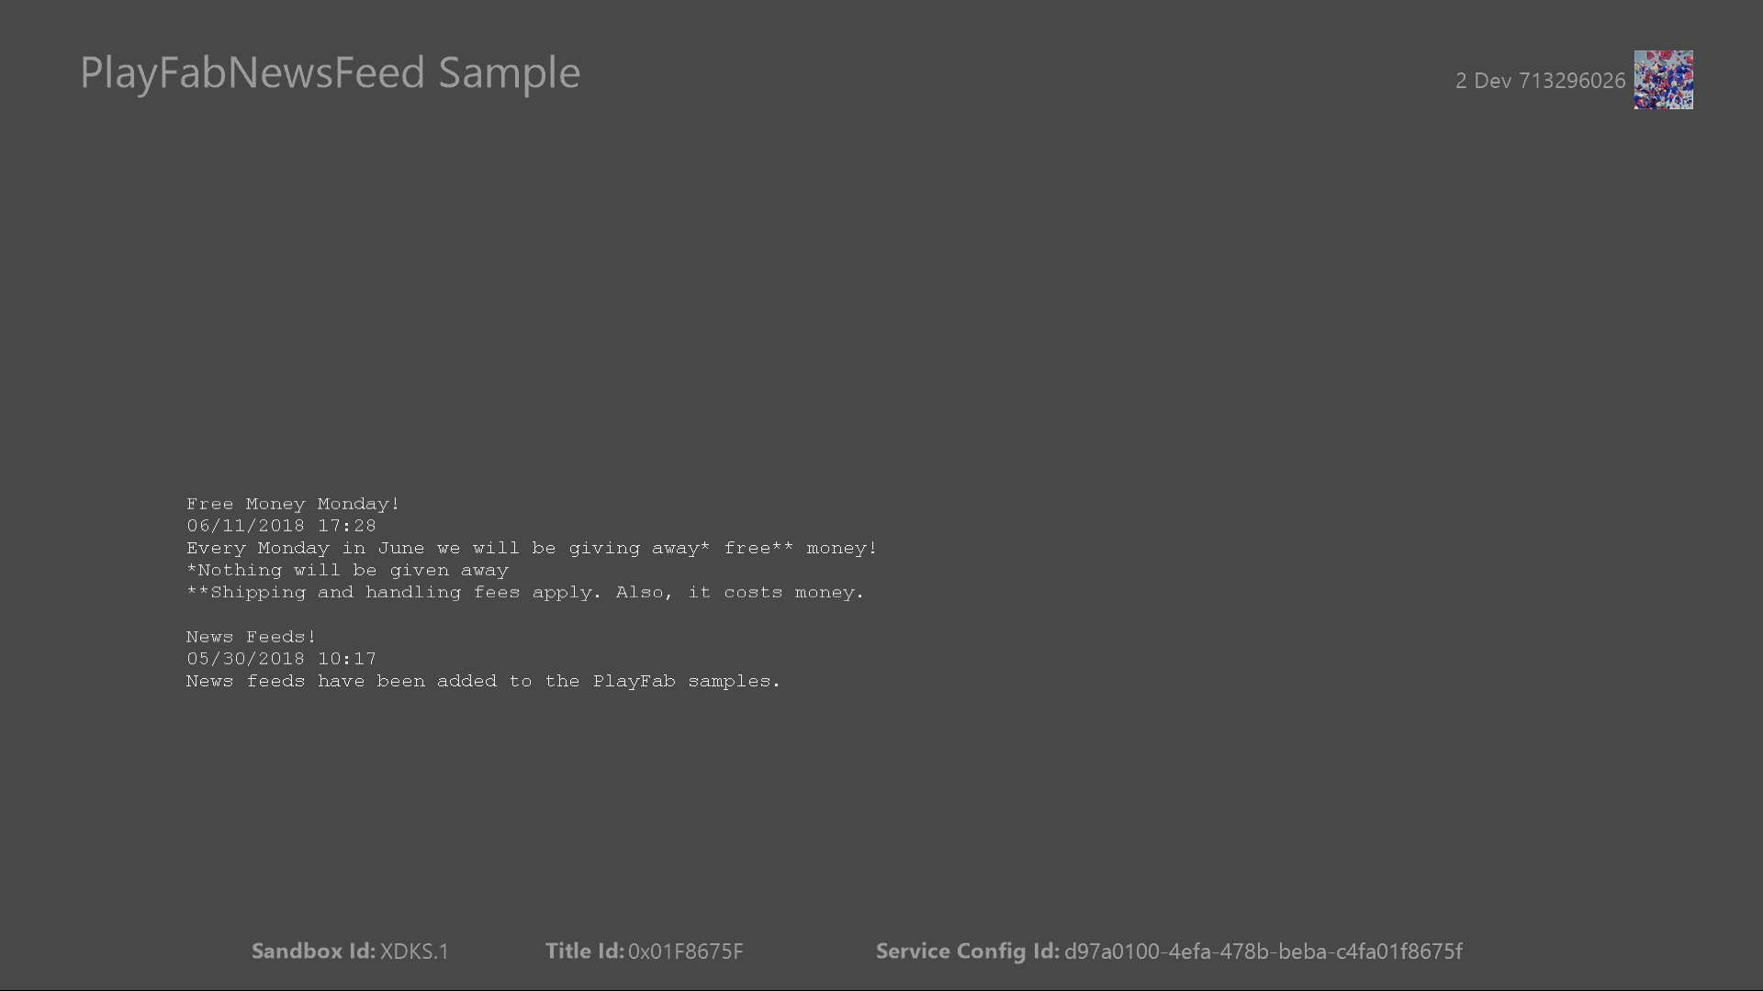

|  |  |
| --- | --- |
| Action | Gamepad |
| Show account picker | Menu button |
| Refresh PlayFab token | A button |
| Exit | View button |

# Implementation notes

In this version of the XDK, the sample also requires your Xbox One console to use the XDKS.1 **SandboxID**. To switch to this **SandboxID**, in the Xbox One XDK command prompt, use:

xbconfig sandboxid=XDKS.1

The PlayFab title ID must be set in the sample initialization code. This sample uses the PlayFab title ID “DC0” which is assigned to the **PlayFabSettings::titleId** static field.

# PlayFab News Feed

This sample demonstrates the GetTitleNews API. It pulls data from the PlayFab servers that can be configured for your title in the **Content** tab of your PlayFab dashboard. The request object, **GetTitleNewsRequest**, allows you to specify the number of items to pull from the service. If this is left blank the API will default to pulling the 10 latest news items.

# Update history

**Initial Release:** July 2018

# Privacy Statement

When compiling and running a sample, the file name of the sample executable will be sent to Microsoft to help track sample usage. To opt-out of this data collection, you can remove the block of code in Main.cpp labeled “Sample Usage Telemetry”.

For more information about Microsoft’s privacy policies in general, see the [Microsoft Privacy Statement](https://privacy.microsoft.com/en-us/privacystatement/).